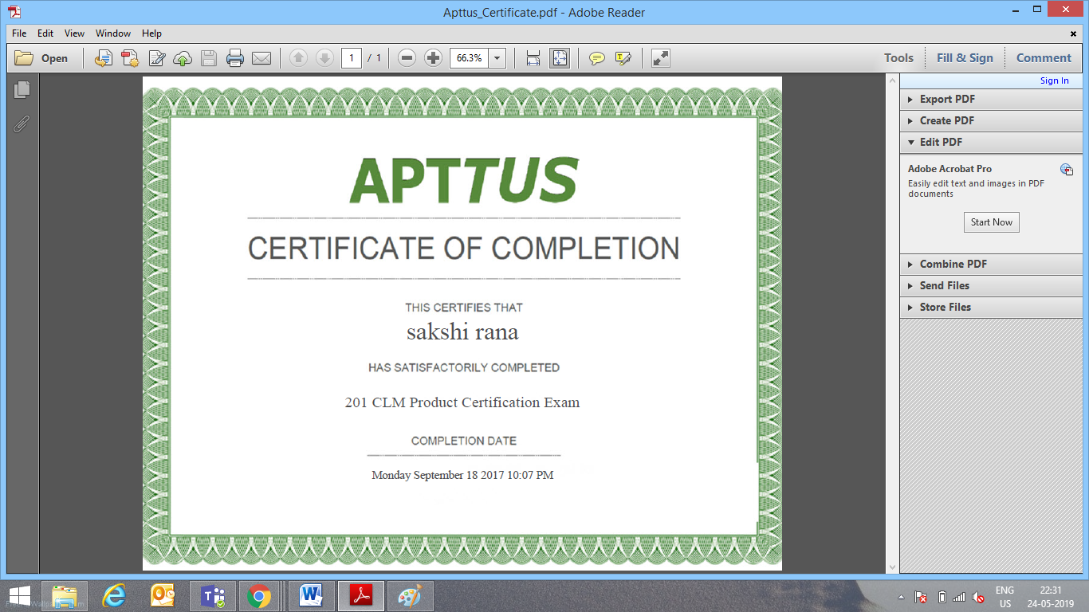 **SAKSHI RANA**

**Noida, U.P., India 122018 | Ph No: 7988360843 | rana.sakshi123@gmail.com**

**Summary**

A result-driven, customer-focused, articulate and analytical Software Engineer who can think “out of the box”. Strong in design and integration problem-solving skills. Expert in **Apttus CLM, Salesforce.com(Force.com),** Skilled in developing requirements specifications, user documentation, and architectural systems research.

Strong written and verbal communications. Interested in a challenging technical track career in an application development environment.

**Certifications:-**

Apttus CLM, Conga CPQ L1, Conga Composer, DocuSign CLM Administration and Workflow Specialist

**Experienced In :**

**Apttus 201 CLM Product certified with 5.11 years of experience on Apttus CLM**

* Proficient in **setup**, **customize** and **deploy** to salesforce.com , perform hands on configuration using **out of box salesforce functionality**
* Implemented various advanced fields like **Pick list**,  **Formula Fields, , Validation Rules, Workflows**, **sharing rules** and **Approval Processes** for automated alerts, field updates, and Email generation according to application requirements
* Complete knowledge of **Apttus clm(X-Author, Query templates, Agreement rules, Agreement protection,** **ApttusMigrationManagerInstaller),Adobe sign(e-signature)**
* Successfully implemented Apttus clm functionalities like **query templates, agreement rules, IWA**
* Have a complete knowledge of **Apttus CLM**
* Analysis and design of databases and user interfaces.
* Managing requirements.
* Providing full lifecycle support to clients from initial client interaction and requirements analysis through design
* Testing , implementation, and integration.
* Managing and supporting multiple projects.
* Highly adaptable in quickly changing technical environments.

**Technical skills:**

|  |  |
| --- | --- |
| **Salesforce Technologies and Apttus ,DocuSign CLM** | Force.com ,Salesforce.com customizations like Workflow Rules, Role Hierarchy, Validation Rules, Formulae, Custom objects, Page Layouts, Record Types, **X-author, Apttus CLM, Query Templates, Agreement Rules, DDA, Agreement protection, Apttus Migration Manager Installer, Adobe sign(e-signature),Apttus/Conga CPQ, Conga Composer,Docusign CLM** |
| **Operating Systems** | Windows 98/2000/XP/2003/2007. |
| **Web Development** | HTML, CSS, |
| **Languages** | C,SQL |
| **GUI and Tools** | Force.com IDE, workbench, Service now |

**Education Detail**

* M.Tech in Electronics and communication Engineering (2012-2014) from GGGI, Dinarpur, Ambala affiliated to Kurukshetra University with 76%.
* Research work: Enhance Energy Utilization in WSN by using chain based protocol
* Certificate of publication: 1.Study and Comparison of Chain Based Protocol to Enhance Energy Utilization in Wireless Sensor Network.

2. Review of Chain Based Protocol to Enhance Energy Utilization in Wireless Sensor Network.

* B.Tech in Electronics and communication Engineering (2009-2012) from M.I.E.T, Mohri affiliated to Kurukshetra University with 75%.
* Diploma in Electronics and communication Engineering (2006-2009) from Govt. Polytechnic Ambala city, Haryana with 76%.
* 10+2 with (2006) from HBSE Board with 77% marks.
* 10th (2004) from HBSE Board with 80% marks.

**Software Skills**

* **LANGUAGES/SCRIPTS :**  **Salesforce,Force.com, Apttus CLM, Conga CPQ, Conga Composer**
* **FRAMEWORKS : Force.com**
* **DATABASES :** SQL,SOSL
* **SOFTWARE :** Eclipse

**Experience**

**ROLE: Associate consultant in IT**

**Employer : WIPRO technologies, Greater Noida**

**Project Name : Xerox(Production Support)**

**Date : September 2019 to present**

* **Independently handling client calls and understand there requirements**
* **Close incidents related to Apttus CLM within SLA**
* **Worked on CRs and implemented and deployed successfully**
* **Successfully made changes to existing templates and check-in new templates using X-Author**
* **Worked on smart field , conditional segmentations, clauses and language(Formatting) of document**
* **Worked on workflows, Field dependencies, Page layouts query template, agreement format, agreement rules.**
* **Hands on Migrated templates from sandbox to production using ApttusMigrationManagerInstaller**
* **Worked on Adobe sign(e-signature),merge mapping and configuration of text tag in templates**
* **Worked on Upgrade of lower version of Apttus CLM to Latest version.**
* **Got certified for Conga CPQ , Docusign CLM administration specialist and Docusign CLM workflow specialist**

**ROLE:** **Senior Associate in IT**

**Employer** : **Mindmerchants Global Pvt. Ltd.,Gurgaon**

**Project Name : Viacom18**

**Date : October,2018 – August 2019**

* Successfully implemented Apttus CLM functionalities like **query templates, agreement rules, IWA**
* Researched and gathered customer requirement and implemented functionality
* Implemented custom **validation rules, custom formulas, Email Templates, Assignment Rules and Auto-Responses for Cases and Leads**.
* Implemented **SOQL, SOSL** query
* Created **Agreement rules, workflow rules and approval process to automate contracts.**
* Successfully implemented **Apttus CLM Lifecycle**
* Successfully created the **query templates**
* Successfully created **smart fields ,clauses and uploaded templates to the specified agreement using X-author.**

**ROLE**: **Senior Associate in IT**

**Employer : Mind Merchants**

**Project Name : Photon**

**Date :** **Septemer,2017 – Augest,2018**

* Involved in **gathering requirements** from the business and implementing those in Salesforce.com
* Created multiple **custom objects, custom fields**, **relationship** between two objects, **page layouts** and **record types**
* Developed different **Validation Rules** to ensure that the valid data is being entered into the organization
* Developed **workflow** **rules** and **approval processes** to automate the business process
* Utilized **Salesforce.com out-of-the-box** functionalities over customization wherever possible
* Successfully implemented Apttus CLM functionalities like **query templates, agreement rules, IWA**
* Researched and gathered customer requirement and implemented functionality
* Implemented custom **validation rules, custom formulas, Email Templates, Assignment Rules and Auto-Responses for Cases and Leads**.
* Implemented **SOQL, SOSL** query
* Created **Agreement rules, workflow rules and approval process to automate contracts.**
* Successfully implemented **Apttus CLM Lifecycle**
* Successfully created the **query templates**
* Successfully created **smart fields ,clauses and uploaded templates to the specified agreement using X-author.**

**ROLE : Senior Associate in IT**

**Employer : Mind merchants**

**Project Name : Myntra**

**Date : June 2016 – September,2017**

* Researched and gathered customer requirement and implemented functionality
* Involved in **gathering requirements** from the business and implementing those in Salesforce.com
* Worked on **Standard objects** like Accounts, Contacts, Lead, and Cases, and **Custom Objects**.
* Created multiple **custom objects, custom fields**, **relationship** between two objects, **page layouts** and **record types**
* Developed different **Validation Rules** to ensure that the valid data is being entered into the organization
* Developed **workflow** **rules** and **approval processes** to automate the business process
* Applied many logic into sending out **email templates** firing through **Workflow** based on the requirement
* Utilized **Salesforce.com out-of-the-box** functionalities over customization wherever possible

**Strengths**

* Flexibility and Adaptability.
* Positive Attitude.
* Enjoys Responsibilities.
* Quick learner.
* Good time management skill.
* Action-oriented and result-focused.

**Extra Curricular & Hobbies**

* Participated in “Techraze” organized in college.
* Participation in various Sports & cultural activities at school & college level.