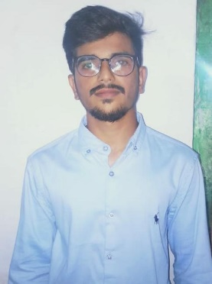

RAMANA SURYA SAI OBUL REDDY
Email : ramanasuryasai@gmail.com
Phone : 9908534200

Reg.No. : 121005115

CAREER OBJECTIVE

Seeking position in your organization to build a career giving my best, with an opportunity of working with diverse group of people and enhancing my professional skills with learning and experience for career growth.
ACADEMIC QUALIFICATION

S. No | Qualification | Name of Institute | Year of passing | Branch | Aggregate
1 | Engineering | SASTRA Deemed University | 2021 | E. E. E | 6.4516/10  (still pursuing)
2 | Intermediate | Bhashyam Educational Institutions | 2017 | M. P. C | 96.7%
3 | Higher Secondary | Bhashyam Educational Institutions | 2015 |  | 9.5/10

TECHNICAL SKILLS

- Proficient in concepts of VLSI Design
- Knowledge in basics of C Programming, My SQL
- Basics in AutoCAD, Microsoft Excel, Microsoft Word, Microsoft PowerPoint
AREAS OF INTREST

- Power Plants
- Transmission and Distribution
PROJECTS

- DC Motor using Buck Converter
- Power Quality Enhancement on a Grid Connected with Wind Turbine
WORKSHOPS ATTENDED

- ECIL: Embedded Systems
Was able to learn about many basic concepts and their applications under embedded systems
- Rayalaseema Thermal Power Plant
Learnt some technicalities in it and some basics about how thermal power plant works
STRENGTHS

- Adaptable to extreme circumstances
- Enthusiastic to learn and explore new things
- Self-Motivation
PERSONAL DETAILS
- Name : Ramana Surya Sai Obul Reddy
- Father’s Name : Chandra Obul Reddy
- Address for correspondence : #1/85, Ramanapalli,
Chennur, Kadapa,
Andhra Pradesh - 516162.
- Date of Birth : 28th September 1999
- Languages Known

LAUNGUAGE | READ | WRITE | SPEAK
English | yes | yes | yes
Telugu | yes | yes | yes
Hindi | yes | yes | yes
Tamil | no | no | yes

- Nationality/Religion : Indian/Hindu
- Interest & Hobbies : Travelling, Chatting with friends, Watching movies

Place : KADAPA R SURYA REDDY

Date : 18/05/2021 (Signature)

