
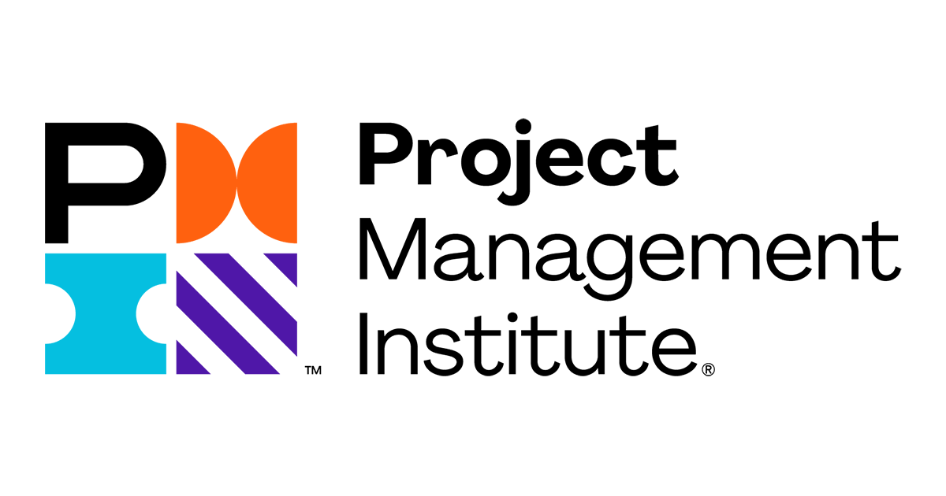

Mudit Verma
muditverma6834@gmail.com
+1 (574)-387-3724

PROFESSIONAL SUMMARY:

- 8 years IT Project Management experience using Agile and Waterfall methodologies, with hands on Implementation, Deployment, Enhancements, and Production support
- Managed several High visibility IT projects that involved cross functional teams
- Significant experience in Large scale, Highly complex and Integrated IT projects, including migrating Legacy applications to SAP VISTEX and BW HANA
- Managed Full life cycle implementations of several/ heterogeneous Go-Live deployment projects for corporate with numerous rollout strategies using PMI, SDLC, PLM and ASAP methodologies
- Experience with Leading and Managing IT Solutions Implementation, Migration, Cloud upgrades
- Strong IT software and hardware knowledge with experience in managing inventories
- Managed and created well defined Project Management documentation that included and not limited to: Project Charter, Blueprint Document, Project Management Plan, Project Schedule, Organizational Change Management Plan, Training Plan, Master Test Plan, Quality Assurance Plan, Test Scripts, Issue Logs, Security Management, Change Logs, Cutover Detailed Plan, Communication Plan, Business Process Master List, Risk Register, Functional spec, etc.
- Worked in Complex Change Projects and applied various Managerial Methodologies including Agile
- High capacity to translate Business Requirements into Project Deliverables list and track the status/ quality of deliveries using Requirements Traceability Matrix and other tools
- Significant knowledge on Large Projects Scheduling, Planning and Tracking by computing the project Scope, Budget and Time
- Outstanding experience in Planning & Leading Testing strategies, developing Testing Approaches and define the ways of working between heterogeneous teams
- Experience in planning and managing Cutovers using various strategies such as Bing-Bang, Hot, Cold, and Hybrid Cycles Cutovers

SKILLS:

Project Management Skills | Project Complexity assessment, Evaluate and define the project Scope, Project sizing, scheduling & WBS creation, Change Management, Test & cutover strategy definition, training and knowledge transfer.
Methodologies | Agile Scrum, Waterfall, Prince II
Technologies | SAP R/3, Veeva Sales Force, JAVA, Blacksmith, WEBAPPS
Tools & Software | MS Project, JIRA, Clarity PPM, SAP Solution Manager, HPQC, Rally, Slack, GANTT, Office 365 (Planner, To Do, Teams, Visio, Excel, One Note, SharePoint, Publisher)

WORK EXPERIENCE:

Nestle North America
Arlington, VA
Project Manager August 2019 - Present

- Managing the Trade Promotion Solution implementation cross Nestle North America OpCos
- Gathered Business Requirements and created key documents including but not limited to Project Charter, Blueprint, Functional Spec, Change Management Plan, Portfolio Planning, Risk Register, Test Master Plan, Cutover Plan, Test Scripts, Project Master Data Repository, Project Schedule & WBS, Testing & Status Reporting Templates, KPIs.
- Developed the detailed list of Deliverables and created the WBS to define the various activities required including Requirement Gathering tasks for Design, Development breakdown, Testing and Cutover Strategy.
- Created Custom workflows, Custom screens and custom fields on Jira projects on Jira and assigned Jira Agile boards.
- Focused teams on Business Process and objectives and tracked progress to ensure project Milestones were completed on time, on budget and with the desired results.
- Managed the team in Planning and Controlling in setting up of Master data.
- Gathered the Project assumptions and identified the associated Risks and worked on the Preventive Action Plans.
- Followed a Hybrid approach, i.e., Agile Scrum approach for Development and Waterfall approach for Testing and Project Planning.
- Reported progress to all Internal and External stakeholders through Sprint Burn-Down Reports, Iteration Burn-Down Reports, and Velocity target updates.
- Worked remotely with key business leaders to understand Organizational Change Management implications across multiple business units.
- Developed Project and Portfolio KPIs and reported Daily Progress.
- Strategically formulated ideas for maintaining Risk Register, using Quantitative and Qualitative Risk Assessment Strategy.
- Implemented Agile management ideals by facilitating exercises such as Sprint planning, Sprint backlog and Sprint review
- Worked remotely with ​Program Leaders, Cross Functional Teams and key executive Stakeholders to drive ongoing clarity of strategy, decisions, execution alignment and project costing.
- Developed and monitored Project schedules using MS Project, Rally, MS Teams/Planner & JIRA.
- Performed Testers Capacity Planning and developed the Test Execution Plans.
- Developed the Master Test Plan, Master Data Management and the detailed Test Plans.
- Created Project Templates and Training materials.
- Managed Defect tracking and Communication during the Execution phase, using JIRA, MS SharePoint.
- Developed the Initial Cutover Strategy and created the detailed Cutover Plan.
- Managed and supervised the Go-Live activities and support the Hypercare activities alongside the COC team.

The Vanguard Group
Malvern, PA
Project Manager April 2017 - July 2019

- Worked on the Project to Design, Develop and Deploy User interface to check Credit Score
- Managed project timelines, tasks, and Business and customer teams. Testing coordination to ensure quality is achieved for optimizing our product into an innovative industry leader.
- Responsible for reviewing and following Strict deadlines while implementing, stabilizing the project.
- Analyzing, documenting, validating and prioritizing requirements during the design phase with proper coordination with stakeholders.
- Planned and executed Enhancements, and Applications Performing Testing.
- Oversaw software developer’s progress on applications and applied Agile principles to keep the project on track.
- Created plan to incorporate Project and Product life Cycle and Researched project resources.
- Worked with multiple software development and DevOps team to address issues and improve quality.
- Assigned user personal space and provided assistance in using MS SharePoint.
- Cultivated Define, Measure, Analyze and Improve strategy to identify the problems, as a part of Continuous Process Improvement
- Managed all security and connectivity-based Deployments with the help of resources.
- Slack analysis and initiation of Corrective and Preventive actions.
- Enforced ​Agile principles with the help of scrum master that resulted in reduction of Cycle time by 20% thus increasing team's throughput.
- Assisted with the integration of products using web technologies like HTML, CSS and JavaScript.
- Prepared Risk Register, High Level Plan, WBS and defined Critical Path for the projects in the project plan document, using Rally, MS VISIO, MS Project.
- Applied problem solving skills that help identification, troubleshoot, and address technical risks and issues with web service integrations, from back-end performance to web front-end UI issues.

Nestle Health Science (NHS)
Eden Prairie, MN
SAP Project Manager October 2015 - March 2017

- The Project was undertaken to Decommission various NHS Legacy applications and migrate the solution to SAP/VISTEX and BW HANA.
- Excellent knowledge of SAP Technology and Business Processes full project Life Cycle implementations.
- Engaged with Functional Managers and key stakeholders to understand the major roadblocks and facilitate estimating sessions with the cross functional teams.
- Implemented the Organizational Change Management strategy and ensured a smooth and adequate infrastructure that helped with KT and Project handover post Go-Live.
- Headed the Redesign of the whole Veeva/Salesforce landscape.
- Led various sessions to understand the roadblocks and define Business Process, what is In/Out of Scope and list down the Key Assumptions that helped building the High Level project plan.
- Gathered and listed the detailed tasks required for each phase and identified the dependencies and duration that served to draw the Project Baseline and identify the Critical Paths using MS Project, MS VISIO.
- Developed the detailed Testing Strategy and helped with Test Scripts creation and Defect Management Process.
- Monitored and mentored team for Agile, Waterfall and Hybrid training.
- Led weekly JIRA Review meetings and implemented excellent team involvement and interaction in weekly status reviews.
- Facilitated Sprint Planning, Sprint Review, Daily stand-up’s, Demos, Retrospectives, Coordinating and other activities as needed for multiple tasks.
- Assisted with team for improved visibility, transparency, and help radiating relevant project communication, through emails, MS SharePoint.
- Assisted with Prioritization and resolution of defects/bugs and proactively developed and maintained team standards, tools, and best practices.
- Managed Requirement Churn during the project by performing Impact Analysis by checking the feasibility in maintaining the Triple Constraint and discussing them in daily meetups.
- Identified and eliminated impediments, prevent distractions, identify and raise Risks, facilitate Mitigation plans, escalate as required, facilitate discussion and Conflict resolution.

Rational Business Corporation Pvt Ltd
New Delhi, India
Marketing Project Manager August 2013 - September 2015
Accomplished projects to handle outdoor marketing and digital marketing branding business

- Functioned Digital Market strategy for design, procurement, manufacturing, quality control and deployment of 2000 Standees in major cities.
- Supported Procurement Managers in the establishment of a Procurement Plan including schedule of long lead time items.
- Effectively ensuring the business requirements are thoroughly converted into well-defined goals and deliverables.
- Developed a product demonstration campaign resulting in various identified opportunities within the first month.
- Coordinated with team for Weekly Inventorying duties for better accuracy and productivity.
- Assisted with Inventory tracking, Restocking and Storeroom organization for the branding collaterals manufactured.
- Worked directly with management clients in gathering, documenting and analysis of data.
- Assisted in proper coordination with the design team for inculcating the desired features in the product as demanded by the client
- Identified and implemented improvements to processes and systems to complete work efficiently, hence delivering excellent service and customer satisfaction.
- Helped with Critical Path review and risk analysis.

Indian Oil Corporation Limited (IOCL)
New Delhi, India
Junior Project Manager May 2012 - July 2012

- Participated in the PMO establishing and Project Management & Quality Management template creation for various department.
- Participated and helped with Communication plans for requirements and Scope gathering.
- Proposed new model (different from existing one) to compensate for any error possible. Efforts were done to upgrade the automation process in Tank Lorry Filling (TLF) Shed of Indian Oil Terminal.
- Investigated and examined more than 20 incidents reported by Terminal authorities for poor management of existing working models for automation and solved more than 15 of conflicts.
- Participated in brainstorming session reducing percentage error reported during the automation process and eliminating any unwanted errors.

EDUCATION:
Florida International University Miami, US
Master of Business Administration (MBA)

Indian Institute of Technology Ropar Ropar, India
Bachelor of Technology
Major: Computer Science

