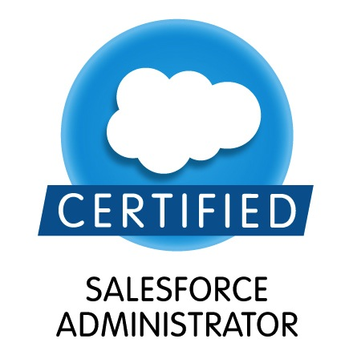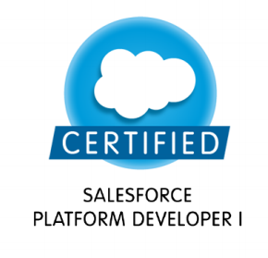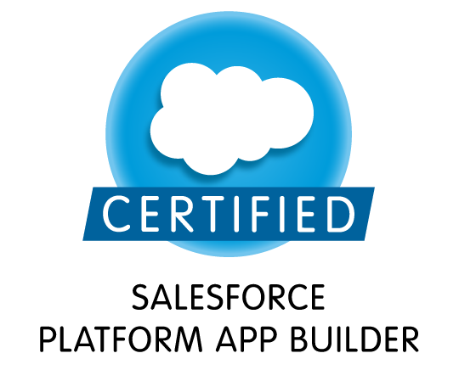

ASHISH NARANG E-mail: ashishnarang25@gmail.com
Phone : +91-8860647910/8368094625

A Salesforce Certified System Administrator and Platform Developer as well as skilled in Object-Oriented Programming (OOP’s), SQL, Java and C++. Strong engineering professional graduated from Guru Gobind Singh Indraprastha University with a demonstrated history of working in the information technology and services industry. Keen and passionate on learning and implementing new things and supports Teamwork.

CAREER OBJECTIVE

Position in an organization wherein I can get to work with experienced professionals and enhance my knowledge and skills with the purpose of contributing to the organization with the best of my abilities and keep myself updated with the latest technologies in the field.
SummarY

- Salesforce.com configuration:
1) Ability to use point and click configuration for Salesforce.com platform to map business requirements.
2) Understanding of SFDC Profiles/Roles, Permission Sets, Sharing Rules, Objects, Workflow rules etc.
- Salesforce.com Customization:
1) Worked on Triggers, Apex, Asynchronous Processing.
2) Worked on lightning framework (LWC AND AURA), event driven architecture and component creation.
3) Worked on SFDC Web Services APIs (SOAP & REST).
- Data Migration:
1) Ability to handle, prepare, analyze data for loading/extracting the data from Salesforce.
2) Ability to work with data migration using tools like APEX dataloader.
- Marketing Cloud And Health Cloud
- Did a POC on marketing cloud and health cloud.

SALESFORCE CERTIFICATION

- Salesforce Certified Administrator (ADM 201 )
- Salesforce Certified Platform Developer1
- Salesforce Certified App Builder

EXPERIENCE DETAILS (5yr 2 months)
DELOITTE – Consultant

DMV (July-2020 To Till Date)
Client | CT-DMV (State Of Connecticut - Department Of Motor Vehicles)
Project overview | Project involved creating a Portal for the customer to renew their licenses, photoId, change of address or any other task related to department of motor vehicles.
Technologies | Apex, Lightning Framework (LWC), HTML and CSS, SFDC configuration.

Covid-360 (May-2020 To July-2020)
Client | Internal Project
Project overview | Project involved creating a Health Care Management system for tackling any pandemic from technology front using the functionality of SFDC Health Cloud, Lightning Flows & Community Cloud.
Technologies | Apex, Lightning Framework (LWC), HTML and CSS, SFDC configuration.

Responsibilities
- Setting up and maintaining Salesforce standard objects and custom objects.
- Customizing the application & creating apex triggers, classes to meet the business needs.
- Creating lightning web components (LWC) and do event handling between them.
- Integrating with their backend system (Mainframe) via Mulesoft in DMV and Integrating SFDC with TWILIO for SMS and Whatsapp in Covid-360.

NAGARRO – Senior Associate (Technology)

NGHCM (Oct-2019 To Dec-2019)
Client | Client describes itself as a global Health Insurance Company that has a diverse set of Health Insurance Policies and Care Plans for the customers.
Project overview | Project involved creating a Next Generation Health Care Management system for the client (insurance company) in order to avoid the losses they have to bear incase the patient gets re-admitted to the hospital.
Technologies | Apex, Lightning Framework (LWC and Aura), Basic HTML and CSS, SFDC configuration.

CAF Application Development (Nov-2018 To Aug-2019)
Client | Lutron
Profile | Senior Associate (SALESFORCE DEVELOPER)
Technology/Environment | Salesforce-CRM, Apex, Lightning Framework (Aura)

Responsibilities
- Setting up and maintaining Salesforce standard objects and custom objects.
- Managing users by providing them the access as per their needs, creating and resetting their passwords.
- Security and Sharing Concepts implementation.
- Customizing the application & creating triggers to meet the business needs.
- Automate the business process by creating the process builder.
- Importing data using data loader and documenting the business needs.
- Communicate with Marketing Cloud team to discuss the requirement regarding the integrations as everything was integrated with it in NGHCM.

TATA CONSULTANCY SERVICES (TCS) – System Engineer

SFDC R&M (Jan-2016 To July-2018)
Client | DuPont
Profile | System Administrator
Technology/Environment | Salesforce-CRM, Force.com, Visualforce, Apex, Web services.
Tools Used | Apex Data Loader

Responsibilities
- Setting up and maintaining Salesforce standard objects and custom objects.
- Managing users as well as security & sharing setting.
- Modifying data owned by other users, mass update, mass import and export using data loader.
- Creating and modifying the reports.
- Regular interaction with the client to understand the needs of the business and providing them the best viable solution.
- Customizations involving creating VF pages, Triggers and writing Apex code, batches to meet the business requirements
- Communicate with other teams to discuss the requirement regarding the integrations as everything was integrated with other systems like Order Management System, SAP.

EDUCATION

Qualification | Year of Passing | Board/University | Institute/School | Percentage
B .Tech (CSE) | July, 2015 | GGS Indraprastha University | Northern India Engineering College  New Delhi | 84.12%
XII Std. | March,2011 | CBSE | DAV Public School | 92%
X Std. | March,2009 | CBSE | DAV Public School | 85.6%

UNDERTAKING

I hereby declare that the above mentioned information is true to the best of my knowledge. I will solely be responsible for any discrepancies found in them later on.

Ashish Narang

