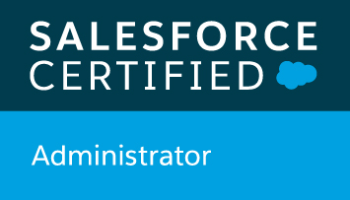 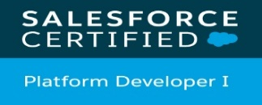 

VISHAL RAMCHANDRA YADAV

vishalmobilestyx@gmail.com Mob: +91-9372316887

**CAREER OBJECTIVE**

To work in a challenging environment towards a successful career the industry by providing the best out of my abilities and interpersonal skills for contributing in a long-term progress and profitability to the organization and thus to make my own identity.

**Technical Details:**

* **Salesforce Developer Certified (2x).**
* Preparing for Salesforce CPQ and Platform App Builder certification.
* A dynamic professional with 5.5+ yrs. of experience.
* Worked with **ACTIFY DATA LABS PRIVATE LIMITED**, as Application Development Analyst - Salesforce.
* Experience in Sales Cloud, Service Cloud, Community Cloud.

● Development:

* Writing and deploying Apex Classes, Visualforce pages, triggers and test classes.
* **AppExchange, Managed Packages, SOQL, SOSL, Salesforce CPQ.**
* Integrations using Platform events & REST APIs.
* UAT of application development in Salesforce technology. Master Synching from Finnone.

● Administration:

* Setting up complex automations using flows, process builders and workflow rules.
* Managing users’ permissions via OWD, profiles & permission sets.
* Creating and managing custom applications, objects, fields, validation rules, page layouts, record types, paths etc.

**TECHNICAL SKILLS:**

* Salesforce Administration
* Lightning Development
* Apex & Visualforce
* Automations using Flows, Process Builder and Workflows
* Apex Data Loader, Visual Studio Code, Workbench, aside, Fuse IT SFDC Explorer, Salesforce Data Import Wizard, Dataloader.io, Postman
* JavaScript, HTML & CSS

**Professional Experience:**

|  |  |  |  |  |
| --- | --- | --- | --- | --- |
| Employer | From | To | Location | Designation-Role |
| Proven Technologies & Services Pvt. Ltd | 23rd June 2014 | 25th August 2017 | Mumbai | Salesforce Developer |
| Mobilestyx Consulting and Solution LPP | 12th September 2017 | 19th December 2017 | Mumbai | Salesforce Developer |
| Capital First Limited - Idfc First Bank | 29thJanuary 2018 | 30th October 2019 | Mumbai | Sr. Salesforce  Developer |
| Actify Data Labs Private Limited | 31stOctober 2019 | 31st March 2020 | Mumbai | Application Development Analyst - Salesforce |

**Professional Experience-:**

**Project 1# India Pharma Application**

Client- Bausch & Lomb 23rd June 2014 – 25th August 2017

Role: Salesforce Developer & Administrator

Team Size - 4

Environment-: Salesforce.com SFA & Force.com Platform, Apex Data Loader, Eclipse.

**Description**-:

The application was already developed in Salesforce CRM and it is used by every employee of Bausch & Lomb Company in China and Korea. To operate the same application in India for their Indian employees this has been modified accordingly. Mainly it is used by the Sales Managers and Sales Representatives to plan the call or to plan the store visit and to report accordingly.

Their plan goes to their respective managers for approval.

**Roles and Responsibilities-:**

● Administration:

* Setting up complex automations using flows, process builders and workflow rules.
* Managing users’ permissions via OWD, profiles & permission sets.
* Creating and managing custom applications, objects, fields, validation rules, page layouts, record types, paths etc.
* UAT of application development in Salesforce technology. Master Synching from Finnone .

● Development:

* Writing and deploying Apex Classes, Visualforce pages, triggers and test classes.
* **AppExchange, Managed Packages, SOQL, SOSL**

**Project 2# Alerts:**

Proven Technologies & Services Pvt. Ltd 23rd June 2014 – 25th August 2017

Role: Salesforce Developer & Administrator

Team Size -4

Environment-: Salesforce CRM, validations and Workflows, Apex Data Loader, Eclipse.

**Description**: Alerts is a real-time notification system designed to alert the concerned personnel about specific business events in real-time. An ‘Alert’ can be defined as a message or notification, which is sent or received. It provides you with real-time information on critical business events and exceptions when they occur. The Alerts application supports international languages. The data entered by a user in languages such as Danish, Latin, Japanese are displayed in the corresponding language in the user interfaces. The alerts sent to users through e-mail are also displayed in the appropriate languages.

**Responsibilities**-:

● Administration:

* Gathering requirements collects information, and co-ordinates with all departments
* Setting up complex automations using flows, process builders and workflow rules.
* Managing users’ permissions via OWD, profiles & permission sets, Page layout
* Creating and managing custom applications, objects, fields, validation rules, page layouts, record types, paths,Data Loader, import processes, Report & Dashboards, workflows etc.
* UAT of application development in Salesforce technology. Master Synching from Finnone.

● Development:

* Writing and deploying Apex Classes, Visualforce pages, triggers and test classes.
* **AppExchange, Managed Packages, SOQL, SOSL**

**Project 3#**

**Udaan Maximizer** 2017 September – December 2017

Udaan - Japan

Role: Salesforce Developer & Administrator

Team Size - 5

Environment-: Salesforce CRM, Apex Data Loader, Eclipse.

Description: – Develop Lead Generation Portal was designed and created to provide Leads and generate quotations for new as well as old vehicles for 24 Dealership of Jaguar cars in India.

**Responsibilities**-:

● Development:

* Writing and deploying Apex Classes, Visualforce pages, triggers and test classes.
* Integrations using Platform events & jitterbit.

● Administration:

* Setting up complex automations using flows, process builders and workflow rules.
* Managing users’ permissions via OWD, profiles & permission sets.
* Creating and managing custom applications, objects, fields, validation rules, page layouts, record types, paths etc.

**Project 4#**

**Jaguar_Udaan1.6-JLR** 2017 September – December 2017

Udaan- BAHRAIN

Role: Salesforce Developer & Administrator

Team Size – 5

Environment-: CRM, Apex Data Loader, Eclipse.

Description: – Develop Lead Generation Portal was designed and created to provide Leads and generate quotations for new as well as old vehicles for 24 Dealership of Land Rover car in India. In this project there are city name and dealer name. Based on city name and dealer name Ex-Showroom price is different for every city. So, there is so many phages like Exchange,

FINANCE ESTIMATOR, STOCK AVAILABILITY, ONLINE PAYMENT.

**Responsibilities**-:

* Create profiled profile and permission sets.
* To Develop Visual Force pages get quote for New Vehicle.
* Status of Quotations sent to Customers.
* Performance of Sales personnel
* Provide Statistics of Vehicle, Budget of Customer and Top 5 Used Vehicle evaluated.
* Senior JLR Management, the performance of Dealership.
* Write business logic in apex controllers for calculating confidentiality finance and exchange pages.
* Created pages locator, model, sub models, finance, exchange pages etc.
* Write test classes for code coverage.

**Project 5#**

**IDFC Loan Application Org-1 to Org-2 Data Migration** 2018 January to 2019 October

**Capital First - IDFC FIRST BANK- INDIA**

Team Size – 10

Role: Salesforce Developer & Administrator

Description -: The project was to migrate data from one salesforce instance to another using a tool, such as Apex Data Loader and natively supported feature of the force.com platform namely salesforce to salesforce(S2S). We migrated standard objects such as Account, Contact, Opportunity, Case, Case Comment, Lead, Solutions, Attachments, Task, Event, Task Relation, Event Relation, Opportunity Product, Schedule, Document etc. using Apex Data Loader as we wanted to keep system audit fields such as created by, created date, last modified by and last modified date same both in source and target organization. For this we had to raise a case with salesforce support to enable audit fields before migration.

● Development:

* Writing and deploying Apex Classes, Visualforce pages, triggers and test classes.
* Integrations using Platform events & REST APIs.

● Administration:

* Setting up complex automations using flows, process builders and workflow rules.
* Managing users’ permissions via OWD, profiles & permission sets.
* Creating and managing custom applications, objects, fields, validation rules, page layouts, record types, paths etc.

**Project 6#**

**IDFC Loan Application Org-1 and Org-2_Live** 2018 January –2019 October

**Capital First - IDFC FIRST BANK- INDIA**

Role: Salesforce Developer

Team Size – 15

Environment-: Salesforce Application (Sales Cloud, Community Cloud, Service Cloud, **Salesforce** **Lightning**), **Salesforce CPQ**

Description: – Capital First is a BFS project providing loans to the customers.

Roles & Responsibilities –

* MuleSoft Integration.
* Fixing technical issues in Production.
* Data migration.
* Pre and Post Deployment Activities.
* Master Synching.
* SFDC User Related.

Description-:

The application allows to create loans through various channels like Website, Mobile App, Platform etc. The users (Sales Officers, Sales Coordinators, Dealers, FOS agents, Tele callers, customers etc.) can create loans by entering the required data and the loan life cycle goes from checking the eligibility, verifying the customer, verifying the credit history, getting checked through underwriters, verifying documents, and taking finally through FinnOne for disbursal of loan .These various stages of loans are mostly common across all the BU’s with few exclusions or additions. Loan process for **CD, TW, UC, BILPIL and PL**.

● Development:

* Writing and deploying Apex Classes, Visualforce pages, triggers and test classes.
* Integrations using Platform events & REST APIs.

● Administration:

* Setting up complex automations using flows, process builders and workflow rules.
* Managing users’ permissions via OWD, profiles & permission sets.
* Creating and managing custom applications, objects, fields, validation rules, page layouts, record types etc.

**Project 7#**

**HFFC Loan Application**  31st October 2019 –31st March 2020

ACTIFY DATA LABS PRIVATE LIMITED- INDIA

Role: Application Development Analyst - Salesforce

Team Size – 4

Environment-: Salesforce Application (Sales Cloud, **Salesforce Lightning, Salesforce CPQ**)**.**

Description: – Legal and Technical verification portal for service provider vendor in HFFC.

Roles & Responsibilities-:

* Legal and Technical Portal to Salesforce Integration.
* Fixing technical issues in Production.
* Pre and Post Deployment Activities.
* Fix bug and issue- Legal and Technical Portal.

Description-:

The application allows to create Legal and Technical verification through various vendor service provider. The service provider can create property by entering the required data and the loan cycle goes from checking the eligibility, verifying with vendor getting checked through underwriters, property team verifying documents.

● Development:

* Writing and deploying Apex Classes, Visualforce pages, triggers and test classes.
* Integrations using Platform events & REST APIs.

● Administration:

* Setting up complex automations using flows, process builders and workflow rules.
* Managing users’ permissions via OWD, profiles & permission sets.
* Creating and managing custom applications, objects, fields, validation rules, page layouts, record types, paths etc.

**Lead -** [**https://apidocs.leadsquared.com/create-or-update/**](https://apidocs.leadsquared.com/create-or-update/)

**Legal and Technical Portal-:**

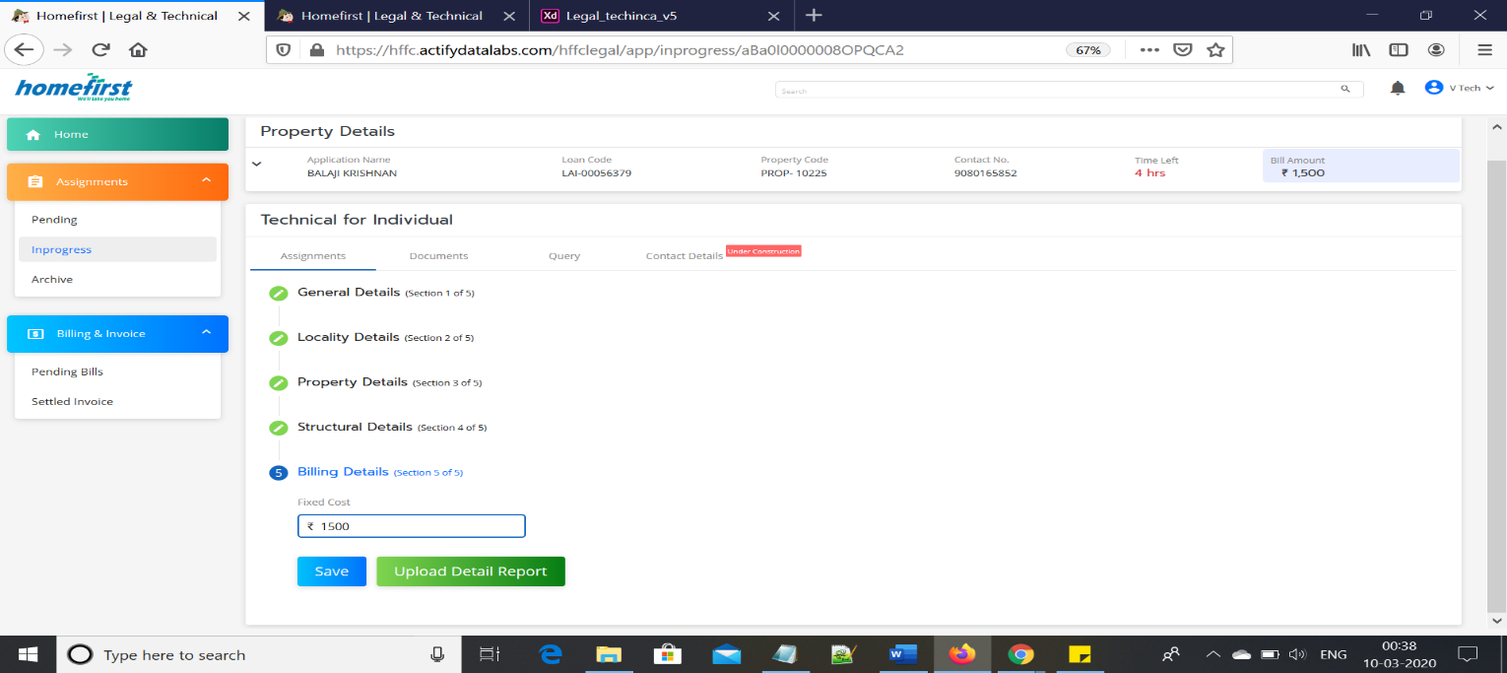

**Project 8#** 31st October 2019 –31st March 2020

Salesforce Integration with Litmus --<https://app-india.litmusworld.com/>

**Description**-: The Litmus World M.A.I. Measure, Act & Improve framework enables enterprises to Measure, Act and Improve business processes through contextual conversations that deliver actionable insights. We have made the data relating to our reports accessible. If you need to construct a particular report then you can do so locally. Reports are built to reflect specific requirements. See what you need to see and know what you need to know. Our reporting is interactive. The data we hold is protected and backed up. Users cannot, intentionally or otherwise, corrupt the original data. One dashboard that says it all!

● Development:

* Writing and deploying Apex Classes, Visualforce pages, triggers and test classes.
* Integrations using Platform events & REST APIs.

● Administration:

* Setting up complex automations using flows, process builders and workflow rules.
* Managing users’ permissions via OWD, profiles & permission sets.
* Creating and managing custom applications, objects, fields, validation rules, page layouts, record types, paths etc.

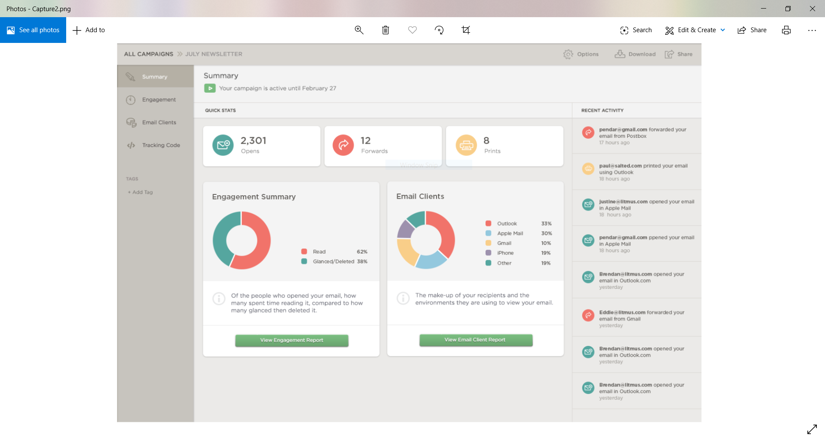

**Personal Information:**

* Father’s Name : Mr. Ramchandra Yadav
* Date of Birth : 10-Dec-1989
* Marital Status : Unmarried
* Gender : Male
* Language : Hindi, English
* Present Address : Mumbai, MH, INDIA.

|  |  |  |  |
| --- | --- | --- | --- |
| Qualification | Branch | Collage | Year |
| 10th | Science | T N Inter Collage, Saidpur | 2005 |
| 12th | Science | T N Inter Collage, Saidpur | 2007 |
| B.E(CSE) | Computer Science & Engineering | Annamalai University, TN | 2008-2012 |
| P.G. Diploma. | Internet Technology | Annamalai University, TN | 2011-2012 |

**Key Strength:**

**Personal:**

* Flexible at work, Ready to take up new challenges, Optimistic, Team Spirit.
* Strong Logical and Mathematical problem-solving approach
* Self-motivated, Hardworking & Honest
* Analytical and problem-solving abilities. An excellent team player with a positive attitude.
* An effective communicator with excellent relationship building & interpersonal Strong skills
* **No location constraints**.

**Professional:**

* Programming Language: Apex, Core java
* Salesforce Administrator
* Salesforce Development
* SOQL & SOSL
* Lightning
* Integration

**Skills:**

* Good listener
* Team Work
* Enthusiastic and Hard
* Leadership ability
* Quick learner

**Declaration:**

I, Vishal Ramchandra Yadav, hereby declare that the information contained herein is true and correct to the best of my knowledge and belief.

VISHAL YADAV PLACE: INDIA- MUMBAI