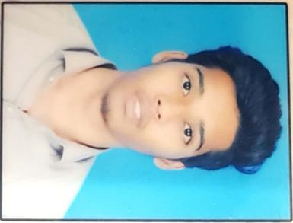**PORAPU PRAVEEN**

**EMAIL-ID:** Praveenstephen1998@gmail.com

**PHONE NUMBER:** 8639614958

**OBJECTIVE**:

To be a part of organization where I can fully utilize my skills in programming languages to make a significant contribution to the success of the employer, while at the same time pursing my individual growth.

**EDUCATION PROFILE:**

|  |  |  |  |  |
| --- | --- | --- | --- | --- |
| **COURSE** | **NAME OF THE INSTITUTION** | **YEAR OF PASSING** | **BOARD/UNIVERSITY** | **PERCENTAGE/CGPA** |
| B.TECH | RAGHU ENGINEERING COLLEGE | 2021 | JNTUK | 7.1 |
| INTERMEDIATE | SRI CHAITANYA JUNIOR COLLEGE | 2017 | BIEAP | 92 |
| SCHOOLING | S.F.S HIGH SCHOOL | 2015 | SSCAP | 9.3 |

**PROJECTS:**

* **Sun tracking solar panel using arduino**

This project involves a smart way to track sun rays to give maximum power storage

* **Laser security system**

This project involves a smart way to detect an abrtacle when it passes through it

**TECHNICAL:**

* PROGRAMMING LANGUAGES: C-language,Basics of java
* TOOLS - Matlab, Ms-office
* OPERATING SYSTEM:WINDOWS

**ACHEIVEMENTS:**

* Member of IETE Raghu engineering college
* Participated in Sparks event organized by department of ece
* Certified as Salesforce System Administrator with 89.5%
* Certified as Salesforce Platform Developer 1

**PERSONAL DETAILS:**

* NAME: PORAPU PRAVEEN
* FATHER NAME : PORAPU SHIVANNARAYANA
* MOTHER NAME:PORAPU LAXMI
* DATE OF BIRTH: 15-07-1998
* NATIONALITY: INDIAN
* GENDER: MALE
* LANGUAGES KNOWN: TELUGU,ENGLISH
* HOBBIES:

1.Playing Cricket

2.Listening to music

3.Reading Books

* STRENGTHS:

1.Adaptability

2.curios to learn

3.Hard worker

4.self motivated and discipline

* **ADDRESS:**

D.No:-25-3-12,Ramalayam street,Chinnanadupuru,RHColony,Pedagantayada,Visakhapatnam,Andhra Pradesh,Pin code:530044

* **DECLARATION:**

I here by declare that the above information is correct up to my knowledge and I bear responsibilities for the correctness of above-mentioned particulars

DATE: 14/12/2020

PLACE: VISAKHAPATNAM