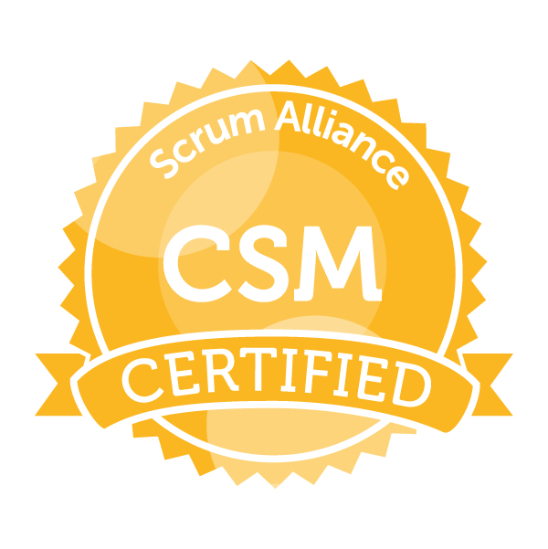 |  | Sudheer Pithani  Certified Scrum Master
Contact  PHONE:  +91 8790556498  EMAIL:  Sid.appsup@gmail.com  LinkedIn: https://www.linkedin.com/in/sudheer-p-564aa48/  Software  Strategic Planning  Data Analysis  SQL and databases  Technical Writing  Gap analysis  Test case scenarios  Release planning  Project Management  Microsoft Office Suite  Marketing research  Workflow Analysis  Negotiation  Project Organization  Team Management  Process Improvement  Software  MS SQL Server  SQL Server Reporting Services  SQL Server Integration Services  Oracle PL/SQL  Python  Microsoft Applications(Word, Excel)  Tableau  Jira  Visio  Agile CRM  ClickDesk  Rest API |  | Professional Summary  - Successful at responding to shifting business needs and priorities in systematic and effective way. Well-versed in implementation of operational assessments and conducting functional requirements analysis for businesses of all sizes. Quantitative expert with exceptional speed in analysis of quarterly and annual reports and providing comprehensive syntheses.  - 7+ years of experience in multiple functional areas like BFSI, CRM, LMS and Rich experience in Relational Databases such as MS SQL Server 2014, Oracle 10g, UNIX, Ticketing Tools & Customer Engagement  - Certified Scrum Master  - Proficient in understanding Business Processes/Requirements and translating them into Technical specifications.  - A quick learner in adapting to technology with ease.  - Versatile team player with Good interpersonal & communication skills.  - Involved in all phases of the SDLC (Software Development Life Cycle).  - Experience supporting applications in a UNIX environment  - Knowledge of ITIL Incident & Problem Management.  - Knowledge of MS SQL Server Suite (SSIS, SSRS) and other Analytics tools like Tableau  - Proficient in creation, modification and effectively use of database objects like Tables, Constraint, Sequences, Indexes, Group Functions, and Views.  - Involved in all phases of the SDLC (Software Development Life Cycle).  - Experience supporting applications in a UNIX environment  - Experience in managing team and grooming newly joined members.  - Providing all support to the team using a servant leadership style whenever possible and leading by example.  - Facilitate agile ceremonies, e.g. backlog grooming, preplanning, planning, daily standups, sprint reviews, retrospectives  WORK EXPERIENCE  Senior Scrum Master  Experis IT, Hyderabad, Telangana  Nov 2020 – Present  - Assessed each scrum team member's responsibilities and delegated tasks to balance each employee's workload.  - Applied agile methodology to shorten cycle time and achieve target margins.  - Facilitated Scrum framework – sprint planning, backlog grooming, daily scrums, sprint reviews and sprint retrospectives.  - Shielded scrum team from external interference for optimal productivity and success of Agile process.  - Drove Scrum team progress to overcome obstacles and realize success throughout life of each sprint.  - Collaborated with product owners, team members, technologists and other scrum masters to define solutions and drive progress.  - Planned Agile best practices and encouraged team cohesion, overcoming impediments and hurdles to productivity.  - Managed product backlog and supported Scrum framework for monthly sprint releases.  - Led sprint reviews, daily scrums and planning meetings to realize full team engagement.  - Coached teams in Agile practices and provided necessary training to create positive mindset to Agile methodologies.  - Provided extensive guidance on Agile scrum processes and methodologies to highly effective teams with goals of improving quality and productivity.  - Worked effectively with multiple Scrum teams both internally and off-shore.  - Managed and motivated project teams to promote collaboration and keep members on-task and productive.  - Adjusted project plans to account for dynamic targets, staffing changes and operational specifications.  - Analyzed projects to determine resource requirements and procured necessary equipment and software.  - Closely collaborated with project members to identify and quickly address problems.  - Investigated and corrected or escalated project problems.  Scrum Master  SumTotal Systems, Hyderabad, Telangana  Oct 2018 – Nov 2020  - Worked closely with software development and testing team members to design and develop robust solutions to meet client requirements for functionality, scalability, and performance.  - Investigated and corrected or escalated project problems.  - Organizing and facilitating daily scrum, sprint & release planning, demos.  - Tracking, reporting of all relevant team performance metrics.  - Providing all support to the team using a servant leadership style whenever possible and leading by example.  - Facilitate agile ceremonies, e.g. backlog grooming, preplanning, planning, daily standups, sprint reviews, retrospectives.  - Gathered requirements, defined scopes, allocated resources and established schedules meeting or exceeding project demands.  - Resolved conflicts and negotiated mutually beneficial agreements between parties.  - Managed quality assurance program, including on-site evaluations, internal audits and customer surveys.  - Synthesized current business intelligence data to produce reports and polished presentations, highlighting findings and recommending changes.  - Assigned tasks to associates, staffed projects and updated all involved parties to enhance optimal business flow.  - Provide Product support to customers as well as supporting other sales teams by understanding issues.  - Validate ETL design and ensure that technical specifications are complete, consistent, concise, and achievable.  - Maintain technical best practices for data movement, data quality, data cleansing, and other ETL-related activities. Develop and ensure adherence to locally defined standards for all developed components  - Participate in Product Management Discussions to help other teams with regards to issues.  - Debug code for complex issues and work towards resolution with respective teams.  Product Support Analyst  Agile CRM, Hyderabad, Telangana  Dec 2016 – Oct 2018  - Owned and prioritized product backlog.  - Coordinated with software developers to create custom applications and trackers to achieve client goals.  - Decompose high-level information into details, abstract up from low-level information to a general understanding, and distinguish user requests from the underlying true needs.  - Resolved conflicts and negotiated mutually beneficial agreements between parties.  - Maintained excellent attendance record, consistently arriving to work on time.  - Coached teams in Agile practices and provided necessary training to create positive mindset to Agile methodologies.  - Facilitated Scrum framework – sprint planning, backlog grooming, daily scrums, sprint reviews and sprint retrospectives.  - Led sprint reviews, daily scrums and planning meetings to realize full team engagement.  - Managed product backlog and supported Scrum framework for monthly sprint releases.  - Performed system analysis, documentation, testing, implementation and user support for platform transitions.  - Developed and tested new product offerings prior to release to assist development team in bug identification.  - Worked with software development team on reported errors and bugs on newly released software and assisted in deployment of release fixes.  - Delivered technical sales presentations to prospects and presented benefits and value of products.  - Created support documentation that empowered and enabled user community to extend skills, leverage system features and find resolutions to questions without intervention from support team.  - Assigned tasks to associates, staffed projects and updated all involved parties to enhance optimal business flow.  - Reviewed files, records and other documents to obtain business information and key data informing responses to development requests.  Adminstrator  Wipro, Hyderabad, Telangana  Sept 2014 – Nov 2016  - Enforced alignment of project strategy with business objectives and made modifications to promote efficient project completion.  - Adjusted project plans to account for dynamic targets, staffing changes and operational specifications.  - Closely collaborated with project members to identify and quickly address problems.  - Gathered requirements, defined scopes, allocated resources and established schedules meeting or exceeding project demands.  - Responsible for Creating SQL scripts for Generation of Reports according to user requirement.  - Created DTS and SSIS Packages for Daily, weekly, monthly reports generation.  - Responsible for developing Oracle PL/SQL procedures, functions and packages SQL scripts to facilitate the functionality for various modules  - Instrumental in implementing the back-end changes in existing products and reports using PL/SQL procedures  - Modifying various existing packages, procedures, functions and triggers according to new business needs  - Closely working with other applications, Teams for application Integration.  - Continuously work with the Business Team and also end-users for feedback and improvements  - To ensure the application issues to be resolved promptly within TAT.  - Interaction with various Data Source systems for attributes / characteristic mapping.  - Developing SSRS Reports & Deploying the generated RDL files into Live environment  - I am making modifications for the existing Stored Procedures, RDL's as per the user's Requirement.  - I am performing unit testing on the Reports.  - Adapted to workflow changes and implemented continuous process improvements to overcome obstacles.  Assistant Engineer  3i InfoTech, Hyderabad, Telangana  Aug 2013 – Sept 2014  - We are resolving the issues which are faced by the end-users/clients over call or mail.  - Monitoring the tickets closures against the tickets rose. Taking necessary initiatives like coordinating with next-level support for Early resolution, to avoid escalation's and maintain TAT & customer satisfaction  - Responsible for Creating SQL scripts for Generation of Reports according to user requirement.  - Created DTS and SSIS Packages for Daily, weekly, monthly reports generation. Automated many reports to avoid repetitive work.  - Instrumental in implementing the back-end changes in existing products and reports using procedures  - We are closely working with other applications, Teams for application Integration.  - Continuously work with the Business Team and also end-users for feedback and improvements  - To ensure the application issues to be resolved on time within TAT.  EDUCATION  JNTU- Kakinada  2007 - 2011  Certifications  Certified Scrum Master  Affiliations  Toastmasters  Intrests  Mentoring  Photography

