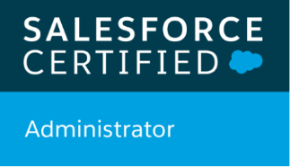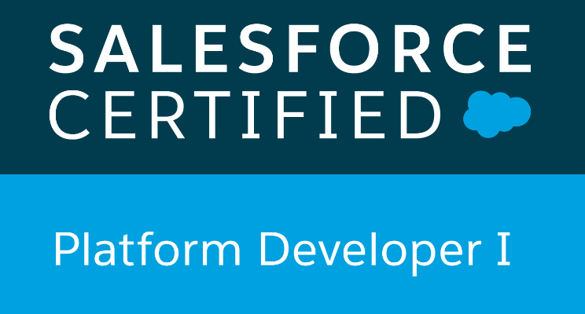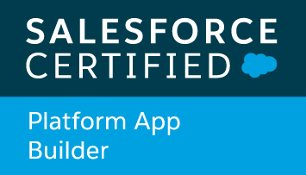

Ashok S
Email: Ashok.sfdc254@gmail.com
Phone: +1 (731) 577-1543

SALESFORCE LIGHTNING DEVELOPER

(Salesforce Certified Administrator (ADM- 201) | Salesforce Certified Platform Developer – I | Platform App Builder)

Certified Salesforce Platform Developer I with 6+ years of professional experience working in IT Industry in areas of Salesforce.com, CRM implementation and Java developer. Experience covers all phases of SDLC including requirement analysis, development, testing and developments. Facilitate communication between Business Owners and Development team to produce effective project outcome. Strong interpersonal communication, time management, process optimizations and problem-solving skills with detail orientation in the technology arena.

Technical Exposure and Expertise

- SFDC development using lightning, Visual Force Pages, VF Components, Apex Classes, and Custom Controllers, Controller extensions, tests, test cases, SOQL, SOSL, MVC architecture and Force.com IDE from scratch
- Salesforce.com Applications Build and Design using the best practices.
- Over 4 Years of experience with Configuration, Salesforce Customization, Security Access, Workflow Approvals, and Data Validation, Einstein Analytics in Salesforce.com CRM, and Force.com Platform, in Salesforce CRM with Apttus CPQ implementation.
- A skilled problem solver and an efficient team player. Can effectively work in both independent and collaborative work environments.
- Had experience of coordinating offshore teams for the entire project life cycle.
- Expertise in building Lightning components for Record pages and Quick actions.
- Worked on new concepts of Salesforce Lightning components, Spinners, lightning action buttons, etc. and Salesforce Mobile Application related development activities.
- Have knowledge on Apttus Quote to Cash Process flow and Order Management flow.
- Extensive business knowledge and customization experience on various salesforce.com standard objects like Accounts, Contacts, Opportunities, Products and Price books, Cases, Leads, Campaigns, Forecasting, Reports and Dashboards.
- Experienced in web technologies like HTML, XML, CSS, JavaScript, and REST.
- Experience in different testing procedures and dealt with training aspects of the technology.
- Proficiency in writing Apex Classes, triggers, Controllers, Visual force pages, Force.com IDE, SOQL and SOSL Salesforce CRM UI customization using Apex, Custom Controllers, Visual force, CSS, JavaScript libraries
- Salesforce Integration with Oracle, SAP ERP using Apex web services WSDL and outbound messaging
- Salesforce.com implementation and customization using Apex (Classes, Controllers, Triggers), Apex Scheduler, Batch Apex, Apex Web Service, Visualforce Pages, Custom Tabs and Objects, Analytic Snapshots, Dashboards.
- Writing Apex batches, Schedule classes by implementing interfaces to process large data sets
- Implement Security and Sharing rules, Configuring Permission sets, Field level security, Object level security, Profiles, Triggers, Resource monitoring using Custom objects, Triggers, Workflow rules, Approval process for Automated alerts, field updates, SOQL, SOSL, Visual force pages and Apex classes
- Experienced in JIRA in bug tracking, issue workflow, Labelling, linking issues and in creating projects and story points.
- Visual Studio Code, Eclipse IDE with Force.com plug-in for writing business logic in Apex programming language
- WSDL, SOAP API, REST API, Call Outs, Batch and Schedule Apex programs
- Implement data security/visibility rules using Sharing rules, configuring OWD (Organization wide default), create criteria-based and owner-based sharing rules across objects and sharing data to different roles.
- Salesforce.com governor limits understanding with ability to optimize code to respect the limits
- Agile Methodologies, Scrum Software Development processes as well as Waterfall model.

EDUCATION

- Texas A&M University Commerce, TX (Aug 2018 – May 2020)
- Master of Science in Computer Science, GPA 3.87/4
- Head Teaching Assistant, Data Structures and Algorithms, Database, Analysis Design (CSCI 2336, CSCI 340, CSCI 359). Managed 120 students per semester and collaborate with my professors for their ongoing projects.
- SCSVMV University, Kancheepuram (Chennai) TN, India (July 2010 – May 2014)
- Bachelor of Engineering in Electronics & Communication Engineering, GPA 8.1/10

PROFESSIONAL CERTIFICATIONS

- SALESFORCE.COM CERTIFIED ADMINISTRATOR (ADM 201)
- SALESFORCE.COM CERTIFIED PLATFORM DEVELOPER I
- SALESFORCE.COM CERTIFIED PLATFORM APP BUILDER

TECHNICAL SKILLS

CRM Applications | Salesforce.com: Sales Cloud, Service Cloud, Community Cloud  Salesforce.com: Reporting and Analytics of Sales, Service and Custom Cloud  Salesforce.com AppExchange: Application for code backup and sub versioning within Salesforce
CPQ Tools | Apttus CPQ
Configuration Skills | SFDC Standard/Custom Object Configuration, Record type/Page Layout Configuration, Field and Object level security, role hierarchies, sharing models, Workflow: time-dependent actions, field updates, email alerts, task creation Reports, Dashboards, Formula Fields and Cross Object Formula Fields Configuration Skills,  , Security.
Operating Systems | Windows 7/8/ Window Server 2008/Windows Server 2012
Languages Known | Java, JavaScript, HTML, CSS, JSP/ASP
Methodology | Agile, Waterfall
Databases | Force.com, DB MySQL, Oracle 8i/9i/10g/11g
Known Tools | SOAP, REST, CVS, SVN, Ant, Visual Studio Code, Eclipse, Force.com Eclipse IDE Plug-in, Force.com Explorer, Force.com Data Loader, Force.com Excel Connector, Force.com Platform (Sandbox, and Production) QTP.
Packages | MS-Office, SharePoint, VISIO, Excel

Professional Experience

Healthy Pets Inc, Union City, CA Déc. 2019 – Till Date
Role: Salesforce Developer
Responsibilities:
- Performed detailed analysis of business and technical requirements and created solutions by customizing various standard objects of Salesforce.com (SFDC) and other Platform based technologies like Visualforce, Force.com API, and Web Services.
- Worked on Desk to salesforce service cloud Integration.
- Worked on Service cloud case management and enabled the shield encryption.
- Configured the Web-to-case and Email-to-Case in service cloud.
- Developed the logic for case assignment in service cloud.
- Designed and deployed Custom tabs, Validation rules, and Auto-Response Rules for automating business logic. Created workflow rules and defined related tasks, email alerts, and field updates.
- Created templates, approval processes, approval page layouts and defined approval actions on them to automate the processes.
- Worked on Q2C Implementation in Apttus.
- Worked on Sugar to apttus Interface.
- Worked on building the pricing rules and implementing the approval matrix.
- Worked on Product catalog configuration and feature set.
- Responsible for all the activities related to configuring Data Loader, uploading data in CSV files intosalesforce.com, checking for the correctness of the data.
- Migrated related sets of data between Orgs while preserving those relationships.
- Refreshed salesforce sandboxes with data from production Orgs.
- Involved in data mapping and migration of data from legacy systems to Salesforce.com Objects and fields. Used SOQL and SOSL queries to pull data from database for data manipulation needs.
- Created page layouts, search layouts to organize fields, custom links, related lists, and other components on a record detail and edit pages.
- Developed Apex Classes, Apex Triggers, and Apex Controllers to develop custom business logic.
- Developed various Batch Apex classes and scheduled those using Apex Schedulable classes.
- Developed Visual force pages and dynamic pages using JSP/ASP and Java Script
- Worked with SOQL, SOSL queries with Governor Limitations to store and download the data from Salesforce.com platform database.
- Configured Data Loader and uploaded data in CSV files into Salesforce, checking for the correctness of the data.
- Used the apex scheduler in order the schedule the action that is needed in the program to get the data exactly and used the cronn trigger to track the progress of scheduler with the help of SOQL quires.
- Integrated the Web Services for extracting the data from external systems to display in the pages of salesforce.com
- Used the sandbox for testing and migrated the code to the deployment instance after testing.
- Performed code review of the application to make sure the source code confirms to industrial coding standard sand followed good programming practices.
- Developed Custom Report Types, Custom Reports, and Dashboards to meet the reporting needs of the organization.

Environment: Sales force.com platform, Apex Language, Visual force (Pages, Component & Controllers), Pages, Data Loader, HTML, Java Script, HTML 5 Apex Triggers, Lightning Experience Web Services, Reports, Custom Objects, Custom Tabs, Email Services, Sandbox data loading, Eclipse IDE Plug-in, Windows XP.

Texas A&M Univ Systems Jan 2019 – Dec 2019
Role: Salesforce Developer/Admin
Responsibilities:
- Worked with the user group for requirement gathering throughout the planning and implementation.
- Implemented the requirements on Salesforce.com platform and Force.com IDE Plug-in using Eclipse.
- Worked with various salesforce.com objects like Accounts, contacts, Solutions and Custom Objects.
- Developed various Custom Tabs, Tags and Components. Implemented Sales force For Outlook functionality and installed outlook integration with different user systems.
- Created custom VF email templates for enabling the localization using Translation Workbench.
- Worked with Validation Rules, Workflows, Approval Process and Reports & Dashboards.
- Worked with Data Loader and App Exchange Applications.
- Worked with different Deployment Plans for each release and Sandbox Refreshing.
- Worked with different Record types to setup for different Page layouts based on profiles.
- Involved in setting up Profiles and assigning the Profiles to the Users.

Key Project Activities:
- Built two communities from initial strategy and design to implementation.
- Configured and customized the marketing communities using Salesforce lightning template (partner central) to best suit the external users’ needs.
- Worked closely with marketing team to develop and implement various campaigns and tracking within SFDC teams.
- Worked on Case management in Salesforce Communities which provides Quote-to-Cash solutions using Apttus CPQ.
- Support and aid Motivate sales reps in the field with any customer issues regarding loading and assist in emergency setups internal user permissions, access, and usability
- Created custom report types and generated report using the report types.

Environment: Saleforce.com platform, Data Loader, HTML, Java Script, Workflow & Approvals, Reports, Custom Objects, Custom Tabs, Email Services, Security Controls, Apex language, Visual Force (Pages, Component & Controllers), Sandbox data loading, Eclipse IDE Plug-in, Windows XP.

Cognizant Technology Solutions, India. Jan 2014 – June 2018
Role: Java/Salesforce Developer
Responsibilities:
- Involved in development, analysis and design of assigned work using Servlets, JSP, Html, Java Script, and Java Beans.
- Worked with various Salesforce.com objects like Accounts, Contacts, Leads, Opportunities, Reports, and created custom objects based on Business need.
- Provided administrative level support for users of the Salesforce application.
- Provided support ongoing Salesforce.com maintenance and administration services including periodic data cleansing, custom objects, workflow, campaign management, Triggers.
- Used Data Loader for insert, update, and bulk import or export of data from (SFDC) Salesforce.com objects.
- Build Apex classes implementing SOQL statements within Force.com IDE to manage interaction with the database.
- Customized the Dashboards and Report to track usage of productivity and performance of business centers and their sales teams.
- Creating interactive views of that data and sharing those views in dashboards using Wave Analytics.
- Migrated data from Salesforce to SQL Database using Data Loader Command Line
- Used QuickBooks to automatically create Invoices to reduce data entry and speed up cash flow and provide visibility to accounts for account management purposes.
- Worked on Quote-to-Cash process and configured Products, Rules, Pricing, Pricing Rules and all other aspects of product set up in Apttus CPQ.
- Monitored and resolved the Service Requests, specifically, visibility issues involving Custom Profiles, Public Groups, and Sharing Rules.
- Involved in the Data Transformation and Data Cleansing activities while transferring the data to the external system using Informatica On-demand.
- Developed JAVA classes as per designed docs.
- Worked on multiple Android applications for REST integration and designed custom views.
- Developed Core Java classes and methods for handling data from database.
- Used connection pooling for better performance.
- Developed Ant builds script and ant task classes to clean, compile, copy, run, deploy, jar, war, and ear files, and develop web service.
- Used JDBC Statements to call the stored procedures and Prepared Statements to perform dynamic SQL operations. DAO classes are accessed in EJBs to connect to Database.
- Involved in writing procedures and Packages for Report Generation using Oracle as Database.
- Responsible for Testing - unit testing & integration testing using Junit.
Environment: Java, JSP, Struts, Android Studio, EJB, JBoss, XML, JavaScript, CSS, Oracle, Junit, Eclipse, Salesforce.com Enterprise Edition, Profiles, Role hierarchy, Workflow & Approval processes, Data Loader, Reports, Custom Objects.

