**D . SOUMYA**

Mobile: **+919703686842**

Email: soumyakantimahanthi@gmail.com

**PROFILE SUMMARY**

Experience of **11** years in implementation and support projects having experience on **Oracle Cloud HCM** and **Oracle Applications Technical (Reports, Alerts, Workflows , OAF, SQL, PLSQL, JTF,JSPs and Java)** as a key participant in all phases of methodologies with an exposure to Oracle AIM methodology. Committed to professionalism, highly organized with strong interpersonal and communications skills, detail oriented and committed to excellence and continuous professional development for fully utilizing strong customer service attitude, exceptional organizational ability and communication skills.

**EXPERTISE**

* In-depth knowledge and experience in Oracle applications R12 in the areas of expertise in modules (HRMS,CMRO,CDH, iProcurement , AR,INV)
* Very good capabilities in understanding the Business Process Functionalities, leading to gaining excellent domain knowledge.
* Strong knowledge and experience on **Oracle Cloud HCM.**
* Strong knowledge and experience on **BI Publisher Reports, HDL Loads , Fast Formulas.**
* Strong knowledge and experience on **Core HR and Payroll of HCM Cloud.**
* Good knowledge and experience on **Absences**
* Strong knowledge and experience on **Oracle HRMS R12.**
* Strong knowledge and experience in supporting **HRMS R12 applications.**
* Strong knowledge and experience on **Core HR and Payroll of HRMS R12.**
* Strong knowledge and experience on debugging reports , Workflows , Alerts and also building data extracts in HRMS R12.
* Involved in patching activities.
* Strong knowledge and experience on **UK Payroll**.
* Strong debugging expertise in **OAF Web Pages , SQL , PLSQL scripts.**
* Strong Knowledge and experience on Oracle Application Frame Work **Extensions / Personalization.**
* Strong knowledge and experience on **SQL** and **PL/SQL** programming.
* Good knowledge and experience on **Oracle Applications Technical AOL Concepts.**
* Excellent communication and presentation skills ensure that relevant stakeholders are kept apprised of project progress and challenges, while ensuring that the level of detail is appropriate for each audience.

**EDUCATIONAL & PROFESSIONAL DEVELOPMENT**

**BTech** from JNTU University

**SKILL SETS**

**ERP**

•

Oracle Cloud HCM (Core HR , Absences , Payroll ),R12 (HRMS,CMRO, iStore, CDH, iProcurement ,AR)

**Tools and Utilities**

•

Jdeveloper ,SQL Developer , WinScp, Putty

**Languages and**

**Frameworks Known**

•

BI Publisher Reports , HDL Loads , Fast Formulas , R12 Reports , Alerts , Workflows,Oracle Applications Framework SQL , PL/SQL, Core Java, Java , JTF Pages,ADF

**Operating Systems**

•

All MS-Windows Version and Unix

**RDBMS**

•

Oracle 9i/10g

**EMPLOYMENT HISTORY**

**Ivy Comptech - Hyderabad , Andhra Pradesh**

**Systems Analyst**

July-2019 to Till Date

**Project :** Oracle Cloud HCM – Ladbrokes

**Client** In house Project

**Role** Fusion HCM Technical Consultant

**Duration** July 2019 -Till Date

**Modules** HCM – Core HR , Payroll , Absences

**Description:**

Oracle Cloud HCM is a module which maintains the employee information. Ladbrokes has the data of around 27000 people and we implemented the application and currently supporting it along with upcoming new enhancements in the future.

**Contribution :**

* Developed BI Publisher Reports in Core HR and Payroll.
* Developed Fast Formulas for Payroll such as creation of object groups dynamically and element level validations.
* Worked on HDL loads such as Document Delivery Preferences , Worker , Balance Adjustments , Person Extra Informations, Object Groups.
* Worked on creation of new elements , Payroll Processes.
* Worked on data migrations from R12 to Cloud.
* Has good knowledge on functionality of the application.
* Preparation of various documents like BR 100, Test Case Documents , MD 150.
* Preparation of project related documents like Weekly Service Reviews, Trend Reports , Weekly Status Reports, Monthly Extracts , Induction and Exit Checklists and fortnightly decks.
* Involved in completion of various requirements given by the team leads by coordinating the activities of the team members. Conducted Weekly status calls, daily standup meetings to promote completion of the deliverables within the time.

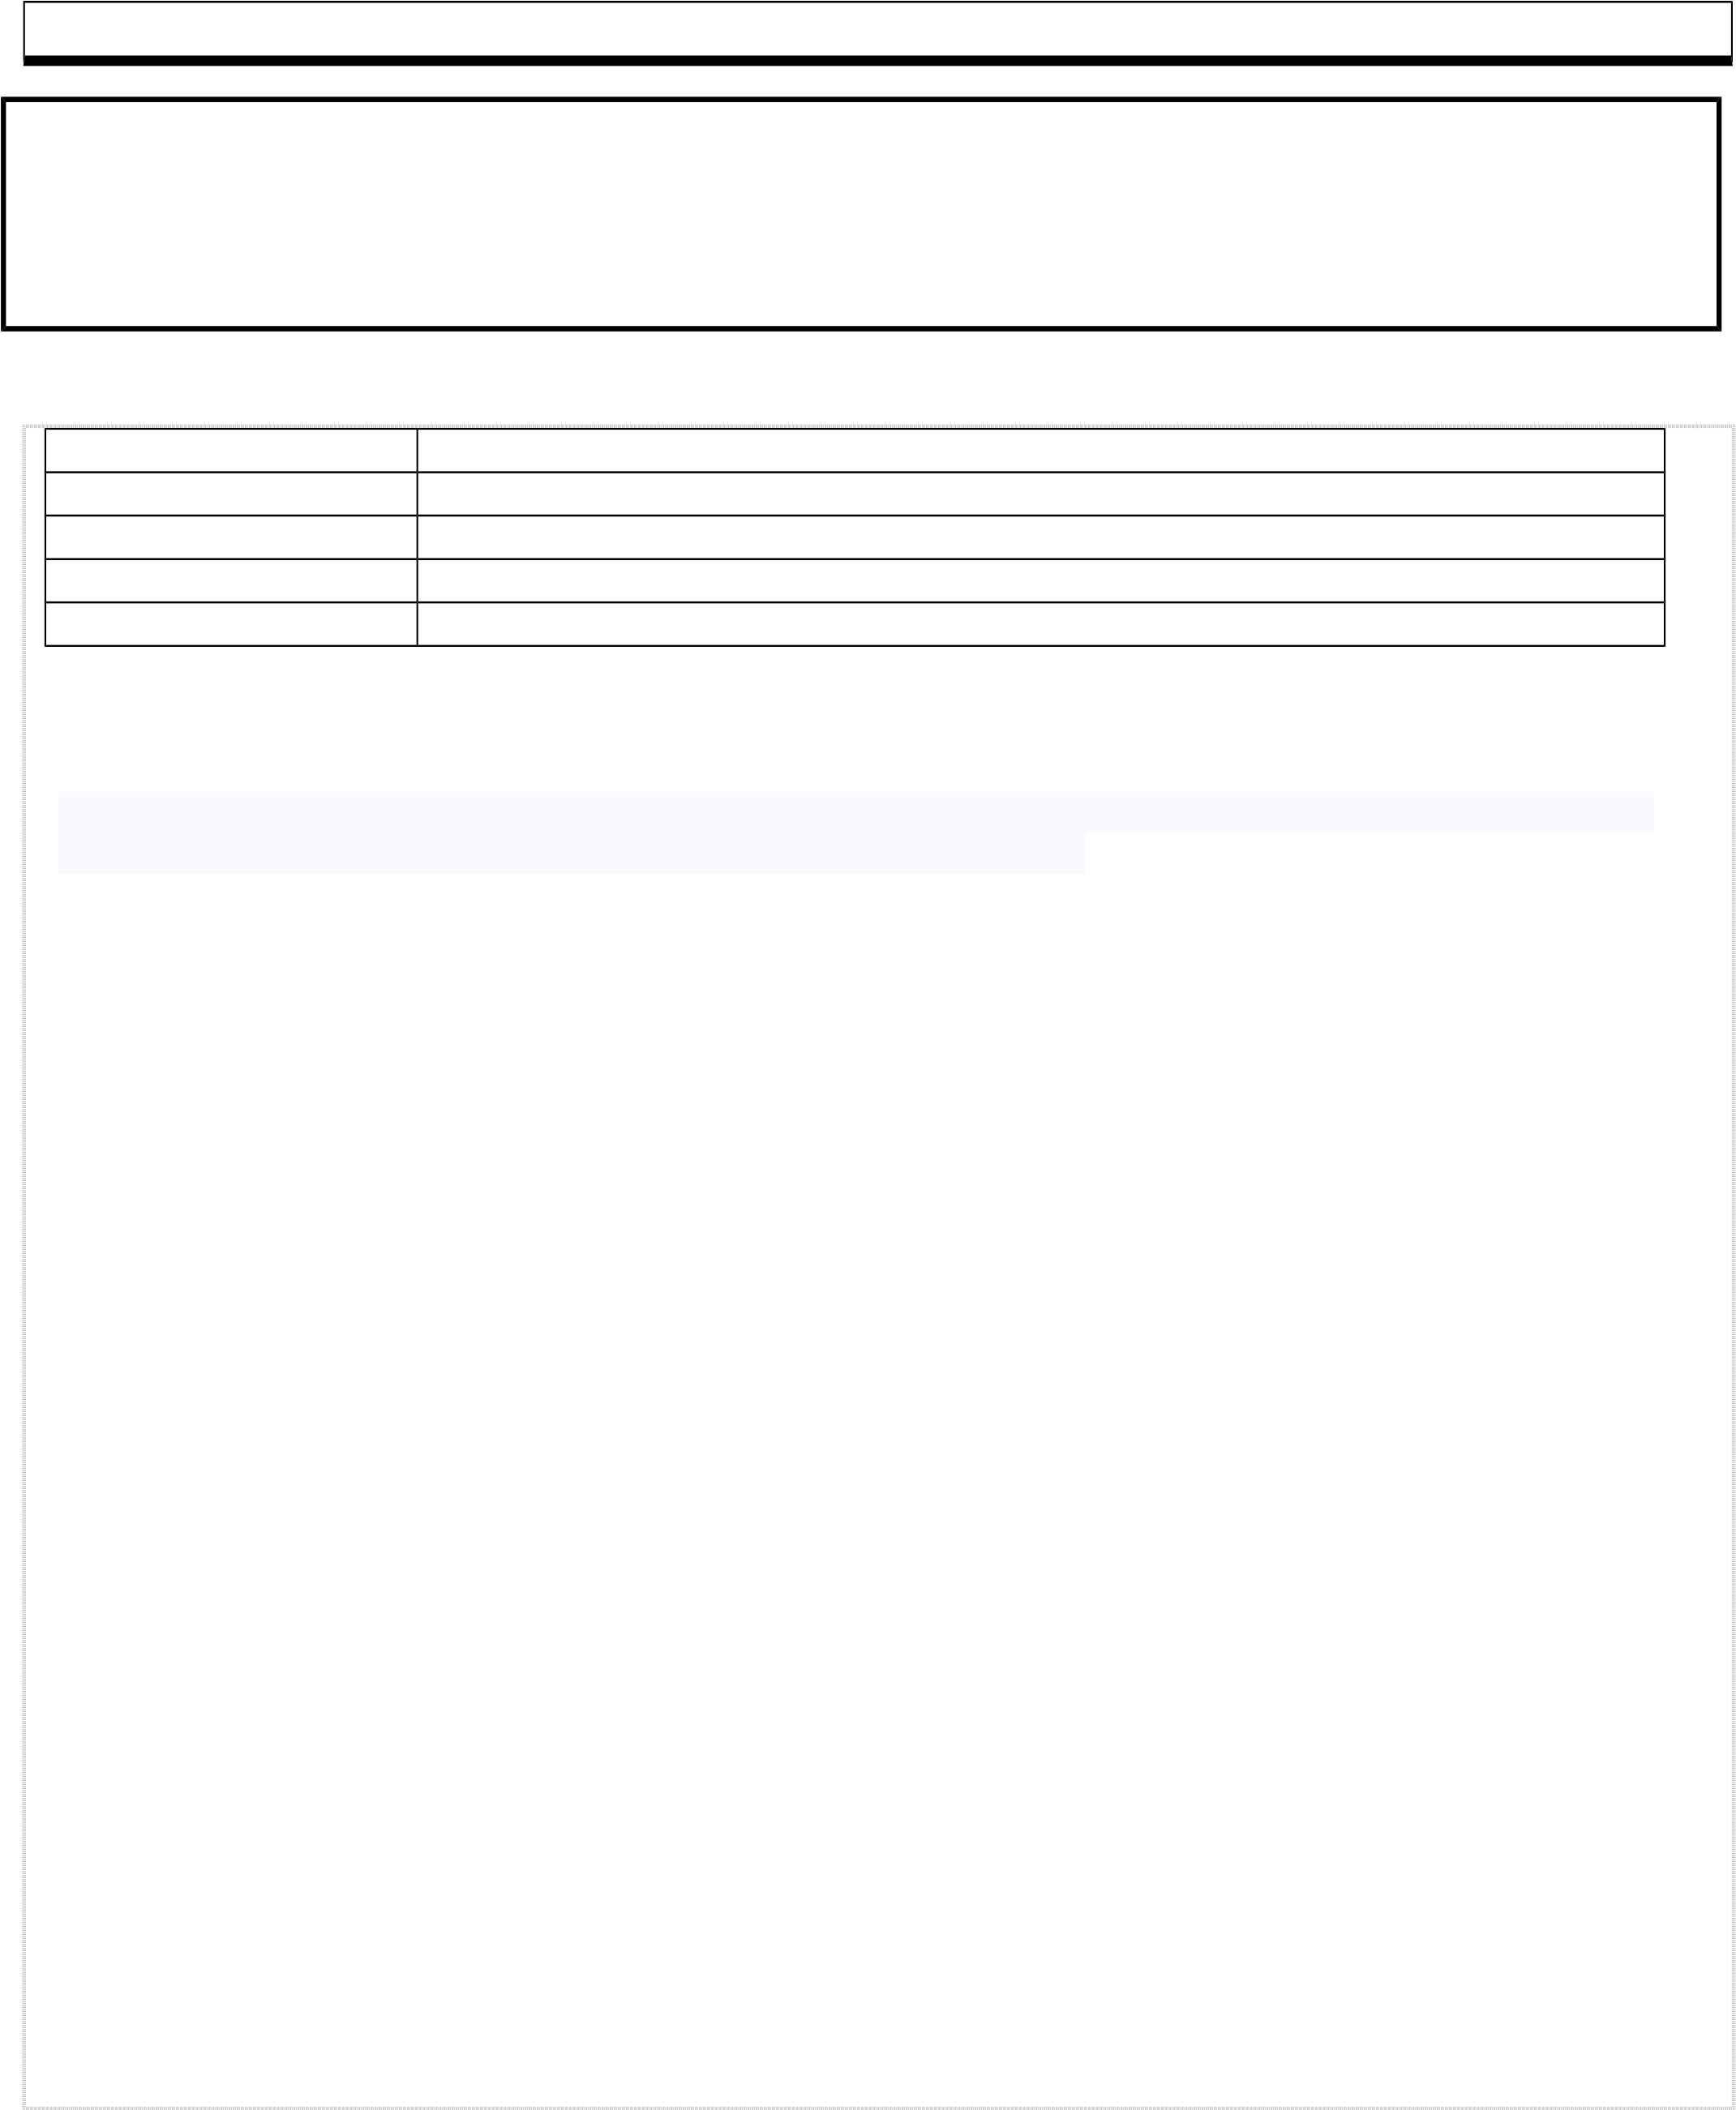**Capgemini - Hyderabad , Andhra Pradesh**

**Senior Consultant**

Nov-2014 to Jul -2019

**Project #1:** Oracle Cloud HCM and HRMS R12

**Client** Lloyds Register

**Role** HRMS and HCM Technical Consultant Team Lead)

**Duration** Mar 2017 - Jul 2019

**Modules** HCM – Core HR, Absences and Payroll, HRMS R12

**Description:**

Oracle Cloud HCM is a module which maintains the information of a Worker.

**Contribution :**

* Developed BI Publisher Reports in Core HR and Payroll
* Worked on HDL Loads .
* Worked on Patching on R12 Applications
* Worked on Report Issues and Enhancements of HRMS R12.
* Worked on Alerts and Workflow Issues of HRMS R12
* Worked on Data Extracts in HRMS R12 .
* Worked on Data Migrations from R12 to HCM.
* Preparation of various documents like Work Order Templates, Test Case Documents.
* Participated in Audit meetings and played a major role in organizing Business Continuity Plan, call tree test and preparation of documents like Business Continuity Plan, Call Tree Test Report and Skills Matrix.
* Preparation of project related documents like Weekly Service Reviews, Trend Reports , Weekly Status Reports, Monthly Extracts , Induction and Exit Checklists and fortnightly decks.
* Involved in completion of various requirements given by the team leads by coordinating the activities of the team members. Conducted Weekly status calls, daily standup meetings to promote completion of the deliverables within the time.

**Capgemini - Hyderabad , Andhra Pradesh**

**Senior Consultant**

Nov-2014 to Jul -2019

**Project #1:** Complex Maintenance Repair And Overhaul

**Client** Lloyd’s Register

**Role** Oracle SOA, OAF, SQL and PLSQL, JTF pages(Team Lead)

**Duration** Nov 2016-Mar 2017

**Modules** CMRO

**Description:**

Oracle CMRO is an application which serves as a repository of vessel specific information and also has details related to defects logged against the vessel.

**Contribution :**

* Developed PLSQL script to add specific node to a master configuration and creating instance and then moving it to complete state.
* Performed Various enhancements on OAF standard as well as custom pages.
* Performed data fixes for issues faced by users.
* Debug and identify the root cause of reported issues, provide the fix.
* Performed enhancements on JTF pages.
* Developed PLSQL script to dump the details into a custom table which are updated on the present day
* Modification of PLSQL packages.
* Performed ADF pages upgrade from 11.1.1.5 to 11.1.1.7.0 version and 11.1.1.7.0 to

12.2.1.3.0.

* Preparation of various documents like Work Order Templates, Test Case Documents.
* Participated in Audit meetings and played a major role in organizing Business Continuity Plan, call tree test and preparation of documents like Business Continuity Plan, Call Tree Test Report and Skills Matrix.
* Preparation of project related documents like Weekly Service Reviews, Trend Reports , Weekly Status Reports, Monthly Extracts , Induction and Exit Checklists and fortnightly decks.
* Involved in completion of various requirements given by the team leads by coordinating the activities of the team members. Conducted Weekly status calls, daily standup meetings to promote completion of the deliverables within the time.

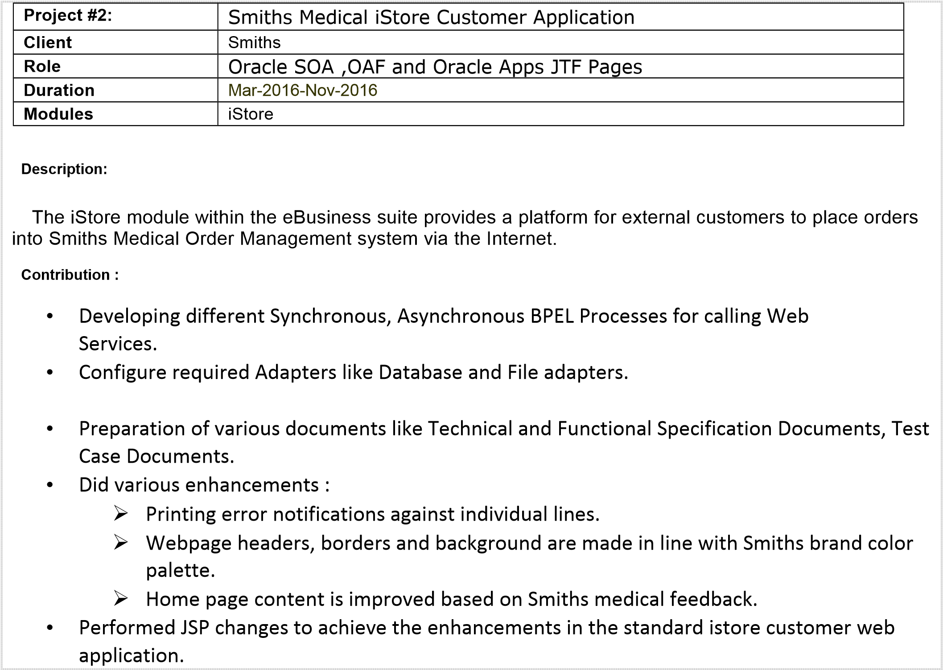

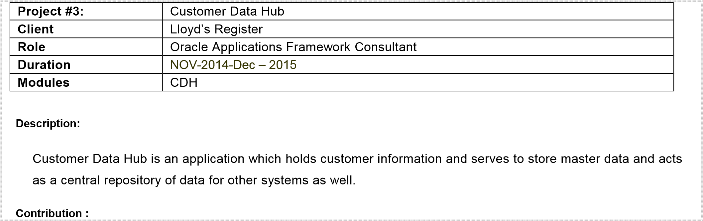

* Preparation of various documents like Work Order Templates, Test Case Documents, IM090 documents.
* Did various enhancements :
  + Bringing an attribute from organization to account level.
  + Creation of custom attributes in DQM, passing an attribute from one system to another system.
  + Routing a request to appropriate approval level based on condition.
  + Implementation of a region that is already present in one application into another application with the appropriate changes.
  + Patch application for bug fixes with the help of DBA team.
* Performed OAF level extensions and personalization and fixed bugs in the standard as well as custom functionality.
* Modification of PLSQL packages and reports.
* Performed data fixes for issues faced by users.
* Debug and identify the root cause of reported issues, provide the fixes in OAF pages.

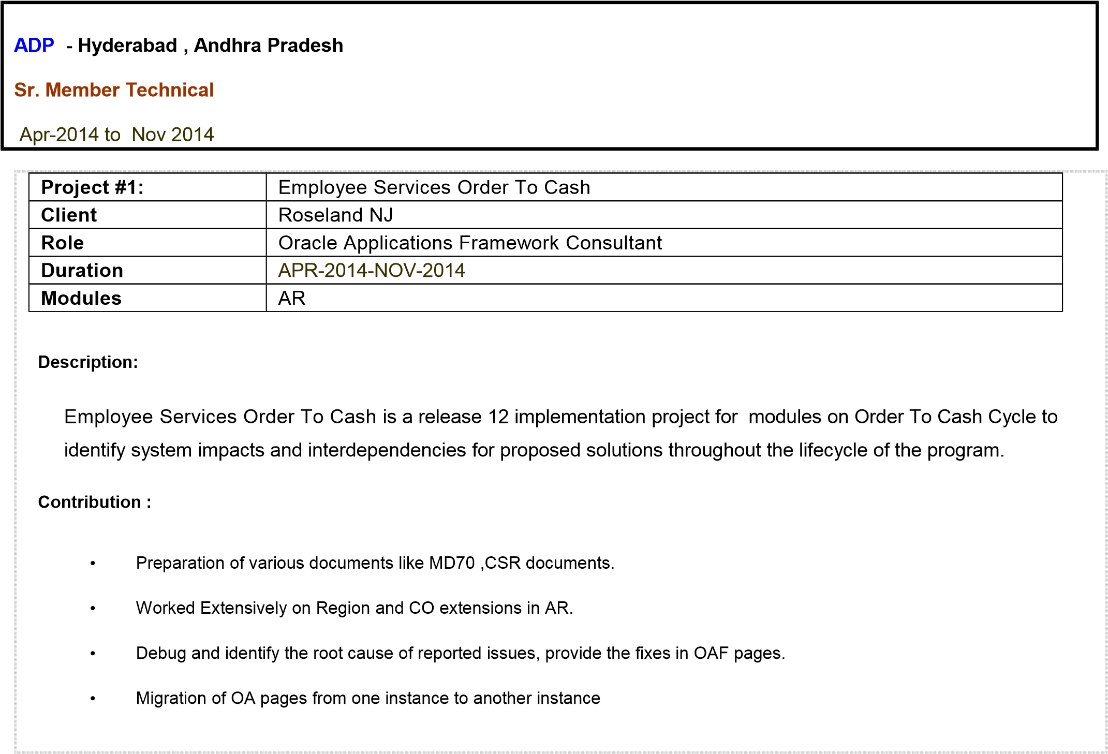

**Mahindra Satyam**

**- Hyderabad , Andhra Pradesh**

**Sr. Software Engineer**

Mar-2010 to Apr-2014

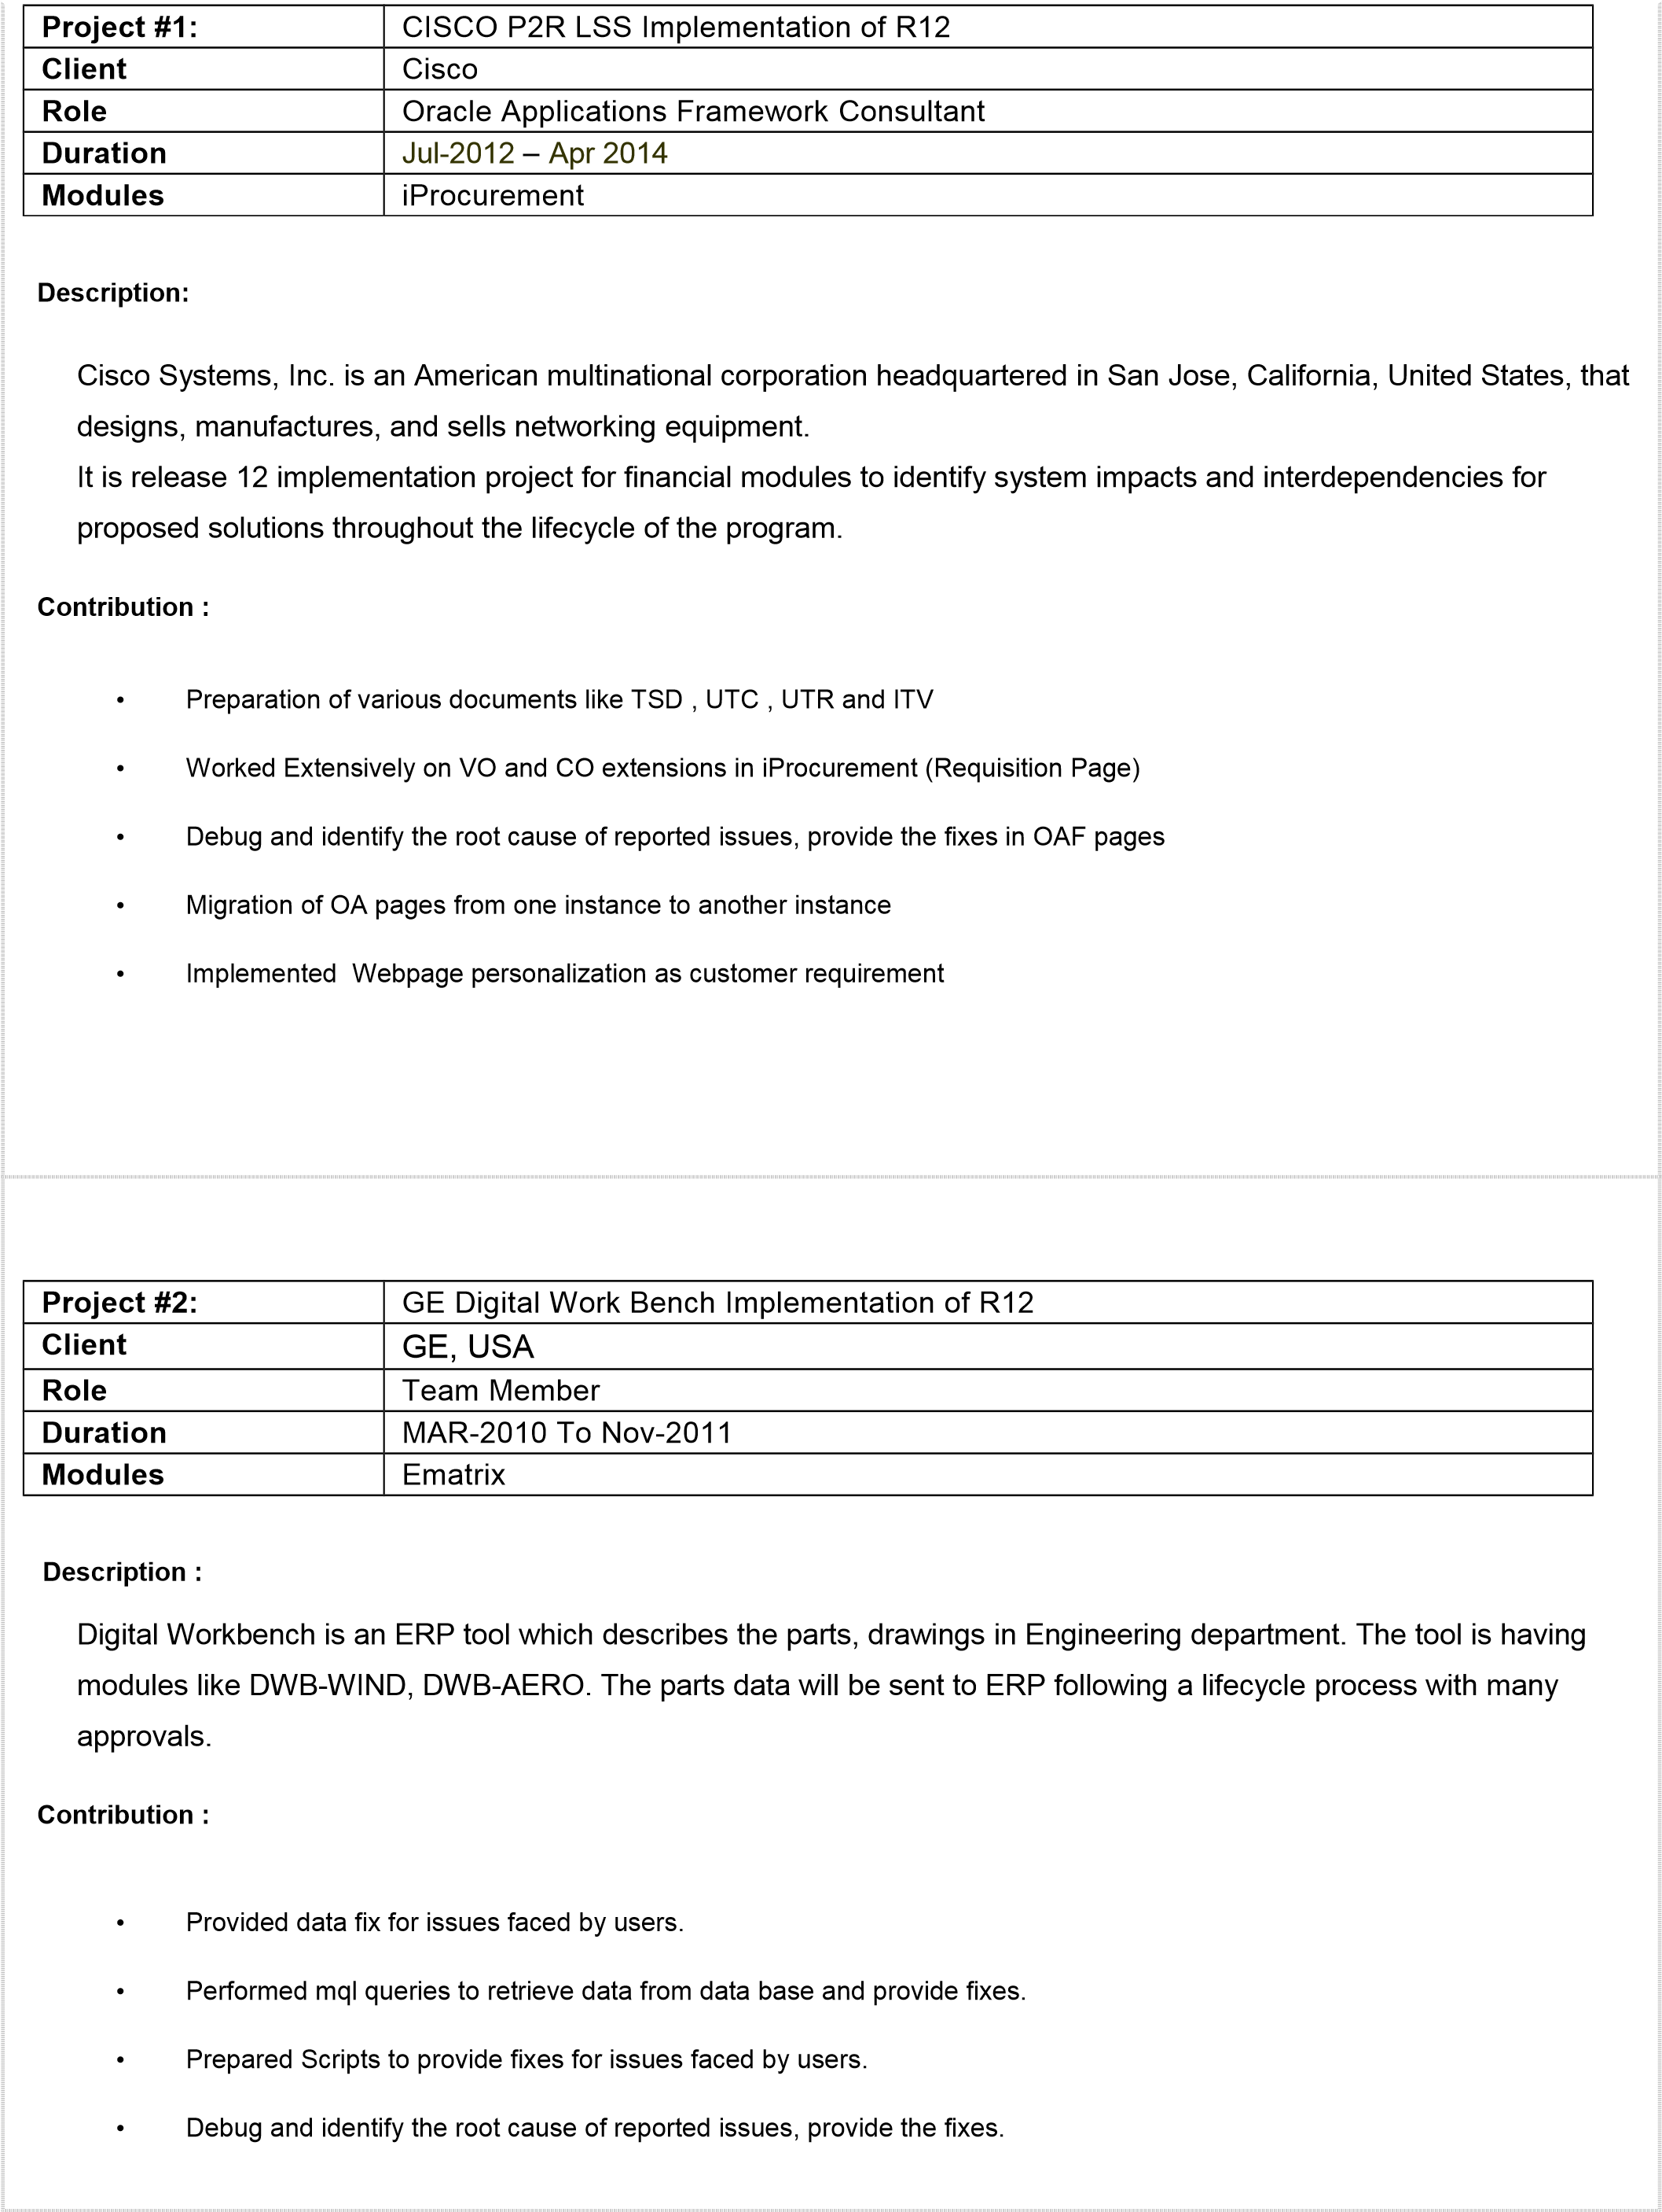





**6**