**PREM KUMAR**

**Mobile**: +91-8884402261 **Email: prem4057@gmail.com**

Top of Form

**Experience Summary:**

Having 8.8 years of overall IT experience and 8+ years of experience in Salesforce, Salesforce CPQ and Servicemax development, consulting & implementation

**As a Senior Consultant, engaging with our global delivery team, across different locations, to scope, size and deliver technology implementations, and manage risks of our delivery, while maintaining strong relationships with clients to grow our digital offerings**

I've helped companies transform the way they work with their customers through various IT projects delivered in Agile methodologies & DevOps which provided a wide range of functions like CRM, billing & custom apps built on force.com Platforms

**Extensive experience in Client interaction, Requirements gathering, Solution design, Configuration management and Release planning**

Hands on development on SalesForce.com development, **Salesforce Integration**, Triggers, Visual Force, Apex class, Batch Apex, **Salesforce Lightening**, Workflows, Process Builder, Approval Processes, Validation Rules, Lead Assignment Rules, Case Assignment Rules

Involved in the creation of User Interface, Page Layouts, Tabs, Custom Fields, Custom Objects, User Management, Roles, Profiles, Security and Sharing Rules

Consulting and hands on experience on Salesforce Administrator, Service cloud, Sales cloud and various feature of Salesforce CRM platform

Worked with business stakeholders and converted the business requirements into

Technical specifications to meet business needs

Lead the scrum meetings from offshore on daily basis, manage and mitigate continuously changing priorities and challenges to drive completion

Have experience of working on Development, Enhancement, Testing and Support projects

**Multiple progressive roles including Salesforce Consultant, Salesforce Solution Architect, Business Analyst and Business Consultant**

**Experience of working at Onshore (Australia) and Offshore in Team Lead & Technical roles**

**Scholastics: -**

|  |  |  |  |
| --- | --- | --- | --- |
| CERTIFICATE/DEGREE | UNIVERSITY/ BOARD | COLLEGE/SCHOOL | PERCENTAGE |
| B.TECH(Computer Science & Engineering) (Batch: 2007-2011) | KIIT UNIVERSITY | KIIT University Bhubaneswar (Odisha) | 73.30% |
| Intermediate | BIEB | TNB College Bhagalpur | 71.6% |
| Matriculation | BSEB | Anugrah High School | 84.14% |

**Current Experience Summary:**

Currently Working with **Deloitte Consulting India Private Limited (Office of the US)** as a **Senior Consultant** with the techno-functional expertise and business acumen necessary to translate business requirement and objective into scalable, highly resilient and successful system solution

**Organizational Exposure: -**

**(1) Employer: Deloitte Consulting India Private Limited (Office of the US)**

**Title: -** Senior Consultant

Duration: - June 2019 till now

**(2) Employer: Wipro Technologies**

Title: Consultant

Duration: August 2016 till June 2019

**(3) Employer: Capgemini (IGATE Global Solution)**

Title: - Senior Software Engineer

Duration: -July 2014-July 2016

**(4) Employer: Capgemini**

Title: - Consultant

Duration: -December 2011-July 2014

**Key Skills and Knowledge: -**

|  |  |
| --- | --- |
| **Technology** | **Tools** |
| Salesforce | Salesforce CRM, Apex Language, Batch Apex, SOQL, Visualforce Pages, **Salesforce Lightening**, **Integration via Web Service and Lightening connect**, **Field Service Lightning**, Workflow and approvals, Custom Settings, Reports and Dashboards, Standard and Custom Objects, Field Sets, Roles and Profile Management, Security and Sharing Setting, Data Loader, Eclipse, workbench |
| Servicemax | Field Service Management, Dispatch console, Work order re-processing |
| Web Design | HTML5, CSS, Java Script, jQuery, Twitter bootstrap |
| Functional Skill | Requirement Analysis, Project scoping, Release planning, Gap Analysis, Customer Relationship Management |

**Certifications: -**

|  |  |
| --- | --- |
| Professional Society / Certification | Certifying Authority |
| Salesforce developer-PD-1 | Salesforce.com |
| Salesforce Certified App Builder | Salesforce.com |
| Salesforce Admin-201 | Salesforce.com |
| Salesforce Certified Field Service Lightning Consultant | Salesforce.com |
| Salesforce Certified Advanced Administrator | Saleforce.com |
| Salesforce Certified Service Cloud Consultant | Salesforce.com |
| Salesforce Certified Sales Cloud Consultant (WI19) | Salesforce.com |
| Quote To Cash Certified Powered by Apttus | Apttus |

**Project Summary: -**

**(1) Indiana Child Support- Deloitte Consulting India Private Limited (Office of the US)**

|  |  |
| --- | --- |
| **Description** | Building Salesforce Application for Indiana Child Support System |
| **Role** | Team Lead/Scrum Master |
| **Operating System(s)** | Salesforce CRM |
| **Skills** | Requirement gathering and analysis, Project planning Release planning, Conversation of business requirements into Technical story |
| **Environment** | All project Environments |
| **Contribution** | (1) Worked with Onshore Team and converted the business requirements into functional specifications (User Story) to meet business needs (2) Translate Functional requirement to technical specification (3) Engaged with onshore team to scope, size, deliver Salesforce implementations and Agile product backlog. (4) Helped the Offshore team to understand the functional requirement and technical flow (5) Lead the scrum meetings from offshore on daily basis, manage and mitigate continuously changing priorities and challenges to drive completion. |
| **Start Date** | March 2020 |
| **End Date** | Till Now |
| **Period** | 5 Months |
| **Team Size** | 15 |

**(2) Amazon- Deloitte Consulting India Private Limited (Office of the US)**

|  |  |
| --- | --- |
| **Description** | Salesforce Application for Amazon Employee |
| **Role** | Team Lead /Scrum Master |
| **Operating System(s)** | Salesforce CRM |
| **Skills** | Requirement gathering and analysis, Project planning Release planning, Conversation of business requirements into User story |
| **Environment** | All project Environments |
| **Contribution** | (1) Worked with Onshore Team and converted the business requirements into functional specifications (User Story) to meet business needs (2) Translate Functional requirement to technical specification (3) Engaged with onshore team to scope, size, deliver Salesforce implementations and Agile product backlog (4) Helped the Offshore team to understand the functional requirement and technical flow (5) Lead the scrum meetings from offshore on daily basis, manage and mitigate continuously changing priorities and challenges to drive completion |
| **Start Date** | July 2019 |
| **End Date** | March 2020 |
| **Period** | 9 Months |
| **Team Size** | 12 |

**(3)** **CHARLES SCHWAB –Wipro**

|  |  |
| --- | --- |
| **Description** | Development for Lead conversion process and addition of new functionality |
| **Role** | Team Lead |
| **Operating System(s)** | Salesforce CRM |
| **Skills** | Requirement gathering and analysis, Project planning Release planning, Salesforce Lightening, Salesforce Customization, Salesforce Configuration |
| **Environment** | All project Environments |
| **Contribution** | Responsible forend to end delivery of the project as an individual contributor during the requirement gathering, Project planning, development phase and lead the three-member team across various locations |
| **Start Date** | November 2018 |
| **End Date** | May 2019 |
| **Period** | 7 Months |
| **Team Size** | 4 |

**(4) NBN- SDM Tool –Wipro**

|  |  |
| --- | --- |
| **Description** | Develop the tool for Service Delivery Manager |
| **Role** | Salesforce Team Lead |
| **Operating System(s)** | Salesforce CRM |
| **Skills** | Requirement gathering & Requirement Analysis, Release planning, Gap Analysis, Customer Relationship Management, Lightning, Salesforce Customization, Salesforce Configuration, Salesforce integration via lightening connect |
| **Environment** | All project Environments |
| **Contribution** | End to end responsible for the Application including Requirement gathering & analysis, Project planning, development, Customer management and coordination of the 6-member team across various geographic locations |
| **Start Date** | July 2018 |
| **End Date** | October 2018 |
| **Period** | 5 Months |
| **Team Size** | 6 |

**(5) Shell –Wipro**

|  |  |
| --- | --- |
| **Description** | Development for displaying the forecast data of Ether Application |
| **Role** | Technical Lead |
| **Operating System(s)** | Salesforce CRM |
| **Skills** | Requirement gathering & Analysis, Project planning, Salesforce Customization, Salesforce Configuration |
| **Environment** | All project Environments |
| **Contribution** | Responsible forend to end delivery of the project as an individual contributor during requirement gathering & analysis, Project planning, development phase and lead the three-member team across various locations. |
| **Start Date** | August 2017 |
| **End Date** | June 2018 |
| **Period** | 11 Months |
| **Team Size** | 3 |

**(6) Mercer-Wipro**

|  |  |
| --- | --- |
| **Description** | Mercer CRM is an implementation of Service Cloud and separate from the Corporate instance called “Mercerforce” which is an implementation of Sales Cloud. Mercer has migrated their Retiree business from ACT to Salesforce in 2015 and their Active business from Workbench to Salesforce in 2016. |
| **Role** | Salesforce Consultant |
| **Operating System(s)** | Salesforce CRM |
| **Skills** | Requirement gathering and analysis, Project planning, Gap analysis, Salesforce Customization, Salesforce Configuration, Customer Relationship Management |
| **Environment** | All project Environments |
| **Contribution** | As a Salesforce consultant, responsible for Requirement gathering, Project planning, Customer relationship management, development, and coordination of the 5-member team across India locations providing the development for Service cloud implementation |
| **Start Date** | February 2017 |
| **End Date** | July 2017 |
| **Period** | 6 Months |
| **Team Size** | 5 |

**(7) US Bank-Wipro**

|  |  |
| --- | --- |
| **Description** | U.S. Bancorp (NYSE: USB) is the parent company of U.S. Bank, one of the largest commercial bank in the United States and the development has been done for displaying the various business data |
| **Role** | Team Lead |
| **Operating System(s)** | Salesforce CRM |
| **Skills** | Salesforce Customization, Salesforce Configuration |
| **Environment** | All project Environments |
| **Contribution** | As a Team lead, responsible for management and coordination of the 3-member team across India locations providing enhancements and product support for Force.com application implementations |
| **Start Date** | August 2016 |
| **End Date** | January 2017 |
| **Period** | 6 Months |
| **Team Size** | 3 |

**(8) GE –IGATE Global Solution**

|  |  |
| --- | --- |
| **Description** | GE business need IT services support to meet its sales business needs. IGATE had provided various consulting Services to support this business. These services included various technical and functional support activities like analysis, design approach, testing, programming, user support and program fixes. |
| **Role** | Techno functional consultant |
| **Operating System(s)** | Salesforce CRM |
| **Skills** | Requirement gathering & analysis, Customer Relationship Management, Salesforce Customization, Salesforce Configuration, Servicemax, Apptus CPQ |
| **Environment** | All project Environments |
| **Contribution** | Responsibilities include requirement gathering, design, development and administration of salesforce.com applications and implemented dispatch Management with Servicemax on customization |
| **Start Date** | July 2015 |
| **End Date** | July 2016 |
| **Period** | 12 Months |
| **Team Size** | 14 |

**(9) NBC Universal –IGATE Global Solution**

|  |  |
| --- | --- |
| **Description** | NBC Universal is the one of the largest media entertainment company of united states. NBC Universal has three parts :-( 1) AD Sales (2) Re-branding (3) Sponsorship. All these parts were configured to Salesforce |
| **Role** | Developer |
| **Operating System(s)** | Salesforce CRM |
| **Skills** | Salesforce Customization, Salesforce Configuration |
| **Environment** | All project Environments |
| **Contribution** | Salesforce Developer |
| **Start Date** | December 2014 |
| **End Date** | June 2015 |
| **Period** | 7 Months |
| **Team Size** | 6 |

**(10) MetIp Innovation Program –IGATE Global Solution**

|  |  |
| --- | --- |
| **Description** | MetLife is the holding corporation for the Metropolitan Life Insurance Company for short and its affiliates. This Project was delivered an initial implementation of Salesforce for MetIp Innovation Program team to leverage in support of their work with various Venture capitals and their respective portfolio companies. |
| **Role** | Developer |
| **Operating System(s)** | Salesforce CRM |
| **Skills** | Salesforce Customization, Salesforce Configuration |
| **Environment** | All project Environments |
| **Contribution** | Salesforce Developer |
| **Start Date** | August 2014 |
| **End Date** | November 2014 |
| **Period** | 4 Months |
| **Team Size** | 5 |

**(11) Royal Mail Group –Capgemini**

|  |  |
| --- | --- |
| **Description** | Royal Mail Group -a world leader in postal innovation - is one of the UK's largest companies. Salesforce was configured to meet the needs of all three brands within RMG: Parcel Force, Post Office and Royal Mail. |
| **Role** | Developer |
| **Operating System(s)** | Salesforce CRM |
| **Skills** | Salesforce Customization, Salesforce Configuration |
| **Environment** | All project Environments |
| **Contribution** | Salesforce Developer |
| **Start Date** | December 2012 |
| **End Date** | June 2014 |
| **Period** | 19 Months |
| **Team Size** | 5 |

**(12) Williams Scotsman Project Lead Handler –Capgemini**

|  |  |
| --- | --- |
| **Description** | Williams Scotsman is the leader in modular space in North America. The Client’s existing CRM implementation was based on the Saleforce.com services. Capgemini was responsible for providing the most effective plan for their CRM solution and implementation strategy specific to Sales process. |
| **Role** | Developer |
| **Operating System(s)** | Salesforce CRM |
| **Skills** | Salesforce Customization, Salesforce Configuration |
| **Environment** | All project Environments |
| **Contribution** | Salesforce Developer |
| **Start Date** | April 2012 |
| **End Date** | November 2012 |
| **Period** | 8 Months |
| **Team Size** | 4 |

**Achievements in WIPRO: -**

* Special Contribution Awards for your outstanding performance
* NBN Raising Super Star Performer
* Certificate of Appreciation**- NBN Australia**

**Academic Highlights: -**

* Rewarded as Second Topper of Bihar board at State Level in class x
* Rewarded as School topper at Intermediate Level

**Significant Highlights: -**

* Certificate of Achievement- ACM –ICPC Multiprovincial Programming contest Overnite in IIT Kharagpur-Kshitij-2010
* Certificate of Merit –Ranked 3rd in Paper Presentation at KRITANSH-2009, Techno-Management Fest of KIIT University
* Ranked 2nd state Level Jawaharlal Nehru Science Exhibition-2001
* Represented State Level Team in Eastern India Science-2001
* Won prizes in various inter house debate, quizzes and drawing competitions in school
* Participated in 9th National youth Parliament Competition-2009
* Worked as a Volunteer during 38th ISTE Annual Convention and National Seminar-2008
* Event coordinator of Publicity Team in Kritansh-2010

**Customer Recommendations: -**

(LinkedIn: <https://www.linkedin.com/in/prem-kumar-754b1b62/>)

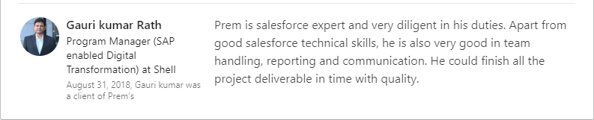

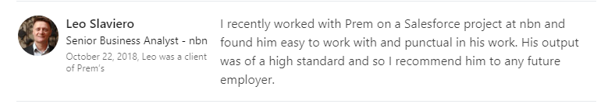

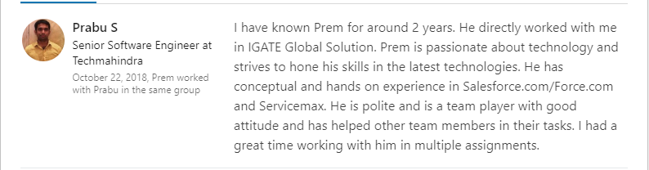

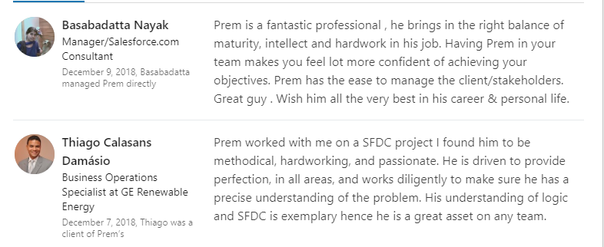

**Personal Dossier: -**

Address: G.K. J House, Opposite of Nitesh Cap code, Bellandur, Bangalore-560103.

Languages Known: English and Hindi

Sex: Male

Nationality: Indian

**Declaration**

I hereby declare that the above written particulars are true to the best of my knowledge and belief.

**DATE: July 7th, 2020 Prem Kumar**

**PLACE: -Bangalore**

Bottom of Form