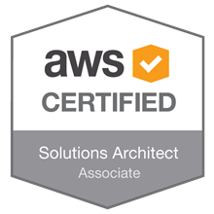
SRINIVAS SEENDRIPU 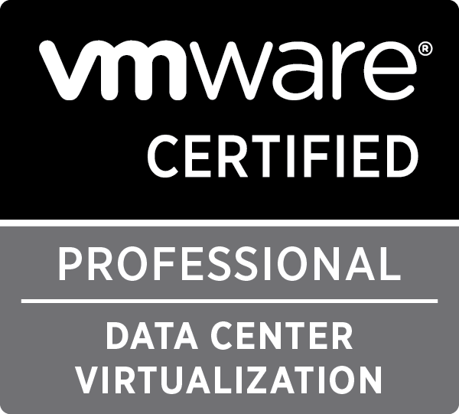
Phone: +91-970-591-0349
E-mail: srinivasseendripu@gmail.com

Career Objective

Looking for a position that unleashes the scope to enhance and contribute my skills to the best, which would result in the mutual growth of self and organization.

Summary

An IT professional with 9 years of IT Experience in Infrastructure Services support, Management & AWS cloud. Capable of quickly adapting to changing environments, flexible and a committed individual with expert troubleshooting skills. Currently working as a Technical Specialist with Proficient working experience in Technologies – AD, VMware, AWS and Azure cloud.
Educational Qualification & Certifications

- Completed “Master’s in Business Administration” in the field of Information Technology
- Completed “Bachelor of Science” from Andhra University
- AWS Certified Solutions Architect - Associate
- VMware Certified professional for Data Center Virtualization
- ITIL v3 (foundation)
- Citrix XenApp 6.0 Certified
- Microsoft Server 2012 Server Administrator

Technical Expertise:

Operating Systems: Windows 2003,2008,2012 and 2016 OS.
Virtualization: VMWare and hyper-V

Hardware: HP Standalone and Blade enclosures, IBM and Dell infrastructure & Cisco UCS
Patching tools: HPSA, SCCM,WSUS and BLADE-Logic .
Ticketing tools: Remedy, SDP, ETMS, HPSM
Debuggers: WinDbg, Wireshark, DIG

PROFILE I: International Business Machines (IBM) September 2017 to till date
Verizon Data services India Pvt Ltd - August 2014 to August 2017
(IBM acquired Verizon Cloud project in the Month of Sep2017)

Designation: Specialist System Administrator

Currently working as Cloud Engineer handling multiple customers of Verizon Cloud–Enterprise Cloud management Edition which was acquired by IBM.
Hands on experience in on multiple platforms like Enterprise Cloud Computing, IP Application Hosting (IPAH), Remote Application Management (RAM) and Computing as A Service (CAAS). Designing, maintaining and managing all Windows Servers for running stable environment which includes Production, Testing, Development and Quality stages for multiple Customers.
Lead and participated in multiple Outages calls & Crises Bridges to resolve critical issues on time. Provided in-depth incident analysis (IA) and Root Cause Analysis (RCA) for all Major outages involved.
Identify repeated issues as part of Problem Management task and present feasible solution for permanent fix to reduce duplicate tickets.

ROLES & RESPONSIBILITIES

- Daily roles and responsibilities includes supporting multiple clients with different Service Level Agreements on multi-tenant heterogeneous cloud and Data Center platforms.
- Providing Root Cause Analysis (RCA) investigation report to clients on critical outages
- Managing and maintaining Windows 2003, 2008,2016 and 2016 server administration
- Escalation point of contact for high priority and wide impacting issues in the infrastructure hosted in Cloud and On-premise Environment.
- Remote Administration using Terminal Services
- Monitoring connectivity, synchronization, replication, netlogon, time services, FSMO roles, schema, NTDS database partitions, DNS settings, SRV records, and trust relationships
- Manage group policy at root of domain and for Domain Controllers OU
- Complex configurations and issues handling with EC2, EBS, EFS, S3, Glacier, VPC, ELB, Route53, IAM
- Re-configurations and movements of services within Availability zone configurations, Regions, changes in AWS architectures
- Performed Windows user administration, managing user accounts, permissions, User rights, Account policies, Security policies and also performed software and hardware maintenance
- Involved in migration of multiple customer workloads from End of Life hardware to brand new servers with minimal downtime which involves lot of coordination with various teams.
- Performing Server patching and service pack upgrades. Expertise on Microsoft clustering & 2008,2012 failover clustering.
- Working knowledge on IBM Blades HS 20/HS 21 /X3650 and Prolliant DL and ML series server hardware platform
- Handling High End Automation environment and managing 3000+ ESXi servers, 8000+VM’s
- Responsible for upgrading servers from end of life version to the latest version of operating system ensuring that all the timelines and change management procedures are followed
- Good experience in migrating the on premises servers to the IaaS environment.
- Experienced in HA, DRS, vMotion, cloning, snapshots and templates.
- Monitoring and Responding to alarms and alerts on VCenter, nWorks and SiteScope.
- Monitoring connectivity, synchronization, replication, netlogon, time services, FSMO roles, schema, NTDS database partitions, DNS settings, SRV records, and trust relationships
- Experience in fixing IBM (RSA) and HP (ILO) connectivity with Blade and Brick Servers
- Hands on experience in network devices like port resets, logs collections, investigations, etc.
- Ensuring that the change process is followed for any configuration changes in the environment. and upon request for technical solutions
- physical and virtual Server Rebuilds and Decommissions with proper documentation
- Responsible for server weekly scheduled reboots and patching schedules on Blade logic and WSUS
- Worked DR test and was successful in recovering two of client’s most critical applications
- Managing snapshots and restoring snapshots of VM’S
- Working on P2V migrations & V Motion
- Working on TSM and COMMvault and Netbackups
- Installation & Configuration in Local, Sharing and Network Printer
- Knowledge on Hardware RAID configurations (RAID 1, RAID 5...)
- Create new TSGS & SOPs for reoccurring issues.

- PROFILE II:
  - Company: DST Worldwide services. Dec 2013 – August 2014
  - Designation: Sr.System Administrator

- As a senior support engineer roles & responsibilities include but not limited to Configuring and troubleshooting Windows and VMware servers.
- Worked on net backup and commvault backups technologies.
- Worked on active directory for user administration level
- Worked on active directory for user administration level.
- Worked as a first point of contact for all the BT end users and their employees. Works 24/7 on all the submitted Service requests and ensuring that the solutions are provided with in the agreed time lines.
- Responsible for weekly scheduled patching and reboot schedules.
- Defining IP address range, creation of subnets, configuration of route tables and network gateways in VPC.

PROFILE III:
Company: Computer Sciences Corporation June 2010 – November 2013
Designation: Associate System Administrator

- Work on Incident and problem management for resolving incidents within the SLA using ticketing tool Remedy 7.0.
- Active participation in Service restoration chats for resolving issues with high severity in MIM calls.
- Strong leadership and communication skills and working experience with customers, end users and colleagues. Demonstrated ability to work in both individual and team environments
- Being a part of RCA to analyze and resolve high severity issues and identify the root cause behind the actual problem.
- Performing daily checks to ensure stability in the environment during off business hours.
- Experience in fixing IBM (RSA) and HP (ILO) connectivity with Blade and Brick Servers using port reset from switch end.
- Monitor/analyze server performance by enabling performance counters.
- Performing daily checks of Cisco UCS and working knowledge on half width blades b200 M2- m4
- Have worked on Change requests related to Wintel Servers during pre-defined maintenance windows.
- Handle the tasks of coordinating with hardware vendors and provide remote support for and assist in resolving issues related to hardware, operating systems and configurations.
- Hands on experience on Remedy7.2, AF Remote, and HP Open view, TEPS, HP insight manager, IBM Director, Grid manager (DNS boxes) and etc.
- Proactively worked to Identify hardware fault from the standard alerting system, HP SIM tools and recommend solution to the hardware vendor.
- Good knowledge in working on various IBM Blades HS 20/HS 21 /X3650 and Prolliant DL and ML series server platform hardware.
- Does possess good knowledge on VMware & managing Virtual infrastructure using VMotion and other tools.
- Creation, Management and Configuration of Virtual Machines, Clone and Templates.

PROFILE IV:
Company: CMS info systems (client – BA Continuum India Pvt. Ltd)
Designation: Systems Administrator Feb 2010 - June 2010
- Email monitoring and providing support to clients for various service related queries. Act as a Bridge between Technical Operations Teams and Clients.
- Follow ITIL standards while delivering services to clients. Strictly Adhere to SLA’s.
- Troubleshooting entry level Windows Issues. Monitoring and troubleshooting service related alerts. Troubleshooting CPU usage, memory usage and Disk Usage Related Alerts. Maintain and Create User accounts and policies within Active Directory.

PERSONAL PROFILE:

Name : Srinivas Seendripu
Father’s Name : Surya Rao
Linguistic Skills : English, Hindi & Telugu
Marital Status : Married

DECLARATION:
I hereby affirm that the information in this document is accurate and true to the best of my knowledge.

Place: Hyderabad. SRINIVAS SEENDRIPU

