MITHILA 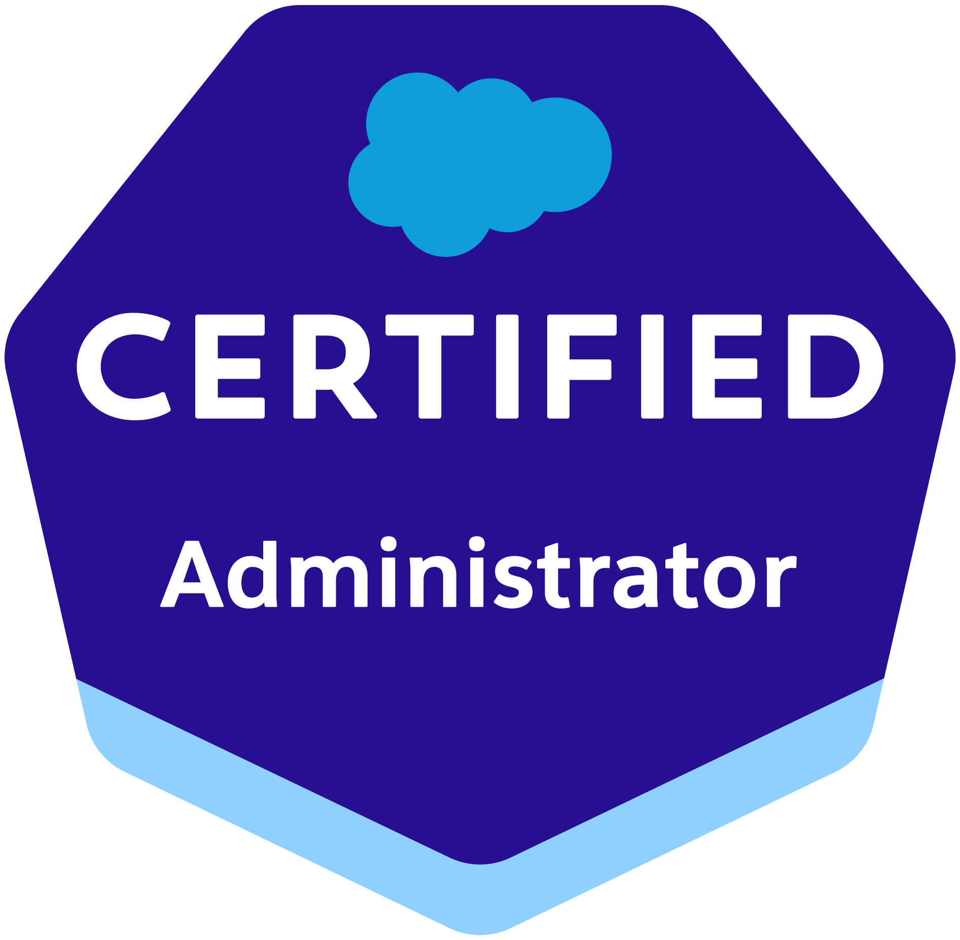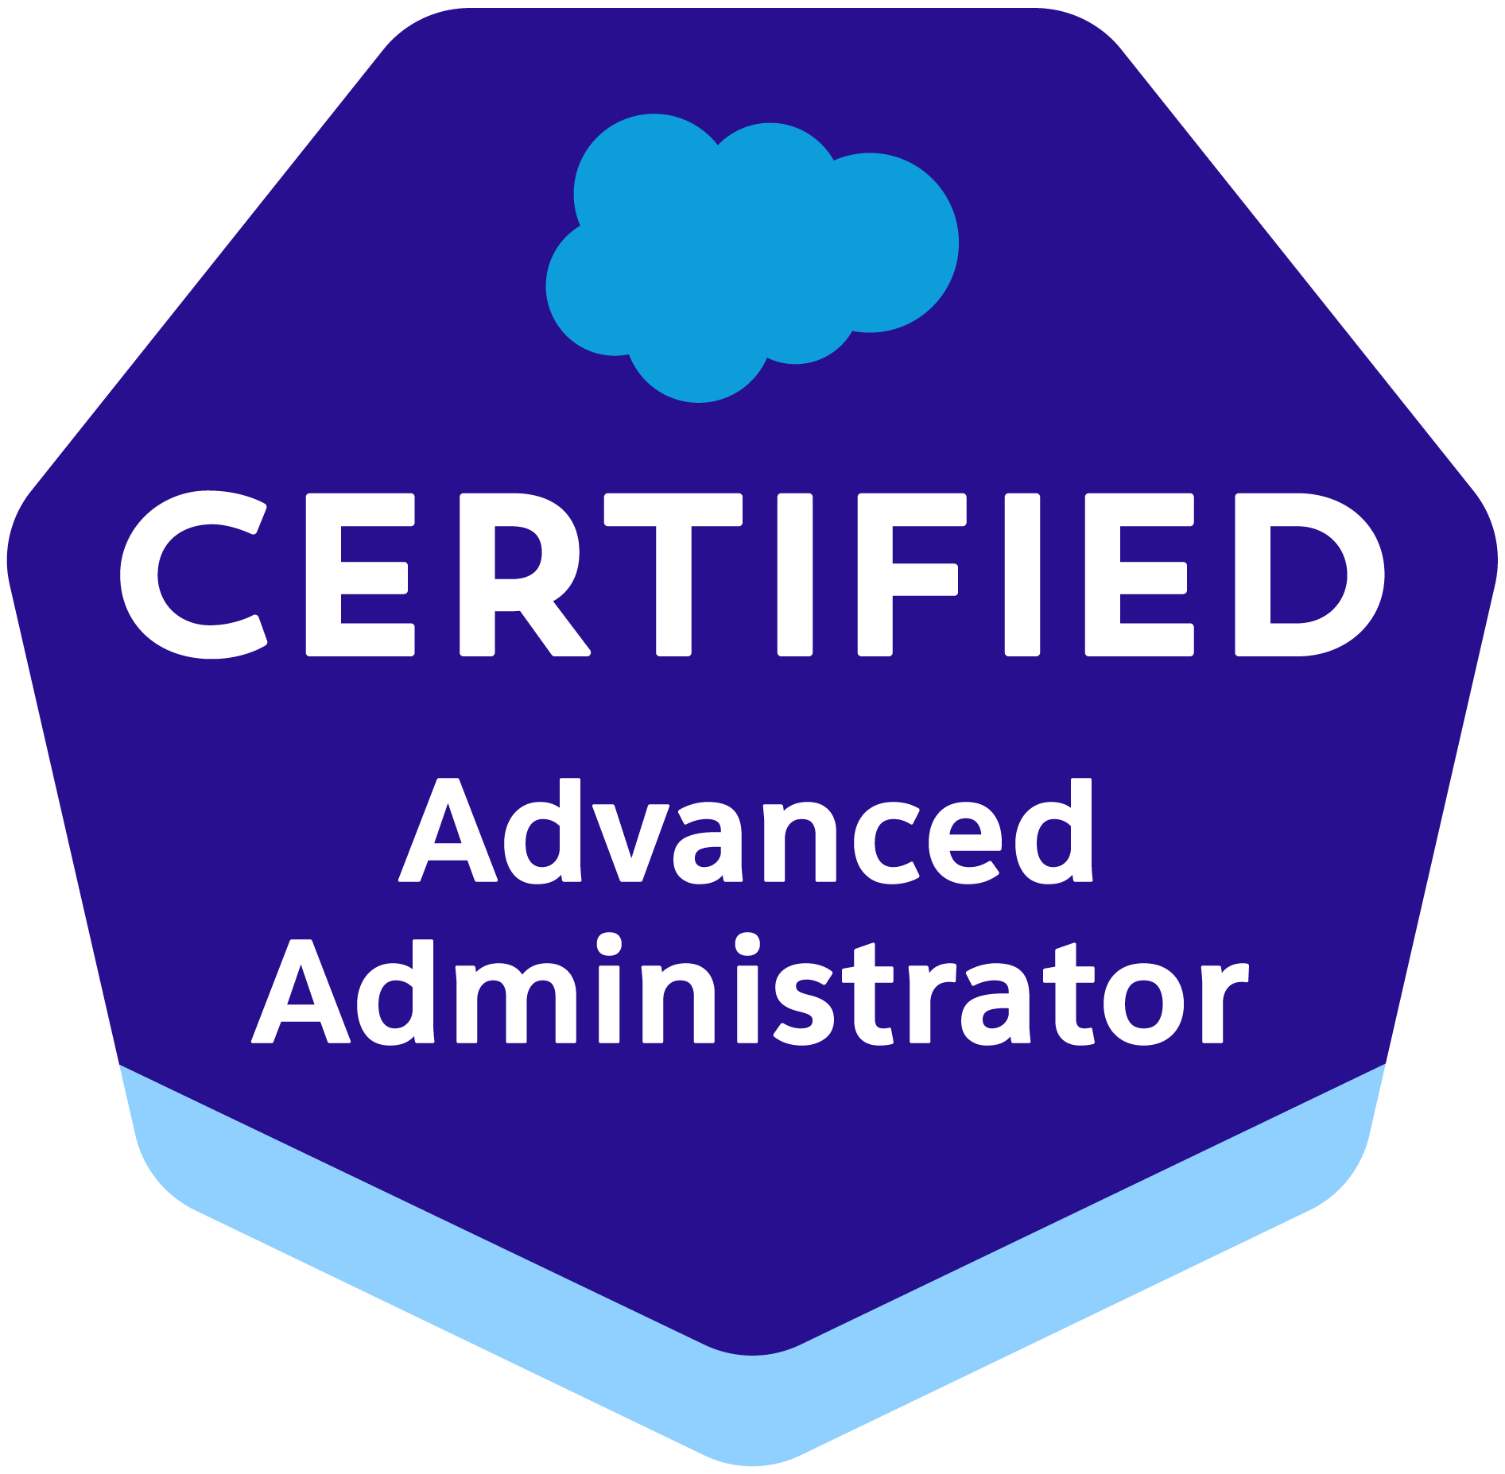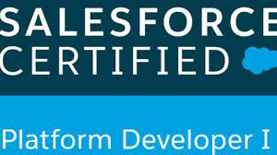Email: mithilam386@gmail.com
Ph: 571-660-1781

PROFESSIONAL SUMMARY

- Around 8 years of Overall Professional IT experience with 6 years of Extensive Salesforce experience, Involved in various stages of Software Development Life Cycle (SDLC).
- Configured, implemented, administrated, and maintained the Salesforce.com Platform.
- Possess comprehensive understanding on SFDC full life cycle implementation experience with Sales Cloud, Service Cloud and Force.com Platform.
- Worked extensively on Salesforce Lightning Platform.
- Salesforce Lightning Experience - Used SLDS for developing Lightning Components, Actions, Events and Server-Side Controller.
- Experience in modifying Visual force pages to be supported in Lightning Experience and good understanding of lightning mode and its features.
- Worked on Validation Rules, Workflows, Approval process & developed user interface through Lightning Component.
- Hands on experience in SFDC development using the APEX classes, Triggers, Components, Reports, Force.com IDE, Eclipse with SOQL, SOSL and Force.com plug-in.
- Experience developing Custom UI with AJAX functionality using Visual force pages, Visual force Tags, Attributes and Controllers.
- Experience in Salesforce.Com CRM Integration, Developing and Deploying Custom Integration Solutions using REST and SOAP API.
- Proficient in analyzing business requirements, Entity Relationship diagram (ERD) and implementing them to Salesforce objects, master-detail relationships, lookup relationships.
- Excellent understanding on OOPS concepts and have experience working on Java to Salesforce Integration using WSC.
- Experience in customizing Sales Cloud and Service Cloud applications and utilizing Lightning App Exchange packages.
- Effective employment of Apex Data Loader, Import Wizard and Data Manipulation Language for data migration and management in bulk.
- Expert in implementing Security, Sharing rules, Profiles and Permission sets at object, field and record level for different users at various levels of organization.
- Expertise in Wave Analytics, Salesforce Reporting and Dashboards for executives.
- Experience in deploying between the Production and Sandboxes by employing the Force.com Migration Tool and Eclipse.
- Strong knowledge of Salesforce standard data structures and familiarity with Force.com Explorer, Force.com Migration and Force.com Excel connector.
- Proficient in creating Custom Objects, Custom Fields, Custom Tabs, Pick list, Profile Based Page Layouts, Custom Reports, Workflows, Relationships, Record types, Validation Rules.
- Worked extensively on various salesforce.com standard objects like Accounts, Contacts, opportunities, Products, Price books, Cases, Leads, Campaigns, Reports and Dashboards.
- Experience with databases such as Oracle and My SQL.
- Proficiency in web technologies like HTML, XML, CSS, JavaScript, WSDL, and SOAP.
- Experience in working with Eclipse IDE with Force.com Plug-in environment for writing Business logic in Apex Programming Language.
- Excellent team player with Interpersonal, Communicational, Organizational and Project Management skills.
- Ability to meet deadlines and handle pressure in coordinating multiple tasks in a work environment. Versatile team player with excellent analytical and presentation skills.

CERTIFICATIONS

- Salesforce Certified Administrator (ADM201)
- Salesforce Advance Administrator (ADM 211)
- Salesforce Platform Developer (PD1)

TECHNICAL PROFICIENCY

Salesforce.com Technologies | Apex Language, Lightning Application, Apex Classes/Controllers, Apex Triggers, SOQL, SOSL, Visual Force Pages/Components & Controllers, S-Controls, Apex Web Services, Apex Data Loader, Force.com Apex Explorer, AJAX, Dashboards, Reports, Analytic Snapshots, Custom Objects, Force.com Eclipse IDE Plug-in, Workflow rule, Approvals, Case Management Automation.
Programming Languages | Java (J2SE, J2EE), C#.Net, PL/SQL, Perl.
Business Processing | Service Requests and Activities, Opportunities, Quotes and Proposals, Order Management, Campaign Management, Case Management, Contract Management, Pricing, Approval, Partner Deal Registration, Data Cleansing, and De-duplication, Agreements and Entitlements.
Scripting Languages | HTML, XML, Java script, CSS.
Web Services | WSDL, SOAP/REST API
Databases | Oracle 10g, 11g, MySQL, Microsoft Access, SQL Server 2000/2005/2008.
Packages | MS Word, MS PowerPoint, MS Excel, MS Project, MS Visio, Macromedia Dreamweaver, Rational Rose, Google Drive, Eclipse IDE.
ETL/Integration Tools | Apex Data Loader, Informatica, Boomi, Cast Iron, Force.com Workbench, TIBCO.

PROFESSIONAL EXPERIENCE

DXC Technology, New Orleans, LA
Duration: July’19 - Present
Role: Sr. Salesforce Lightning Developer

Responsibilities:
- Interacted with various business user groups to identify gaps between business needs and standard application functionality, design and documented solutions that fill the gaps.
- Created modern Lightning Apps combining Lightning Design System, Lightning App Builder and Lightning Component features.
- Upgraded some Apps from Salesforce Classic to Lightning Experience to develop rich user interface and better interaction of pages.
- Worked on Salesforce1 Platform to build Mobile App by enabling Lightning Components for use in Salesforce1 mobile platform to make Lightning Application mobile.
- Designed, developed and deployed Apex Classes, Controller Classes, Extensions, Apex triggers and API integration for various functional needs in the application using the Eclipse IDE.
- Designed and developed the Custom objects, Custom tabs, Validation rules, Page layouts, Components, Visualforce Pages on Lightning Platform.
- Worked on Jira to track daily progress and followed Agile methodology for best practice.
- Experience delivering CI/CD automation solutions in an agile software organization.
- Experienced supporting custom CPQ processes in Salesforce.
- Created integration with Apttus CPQ and CRM applications and automating processes on salesforce platform.
- Administered setting up of Analytics Cloud- Wave Analytics onto Business Platform.
- Worked on Salesforce1 Mobile Administration.
- Implemented Pick lists, Dependent Pick lists, Lookups, Master detail relationships, validation, and formula fields to the custom objects.
- Created Field Level Security along with Page Layout to manage the visibility and accessibility of fields for different Profiles.
- Integrated the Web Services for extracting the data from external systems to display in the pages of salesforce.com.
- Worked with SOQL & SOSL queries with Governor Limitations to store and download the data from Salesforce.com platform database.
- Imported data from excel sheets in to Leads, Accounts, Contacts and Opportunities using Data Loader and Import Wizard.
- Implemented Web to Case, Email to Case functionalities to provide a better customer support to the customers.
- Created Lightning Apps combining Lightning Design System, Lightning App Builder and Lightning web Component features.
- Developed Assignment rules, Escalation rules to enable proper routing of cases to the case team members.
- Developed Workflow Rules, Tasks, Emails and Alerts to track customer related tasks and activities.
- Designed several types of Email templates for auto response to customers.
- Develop mockups using Visual force pages, Boot strap, Java script for feedback.
- Develop complex functionality using Apex – Triggers, Classes, Controllers, Web Services.
- Application framework design with respect to convenience of the end users.
- Environment: Salesforce.com Setup Builder, Data Loader, Apex Language, Security Controls, Sandbox data loading, Eclipse IDE Plug-in, force.com IDE, Microsoft Office.
Comcast, Philadelphia, PA
Duration: Dec’17 – June’19
Role: Salesforce Developer/Administrator

Responsibilities:
- Worked closely with Business managers to understand the Use Cases, Business requirements and further converted them the technical specifications.
- Involved in analyzing the implementation gap between Salesforce Classic and Salesforce Lightning.
- Developed Lightning Components and Lightning Apps to provide better and more interactive interfaces to help with the enhancement of Sales to End users.
- Designed and developed Lightning Community website for Sales team using Lightning Community Builder, Lightning Components, Lightning Events, HTML, CSS, and Lightning Controllers.
- Implemented user interface using JavaScript and CSS on top of Visualforce.
- Worked on Analytics Cloud.
- Enabled Preview Thumbnails for all Lenses and Dashboard on Wave Analytics Wrote Custom Web service classes in Apex to integrate the salesforce with third party application by REST API, SOAP API.
- Customized objects, page layouts, record types, workflows, validation rules, formula fields, reports, dashboards and chatter as per business requirements on Salesforce Lightning Platform.
- Implemented CTI to serve both sales and service purposes for both inbound and outbound calls.
- Wrote scheduled classes to perform the data manipulations on nightly or weekly bases using the batch apex.
- Created the APEX classes, custom controllers, controller extensions, Visualforce pages and APEX Triggers to develop the custom functionality and meet the business requirements.
- Used GIT for version controlling system and used source tree as an UI to perform the code push/pull operations.
- Used Sublime, MavensMate, GIT, force.com migration tool and Jenkins combination along with script to develop code, maintain the versioning and moving code around the environments.
- Defined sharing and visibility along with roles, profiles, sharing rules and written apex-based sharing in few scenarios where it’s required to add sharing and team members.
- Created test scenarios on Sandbox environment, created packages and moved it between Sandboxes and Production environments to place final implementations.
- Installed and configured Apex Data Loader and involved in migrating data into Salesforce application using Apex Data Loader through CSV files.
- Used SOQL & SOSL for data manipulation needs of the application using platform database objects.
- Provided Post-Implementation support to assist end users in creating reports, dashboards and certain Administration tasks including creating and maintaining user profiles and privileges.
- Implemented Security and Sharing rules at object, field, and record level for different users at various levels of organization. Also created various profiles and configured the permissions based on the Organizational Hierarchy.
- Executed various levels of Unit, Integration, User Acceptance and Operational Acceptance testing using test cases to prove that system conform to specifications of business and quality requirements.
- Participated in weekly change control meetings and performed application and global impact analysis. DAP Directory integration for Salesforce.com.
- Worked on SFDC, CRM, SFA and Billing Modules (Sales Process Automation, Lead and Marketing Automation, Mass Marketing Automation, Customer Care, Accounts Receivables, Credit Limit process, Collections, Rating, Billing, Discounts, Catalogues, Invoicing, Reporting).

Environment: Saleforce.com platform, Apex Language, Visual Force (Pages, Component & Controllers), Pages, Data Loader, HTML, Java Script, Marketo configuration and customization, Security Controls, Sandbox data loading, Eclipse IDE Plug-in, Windows.

Charles Schwab, West Lake, TX
Duration: June’16 – Nov’17
Role: Salesforce Developer/ Administrator

Responsibilities:
- Participated in requirements gather and develop data model to suit complex business needs.
- Closely worked with Salesforce Consultants while implementing the solutions for the requirements.
- Involved in Implementation of Analytics cloud- Wave Analytics platform.
- Customized the Dashboards to the track usage for productivity and performance of business centers and their sale
- Created Wave Analytics Permission Sets and Assigned them to Users.
- Created Custom Objects and defined lookup and master-detail relationships on the objects and created junction objects to establish connectivity among objects.
- Developed Apex classes, Controller classes and Apex Triggers for various functional needs in the application.
- Developed workflow rules for various tasks and Email alerts as per the requirements.
- Developed a flex based custom application for data validation and check for data discrepancies.
- Developed and supported Extraction, Transformation and Load process (ETL) using Informatica.
- Implemented pick lists, dependent pick lists, and validation formula fields to the custom objects
- Developed Approval process for the application by implementing custom formulas in various stages of approval.
- Developed Visual force pages to enhance User Interface on Salesforce Platform.
- Imported data into custom objects from various sources using Data Loader.
- Involved with Salesforce.com Premier Support and handled the support cases with the help Salesforce.com support.

Environment: Salesforce.com, Informatica power Centre V7, Apex, XML, Controllers, Sharing Rules, Workflows, Email Updates, Eclipse IDE, JavaScript, Web Services API.

Anthem, Indianapolis, IN
Duration: May’15 – Jan’16
Role: Salesforce Developer/Analyst

Responsibilities:
- Worked as enhancement team member and performed the roles of Salesforce Administrator in the organization.
- Worked closely with Sales team and Business analysts and performed detailed analysis of business and technical requirements and designed the solution by customizing various Standard objects of Salesforce (SFDC).
- Involved with Operations Manager and Users to determine business requirements, provide administrative support and design /implement solutions in Salesforce CRM.
- Involved in the maintenance of the previous versions of the product by addressing bugs and client issues.
- Responsibilities include defining integration architecture, documenting technical requirements, and identifying success criteria.
- Created Profiles, Roles based on Organization Role hierarchy and implemented Record-Level and Field-Level security and configured their sharing settings.
- Created Workflow Rules, Page Layouts, Approval Process, Tasks, Email Alerts, Field Updates and Outbound Messages to manage the Workflow & Approvals.
- Responsible for enabling Network-based security and organization-wide list of trusted IP address.
- Worked on various salesforce standard objects like Accounts, Contacts, Leads, Campaigns, Opportunities, Quotes, Activities, Dashboards and Reports.
- Created the workflows for automated Lead Routing, Lead Escalation and Email alerts.
- Customized Page layouts for Opportunity, Contacts, and Accounts depending upon user roles, and groups.
- Developed and configured various Reports and Report Folders for different user profiles based on the need in the organization.
- Responsible for creating Sharing rules among all the users in Different Roles and Subordinates.
- Responsible for creating Queues, Workflows rules and Tasks to share and automate work to the users in the Queue.
- Created Unit test cases and coordinated change requests to drive the business requirements during Integration and Testing stages.

Environment: Salesforce.com platform, Apex, Visualforce pages, Data Loader, HTML, Java Script, Eclipse IDE.

A Square Technologies, Bangalore, India
Duration: Aug’12 – Dec’13
Role: Jr. Developer

Responsibilities:

- Involved in all aspects of Software development life cycle and followed Agile methodology to develop project plans.
- Developed the user interface using JSF with client-side validation to view the individual details and implemented jQuery AJAX calls in JSF web pages to render the response on to UI.
- Implemented Spring Controllers that integrates with front-end framework. Developed DAO components by implementing Spring DAO and established efficient exception handling and logging using Spring AOP.
- Implemented Generic DAO using Spring JDBC to handle database operations on Similarly Constructed Tables.
- Developed web application using JSF Framework. Used JQuery and JSF validation framework for front end validations.
- Used Jersey-Client API for creating client classes to consume Restful services.
- Worked on Used Struts-Validator framework for all front-end Validations for all the form entries.
- Developing SQL queries for different database operations in DB2.
- Deploying and testing the application in WebSphere App Server.
- Used RAD for developing the application components.
- Participating in Code review process for peers.
- Involved Analyzing, Fixing Production, UAT and QAT Issues.
- Extensively Using Junit for Unit Testing.
- customized in place of testing built-in salesforce functionality
- Responsible to validate end-to-end test case scenarios and coordinating with QA Team.

Environment: J2EE, Spring, Web Services, REST, SOAP, WSDL, XML, XSD, Oracle, DB2, Web Sphere, JSF, JSTL, JQuery, Ajax, HTML, JavaScript, Linux

Essae Digitronics, Bangalore, India
Duration: June’11 – Aug’12
Role: Business Analyst

Responsibilities:

- Interacted with the client and the Technical Team for requirement gathering and translation of Business Requirements to Technical specifications.
- Performed extensive data modeling to differentiate between the OLTP and Data Warehouse data models.
- Hosted the application online using Microsoft share point excluding some functionality those were developed to use by employees only.
- Identified and documented the dependencies between the business processes.
- Documented the Use Cases and prepared the Use Case, Activity, Sequence diagrams and Logical views using MS Visio, MS Office and Rational Rose for a clear understanding of the requirements by the development team.
- Conducted JAD sessions and Data modeling using UML.
- Worked on Lotus notes for getting feedback, web-based requests and bill approval.
- Responsible in testing and analyzing data consolidation, organization, and presentation.
- Create and maintain Use Cases, visual models including activity diagrams, logical Business process models, and sequence diagrams using UML.
- Involved in preparing project plans and identifying major milestones for each stage as per the SDLC model (RUP Methodology).
- Responsible for teaching sessions for end user to tell how to use tools.

