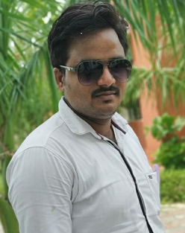

Contact

**Address:**

Tandwa, Amethi, Uttar Pradesh

**Phone:**

+91 9670418629

**Email:**

[er.shubham.ce2015@gmail.com](mailto:er.shubham.ce2015@gmail.com)

**LinkedIn:**

linkedin.com/shubham-kumar-5a34671ab

Languages

Hindi – Native

English – Good

Hobbies

* Writing
* Reading
* Photography
* Design

Summary

I’ve been working as lab instructor in an academic institution. On a part time basis, I work as freelance data entry operator. I also work on transcription projects.

Skill Highlights

|  |  |
| --- | --- |
| * Data Entry * Transcription * Review | * Editing * Innovative * Service-focused |

Experience

**Data Entry** - 01/2020 to Till Date

**Freelance**

**Lab Instructor** – 08/2017 to Till Date

**RRSIMT, Amethi**

**Site Engineer-** 08/2015 to 07/2017

**SCPL, Lucknow**

Education

Bachelor of Arts: **Hindi, English** - 2018

**Dr. Ram Manohar Lohia Avadh University, Ayodhya**

Certifications

Diploma in Civil Engineering

Shubham Srivastava