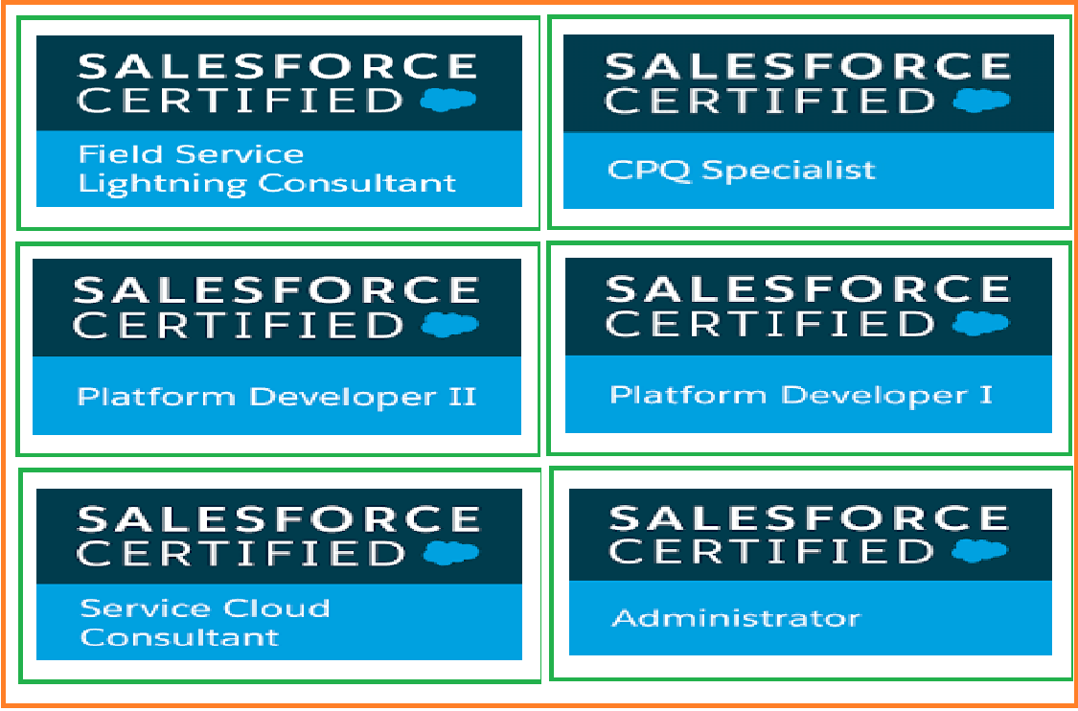

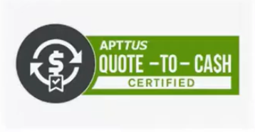

**Kondapalli Srinivasa Varaprasad**

[**Varasree67@gmail.com**](mailto:Varasree67@gmail.com)

**8978354943**

**Sr SALESFORCE TECHNOLOGY PRACTICE HEAD**

* **TOTAL IT EXPERIENCE: 17.9 years**
* **RELEVANT EXPERIENCE IN THE TABLE BELOW**
  + EXPERIENCE IN SFDC DEVELOPMENT (YEARS): **12.9 YEARS**
  + EXPERIENCE IN APEX (YEARS): **12 .9YEARS**
  + EXPERIENCE IN VISUAL FORCE (YEARS): **12 YEARS**
  + EXPERIENCE IN TECHNICAL ARCHITECT/HEAD (YEARS): **8 .9YEARS**
  + EXPERIENCE IN SFDC INTEGRATION (SOAP API, REST API: **8 YEARS**
  + EXPERIENCE IN SERVICE CLOUD (YEARS): **6 YEARS**
  + EXPERIENCE IN SFDC COMMUNITY CLOUD: **6 YEARS**
  + EXPERIENCE IN SFDC COMMERCE CLOUD(YEARS): **4.6YEARS**
  + EXPERIENCE IN SFDC LIGHTNING (YEARS): **4.6YEARS**
  + EXPERIENCE IN SFDC STEEL BRICK CPQ (YEARS): **4.6 YEARS**
  + EXPERIENCE IN APPTUS CPQ (YEARS): **4 YEARS**
  + EXPERIENCE IN ORACLE CPQ (YEARS): **4 YEARS**
  + EXPERIENCE IN FIELD SERVICE LIGHTNING(YEARS): **3.6 YEARS**
  + EXPERIENCE IN FINANCE SERVICE CLOUD(YEARS): **2.6 YEARS**
  + EXPERIENCE IN SALESFORCE ORDERMANAGEMENT SYSTEM (OMS) .

**Skills:**

SFDC: Sales Cloud, Service Cloud, Community Cloud, Salesforce CPQ, Apptus(QUOTE-TO-CASH), ORACLE CPQ Zuora Quotes, Zuora 360 for Salesforce, Lightning component frame work, Lightning data service, Einstein Analytics. Knowledge in Sales cloud Einstein, Salesforce Finance Service cloud,. Salesforce Field service Lightning..

**Pre-sales Responsibilities:**

* Business requirements gathering
* Resource Planning
* Manage staffing, maintain effective workforce.
* Statement of work
* Estimation of work and Financials, etc…
* Sales forecasting Prepare and present reports and dashboards all over the group.

**Responsibilities**

* Overseeing the process for choosing to buy or build technology solutions
* Managing processes like requirements gathering, project intakes, and prioritization.
* Conducting post-execution reviews of installed applications to ensure effectiveness.
* Creates and maintains end to end system architecture and solution designs for Commercial Lending CRM OR BackOffice Automation.
* As a Sales force Head Leading Team and putting efforts to achieve operational objectives of the group and Organization.
* Resource Planning, manage staffing, maintain effective workforce.
* Prepare and present reports all over the group.
* Technical leadership and consultation to development teams detail design and application security reviews.
* Strategic guidance to technical staff in the alignment to business and Information Technology (IT) strategies, as well as enterprise architecture.
* Creates written proposals on technological opportunities based on application specific expertise and knowledge about the enterprise direction.
* Technology lead role in vendor engagements to assess their product offerings and integrations into Bank’s enterprise systems.
* Collaborates with Senior Technical Specialists (STSs) and other Solution Architects and provides estimation details (e.g., cost and benefits) of technology solutions to the business partner, including investment plan input.
* Represents projects in various review and governance bodies to provide expertise on projects with respect to technology solution.

**Area of Expertise:**

* Excellent understanding of Software Development Life Cycle (SDLC) including analysis, requirement, design, development, enhancements, testing, deployment and maintenance of enterprise applications.
* Experience in SFDC Administrative tasks like creating Users, Roles, Profiles, Page Layouts, Email Services, Workflows, Validation rules, Reports, Dashboards.
* Extensive experience on creating Apex Classes, Apex Triggers and Visual Force Pages.
* Designed various Web Pages in Visual force for functional needs within SFDC.
* Experience in writing the SOQL and SOSL queries
* Experience in Designing of Reports, Dashboards, and Analytic Snapshots.
* Experience in Data Migration using Import Wizard, Workbench, and other integration tools like Apex Data Loader.
* Worked on the Security model using Profiles, Roles and Sharing Model (Organizational-wide defaults & Sharing rules) settings.
* Experience in Deployment process using Change Sets.
* Experience Streaming API, incremental sync with SQL Database with SkyVia application. In Integration.
* Experience in Integration SOAP API, REST API, Web Services
* Preparation of Configuration Workbook and Technical Document.
* Zuora Experience (Zuora quotes and Zuora salesforce 360)
* Using Zapier application tool for integration Stripe and Salesforce
* Experience in Lightning Components Frame Work in Sales Force.

**Education:**

B. Tech. (JNTU campus) JNTU-Hyderabad, 1990.

**E3 GLOBAL INC., USA Aug 2015 - Present**

**Salesforce Practice Head /Sr Salesforce Solution Architect**

**Maintaining a team of 45 Resources from India, 20 Resources from US.**

**Project 12:** Trimble USA

* **Apttus CPQ /CLM Project**
* **Apttus Pricing Setup**
* **Apttus Product Setup**
* **Apttus Approval management**
* **Apttus contract Management**
* **Apttus Batch Updates**
* **Address Validation Setup**
* **Apttus Approvals Setup**
* **Apttus order management.**
* **Apttus Billing Setup**

**Project 11:** Philips Ltd USA

* **Apttus CPQ /CLM Project**
* **Apttus Pricing Setup**
* **Apttus Product Setup**
* **Apttus Approval management**
* **Apttus contract Management**
* **Apttus Batch Updates**
* **Address Validation Setup**
* **Apttus Approvals Setup**
* **Apttus order management.**
* **Apttus Billing Setup**

**Project 10:** DMS US, ESO Solutions, Zing Box, USA, Illumio USA,LAN canada

**Product development: Simulation to T-Mobile App which is Integration between Dot net and Salesforce Field Service Lightning.**

* Getting slots from FSL.
* Booking Appointment from Web UI.
* Creating Service appointment in FSL and Auto assigning Service resource in FSL.
* Complete Dispatch Process

SALESFORCE ORDER MANAGEMENT SSYSTEM (OMS)(LIAN Canada)

* SFDC Order management system, creating flows
* for automation, capturing order,Fullfillment of order, delivery order , support with service cloud
* shipping order, status, delivery, tracking order,
* Salesforce EDI integration, SAP ERP integration.
* Process payments automatically.
* Manage cancellations and returns. Using credit memo, invoice objects.

**Project 9:** DRAGON MART DUBAI, UAE

* Application Data Administration (User Management)
* Lead Management.
* Account/Contact Management
* Opportunity Management.
* Product Management.
* Taxation and commission management
* Order management System (OMS)
* New orders, pending orders, Completed orders, ...
* Delivery management
* Offers & discounts management
* Feedback management.
* Customer support
* Dashboard and various reports
* Analytics platform

SALESFORCE ORDER MANAGEMENT SSYSTEM (OMS)

* SFDC Order management system, creating flows
* for automation, capturing order,Fullfillment of

order, delivery order , support with service cloud

* shipping order, status, delivery, tracking order,
* Salesforce EDI integration, SAP ERP integration.
* Process payments automatically.
* Manage cancellations and returns. Using credit memo, invoice objects.

**Project 8:** DMS US, ESO Solutions, Zing Box, USA, Illumio USA

**Salesforce Lightning Project**

* Lightning Migration from salesforce classic, creating ready ness report
* Creating Lightning Bundles, components, reports and dashboards
* Created Lightning Apps like Buy a property, Jewellery, Granites products.
* Created different types of Lightning components like Accounts map Locator.
* Created visual force pages using salesforce Lightning Design system(SLDS).

**Project 7:** DMS US, ESO Solutions, Zing Box, USA, Illumio USA

**Salesforce Financial service cloud project**

* Creating client -advisor relationship. Financial accounts and goals.
* Creating automating administration tasks
* Creating communities for engage clients from Every where
* Creating different Action plans.
* Creating different Lead and referrals.
* Created different wealth management reports and Dashboards. like
* Client Reports
* Client Interest Reports
* Financial Account Reports

**Project 6:** DMS US, ESO Solutions, Zing Box, USA, Illumio USA

**CPQ ProjectS**

* Creating product bundles,
* Creating Price rules, Product rules.
* Creating different quote templates.
* Created different customization in quote like quote contract period.

**Project 5:** DMS US, ESO Solutions, Zing Box, USA, Illumio, USA

SALESFORCE ORDER MANAGEMENT SSYSTEM (OMS)

* SFDC Order management system, creating flows
* for automation, capturing order,Fullfillment of

order, delivery order , support with service cloud

* shipping order, status, delivery, tracking order,
* Salesforce EDI integration, SAP ERP integration.
* Process payments automatically.
* Manage cancellations and returns. Using credit memo, invoice objects.

**Project 4:** DMS US, ESO Solutions, Zing Box, USA, Illumio, USA

**Responsibilities:**

* Creating an architecture implementation plan and developing a risk assessment on related applications
* Overseeing the process for choosing to buy or build technology solutions
* Managing processes like requirements gathering, project intakes, and prioritization.
* Conducting post-execution reviews of installed applications to ensure effectiveness.
* **XaasZoomTechnologies Inc ,Texas,USA (Merged in E3 Global InC) Sep 2014- July 2015**

**Project 3:** Citycom, UK

Citycom, Unified management of telecom networks, which includes Sales cloud, service cloud, Community cloud with Integration, Lightening, Wave Analytics Included.

**Responsibilities:**

* Creating an architecture implementation plan and developing a risk assessment on related applications
* Overseeing the process for choosing to buy or build technology solutions
* Managing processes like requirements gathering, project intakes, and prioritization.
* Conducting post-execution reviews of installed applications to ensure effectiveness.

**Project 2:** John Hopkins Labs, USA

**Responsibilities:**

* Individual Contributor, Technical Documentation, Design, Development, Deployment, End-to-End Implementation
* Project: Lab Information system
* The goal of this project is to, we need a way to identify deceased patients in CRM and prevent future communications to those who are deceased and their associated contacts
* Feature record owner i.e. lead/account owner can mark a lead/patient as deceased at any stage. This action will stop all the email communication to the lead or account (i.e. patient) users.
* Upon marking an account as deceased, users will have an option to ‘Cancel Pending Visits’ under account🡪Actions? Upon hitting the “Cancel Pending Visit”, it will internally cancel all the open/future visits along with their open (not cancelled and not completed) Waves, RI’s, Jobs, tasks along with marking account as deceased and in-active. Also disables the patient portal access to the patient along with blocking all future email communication.

**Project 1:** Tesla motors US

**Responsibilities:**

* Leading Team, Technical Documentation, Design, Development, Deployment, End-to-End Implementation
* Implement a Product Specialist Object access by community License user via Salesforce.com
* The goals of this project are to:
  + - Tracking of Lead/Opportunity activities in product specialist object vice versa.
    - Fleet management Dashboard
    - Incremental sync with SQL database Integration.
* **Jeevan technologies Pvt Ltd., Chennai, India May2014- July 2015**

**Sales force Solutions Architect/Technical Architect**

**Responsibilities:**

* Leading Team, Technical Documentation, Design, Development, Deployment, End-to-End Implementation
* Working on Corporate Partnership, LT Health, Coaching, Large Group, on site services Creating work flows, data cleansing, Generating Reports.

**Project 3: E-commerce Ordering System Client: M**onsanto USA

**Sales force Lead consultant**

**Responsibilities:**

* Leading Team, Technical Documentation, Design, Development, Deployment, End-to-End Implementation
* Implement a web enabled UI to allow subset of NAFTA dealers to complete the Vegetable seed order form online via Salesforce.com
* The goals of this project are to:
  + UI Creation for online order, add products to order, Confirmation Order.
  + Web app integration with sap for sales order creation, Integration...
* Rest API Integration with Sugar CRM: Pushing and Pulling Data from sugar CRM to SFDC using REST API web services.

**Project 2: Hospital Management system**

• Period: Sep 2014- Nov 2014

• Client: Global Hospitals

Roles and Responsibilities:

Individual Contribution, Technical Documentation, Design, Development, Deployment, End-to-End Implementation

Generating Reports and Dash Boards

**Project 1: Case management Setup (Service Cloud)**

• Period: May 2014- Aug 2014

• Client: Deloitte US

• Roles and Responsibilities:

Leading Team, Technical Documentation, Design, Development, Deployment, End-to-End Implementation

Team size: 7 members

To implement case management, set up the following features:

**NIIT -TECHNOLOGIES PVT LTD, Thailand. Feb 2014 – Apr 2014**

**---------------------------------------------------------------------------------------------------------------------------**

**Sales force Lead consultant**

• Period: Feb 2014- Apr 2014

• Client: Daikin Ac Industries, work from client place Thailand

• Payroll: NIIT -TECHNOLOGIES PVT LTD, Thailand

• Designation: Salesforce Lead Consultant

• **Roles and Responsibilities:**

Leading Team, Technical Documentation, Design, Development, Deployment, End-to-End Implementation

Team size: 6 members

Projects: Sales force Support system Implementation

Implementation of sales Force.com CRM Sales Support system: (Client: Daikin Ac Industries, Thailand)

* The goal of this project is to:

Analylizing Quotations Based on Different Sales Processes.

My role:

• S r Consultant (lead team of 2 senior developers, 2 developers and 1 tester)

• Developed Standard and Custom reports.

• Declarative Customization and Programmatic Customization**.**

**Deepala Technologies Pvt. Ltd Hyderabad, India. Apr 2010 – Feb 2014**

**----------------------------------------------------------------------------------------------------------------------------**

**Sales force Team lead/Technical Architect**

**• Declarative Customization and Programmatic Customization**•

Period: Apr 2010- Feb 2014

• Client: Various clients

• Designation: Salesforce Team Lead/Architect

• Roles and Responsibilities:

Leading Team, Technical Documentation, Design, Development, Deployment, End-to-End Implementation

Team size: 5 members

• Selected Projects:

Pharmacy Management and Billing System (Client: Sharp Healthcare (San Diego (US))

• The goal of this project is to:

This system provides Patient Administration, Billing and Pharmacy Management functions for the hospital.

My role:

• Technical lead (lead team of 2 senior developers, 2 developers and 1 tester).

• Developed performance and Technical reports.

HealthCare Information System (Client: Intersystem Healthcare (Atlanta (US)), Next gen Healthcare (Dallas (US)).

. The goal of this project is to:

* Provides the Departmental solutions for Healthcare institutions like Hospitals and Primary Care Services all over the world. The administrative functionality includes Registration, Appointments, Labs, ADT, Results Viewing, Scheduling, Billing etc. It contains Oncology, Cardiology, ICU departments. The Departmental functionality includes Prescription, Diet, and Medication.
  + Maintaining Workflow rules and Approvals.
  + Creating Visual force Pages, Apex Classes and Triggers.

• Involved in writing Test Cases for Classes and Triggers. • Involved in code deployments using Change Sets.

E-Health Service cloud Architecture (Client: Intersystem Healthcare (Atlanta (US)), next gen Healthcare (Dallas US))

**Skill Cap Global ITS Solutions, Hyderabad, India. March 2008- March 2010**

**-----------------------------------------------------------------------------------------------------------------------------**

**Sales force Developer**

Selected Projects:

#CRM Project with Application (Client: Esteem Santa Clara, US)

• The goal of this project is to:

It is a CRM project in which there are three modules. They are Inventory, Procurement and Costing. It is designed and developed using n-tier J2EE application framework. Inventory module covers the Stock location Management and Tracking, addressing alerts, Maintain Stock Status etc. Procurement module covers the Procurement planning and how the procurement is done. Costing module covers the transfer pricing of marketing, production and other sections

#Real Estate Application (Client: Esteem Santa Clara, US)

**Genuine Technologies P v t. Ltd, Hyderabad, India. August 2003- March 2008**

**----------------------------------------------------------------------------------------------------------------------------------**

**Software engineer**

**Skills: java, Dot net and oracle.**

Responsibilities:

Developed high-quality code, established development standards. served as a technical resource and mentor for the team

Worked with the user group for gathering requirements throughout the planning and implementation.

**Other Certificates**

* **Sales force Field Service Lightning Consultant Certified**
* **Sales force CPQ specialist**
* **Sales force Platform Developer 1**
* **Sales force Platform Developer 11.**
* **Sales force Administrator Certified.**
* **Sales force Service Cloud Consultant Certified.**
* **Apttus (QUOTE-TO-CASH)**
* **.Net Certification JNTU Hyderabad, India**
* **AI/ML Data science with Python**
* **AI/ML Machine Learning**