**CURRICULAM VITAE**

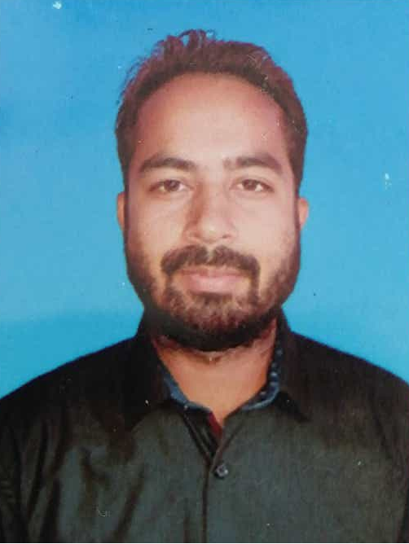

**SHEETAL KOTHARI**

[sksheetal09@gmail.com](mailto:sksheetal09@gmail.com);

+918010088910

T-177/A, Shukar Bazar,

Uttam Nagar West, Delhi-110059.

**Career Objective**

To make a sound position in corporate world and work enthusiastically in team to achieve goal of the organization/MNC with devotion and smart work and earn a job which provides me job Satisfaction and self development and help me achieve personal as well as organization goals.

**Professional Experience – 7+year’s**

* From Jun 2018 – present date as Software Engineer at **Rose International.**
* From March 2017 – Jun 2018 as Software Developer at **SunTec Web Services** Pvt. Ltd.
* From Oct 2016 – March 2017 as Software Developer in **Originate Infotech** Pvt. Ltd.
* From Aug 2014 – Sept 2016 as Software Developer in **7x Technologies** Pvt. Ltd.

**Relevant Skills**

Development Tool : MS Visual Studio, SharePoint Online

Programming Language : C#, VB

Data Base : SQL Server, MySQL.

Reporting : SSRS, Crystal Report, RDLC.

Technology : Asp.net, LINQ, EDM, Ajax.

Web : HTML, CSS, JavaScript, Jquery.

Familier with : SSIS, WCF, Devexpress,

**Acadmemic Distinctions**

|  |  |  |  |  |
| --- | --- | --- | --- | --- |
| **NAME OF EXAM** | **COLLEGE** | **UNIVERSITY** | **YEAR OFPASSING** | **PERCENTAGE** |
| MCA | CPJIMT, DELHI | GJU, HISSAR | 2013 | 66.25% |
| BCA | Dr.RK COLLEGE, NEEMUCH | MCU, BHOPAL | 2010 | 70.02% |

**Project Details**

**Rose International Project Details :**

**Project Name :** Client Management

**Technology :** Asp.Net with C#, Sql Server, SharePoint Online

**Reporting :** SSRS

**Project Type :** Web Application

**Description: -** This project has many modules; I have created new modules and worked on Existing as below –

* Incident Tracking
* Talent Request Process and Dashboard
* Share Point Online Tracker
* Client Management
* Candidate Portal
* Client Portal
* QAccounting
* QPayRoll

**Suntec Project Details :**

**Project Name :** ERP

**Client Name :** Jaquar

**Technology :** Asp.Net with C#, Sql Server.

**Reporting :** SAP Crystal Report

**Project Type :** Web Application

**Description :-** This project has three major sub project are:

* DWA(Dealer Management System) - ERP for Domestic level stock management.
* JaqExport – ERP for International level stock Management.
* SMS(Sales Management System) – Manage all master page for DWA, JaqExport.

**Originate Project Details :**

**Project Name :** Payzall

**Client Name :** Originate Group

**Technology :** Asp.Net with C#, Sql Server, LINQ, EDM.

**Reporting :**  SAP Crystal Report

**Project Type :** OnLine Recharge Portal (Web Application)

**Description :-** This is OnLine recharge portal for Mobile, DataCard, DTH, Utility bills and Booking for Bus, Car, Flight, Hotel, Movie Ticket and also Money Transfer slab. It has two panel for B2B and B2C and also membership plan for achieving some benefit and shopping with us.

**7x Technologies Project Details :**

**Project Name :** Inventory ERP

**Client Name :** Nirmals Handuliam Pvt. Ltd.

**Technology :** Asp.Net with C#, Sql Server.

**Reporting :** RDLC Report

**Project Type :** Web Application.

**Description:-** This is Web Application ERP and there are two users – Admin and Users. It’s dynamic in nature, because admin can assign particular permission menu to particular user. Main purpose of this project is maintaining stock Inward & Outward and generating report. Admin can control and adjust stock from one godown to another company of branch’s godown. In this inventory ERP reports are generated by using RDLC Report.

**Project Name :** Inventory ERP

**Client Name :** Krishna Hardware Pvt. Ltd.

**Technology :** Asp.Net with C#, Devexpress, Sql Server.

**Reporting :** RDLC Report

**Project Type :** Devexpress(Windows) Application.

**Description :-** This is Windows(Devexpress) Application ERP and there are two users – Admin and Users. It’s dynamic in nature, because admin can assign particular permission menu to particular user. Main purpose of this project is maintaining stock Inward & Outward and generating report. Admin can control and adjust stock from one godown to another company of branch’s godown. In this inventory ERP reports are generated by using RDLC Report.

**Project Name :** Inventory ERP

**Client Name :** Esquire Space N Style.

**Technology :** Asp.Net with C#, Devexpress, Sql Server.

**Reporting :** SAP Crystal Report

**Project Type :** Devexpress(Windows) Application.

**Description :-** This is Windows(Devexpress) Application ERP and there are two users – Admin and Users. It’s dynamic in nature, because admin can assign particular permission menu to particular user. Main purpose of this project is maintaining stock Inward & Outward and generating report. Admin can control and adjust stock from one godown to another company of branch’s godown. In this inventory ERP reports are generated by using Crystal Report.

**Skill Set and Strength**

* Learning ability: Quick learner.
* A self-motivated, Honesty and Integrity.
* Computer Skills, Responsible.
* Key skills include quick understanding and swift grasping power.

**Personal Details**

Father’s Name : Sh. Laher Singh Kothari

Date of Birth : 12/10/1989

Sex : Male.

Marital Status : Married.

Nationality : Indian.

Language Known : English, Hindi, Rajasthani.

Current Address : T-177/A, Shukar Bazar, Near NR Jindal public school,

Uttam Nagar West Delhi-110059

Permanent Address : C/o Laher Singh Ji Kothari, V&P Kanera,

Teh. – Nimbahera, Distt.- Chittor garh

Rajasthan Pin. – 312606.

Contact No. : +918010088910, +919024053173.

I hereby declare that the information furnished above is true to the best of my knowledge.

**Date:**

**Place: SHEETAL KOTHARI**