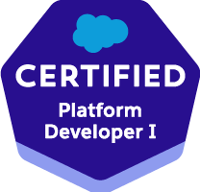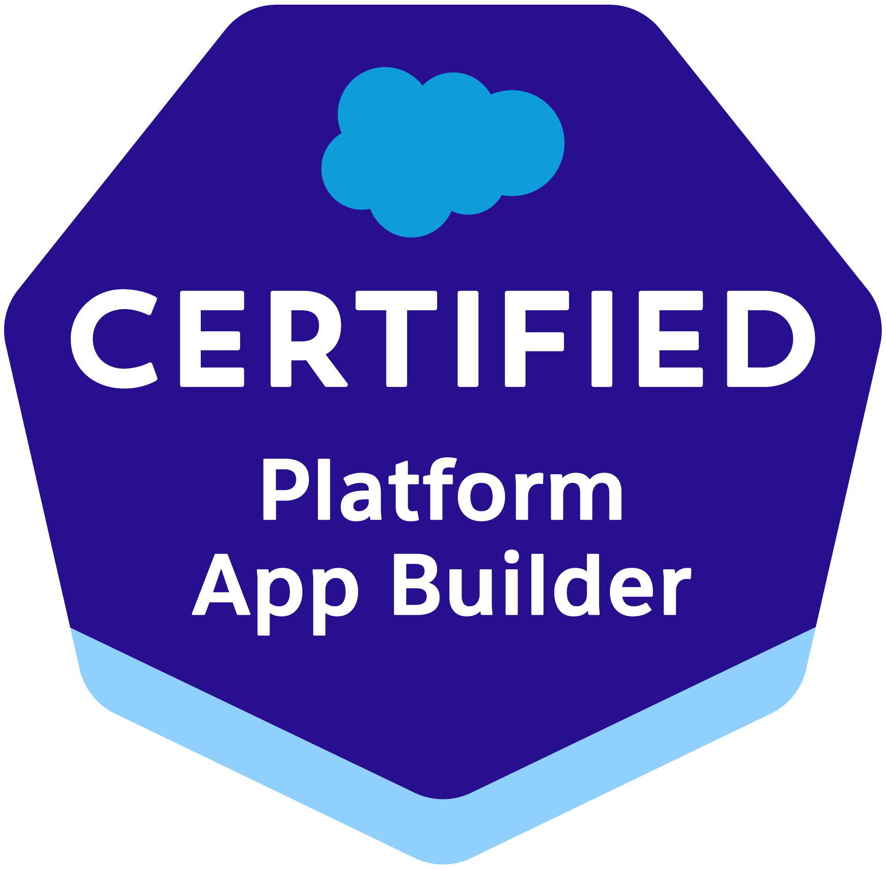

Lokesh Gutha/ H1B Consultant
609-789-0602/417-599-0151
lokeshg.atwork@gmail.com
https://www.linkedin.com/in/lokesh-g-2559731b0/

Summary

- 6.4 years of IT experience with 5+ years of Salesforce.com and Force.com Platform experience. This involves configuration, customization, integration with external systems and classic to lightning migration, lightning development. 2 Years of experience on Java/J2EE.
- Experienced in all phases of SDLC, quality management systems and project life cycle process.
- Working expertise in Salesforce configuration, Apex classes, controllers and triggers, Visual force pages, Flows, workflow rules, process builder, validation rules, standard objects, custom objects, Reports and Dashboards.
- Experience in Administration, Configuration, Implementation, Lightning, Lightning Web Components support experience with Salesforce platform.
- Did the POC (Proof of Concept) For Lightning Web Components, Designed and Developed Various Lightning Web Components
- Skilled Database Administrator and working experience of Work bench, SQL, SOQL and SOSL.
- Experience in Salesforce lightning features like activities, contextual Hovers, Opportunity board, Customizable dashboard.
- Customized existing Visual force to align with Salesforce new Lightning UI experience.
- Created multiple Lightning Components, added CSS and Design Parameters that makes the Lightning component look and feel better.
- Used Salesforce Lightning Design System (SLDS) for developing Lightning Components, Actions, Event and Server-Side Controller.
- Creating Lightning Components and used Salesforce SLDS to convert existing Visual force pages to lightning components.
- Created Apex methods for the lightning controller and helper methods to perform DML operations on the case records.
- Hands-on experience on implementation and integration projects, Web Services, Salesforce API, SOAP API, and REST API.
- Excellent knowledge and working experience of Integration and Migration tools–Data Loader, Informatica, Heroku, and Mule Soft.
- Strong Hands-on experience in Cloud Application Development, Enterprise Application Integrations using Salesforce Cloud Platform, Java, jQuery, Ajax Oracle RDBMS etc.
- Apttus CPQ (Configure Price Quote) is a Lightning-Ready quoting tool built on Salesforce1.
- Experienced in Force.com Apex Classes, Apex Triggers, Visual force, and Force.com API.
- Experience working with Salesforce.com sandbox and production environments.
- Extensive experience in designing, creating, and maintaining Salesforce.com Workflow Rules, approvals, Roles, Profiles, Email Templates (HTML & Visual Force Templates).
- Worked on the designing of custom objects, custom fields, Record Types, custom Tabs, custom reports, and design of Visual Force Pages, Snapshots and Dashboards.
- Research and strategies for new market segments, including competitive positioning and direct marketing.
- Used Data loader for data management in force.com platform.
- Expertise in developing, deploying, and integrating Salesforce.com CRM solutions.
- Sales and Service Cloud implementation along with other custom applications developed on Salesforce.com platform.
- Experience in installing, evaluating the AppExchange application under the Salesforce.com platform.
- Implemented and delivered projects under Agile Development Environment and Test-Driven Environments with large & small project teams.
- Good familiarity with Service Cloud and Salesforce Communities.
- Adept at determining end user needs, and in translating those needs into powerful, but easy-to-use software solutions.
- Configured the GIT, GitHub to maintain the different versions in common development environment.
- Possess excellent communication, interpersonal and analytical skills along with can-do attitude.
- Expertise in complete Software Development Life Cycle (SDLC) like analysis, design and development of Multi-Tier Client/Server and Web based applications.
- Expertise in SQL, PL/SQL, Oracle 9i and MySQL databases.
- Experienced in Software development and business modeling of Web applications, Client/Server Systems, distributed applications, and other custom-built projects.
- Possess exposure of working for projects spanning Financial, Business Process Management.
- Good Knowledge of various methodologies like Waterfall and Agile.
- Experience in providing functional and technical support to peer Team members.
- Excellent Client interaction skills and proven experience in working independently as well as in a team.
- Good communication and problem-solving skills.
- Have good working knowledge in querying Salesforce.com database using SOQL & SOSL queries and with web technologies like SOAP, HTML, XML, CSS, WSDL and JSON.

Education:
- Bachelor of Science from Jawaharlal Nehru Technological University in 2014, India.
- Master of Science from Southern Illinois University in 2016, USA.

Certifications:
- Salesforce Certified Administrator (ADM 201)
- Salesforce Certified Platform Developer 1
- Salesforce Certified Platform App Builder

Technical Skills:

CRM | Salesforce CRM, Siebel CRM, Microsoft Dynamics CRM
Salesforce | Apex, Visual force, Controllers, Triggers, Batch & Schedule classes, Salesforce1, Lightning (Components, Apps, Events), Lighting Web Components, Web Services, SOAP, REST, Sales cloud, Service cloud, Marketing Cloud, Force.com Platform, Sites, Knowledge, Article Management, SOQL, SOSL, Reports, Dashboards.
SFDC Tools | Eclipse, Developer Console, Workbench, Force.com Migration tool (Ant based), Force.com Explorer, Data Loader, Excel Connector, Command line Data loader, Cast Iron
Languages | C, C++, SQL, SOQL, SOSL. Apex Programming, Java.
Web Technologies | XML, HTML5/4, CSSS3/2, JavaScript, jQuery, AngularJS
Application Servers | Apache Tomcat, Sun Web server, Resonate, WebSphere 4.0/4.1, Tomcat 6.0, JBOSS 5.
Databases | SQL, PL/SQL, Oracle 11g/10g/9i, SQL Server 2008/2005, MySQL

Professional Experience:

Guardian Life Insurance, Holmdel, NJ Jan 2019 – Present
Salesforce Lightning Developer
Responsibilities:
- Performed the role of Salesforce developer, lightning developer and interacted with various business user groups for gathering the requirements for Salesforce.com, Lightning and CRM implementation.
- Experience in creating Lightning web Components and used Lightning Design System to convert existing Visualforce pages to lightning web components.
- Worked on various Salesforce.com Standard objects, Custom Objects, Triggers, Classes, Pages, Reports and Dashboards.
- Designed and developed SFA based Application on Force.com Platform in Salesforce.com environment with Apex programming language at backend and Visual-Force pages as user interface.
- Developed various Visual force Pages, Apex Triggers to include extra functionality and wrote Apex Classes and Controller to provide functionality to the visual pages.
- Designed, developed, and deployed the Custom objects, Page layouts, Custom tabs, Components, Visual force Pages to suit to the needs of the application.
- Automated business processing using salesforce automation tools, such as process builder, Workflows, Formulas, Flows, Assignment Rules and Email Alerts.
- Ensured data integrity through the appropriate use of de-duping, loading, and exporting tools, for bulk of data using Data Loader, Admin Garage and Lexi Loader.
- Used SOQL & SOSL for data manipulation needs of the application using platform database objects. Responsible for writing SOQL & SOSL queries with consideration to Governor Limits for data manipulation needs of the application using platform database objects.
- Defined lookup and master-detail relationships on the objects and created junction objects to establish connectivity among objects Defined lookup and master-detail relationships on the objects and created junction objects to establish connectivity among objects.
- Used Data Loader for insert, update, and bulk import or export of data from Salesforce.com Objects. Used it to read, extract, and load data from comma-separated values (CSV) files.
- Developed dynamic Salesforce.com Visual force pages using Apex page functions and actions, designing them using HTML, CSS, and JavaScript.
- Build Lightening controllers with the AURA framework.
- Involved in developing Salesforce Lightening Apps, Components, Controllers and Events.
- Created Multiple Lightning Web Components, added CSS and Design Parameters that makes the Lightning component look better.
- Created Multiple Lightning Web Components with reusable Custom HTML Element, Java Script and Css.
- Implemented Salesforce Lightning Components for small set of users for customizing reports and dashboards.
- Utilized Lightning Connect to get real time data from external system.
- Experience in Creating Roles, Profiles, Email Templates, Page Layouts, Workflows, Workflow Actions and Approval Process.
- Worked in Administration, Configuration, Implementation and Support of service max and Salesforce applications.
- Worked closely with sales team and business analysts and performed detailed analysis of business and technical requirements. Designed the solution by customizing various standard objects of Salesforce.com (SFDC).
- Worked with GENESYS Gplus adaptor for CTI integration, so agents can click-to-dial and screen pop capabilities.
- Created Batch Apex classes for batch execution and updating of related fields.
- Created various Reports (summary reports, matrix reports, pie charts, dashboards, and graphics) and Report Folders to assist managers to better utilize Salesforce as a sales tool and configured various Reports and for different user profiles based on the need in the organization.
- Integrated the Web Services for extracting the data from external systems and used the Sandbox for testing to ensure minimum code coverage for the application to be migrated to production.
- Involved in Agile methodology, Scrum which improved productivity and reduced errors.

Environment: Salesforce.com platform, Workflow and Approvals, Reports, Custom Objects, Tabs, Reports, Dashboards, Email Services, Apex Language, Visual force Pages, Components and Controller, Data Loader, Apex classes, Apex triggers, JavaScript.

Ellie Mae, Pleasanton, CA Aug 2017 – Dec 2018
Salesforce Developer

Responsibilities:
- Performed the role of Salesforce Developer in the organization.
- Technical Knowledge about Salesforce lightning schema builder, process builder, app builder, components and lightning connect.
- Worked on developing Salesforce Lightning Apps, Components, Controllers and Events.
- Upgraded some Apps from Salesforce Classic to Lightning Experience to develop rich user interface and better interaction of pages.
- Good hands-on practice with the new Lightning System Design which helps to create modern enterprise apps using Lightning App Builder quickly and easily and Lightning Components Performed.
- Experience in modifying Visualforce pages to be supported in Lightning Experience and good understanding of lightning mode and its features.
- Integrated Salesforce data with external systems by writing Salesforce REST Web Services for Inbound classes and used Http Request methods to call external application REST API endpoint.
- Used HTTP Callout using JSON to fetch records/data from other system and display them on the fly in the Visualforce Page each time the page opens.
- Design, develop and implement solutions for the APTTUS CPQ system deployed on the Salesforce platform.
- Implemented Quote-to-Cash solution using APTTUS CPQ. Depth understanding of the APTTUS CPQ, APTTUS CLM data model and functionality.
- Designed, developed, and deployed Apex Triggers, Apex Classes considering governor limits and various other components as per the client and application requirements.
- Developed Visualforce Pages using standard/custom controllers and extensions as applicable.
- Used Sales Cloud to get the customer information together in an integrated platform that incorporates marketing, lead generation, sales, customer service and provides access to applications through the AppExchange.
- Analyzed customer requirements, performed detailed analysis of business and technical requirements, and designed the solution by customizing various standard and custom objects of Salesforce.com like accounts, contacts, properties, discounts, reports, and dashboards in sales cloud.
- Worked on Jitterbit to automate the processes of reporting, Data Mapping, and connecting it to partner’s application.
- Worked on various Salesforce standard objects like Leads, Accounts, Contacts, Cases, Roles, Opportunities, and Products.
- Used SOQL & SOSL with consideration to Governor Limits for data manipulation needs of the application using platform database objects.
- Implemented the requirements on Salesforce.com platform and Force.com IDE Plug-in using Eclipse.
- Created appropriate data conditioning templates and field mapping files for data loading.
- Implemented complex security & sharing model for orgs with 500+ Salesforce users.
- Worked on User's Profiles, Workflow & Approvals, Permission Sets, Roles, Groups, Queues, and Sharing Settings etc.
- Experience in developing Salesforce Lightning Apps, Components, Controllers, and Events.
- Worked on different App Exchange Products.
- Developed Lightning UI using AJAX, JavaScript, jQuery, and HTML.
- Created custom reports to track the cases, assets to be available to different levels in the organization based on their profiles.
- Implemented Communities in Salesforce for the customers.
- Written apex unit test classes for code coverage of apex classes and triggers to promote code to production and implemented Salesforce apex annotations like @isTest, see AllData.
- Sound knowledge of Customer Support tools – desk.com, Service Cloud, Marketing Cloud with exact target, Web Analytics.
- Working knowledge of Project Management tools – Asana, Jira, and Stack.
- Working exposure to Demand Tool, Financial Force, Salesforce Communities, Mobile Workforce, and Salesforce1 Platform.

Environment: Saleforce.com, Apex Classes, Lightning, Apttus CPQ, Controller Classes, REST/SOAP API, Triggers, Visualforce, Salesforce.com Data Loader, Workflow & Approvals, Reports, Custom Objects, Custom Tabs, Page layouts, Email Services, SOQL, SOSL, Sandbox, Force.com IDE.

Be the Match, Minneapolis, MN Oct 2016 – Jul 2017
Salesforce Developer
Responsibilities:
- Created new Apex Triggers, Apex Classes, Batch Classes and Schedule Classes, Email Services According to the Project Requirement.
- Implemented Batch Classes to provide Data Migration without loss of data/ to avoid corruption of data.
- Worked with the user group for requirement gathering throughout the planning and implementation.
- Created new User Accounts and assigned Profiles as per their role in role hierarchy.
- Customized Page layouts for Standard/Custom objects and assigned Record Types.
- Performs day to day administrative tasks and addressing production support issues (unlocking / re-setting passwords, modifying data, and creating ad hoc reports)
- Used SOQL & SOSL with consideration to Governor Limits for data manipulation needs of the application using platform database objects.
- Worked with various Salesforce.com Standard objects like Accounts, Contacts, Leads, Opportunities, Products, and Price book, Cases, Entitlement, Reports and Dashboards.
- Worked on CRM Platform environment of SFDC Sales Cloud, Service Cloud modules.
- Provides training to department employees on the use of the company website and all related systems and processes.
- Created Data Validation rules and Formulas as per business requirement.
- Created Workflow Rules to automate Tasks, Email Alerts, Field Updates, time-dependent actions, and Outbound API Messages.
- Performs day to day administrative tasks and addressing production support issues.
- Created Reports and Dashboards to track Opportunity pipeline/Stages for Management visibility.
- Worked with groups, participated in Requirement Gathering Sessions & JAD Sessions to define their needs, and developed an action plan and specification document.
- Designed various Webpages in VisualForce for capturing various customer enquiries and Implemented logic for migrating cases to different queues based on the type of customer enquiry.
- Created and used Email templates in HTML and VisualForce.
- Used SVN Subversion as Code Repository.
- Created Custom Buttons Using JavaScript. Implemented Single Sign On in Salesforce.
- Developed reports, dashboards, and processes to continuously monitor data quality and integrity.
- Experienced with Salesforce to outlook, Web analytics, Desk.com, JIRA, ASANA, Slack, Tibco, PeopleSoft, and Oracle.

Environment: Saleforce.com, Apex Classes, Batch Classes, Controller Classes, Triggers, Visualforce, Salesforce.com Data Loader, Workflow & Approvals, Reports, Custom Objects, Custom Tabs, Page layouts, Email Services, SOQL, SOSL, Sandbox, Force.com IDE.

Wells Fargo, Charlotte, NC Jan 2016 – Sep 2016
Salesforce Developer

Responsibilities:
- Collaborated with sales team and business analysts to analyze business, technical needs, and design solutions by customizing standard objects of SalesForce.com (SFDC); developed project templates as per SDLC methodology.
- Developed various lightning components that integrate to form a single point of interactive payment calculator to generate a payment plan.
- Worked on Chatter and Email integration features for Sales Cloud and Marketing Cloud; designed, developed, planned, tested, and integrated Salesforce Cloud Services; configured Chatter usage to generate dashboard reports.
- Developed various Apex Classes, Triggers, Controller classes and methods for functional needs in the application compatible with lightning.
- Developed Apex program and Apex triggers for various functional needs and worked with dynamic Apex to access objects and fields to describe information, execute SOQL, SOSL and DML queries from scratch.
- Supported the data migration and data export activities through various business centers using Apex Data Loader, Apex Data Export, Force.com Excel Connector, and Import Wizard.
- Employed Data Loader to migrate data from Oracle to Salesforce database and configured in Oracle application to Salesforce platform; migrated leads, accounts and contacts to Sales Cloud using third party tools.
- Worked on sales cloud and customized objects Accounts, Contacts, Opportunities, Products, Price Books, and custom objects, implemented Web-to-Lead and custom Lead conversion.
- Experience in working on Sales Cloud (Partner Portals) as well as Service Cloud (Customer Portals). Good knowledge in writing test classes before deploying into production.
- Implemented on Force.com/ service cloud functionality leveraging web and email services/web-to-custom object/email-to case functionality.
- Triggered interface events by user interactions, which includes Lightning Component framework and involved in building Lightning Components using the aura framework. Integrated web services by making WSDL files to extract data from external systems to display in salesforce.com.
- Established SOAP API with the aid of a two-way communication between Salesforce and other applications. Code deployment was done using the Eclipse IDE, Deployment Change Set and Snapshot.
- Designed and deployed custom tabs and objects, page layouts, components, visual force pages, validation rules, approval processes and auto-response rules; added fields and functionality using custom controllers and extensions.
- Salesforce Lightning Design System and Lightning App Builder.
- Developed enterprise Einstein Analytics strategy to replace the tableau dashboards.
- Configured product and pricing setup using CPQ/Product consoles Formatted and migrated the user data into Lightning Experience.
- Worked on Partner Portals for clients and updating price books often for the vendors.
- Worked with Accounts, Contacts, Leads, Campaigns, Cases, Solutions Standard Objects and Custom Objects.
- Implemented pick lists, dependent pick lists, lookups, master detail relationships and record types to enforce data quality setup marketing campaigns and assignment rules.
- Implemented search, filtering and tagging features on page layouts for sales to locate relevant marketing content and documents in SalesForce.com CRM content; ensured effective ways to leverage Saleforce.com CRM features
- Developed enterprise Einstein Analytics strategy for data integration, mobile first approach in designing the dashboards.
- Defined Analytics dashboards to bring action-based insights on Opportunities / Sales / team performance.
- Developed Rest API callouts to perform data sync between salesforce and Apttus.
- Research Salesforce and Apttus CPQ capabilities as needed to suit business requirements.
- Quote/Proposal and Agreement document generation using Apttus.
- Used Sandbox for testing and migrated the code to the deployment instance after testing.
- Created summary reports, matrix reports, pie charts and dashboards and setup report folders to authenticate users based on profiles permissions; created objects screen that compares databases and schema changes.
- Performed periodic data cleaning and administered custom objects, workflow, and campaign management.
- Involved in project documentation review cycles and followed-up for reviews to see them through to completion.

Environment: Saleforce.com Platform, Salesforce APIs, Reports, Dashboards, Email, Triggers, Chatter, Sharing Rules, Validation Rules, SOQL, SOSL, OOTB, Documentation, Data Loader, App Exchange, WSDL, Reports, AppExchange, Data Tools.

Reliant Vison Group, India Oct 2013 – Dec 2014
Java/J2EE Developer

Responsibilities:
- Involved in Object analysis, design, and documentation (OOAD) of the application model using UML.
- Designed and developed interactive static HTML screens as screen level prototype, JavaScript for client-side validation and used Cascading Style Sheet (CSS).
- Created browser-based UI using HTML, JavaScript, AJAX components and.
- Developed JSP custom tags and used JSTL for reusability.
- Used AJAX to support dynamic page element rendering to enhance user experience.
- Involved in component development and used design patterns such as Singleton, Factory and Data Access Object (DAO) in the implementation of the application. Used Spring Context for EJB Support and Spring DAO for enhanced JDBC and DAO support.
- Used Eclipse IDE for development, configured and deployed the application on to WebLogic using Maven, version control by Rational Clearcase and tested using JUnit.

Environment: Java/J2EE, JSP, Servlets, WebLogic, Eclipse, JMS, Log4J, JUnit, HTML, DHTML, JavaScript, UML, ClearCase and ANT.

