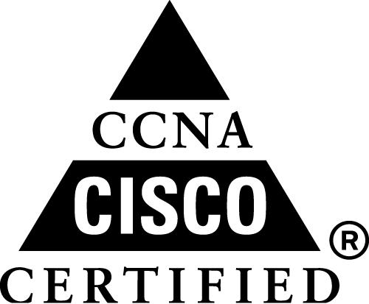 | 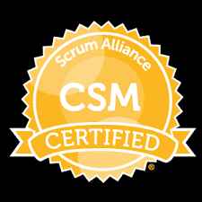 | 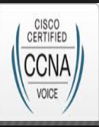 |  | 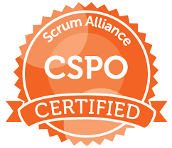 |  | 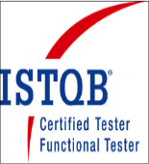
SANJAY KUMAR SAHU
Email: kumarsanjay.cse@gmail.com
Mobile: 9986990624
11 Years of experience in various roles such as Scrum Master, Tech/Program Lead, QA Engineer.
Career Objective:
Seeking a career in the field of Agile Product Development, Program Leadership, QA management, Program management, where I can contribute to meet the quality goal of the organization and my professional growth.
Professional Summary:
- Performing Scrum Master role and mentoring the team for Agile way of Product development.
- Working Exposure in SDLC, Agile Methodologies, Scrum Framework and SAFe Agile.
- Closely Involved in Product and Sprint Backlogs Enhancement.
- Working experience is various customer facing Program Management activities.
- Working exposure in CI/CD processes and associate activities.
- Mentoring and Supporting the team members to adhere to Agile development values.
- Work as a Proxy Product Owner for 2 consecutive releases.
- Performed as a QA Engineer/Lead and Program Lead for RCA/EDA for the Feature components.

Certifications:
- Certified Scrum Master (CSM) from Scrum Alliance in January 2020.
- Certified Scrum Product Owner from Scrum Alliance in April 2020.
- Certified SAFe Agilist 5.0 in June 2020.
- CCNA Voice certified in 2014 and CCNA routing and switching certification in 2011.
- ITIL V3 foundation certification in 2012.
- ISTQB Foundation certification in 2009.

Key IT Skills
- Working exposure on JIRA, Rally, HP Quality Centre, Confluence and collaborator tools.
- Hands-on knowledge of Continuous Integration tools Git and Jenkins.
- Exposure on Robot Framework, Java, Selenium WebDriver, TestNG.
- Working exposure on Unix, OpenStack, Shell Scripting and SQL.

Academic Qualification:
Bachelor of Engineering in Computer Science from CEC, Bilaspur (C.G) in year 2005 (73.44%)

Current work experience at Nokia:
March 2017 to till date: as a Scrum Master/Technical Lead/ QA Engineer.
Responsibilities:
- Perform the role of Scrum Master and conduct the Scrum ceremonies.
- Prioritizing the User Stories and defined Acceptance Criteria based on customer requirements.
- Active participant of PI planning, Sprint planning, Backlog grooming.
- Leading the RCA/EDA program and responsible for delivery of Customer Acceptance Document.
April 2015 to Feb 2017 as QA Lead/Program Lead/Scrum Master
Responsibilities:
- Performed the role of Scrum Master for INT team
- QA Lead for Integration team and Program Lead for cross functional RCA/EDA program
July 2013 to March 2015: as Senior Integration Tester:
Responsibilities:
- Managing Functional Automation Test cases for Continues Integration
- Handled Test automation and associate activities.
Previous Work Experience:
- At Cisco Systems, Bangalore (As a Client Place through Bodhtree Consulting Pvt. Ltd.) (July 2010 till June 2013) as Technical Lead/QA Lead/QA Engineer
- At Softsmith Pvt. Ltd, Bangalore (January 2010 to June 2010 as QA Engineer
Projects Details:
Project #1: SS
Role : QA Lead/Scrum Master/Program Lead in CI.
Project Description:
SS is a project which maintains and correlate FM and PM for NMS it is a tool which is responsible for maintaining and managing FM and PM
Roles and responsibilities:
- Perform role of Scrum Master.
- Program lead for RCA/EDA, Continuous Integration and Customer Acceptance Manual.
Project #2: NDSA
Role : QA Lead.
Duration : From December 2012 to June 2013.
Project Description: NDSA is single tool which does the security assessment and provide adequate recommendation to Organizations regarding Network security vulnerabilities
Roles and responsibilities:
- Prepare Master Test Plan and Prepare Test Scenarios.
- Executed Functional, Regression Testing.
Project # 3: ASAM
Role : QA Lead /Test Engineer
Duration : From July 2010 to December 2012
Project Description: Migration Tool provides the ability to automate common, time-consuming tasks involved in the migration from Check Point/Juniper to ASA devices.
Roles and responsibilities:
- Prepare Alpha Test Plan and Test Scenarios
- Responsible for functional and Regression testing.
Project # 4: SPCG
Role : Test Engineer
Duration : From January 2010 to June 2010
Project Description:
SPCG, a state of art product from Softsmith is a web-based process management solution that helps IT organizations in process improvement across the SDLC and is based on the current IT industry standard
Roles and responsibilities:
- Prepared Test effort estimation and reviewing the BRD.
- Involved in preparation of Test Cases and Executed Functional, Regression Testing.

Personal Details:
- Father’s Name: R. S. Sahu
- Current Address: Nehru Nagar, Jakkur, Banaglore-64.
- Language Known: English, Hindi

I hereby declare that all the details provided above in my credential are true to the best of my knowledge and belief.
Sanjay Kumar Sahu

