# A picture containing drawing Description automatically generatedObjective

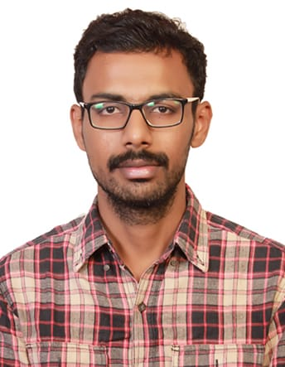

**Mohamed Yousuff S**

smdyousuff@gmail.com

+91-7200055108

***CLOUD TECHNOLOGIES:***

* AWS
* VMware

***VMWARE SKILL SET:***

* vRealize Orchestrator
* vRealize Automation
* VMware vSphere

***Dev-ops TOOLS:***

* Git
* Jenkins

***SCRIPTING AND AUTOMATION:***

* REST/SOAP API
* JavaScript
* Python

***CORE SKILL SET:***

* AWS
* Core Java
* JSP and Servlet
* JDBC
* SQL Server 2008 R2
* MySQL

Experienced Developer in Cloud Automation using VMware vRA/vRO tools and having experience in AWS, Scripting and Core software development looking for new opportunities in the domain of engineering services.

# Profile Summary

Offering 3 years of experience in Software Development across IT domain and having 1 year of experience in VMware, AWS and DevOps. Hands-On experience in Linux, VMware tools and AWS.

# Summary of Skills

* Experience in software design, development and production support of several banking and commercial applications.
* Java developer with good knowledge of the SDLC.
* Well-versed in design, testing and implementation of web and client server applications using Java technologies.
* Setup/Managing Linux Servers on Amazon (EC2, EBS, ELB, VPC, ACL, Security Groups, RDS and IAM).
* Create/Managing buckets on S3 (CLI) and logs backup, upload images.
* VMware vRA based Cloud deployment with customization and integration.
* VMware vRO based cloud customization using various plugins and APIs.
* VMware Application Services customization and integration with vRA.
* VMware vSphere Java SDK knowledge for creating custom operations from web portal.

# Certifications

* **AWS Certified Solutions Architect – Associate** certification.

# Professional Experience

## EZDC Automation, Chennai

*Jr. Software Developer (*Apr-2019 to Jun-2020)

* Expertise in setting up and maintaining CI and CD pipeline using Jenkins, GitHub.
* Creating/Managing AMI/Snapshots/Volumes, Upgrade/downgrade AWS resources (CPU, Memory, EBS)

***EDUCATION:***

* **MCA**:

KLN college of Engineering (2013-16) with 72.01 %.

* **B. Sc (IT):**

Madurai Institute of Social Science (2010-13) with 71.12 %.

* Configured Jenkins jobs, install plugins for generating project artifacts.
* Knowledge on Docker files to build the Docker images.
* Design roles and groups for users using AWS Identity and Access Management (IAM).
* Instances, Auto scaling, Elastic Load Balancer and AMIs.
* Installed and Setup Web Server (Apache, Tomcat) on EC2.
* Installed and Setup Git, Jenkins, Maven, Docker on EC2 .
* Automation of Day-0 VM provisioning (VM Provisioning) through a self-Developed vRO workflow for vSphere User Onboarding when new users get onboarded in vRA.
* BMC Integration using REST API and developed workflows to create, close & update the status of the request.



## Silicon Software Services, Madurai

***Associate Software Engineer (***Mar-2017 to Apr-2019)

* Designing, coding and debugging applications using Java and MySQL in Asset Management System.
* Responsible for Java/Java EE application development while providing expertise in the full software development lifecycle
* Experience in developing scalable web-based applications and working with high volume consumer facing Internet Applications.
* Clear understanding of JDBC database connectivity and usage of different type of statements
* Assist in the implementation scoping and planning effort, including development of the overall project plan as well as individual work plans
* Configure the product per the requirements specifications and design documents
* Software Analysis, Design and Development using J2EE technology stacks (Core Java, JSP, XML, Java scripts)and Oracle database (PL/SQL).