Satish S
Mobile: +91- 9886225383
E-mail: sivasatish85@gmail.com
Experience Summary
- Total work experience of 10+ years in Software Industry, currently working as Senior Business Analyst (Certain EMS, Oracle Eloqua, Confluence Admin) at Oracle Solution Services (India) Pvt Ltd, Bangalore.
- Eloqua Master 2020 Certified. 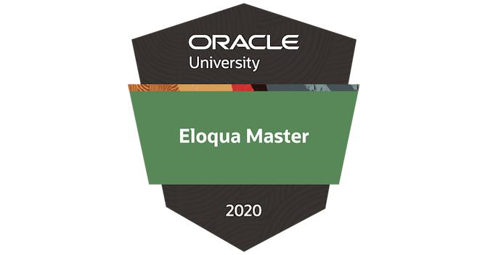
- Worked on setting up Virtual Events with Zoom, Eloqua.
- Knowledge of marketing systems with a profound customer centric and systems driven approach to design marketing and business strategies
- Involved in functional testing, regression testing and user acceptance testing (UAT) to ensure systems work with no issues before moving to production
- Worked with Development team to update Business Requirement Documents (BRD) and create test scripts
- Worked on Progressive Profiling Form for our Eloqua Landing pages
- Worked effectively on some enhancements independently to create Functional specifications and take responsibility of tasks assigned and ensure they are completed in a timely fashion
- Possess excellent communication and organizational skills with proven ability to negotiate, build and maintain relationships with stakeholders and decision makers
- Worked with Product Owners to discuss on the application functionality that can help us integrate stakeholder’s requirement

Area of Expertise

Technology
- Business Analysis  - Requirement Gathering  - Marketing Automation | - Eloqua  - Oracle UPK  - Siebel Marketing | - Certain (EMS)  - Process Re-Engineering  - SQL
Software: Dreamweaver, Adobe Photoshop, MS Office (Word, Excel, PowerPoint)
Languages: HTML, CSS, JavaScript, SQL

Trainings
- Scaled Agile Framework
- Business Communication

Career Progression
Oracle Solution Services (India) Pvt Ltd, Bangalore March 2018 – Till Date
Job Title : Sr. Business Analyst
Primus Global Technologies Pvt Ltd, Bangalore Aug 2017 – Feb 2018
Caritor India Solutions Pvt Ltd, Bangalore April 2011 – July 2017
Client : Oracle India Pvt Ltd, Bangalore
Job Title : Software Consultant
Role : Business Analyst
PROJECT: Global Marketing Shared Services (GMSS)
Responsibilities:

CERTAIN
- Business Analysis, Process flow
- Gathering marketing requirements, creating test strategies and test plans, organized and conducted User Acceptance Test of marketing applications, and business sign-off on quarterly basis
- Writing JavaScript code as per requirement for Event Registration Pages and Landing Pages
- Currently involved in multiple concurrent tasks as Senior Business Analyst
- Worked with team for integrating ‘Custom Object Properties’ in Certain to Eloqua
- Worked on ‘User Conference Module’ implementation
- Worked for Employee Event Forms setup and updating the JavaScript code, XML sheet for pulling up the hierarchy list
- Worked with Certain and OAL team to setup SAML SSO in Certain forms, and tested the end to end process flow
- Learning new features, setting up Speaker and Session Management in Certain, including the Speaker Portal and then to accommodate it as per the requirement we need.
- Manage Certain Event template Updation as and when changes are needed, this includes JavaScript coding in forms.
- Involved in testing and Roll-out the concept of Role-based user functionality in Certain and , which means it provide us more control towards user visibility of events.
- Co-ordinate with Dev teams for Certain Sub-Accounts Integration To Eloqua for registration data flow
- Created Certain UPK pages which helps new Joinee as Training material
CONFLUENCE

- Involved in Migration of Content from our old Knowledge Base called Twiki to Confluence
- Confluence Admin for our Project, involved in initial setup of Confluence space for our Project, worked in designing page templates with some coding of HTML, CSS and JavaScript
- Template design has helped us maintain a consistent look and feel throughout all pages in Confluence.
- Interacted with different teams to gather process details before it was made live on Confluence Production
- Currently we do a quarterly check with different teams so the content updated in Confluence is all up-to-date

GMSS HELPDESK

Responsibilities – as GMSS Helpdesk Analyst
- Preparation of Test Conditions and Scenarios
- Preparation of Test Script, Test Cases
- Execution of manual test cases and logging test failures
- Raise and track - Enhancement and bug tickets
- Providing support for Marketing and MyProfile (SSO) issues and queries
- Ensure out of scope issues are re-directed to the correct teams
- Maintaining SLA, service quality & relationship with client
- End to End testing in Eloqua and Certain for the below said tracks:
1) Campaign set up
2) Emails and segment set up along with tracking email clicks/open rate
3) Event set up in certain along with event registration flow to Eloqua and CRM
4) Forms, LP set up and registration flow in Eloqua

Mphasis, Bangalore Mar 2009 – Mar 2011
PROJECT: Swift

Job Title : Technical Support Officer
Organization : Mphasis
Synopsis:
Swift is a project developed specially for the Providing Support on Windows and supporting software. The modules presently cover the process ranging from customer approach details to the agent processing and delivering with the right resolution by troubleshooting the issue.
Responsibilities:
- Handling SLA Based tickets raised by the customers for Windows, Supporting and Hardware issues
- Monitoring clients online and troubleshooting complex issues with remote assistance
- Assisting with Hardware upgrade and installation
- Supporting software issues and assisting with installation
- Taking ownership of Complex, escalated and high priority issues and supported till they are resolved

Education

BE (Computer Science Engineering, Visvesvaraya University Belgaum) 2007

Personal Details

Full Name : Satish S
Father’s Name : Sivaram
Mother’s Name : Venkataramanamma A
Date of Birth : Sep 9th, 1985
Nationality : Indian
Languages : English, Kannada, Hindi, Tamil, and Telugu
Address : # 179, Vivekananda Road, Gokul Extension, Devasandra, K.R. Puram, Bangalore-36

