Pravalika 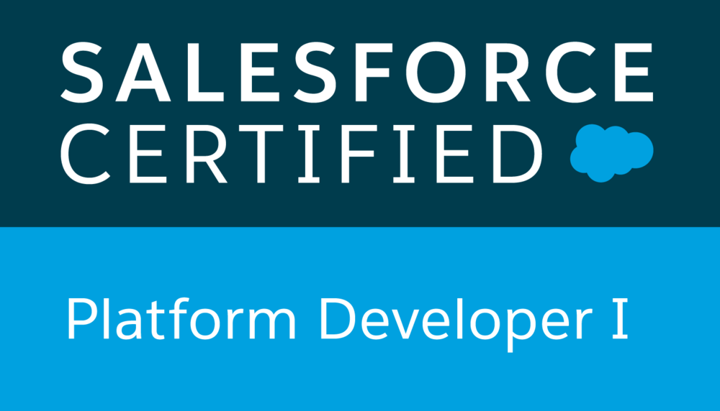
sam@nicinfotek.com
813-600-3594

PRIMARY SKILLS

- Salesforce Developer with 7+ Years of IT experience that includes around 6+ years of experience in Salesforce.com CRM Platform.
- Involved in various stages of Software Development Life Cycle (SDLC) including analysis, requirement engineering, architecture design, development, deployment and maintenance of standalone, Multi-tier, web-based and portals-based object-oriented enterprise applications.
- Experience in Administration, Configuration, Implementation, Lightning, and support experience with Salesforce platform.
- Experience in Salesforce Customization, Security Access, Workflow Approvals, Data Validation, data utilities, Analytics, sales, Marketing, Customer Service, and Support Administration.
- Expertise in SFDC Development using Lightning Web Components, Apex Language, Visual Force Pages, Classes, Controllers, Triggers, Indexes, Locks Web Services, Components, Tabs, Apex Web services, Custom Objects, Reports, Analytic Snapshots and Dashboards, Profiles, Creating Roles, Page Layouts, Org - Wide default, Sharing rules, Work Flows.
- Worked on Lightning Process builder flows, Connect API, Chatter and quick Action.
- Integration Methodologies, different API, Trigger framework, Recursive Triggers, VF Remoting, Asynchronous Framework & options.
- Good Experience on Salesforce Lightning. Experience in third party integration with ERP (Marketing Cloud, Service Cloud). Hands on experience in writing queries using SOQL and SOSL in Apex Classes and Triggers.
- Creating Custom Apps, Custom fields, Profiles, Applying Sharing Rules, Handling Page Layouts, Search Layouts, and Related List and defining Field Dependencies, custom buttons, Validation Rules, workflows, approval processes.
- Ensured data integrity through the appropriate use of de-duping, loading, and exporting tools, for bulk of data using Data Loader, Admin Garage, and Lexi Loader.
- Created and updated users, reports, and dashboards to track pipeline/stages for management visibility, while integrating Apex (applications) to Salesforce accounts.
- Extracted the data from salesforce.com application into the external databases like SQL, DB2 for generating large data reports.
- Experienced in scripting languages like HTML, XML, CSS, JSP, WSDL, SOAP, AJAX, APEX Web Services API development skills and Java Script, Web Services-Axis.
TECHNICAL SKILLS

Salesforce | Salesforce CRM, Lightning Application, Apex Custom Controllers, Apex Classes, Apex Triggers, Visualforce Pages/Components, Apex Web Services, SOQL, SOSL, Workflow and Approvals, Reports and Dashboards
Salesforce Tools | Eclipse, Force.com Eclipse IDE Plug-in, Force.com Explorer, Change Sets, Force.com Import Wizard, Force.com Excel Connector, Force.com Platform
Web Services | Rest, SOAP, WSDL
Scripting Languages | Visual Force, Lightning, JavaScript, HTML, CSS
Other Technologies | ANT, UNIX, TOAD, Java, JSP, ADF, JavaScript, CSS, Eclipse, XML, HTML, Tomcat

PROFESSIONAL EXPERIENCE:

Client: PPG, Pittsburgh, USA April 2019 - Till date
Role: Salesforce Developer
Responsibilities:
- Created modern Enterprise Lightning Apps combining Lightning Design System, Lightning App Builder and Lightning Web Component features.
- Upgraded some Apps from Salesforce Classic to Lightning Experience to develop rich user interface and better interaction of pages.
- Worked on Salesforce1 Platform to build Mobile App by enabling Lightning Components for use in Salesforce1 mobile platform to make Lightning Application mobile.
- Retrieved some data and its functionality from Third-Party API’s and displayed within the lightning component.
- Created multiple Lightning Components, added CSS and Design Parameters that makes the Lightning component look and feel better.
- Leveraged APEX Controller to make a call for external requests to retrieve data from various API’s and displayed them on to the component.
- Enabled Aura Framework, by adding Aura Attributes and Aura Handlers for Events to focus on Logic and Interactions in Lightning Applications.
- Minimized code in JavaScript Controllers by adding reusable functions in Helper Component.
- Updated the APEX Controller and Helper functions regularly making the Component Context Aware as per business requirement.
- Created modern Enterprise Lightning Apps combining Lightning Design System, Lightning App Builder and Lightning Component features.
- Tested apps by appending multiple components to a Lightning Application thereby deployed Applications from Sandbox to Production.
- Used refined global search in Lightning by developing Apex classes and Controllers.
- Experienced using Force.com IDE for creating, modifying, testing, and deploying Force.com Applications.
- Used SOQL and SOSL statements within Governor Limits for data manipulation needs of the application using platform database objects.
- Maintenance of installed Managed Packages in Lightning using Apex. Experienced in using Data Migration tool called Data Loader.
- Visualforce Pages for Lightning Experience, Alternates for Java Script Codes, Sharing Visualforce pages between Classic and Lightning.
- Worked on Lightning Process builder flows, Connect API, Chatter and quick Action.
- Built Lightning Component Tab for Salesforce Navigation and Custom Applications in Lightning Experience.
- Used field level security along with page layouts in Lightning to manage access to certain fields.
- Implemented the Web Services through WSDL in the Salesforce.com for outbound messaging.
- Worked on Integrating SAP and Salesforce systems using SOAP and REST API's.
- Involved in daily standup meetings, Scrum. This resulted to bring good solution to the business requirement.
Environment: Force.com platform, Lightning App Builder, Apex Language, Visual Force Pages, Process Builder, Data Loader, SAP, SOQL, SOSL, LWC, HTML, CSS, Templates, Sandbox, JavaScript, SOAP & REST API, Reports, Dashboards.

Client: Zen3 Infosolutions, Seattle, USA September 2017 – March 2019
Role: Salesforce Developer
Responsibilities:

- Participated in the Software Development Life Cycle (SDLC) processes including Analysis, Design, Programming, Testing and Deployment.
- Administering new configuration by creating Objects, custom fields, workflows (Field Updates, Email Alerts), Reports and Dashboards.
- Developed new functionalities by writing Apex Controllers and VisualForce Pages.
- Created custom labels and list views.
- Deployments through Change Sets and Force.com IDE. Prepared Test scripts.
- Created Custom Object and also worked on Standard Objects.
- Created users, roles, profiles and implemented role hierarchies, sharing rules and record level permissions to provide shared access among different users.
- Created profiles and implemented Object and field level security to hide critical information on the profile users.
- Created page layouts, search layouts to organize fields, custom links, related lists, and other components on a record detail and edit pages.
- Created workflow rules and defined related tasks, time triggered tasks, email alerts, field updates to implement business logic.
- Imported excel based customer information records in to Accounts, Contacts and Cases using Data Loader and Import Wizard.
- Involved in Data Mapping and Migration of data from legacy systems to Salesforce.com Objects and fields.
- Customization and configuration salesforce.com Particularly Sales Cloud
- Involved in gathering requirements, respond to requested changes and identify Customizations.
- Adding/Removing Users and Resetting Passwords if user gets locked out.
- Monitoring user login history. Creating additional Custom Fields for an organization.
- Modifying/maintaining pick-list values. Importing bulk lists (Leads, Customers)
- Creating additional public reports used by the entire organization as needs arise
- Created SQL objects like Tables, Stored Procedures, Functions, and User Defined Data-Types.

Environment: Apex, Visual Force, Force.com IDE, Data Loader, Workflow Rules, SalesForce.com, SQL.

Client: Accenture, Hyderabad, India August 2013 – August 2017
Role: Software Developer
Responsibilities:
- Responsible for requirements gathering from business users and prepare technical requirement specification documents. Implemented Agile Methodologies in developing SDLC.
- Created Objects, Page Layouts, Record Types, Relationships, Validation Rules, Workflows & Approval Process.
- Using Data Loader and Import Wizard for Data Export, updates and backup for the organization.
- Working with Administration activities like Users, Profiles, Permission Set Role, OWD settings and Sharing Rules. Designed and Developed Service Cloud and Integration.
- Created workflows for Automated Lead Routing, Lead Escalation, Alerts & Custom Coaching Plans.
- As Per the business user’s requirement, creating Reports and Dashboards.
- Worked with various salesforce.com objects Lead, Account, Contact, Opportunity, Campaign, Cases, Solutions Standard objects & Custom Objects.
- Created Public Groups, Queues, Permission Sets, Profiles, Users & Security Settings based on role hierarchy. Involved in Data Migration from three Legacy Systems to Salesforce.
- Implemented Salesforce Service Cloud & Opportunity Management (Case Management, Entitlement Management, Product & Price Book, High Volume Customer Portal, Partner Portal, Visual Force Sites) for business support and technical support for its channel customers.
- Worked with SOQL, SOSL queries with Governor Limitations to store and download the data from Salesforce.com platform database. Worked on writing Apex Triggers & Apex Classes, Batch Apex and Scheduled Apex.
- Experienced in designing UI in Visual Force Pages using JavaScript, HTML, AngularJS and CSS. Wrote Test Scripts for various scenarios. Migrating Metadata from one sandbox to another sandbox using Force.com IDE tool.
- Worked on ETL tools and Web Services like REST API and SOAP API to integrate Salesforce with other applications within the organization. Stash version control & Jenkins for Continuous Integration.
Environment: Workflows, Approval Process, Apex Triggers & Apex Classes, Batch Apex and Scheduled Apex, Visual Force Pages using JavaScript, HTML, AngularJS, CSS, REST, SOAP, ETL tools.

Education Details:

Bachelors in Electronics from Jawaharlal Nehru Technological University (Hyderabad, India) - 2012

