**CURRICULUM VITAE**

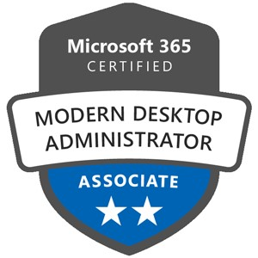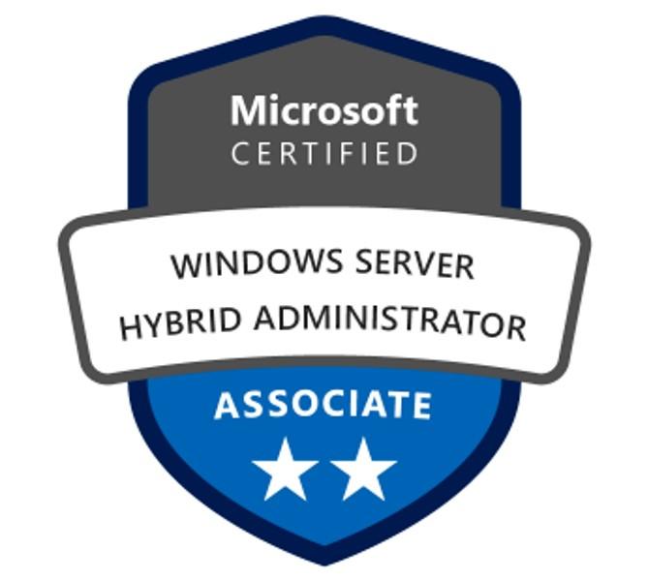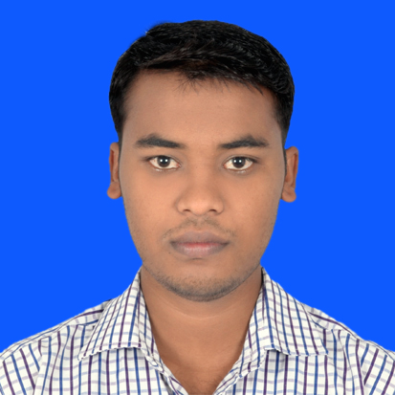

**Barkath. A**

Mobile: +919655178917

🖂: barkathdct@gmail.com

Professional Objective

# Seeking a position to utilize my skills and abilities in the Information Technology industry, offering security and grow professionally by being resourceful & innovative.

## Technical Skills

* **Ticketing Tools** – Service Now, Jira.
* **Remote Tools –** Dameware, Team viewer, MSTSC, Quick Assist,Bomgar.
* Manage Engine.
* SCCM Administration
* Software Distribution
* Patch Management
* Intune
* OS Deployment
* Compliance Management
* PowerShell Scripting

## Career Summary

* Working as a Senior Analyst in Klripti Consulting Solutions Private Limited (Project Name- United Data Technologies Inc) from July 2022 to till date.
* Worked as an IT Analyst in Tata Consultancy services – AMD Project from Sep-2014 to Jun-2022
* Worked as a Technical support Engineer in Wipro InfoTech as a franchise role from Apr-2012 to Sep-2014.

* Worked as a Technical support Engineer in Raksha Technologies from Jan-2011 to Feb 2012.
* Worked as a Customer support engineer in HCL INFOSYSTEMS LTD from Dec-2009 to Dec-2010.

**Certification**

* MCSA (70-410) - MCID: 12863087.
* MD-101
* AZ-800

**Roles & Responsibilities:**

**MECM (SCCM) Support:**

* Successfully executed SCCM upgrades and migrations, ensuring minimal disruption to end-user productivity.
* Implementation and configuration of SCCM for a large-scale enterprise environment, managing over [15+K] endpoints.
* Configuring Roles (DP/MP/Reporting)
* End-to-end application lifecycle, from planning and deployment to ongoing maintenance and optimization.
* Collaborated with cross-functional teams to assess and enhance application compatibility and integration with existing systems.
* Implemented patch management processes, ensuring timely updates and minimizing security vulnerabilities across the organization. Troubleshooting failed patch devices and reporting to Management.
* Deploying Win10 Feature updates package via Servicing plans.
* Worked closely with IT teams to ensure timely remediation of identified vulnerabilities, reducing exposure to potential threats.
* Monitoring and Remediating the Zero-day Vulnerabilities.
* Working with Application owners and deploying updated versions to fix Vul.
* Deploying Operating systems via Task Sequence.
* Monitoring restricted software & freeware
* Creating Collections and maintaining the existing architecture
* Writing Queries for generating reports as per the Management requirement.
* Inventory Management – Hardware & Software
* Reporting on the success or failure of Application deployments.
* SCEP/Windows Defender Virus Definitions, Definition update via Auto Update Rule
* Configure antimalware policies, Windows Firewall settings, and manage Windows Defender Advanced Threat Protection
* Deployment of Definition Updates via package that failed to get auto update via ADR.
* Manually updating definition that failed to update via ADR and package.
* Reporting of machine that failed to update via ADR and manual deployment.
* Installation, Upgrade and Configuration of SCCM/ Client.
* Working on Service Now tickets with SLA which are reported by End User.

**System Administrator:**

**END User Support:**

* Providing support based on Tickets and following SLA.
* Working on Service Now ticketing Tool to create Incident & Request.
* Unlocking account and Reset AD password using AD console
* Installation and troubleshooting of operating system like win 7/Win 8 & 8.1/Win 10
* Installation and configuration of application software’s (SAP,O365,Cisco Softphones, NGEDA,KDF..etc)
* Establishing LAN connection and troubleshooting LAN & Wireless related issues.
* Configuring and Troubleshooting Network Printers(HP, Fuji Xerox, Intermec Label Printers)
* Installing & Troubleshooting VPN, RSA related issue.
* Configuring & Troubleshooting Cisco Desk phones using CUCM console (7965,7940,7945,7841)
* Setup Polycom Video Conference for End users.
* Configuring and Troubleshooting RF Scanners issue.

**IT Infra Support:**

* Work with Network Team to Configure New switches, Routers, Network Monitor Devices.
* Commissioning & De- Commissioning Network Devices & Servers (Switches & Router,HP,DELL, EMC) from Data Centers & HUB Room.
* Working with Storage & VM team to setup new servers at DC & HUB Room (Tintri, HP, DELL, EMC)
* Work With IT Infra Team during Priority issues (SAP, Network (Voice & Video), Power Outages, Servers)
* Support to IT Infra Team during critical activity.

**Vendor Co-Ordination:**

* Co-Ordinate with various Vendors to get Quote for Laptops, Desktops, Desk phones, Connectors, Printers cartridge & IT Accessories.
* Co-Ordinate with Vendors to Lay New LAN Cables, Replace LAN Ports, Install New Displays & Projectors.
* Logging Case with HP to replace the faulty Hardware (SSD HDD, Mother Board, Keyboards, Battery..etc..)

**Asset/ Inventory Management:**

* Maintaining & Updating Laptops, Desktops, Printers and Desk phone inventory.
* Maintaining & Updating Data Center & Hub Rooms Inventory such as Servers, Switches, Routers, Wireless Controllers.

## Strength

* Good Planning and Monitoring Skills
* Comprehensive problem-solving abilities.
* Self-Motivated and Enthusiastic & Team facilitator.

## Personal Information

Date of birth : 11th May 1989

Age : 34

Nationality : Indian

Gender : Male

Marital status : Married

Father’s name : Mr. Anwar

Languages known : English, Tamil, Kannada, Hindi, Urdu

Hobbies : listening to music, chatting with friends, playing carom.

Permanent address : D.NO:2/137,

Maharajakadai,

Krishnagiri (DT)

Pin-636120

Mobile: 9655178917

**Education**

|  |  |  |  |  |  |
| --- | --- | --- | --- | --- | --- |
| **Examination** | **Discipline/**  **Specialization** | **School/College** | **Board/**  **University** | **Year of Passing** | **%** |
| Diploma | Diploma in  Computer Engg | Govt Polytechnic college. Krishnagiri | State board  Of technical  Education | 2009 | 90 |
| H.S.S | Maths-Bio | Govt.H.S.S.  Krishnagiri. | Board of Higher Secondary Education | 2006 | 55 |
| S.S.L.C |  | G.H.S.  Maharajakadai | Board of Secondary Education | 2004 | 80 |

## Declaration

I do hereby declare that the particulars of information and facts stated herein above are true, correct, and complete to the best of my knowledge and belief.

Place: Bengaluru.

Date: (**BARKATH A)**