PROFESSIONAL SUMMARY

KINGSLEY O

ANDROID DEVELOPER

Analytical and detail-oriented Android app developer professional with stellar communication skills. Conceptualizing app solutions with the latest technology, design theory, and a large dose of creativity. Committed to viable and easily functional app solutions for clients

* **5+ years** of **total IT experience**
* **4+ years** of experience in **Android development**
* **1year** of experience in **React Native development**
* Good understanding in End user requirement analysis, Android OS, interactive application development, testing and maintenance and full Software Development Life Cycle (SDLC)
* Experienced in working with android architecture components such as Live Data, Lifecycle aware components, Room
* Develop and maintain existing and new Android applications in both Java and Kotlin
* Proficient in writing reusable software modules using Android SDK and UI tool kit
* Expertise with App components Activities, Services, Broadcast Receiver and Content Providers
* Experienced in using Storage options in Android like Shared Preferences, File, SQLite & Room
* Knowledge in designing and developing adaptive UI components, widget for android phones and tablets using Notifications, Adapters and Services
* Developed User interfaces with rich features with material design guidelines
* Experienced in working with design patterns MVP and MVVM
* Solid understanding of Algorithms, Data Structures and Object-Oriented Programming
* Known for writing efficient, maintainable, and reusable code
* Profound knowledge in integration of third-party APIs like Twitter, Facebook, Google Maps besides other open-source APIs
* Fully versed with Gradle, Maven and other Android development libraries
* Management of projects from Analysis through to Testing and Deployment
* Extensive experience in backend functionality using web RESTful/SOAP/JSON web services
* Hands-on concepts of Android like Material design, Activities, Fragments, Services, Asynctask, UI Layouts, and Widgets etc.
* Managed tasks within Agile framework, cleared Sprinted tasks, and controlled JIRA workflows

SKILLS ● Java JDK, Android SDK, Kotlin, React Native, JavaScript

* + Android App Mobile Development: Android SDK, API - Activities, Recycler View, List Views, Adapters, Horizontal scrolling, Notification Manager, Contacts, Content Provider, Location, Map, HTTP Client, GSON, JSON based Web Services, Camera API, Facebook API
  + Debugging and Testing Tools: JUnit, Logcat, HTML5 and XML, JSON
* Web Services & Parsing Techniques: SOAP, REST & XML (SOAP API), JSON (RESTful API),
* Operating Systems: Windows, Android, Linux
* Other: SQLite, RESTful API's, Firebase, Room DB, Google Services

WORK HISTORY **REACT NATIVE DEVELOPER** 05/2020 to Current

Walgreens, Chicago, IL

**https://play.google.com/store/apps/details?id=com.usablenet.mobile.walgreen**

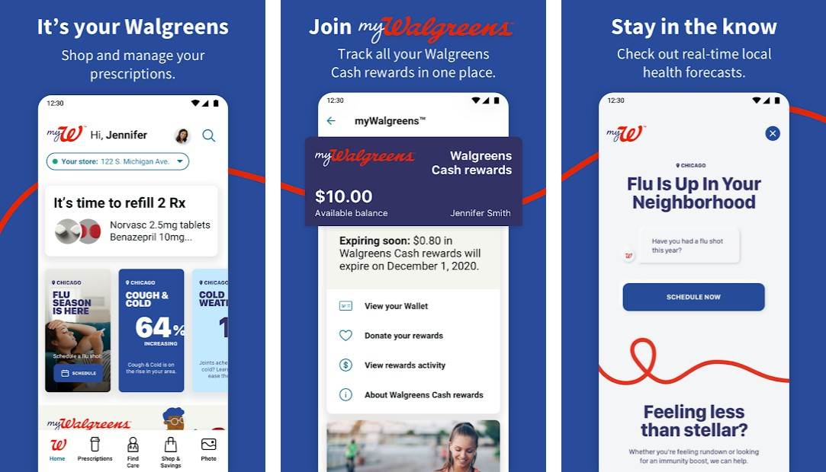

## Performed analysis, debug and document screen loading performance and load times using Sys Trace and Android Profiler on Native Android

* + Found and reported ways to enhance screen load time performance on Native Android
  + Built screen UI for the respective story journeys based on comps from the CX design team for both iOS and Android phones as well as tablet devices.
  + Insured code robustness by using Typescript on React Native mobile frontend.
  + Ensured that various UI screens were responsive and scaled well with smaller devices.
  + Worked on accessibility issues to enhance smooth navigation on the UI elements.
  + Code reviewed pull requests from various team members.
  + Assisted team members when needed in regards to writing quality code
  + Wrote unit tests for various functionalities with libraries such as jest, enzyme, and react-testing libraries.
  + Maintained app state using the redux library.
  + Integrated React Native app as a library with a simple Android native application as the first step towards integrating the whole react-native into existing core app.
  + Created reusable components for building UI screens faster.

**ANDROID DEVELOPER** 02/2019 to 04/2020

Abercrombie & Fitch, New Albany, OH **https://play.google.com/store/apps/details?id=com.abercrombie.abercrombie&hl=en_US** Hollister: **https://play.google.com/store/apps/details?id=com.abercrombie.hollister&hl=en_US**

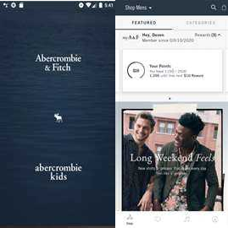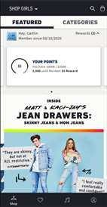

* Worked on fixing bugs on both front end and backend
* Connected with other departments on resolving existing issues that may have affected our android platform
* Worked closing with QA on arising issues to make sure development work meets the acceptance criteria
* Gradle plugin written in Kotlin, used to bring files into your source tree from the Internet or local
* Implemented feature to handle different user experiences based on world regions
* Partook in upcoming app redesign compositions and features
* Worked closely with the UX team on newly implemented features
* Implemented feature to show different price ranges for loyalty users in loyalty regions
* Updated assigned new features version numbers for development, stage and production feeds
* Implemented recommendations feature for app home page to show users other recommended products
* Contributed to apps redesign architecture moving forward in order to have a

maintainable codebase

* Used third party libraries for making multiple network calls and parsing data
* Extended several android framework components in order to achieve the desired effect per UX team requirements
* Provided accessibility features using talkback for product categories, search, my saves, shopping bag, and product display page
* Set feature flags in development feed used as a switch to determine if a specific feature is available in a given user region
* Consumed translated localized strings from feeds for overall great user experience.
* Develop for two different apps with the same code base and build variant
* Fixed and upgraded AppBoy/Braze library for sending instant user notifications
* Handled multiple network calls and mapping using Rx java at the backend
* Approached and handle all development work using Kotlin and MVVM architecture

**ANDROID DEVELOPER** 04/2017 to 01/2019

WAYFAIR, Boston, Massachusetts

# https://play.google.com/store/apps/details?id=com.wayfair.wayfair&hl=en_IN

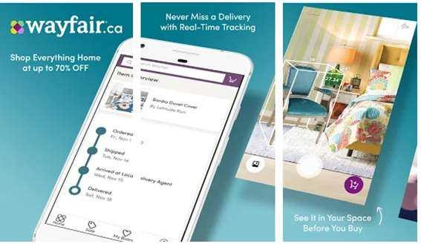

* Worked with Notification Service to notify the user about upcoming sale and update the apps version
* Inserted suitable code to capture the various button and text field events and implemented the desired action for each of the widgets
* Used AsyncTask, AsyncTask Loader to invoke web services in the background thread to provide smooth UI experience
* Utilized the device’s camera to allow the user to see life-sized version of product in any part of room
* Hands on experience with BLE, Android Wear in Kotlin
* Developed different fragments, activities and other UI for the application. Used web views, list views & populated lists to display the lists
* Contributed to design and implementation of the front-end UI/UX with ViewPager

and RecyclerView animation as well as back-end Java development

* Implemented the image slider with dot indicator using ViewPager
* Used debugging tools such as LogCat and Android Profiler to detect bugs and unusually high memory usage
* Used Retrofit for REST API requests and responses, ButterKnife for injecting the views and Retrofit for consuming the rest APIs
* Implemented the ability to purchase items with money or use reward/loyalty points with SeekBar and EditText input

**ANDROID DEVELOPER** 12/2015 to 03/2017

Sears, Hoffman Estates,IL

# https://play.google.com/store/apps/details?id=com.sears.android&hl=en_IN

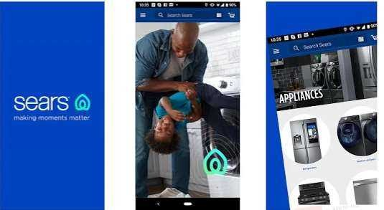

* + Full life cycle experience including requirements analysis, coding phase and testing phase
  + Reviewed business requirements, functional designs in order to gain a deep functional understanding of the application
  + Used Google maps and location services to get location updates and change map UI
  + Implemented Content provider for the application to share the database with other applications
  + Used Test Driven Development (TDD) technique to provide reliable, working software early
  + Helped with the improvements that were added to support Android Marshmallow
  + Worked on background jobs which were long running operations using multithreading concepts like Asynctasks, Services and threads
  + Worked on styles, colors, and fonts and using images for the entire application
  + Context and Options menu were handled dynamically to display counts for the menu items
  + Worked with Android UI components such as Layouts, Menus and Action Bars
  + Google APIs have been used to integrate map feature into the application
  + Implemented logic to store and retrieve data related to latest deals in a SQLite database

EDUCATION Queens College, NY

Attended

Bronx Community College, NY

Associate Degree for Computer Science