**Mohit Raghani – Lead Business Analyst/ Salesforce Admin**

|  |
| --- |
| **Summary** |
| * Visionary enterprise technology professional leveraging over 7 years of experience as Business Analyst/Scrum Master across entire domain experience of Banking Payments, Ecommerce, Salesforce, US Healthcare, and Investment Banking (BFSI) domain**.** * Experience with Investment Banking for Derivative Markets, Debt Markets & Equity Markets & provide solution for end customers to   manage current holdings, Transaction History, Gain/Loss in stocks, compare stocks, Check risks, Liquidity & Latest News. |
| Professional Experience |
| * Worked with PSDtoANY from Jan 14 – Mar 20 as Sr. Business Analyst * Worked with Standav labs pvt ltd Apr 20 – Apr 21 as Sr. Business Analyst * Below are the client details which I served being payroll to PSDtoANY.   Client Role Time Duration  Accenture Business Analyst May 16 – Jul 19  Boeing Sr. Business Analyst Aug 19 – Feb 20 |
| Roles & Responsibilities |
| * Handled SDLC for project development through Agile methodology & process improvement through lean approach. * Responsible to create User stories, prepare sprint planning & do sprint grooming. * More often to that prepared documents like FRD, BRD, SRS, Test Cases & User Manual. * Knowledge on API integration through REST & SOAP API messages for GET, PUT, POST and DELETE data * Involved in BPM modelling using Cameo tool, by following TOGAF Framework. * Involved in Presales consultation for Government Tenders & International Clients. * Prepared Training material like User Manual, Presentation & Videos. * Worked with several stakeholders for project update, sprint grooming, solving technical queries, SQL Database design & defining architecture flow for the project. * Hands on Experience with implementation of different modules of salesforce like CPQ, CLM etc. * Perform Data Visualization using the data in Tableau & Excel for data analysis by performing V Lookup, H Lookup, Pivot Table & Reports.   •Assist in making wireframes by using tools like Just in mind, Balsamiq, etc.  •Developed many UML diagrams using Creately & Lucid chart tool for better understanding of project flow.  •Participated in Client meeting for requirement gathering, request change, project sprint update & demo. |

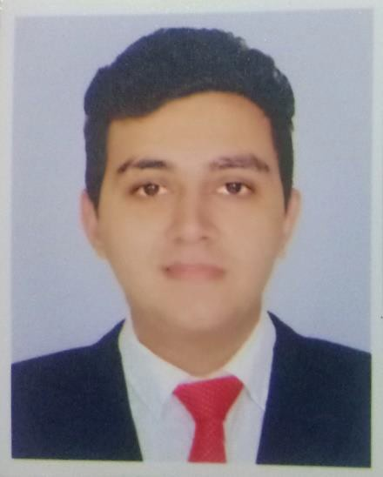

|  |  |  |
| --- | --- | --- |
|  |  |  |
|  |  |  |
|  |  |  |

[raghani.mohit92@gmail.com](mailto:raghani.mohit92@gmail.com)



+91-8160079913

|  |  |
| --- | --- |
| **Skills** | **Projects** |
| * Documentation * Wireframing * Project Management * Client Communication * UML Modelling * UAT * SQL | * **Electronic Health Record/Revenue Cycle Management/Order & Logistics Management Overview:** Experience with US Health care for patient data record management their claim processing & order management between physicians & laboratory.   **Platform:** SaaS Platform  **Roles & Responsibilities:**   * Requirement Gathering * Preparing BRD/FRD and User manual * Conducting Daily stand-up meeting, doing sprint planning & retrospective. * Writing user stories with a detailed acceptance criteria. * Involved in four ceremonies of agile methodology. * Performed UAT before releasing sprint demo. * **Learning Management System**   **Overview:** LMS developed in WordPress for government course selling and giving &   integrated with zoom video calling for online classes.  **Roles & Responsibilities:**  - Creating UAT Models &amp; Data flows for one/two-way data sync from one product to other.  - Preparing BRD documents to get sign off from the client on the scope of the project.  - Involved with developers for solution architect for the project &amp; database design.  - Writing User Stories with proper acceptance criteria & doing sprint grooming for each story to get story points for each user stories.  - Coordinating with several stakeholders - developers, designers & testing team for regular updates.   * **ATCO** - Salesforce B2B site integration with Salesforce & Oracle  **Overview:** Different Product Configuration on cpq & managing quote & order process with Billing on oracle.   **Responsibilities:**  - Requirement Gathering * Understanding As is & defining To Be solution * Writing User Stories * Preparing Flow Chart, FRD Document. * Handling Salesforce Admin activities like data security, user role set up, email marketing, Data Mangement etc.. * **Silicon Expert** - Salesforce CPQ project  **Overview:** Different Product Configuration on cpq & managing quote, order, Billing, renewal & Contract for different Business users. Customize price list calculator  **Responsibilities:** * Requirement Gathering * Understanding As is & defining To Be solution * Writing User Stories * Handling Salesforce Admin activities like data security, user role set up, email marketing, Data Mangement etc.. * **Walking with Purpose**   **Overview:** WordPress & shopify site integration with Salesforce, creating product price, orders & invoice.  **Web:** https://walkingwithpurpose.com/  **Salesforce:** https://walkingwithpurpose.my.salesforce.com/?ec=302&startURL=%2Fhome%2Fhome.jsp  **Platform:** SaaS Platform  **Roles & Responsibilities:**   * Requirement Gathering * Project planning * Preparing documents * Wireframing * Performing UAT * Coordinating with developers, designers & testing team for regular updates * **Loan Processing Management, Commercial Banking & Payments via Mobile Banking**   **Overview:**   * Instant Payday loans for salaried customer with tenure of 25days Maximum. * Available channel to avail loan Loans on mail, Mobile banking, Net Banking. * Implemented different payment procedures in internet banking like NEFT, RTGS, and SEPA & UPI. * Involved in process of commercial credit/Debit cards to different companies. * Payment Settlement, CHIPS & International Fund Transfers through GPP using different swift messaged for transaction.   **Roles & Responsibilities:**   * Involved in Requirement Gathering, consulting client for the solution. * Preparing FRD & Flowcharts for product customization. * Writing User Stories * Performed Sprint Grooming, solving queries for the internal development team. * Coordinating with several stakeholders - developers, designers & testing team for regular updates. * Prepared wireframes * Performed UAT Testing.   ➢ **Shortroundsupply**  **Overview:** Integrated ecommerce website & Mobile App with Salesforce CPQ & handled two-way sync.  **Platform:** Magento  **Database:** MySQL  **Integration**: Salesforce CPQ  **Roles & Responsibilities:**  - Preparing FRD & Flowcharts.  - Writing User Stories  - Creating Data flow forB2B/B2C Customer, Product, Order, Invoice & Shipment data from Magento to Salesforce, vice versa.  - Created different objects in salesforce as per the business requirement.  - Performed UAT on staging server before release. |
| **Tools** |
| * JIRA * Confluence * Balsamiq, Justinmind * Lucid Chart, Creately * Tableau * Excel * MsWord |
| **Personal Details** |
| **Date of Birth**  30-January-1994 **Martial Status** Unmarried **Languages Known**  English, Hindi, Gujarati, and Sindhi  **Hobbies**  Watching Movies, Travelling, Gymming & Swimming  **Personal Details Personal D** |