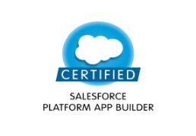 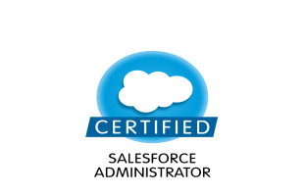 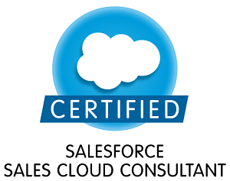 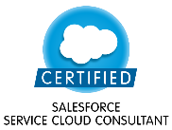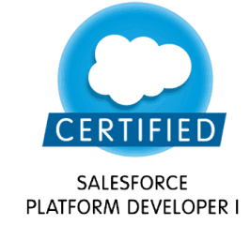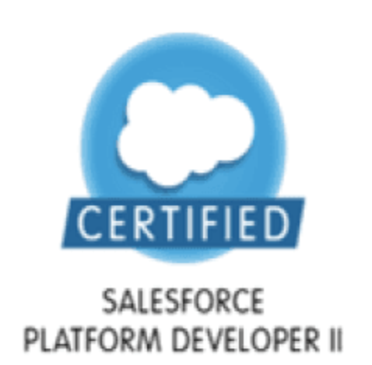

✆: **+91-9038271112**

**Sankhadeep Biswas** [🖂 sankhadeep.biswas100@](mailto:# sankhadeep.biswas100@tc)gmail.com

# Career Objective

## To achieve a challenging, dynamic and responsible position in an environment where I can contribute my skills acquired during my period of experience that strives for overall Development of the Organization and myself.

# Professional Summary

* **5 + year** of experience in Salesforce.com (SFDC).
* Experience in **Lightning** to develop **Aura** components and lightning bundles and implementing in **Community Cloud**.
* Experienced in writing **Apex class, Apex trigger, Test class, Batch Apex**
* Ability to write **SOQL** queries across multiple objects in SFDC database.
* Implemented **Security** and **Sharing rules** at object, field, and record level for different users at different levels of organization.
* Extensive experience in creating **Roles**, **Profiles**, **Page Layouts**, **Record Type**, **Workflow**, **Reports**, **Dashboards** and **Approval, Workflow.**
* Experience with data loading tools like **Apex Data Loader.**

# Technical Skills

* + - 1. **Salesforce Technologies:** Salesforce CRM , Apex Triggers, SOQL, Security and Sharing rules, Apex class,Workflow & Approvals, Custom Objects, Dashboards, Custom Settings
      * **Certification**: **Salesforce certified Platform App Builder**, **Salesforce certified Administrator, Salesforce certified Sales Cloud Consultant, Salesforce certified Service Cloud Consultant, , Salesforce certified Pd1, Salesforce certified Pd2**

# Career Graph

* Working with **Tata Consultancy Services** from July, 2018 to till date.
* Worked at **Atos Global IT Solutions And Services Private Limited** from July 2017 to June 2018.
* Worked at **Cognizant Technology Solutions Pvt Ltd** from May 2014 to June 2017

# Educational Qualification

* Completed Bachelor of Technology from WBUT, Kolkata in 2013.

## Work Experience in Tcs

**Project #1: Insurance project engagement Duration: April ‘19 – Present**

**Description:** It’s a project of a famous Insurance company in USA. Implementation was done in sales and community cloud.

**Responsibilities:**

* Development in sfdc **Lightning** **Aura** based on complex user story.
* Integration using **Rest Api, Tooling Api**
* **Heroku App Integration with salesforce**
* Writing apex code and test classes for the required development.
* Taking daily calls with testers, client, business and communicate with them.
* Taking care of other team member’s Task in case they got stuck in any development.

**Project #2: Banking project engagement Duration: Jul ’18 – March’19**

**Description:** It’s a project of a famous bank based in USA. Implementation was done in finance cloud.

**Responsibilities:**

* Development in sfdc **Lightning** **Aura** based on complex user story.
* Development in Process builder and Flow.
* Writing apex code and test classes for the required development.
* Single person to work on user stories from my current employer and communicate with the client.
* Taking daily calls with testers, client, business and communicate with them.

## Work Experience in Atos

**Project #1: Enel Community Cloud Implementation Duration: Aug’17 – June ‘18**

**Description:** Enel is an Italian multinational manufacturer and distributor of electricity and gas. Our purpose in this project was implementing partner portal and community cloud for Enel users and also making custom functionality using Apex and lightning Bundles.

**Responsibilities:**

* Worked on creating Lightning bundles and necessary apex code for that.
* Responsible for writing most of the test class for this project.
* Creating the Community and arranging it as per necessity.
* Used Custom Metadata type Component ad provided training for the entire team for it.
* Migrating Custom components from one org to another org using Package Xml and Change Set.
* Loading Custom Settings data and changing it in different org.
* Changing Custom Label value according to client requirement.
* Worked on Knowledge settings, Knowledge Article, Article language.
* Worked on translating Knowledge article language for single language and multi-language enabled org.

## Work Experience in Cognizant

**Project #1: Amgen GCO Duration: Sept’16 – June ‘17**

**Description:** Amgen Inc. is an American multinational biopharmaceutical company headquartered in Thousand Oaks, California .The Company’s largest selling product lines were Neulasta/Neupogen. We use to provide enhancement and support for its different application.

**Responsibilities:**

* Extensively worked on SFDC security model.
* Making reports and dashboards.
* Writing trigger, workflow, validation rules.
* Learned Schema builder
* Wrote Batch Apex

**Project #2: Allergan Duration: Sept’15 – Aug’16**

**Description** Allergan, Inc. was a global [pharmaceutical](https://en.wikipedia.org/wiki/Pharmaceutical) company focused on eye care, neurosciences, medical dermatology, and medical aesthetics. We were responsible for performing requirements gathering, analysis, design, coding configuration, Customization to develop a Salesforce based system to track their Sales and Marketing related activities.

**Responsibilities:**

* Created custom Objects and also worked on Standard objects.
* Import/Export records to sales force via data loader
* Working with Triggers, Apex class.
* Created roles and profiles.
* Security Model - Role Hierarchy/Sharing Rules/FLS.

**Project #3: Lundbeck Rollout Duration: April’15 - Aug‘15**

**Description:** Lundbeck A/S is a Denmark-based company active in the pharmaceuticals industry. Lundbeck decided to upgrade their existing UNIX based system to cloud based SFDC CRM. Based on their old system design; SFDC integration, configuration and customization has been done. Then migrated old system data to SFDC.

**Roles & Responsibilities:**

* Understanding Business requirements.
* Entities/Relationship creation.
* Created workflows and validation rules
* Maintain custom Apex triggers.
* Security Model - Role Hierarchy/Sharing Rules/FLS.
* Used Workbench for loading and testing purpose.

**Project #3: BAX_MP_US Gmbro Impl_Phase II Duration: August’ 14-March’15**

**Description**: Baxter International Inc., the US based leading healthcare company has acquired Gambro, a global medical technology company that manufactures products for Chronic and Acute Renal care , in September 2013. As both Renal Force and Gambro use Salesforce.com to track their Sales and Marketing related activities.Now all the data will be migrated from Gambro to Renal system. Because going forward Gambro system will be decommissioned.

**Responsibilities:**

* For doing customization like creation of Objects, Relationships, Record Types, Page Layouts, Custom Settings, Validation Rules, Email Templates, Workflow Rules and Approval process
* Responsible for creating Users, Profiles, Roles and Sharing Settings.
* Worked on FLS.
* Involved in writing Visual Force pages.

# Personal Details

**Permanent Address:** 347/13/3 Dumdum Kashipore Road, Kolkata-700074

**Contact Details:** +919038271112/+919874114360

**Date of Birth:** 11th Jan, 1991

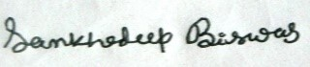

____________________ ________________________

Signature Date