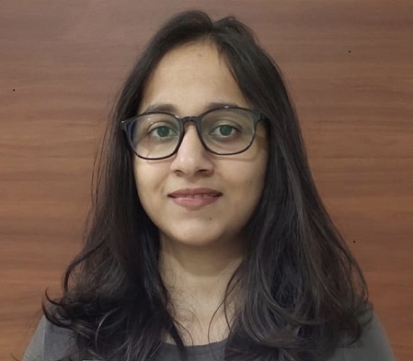
Shreya Mehta
+91-9823022594
shreya_mehta93@yahoo.com

PROFESSIONAL SUMMARY

- 5+ years of IT experience in CRM domain including 3+ years of SFDC experience.
- Currently designated as Associate Consultant at Infosys Ltd.
- Well versed with Agile methodology.
- PD1 certified and admin certified.
- Good working experience in creating validation rules, workflows, Approval Process, custom settings, Reports, Profiles and Permissions.
- Good Working knowledge in developing Apex Classes, Aynchronous apex code and Apex Triggers.
- Good Working knowledge in developing lightning components and communicating between them through Events.
- Good working knowledge in Sharing and Visibility Aspects(OWD, Profiles, Permission Sets, User Settings, Role Hierarchy, Sharing Rules etc).
- Basic Knowledge of REST API Integration – both Callouts and Callins.
- Worked on Requirements analysis, Knowledge sharing, Unit testing, client demo presentation & RFPs.

WORK EXPERIENCE

ATOS India

Project: Dubai Telecom, T-Mobile
Date: May 2015 – April 2019
Role: Siebel Developer, Salesforce Developer

Role & Responsibilities:

- Designed Custom objects, validation rules, Page layouts, Components to suit to the needs of the application.
- Worked on sharing settings, workflow rules, assignment rule.
- Worked on Apex Programming by creating Custom Triggers to implement business logic.
- Worked on developing custom Aura components wherein called server side controller to perform some logic
- Worked on unit testing and test classes.
- Worked on requirement gathering and unit testing, conducting discussions with client and providing demo to clients. Expertise in Admin and Development User stories implementation.

ATOS India – Onsite

- Part of L3 team on client location.
- Worked on critical Production issues, analyzing and resolving the Defects within defined SLA.
- Coordinated with Client and External L2 team, testing to reduce the turnaround time of defects.

Infosys Ltd

Client : Securian Financial, Aetna Healthcare.
Date: April 2019 – Present
Role: Salesforce Developer

Roles & Responsibilities:

- Designed Custom objects, validation rules, Page layouts, Components to suit to the needs of the application.
- Worked on sharing settings, workflow rules, assignment rule, process builder, flow.
- Worked on Apex Programming by creating Custom Triggers and performed Asynchronous calls using future methods, batch apex, queueable apex and scheduled jobs to implement business logic.
- Worked on Apex integration to update external system based on field updation in Salesforce.
- Worked on developing custom Aura components wherein called server side controller to perform some logic
- Worked on LDS to display and edit data.
- Worked on Aura component communication through Component events.
- Worked on standard objects like Case and contact.
- Worked on unit testing and test classes.
- Worked on requirement gathering and unit testing, conducting discussions with client and providing demo to clients.
- Worked in project that migrated from non-Salesforce to Salesforce application.
- Worked in Agile Methodology, involved in stories implementation and actively participated in standup call.
TECHNICAL SKILLS

- CRM : Salesforce.com
- Languages : Apex, Javascript, SQL, SOQL.
- Operating Systems : Windows.
- Web Technology : Lightning
- Tools : Workbench,SQL Developer.

ACADEMICS

Course | Institution/University | Year | %
B.Tech. (CSE) | LPU | 2015 | 63%
H.S.C | Oxford Sr. Sec. School | 2011 | 73%
S.S.C | Oxford Sr. Sec. School | 2009 | 81%

PERSONAL DETAILS

Date of Birth : Nov 22, 1993
Father’s Name : Mr. Raman Kr. Mehta
Marital Status : Single
Current Location : Bangalore
Permanent Address : C-123, Vikas Puri, New Delhi - 110018

