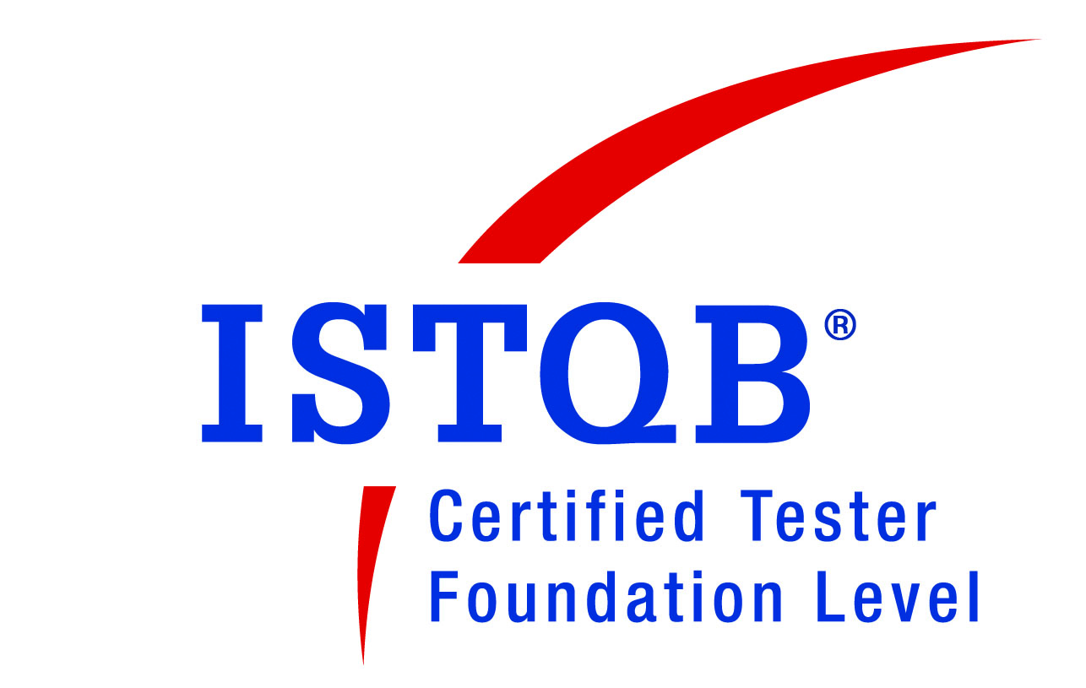
DEVI PRASAD PALLAI
Marathalli, Bangalore, Karnataka, India |Ph: (M) +91 9590317458 Email: pallaidevi992@gmail.com

Seeking for a challenging role in IT sector and continue my professionalism, dedication and talent so as to bring the organization a sharper edge within the industry besides ensuring personal growth

SYNOPSIS

Highly accomplished, goals-driven B. Tech (Applied Electronics and Instrumentation) with ISTQB certification professional offering 8.5 years of experience; currently associated with Intel Corporation Limited, Bangalore as a QA Team Lead. Hands on experience with testing –Test Automation in Selenium Web Driver in C#, VSTS Coded UI test,Java,Telerik Test , REST ,SOAP UI, ,Functional, Regression, Smoke, etc.

- Provide software delivery operations and application release management support, including coding and scripting, automated build and deployment processing, agile deployment, and process re-engineering.
- Perform script maintenance and updates due to changes in requirements or implementations.
- Build automated deployments for consistent software releases with zero downtime
- Proficient in root cause analysis of issues/errors in production environment
- Work experience on Agile and Waterfall model, Team Spirited and professionally driven Engineer with a blend of leadership and innovative ideas
- Ability to communicate and motivate team mates to enhance strategic goals and bottom line objectives with creative problem solving skills
- Expertise in Marketing cloud , Sales cloud admin modules and skills on cloud test automation strategy development.
- Strong Understanding of Measuring and Calibration tools like INCA,MDA,CDM.
- Skilled with Silk Test scripts, Shell Programming for Creating Batch file for Execution of Scripts.
- Expertise in Software Testing Life Cycle (STLC), Defect Management Life Cycle (DMLC) and Software Development Life Cycle (SDLC) Methodologies
- Competency in VSTS 2017 Coded UI test, Selenium Web driver in C#.
- Proficient in developing /coding operational processes such as build tools using C#.
- Well Versed with Build/Release/Configuration Management, Build Utilities like Gitlab,Dcoker,MS Build in VSTS 2017,Git hub, Team City ,Rally.
- Strong understanding & hands on experience with testing of REST APIs using custom automation framework.
- Basic Understanding of Network Administration such as .admin rights, managing registry entries ,VM creation in iLAB.
- Review of deliverable for correctness and completeness in understanding the requirement and the application
- Excellent communication and decision making skills with a positive approach
- Quick learner, able to grasp new ideas, concepts and methods
- Adept at directing high-tech software solutions for clients
- Ability to work independently or be as a part of a team

CORE COMPETENCIES

- Punctual and Trustworthy
- Optimistic and Fast Learner
- Strong Work Ethics
- Team Management Skills
- Strong Interpersonal Skills
- Persistent
- Self-Motivated and Self-Disciplined

PROFESSIONAL DOSSIER

QA Team Lead, Intel Corporation, Bangalore, Since May 2016-June2019
Projects Handled
#1) Intel Inside Program (US),Intel Corporation(June 2016-Current Date)
- Team Size : 40
- Technology : Salesforce, Eloqua, Power BI, SQL 2012,.NET 4.6 Framework, MS Share point 2013
- Tools : Gitlab,Docker,Selenium,VSTS,Git hub, Team City, Team Foundation Server 2013,Urban Turtle 2013,Selenium Webdriver
- Browser :Mozilla Fire fox,Chrome.Safari,IE7-9,Edge
- Summary : The Intel Inside Program is a core element of Intel's worldwide marketing programs and a major influence to the computer industry advertising ecosystem. The program continues to evolve to accommodate industry trends and remains consistent with Intel's direct advertising.

- Responsibilities :
  - Understanding Analyzing and scoping the business requirements, define test strategy.
  - Migration of Test Automation scripts from Telerik Test to Selenium Webdriver in C#.
  - Design and Develop Hybrid automation framework SMART.
  - Creation of Test Scripts based on new functionality and priority customer calls.
  - Coordinating with team members, client on status reports, queries, business requirements
  - Good working knowledge on source control using TFS 2015 and GIT hub as ALM.
  - Managing Test Suite Builds using VSTS 2015 and VCS such as Team City.
  - Test Automation for Web Service API (REST /SOAP UI ).
  - Proficient knowledge on execution/management/creation of Performance Test scripts in VSTS.
  - Create batch file for execution of Silk Test scripts using Shell scripting.
  - Defect Characterization, Reporting and retesting and Aware of complete end to end front-end flow.
  - Perform Functional test, Regression test, tracking bugs in Rally.
  - Knowledge in TFS, automation scripts using Telerik Web UI studio.

#2) INCA, ETAS Gmbh, BOSCH,Germany[April-2014-May 2016]
- Team Size : 30
- Technology : VS 2010 (C#), SQL 2012,.NET 4.6 Framework, MS Share point 2013
- Tools : VSTS Coded UI Test, Team Foundation Server 2013,Urban Turtle 2013,Silk Test 14
- Browser :Mozilla Fire fox,Chrome.Safari,IE7-9
- Summary : A CSAT 9.2/10 Windows based Application developed to provide real time access to customers for ECU Development, and Calibration, Validation Test of electronically controlled systems.
- Responsibilities :
  - Understanding Analyzing and scoping the business requirements for Calibration and Measurements.
  - Strong knowledge in device variable set up/analysis, filters, calculated signals, comparing Data sets.
  - Migration of Test Automation scripts from Silk Test to Ms Test Coded UI.
  - Creation of Test Scripts based on new functionality and priority customer calls.
  - Intermediate knowledge of test Framework flow and declaration .
  - Coordinating with team members, client on status reports, queries, business requirements
  - Good working knowledge on source control using TFS 2013.
  - Managing Test Suite Builds using VSTS 2013.
  - Proficient knowledge on execution/management/creation of Performance Test scripts in VSTS.
  - Create batch file for execution of Silk Test scripts using Shell scripting.
  - Defect Characterization, Reporting and retesting and Aware of complete end to end front-end flow.
  - Perform Functional test, Regression test, tracking bugs in TFS 2013.
  - Knowledge in TFS, recording action scripts using Telerik Web UI studio.

Test Engineer, Wipro Technologies, Bangalore, Since March 2011

#2) Shell eServe, Shell Petroleum, USA[March-2012-Current Date]
- Team Size : 20
- Technology : VS 2005 (C#), SQL 2005, SAP R/3, .NET 3.5 Framework, MS Share point 2010
- Tools : HP ALM, Eclipse IDE,Selenium Web Driver.
- Browser :Mozilla Fire fox,Chrome.Safari,IE7-9
- Summary : A CSAT 8/10 Web based Application developed to provide real time access to customers for ordering, shipping, reporting and manage billing & account information 24x7x365.
- Responsibilities :
  - Understanding Analyzing and scoping the business requirements
  - Creation of high level Test Automation Scenario.
  - Involved in preparation of test plan & maintenance of test Framework environment
  - Coordinating with team members, client on status reports, queries, business requirements
  - Developed the Automation Test Scripts and Execution of test scripts using Selenium.
  - Defect Characterization, Reporting and retesting and Aware of complete end to end front-end flow .
  - Perform Test Automation Scripting and maintenance, Smoke test, Functional test, Regression test, tracking bugs in HPQC & the team foundation server
  - Basic Knowledge in SQL.

#3) Canada eLPG, Shell Petroleum, USA[Aug 2011-March 2012]
- Team Size : 22
- Technology : VS 2005 (C#), SQL 2008, SAP R/3, .NET 3.5 Framework
- Tools : Mercury Quality Center 11, DTS and Quick Test Professional 11, Win Server
2005, SSRS, Windows Service
- Summary : A Web based Application developed to provide real time access to customers for ordering, shipping, and view sales and volume report & statements on demand
- Responsibilities :
  - Collecting the business requirements, reviewing use cases
  - Involved in preparation of test plan & maintenance of test automation Framework environment for QTP.
  - Perform Black box testing, smoke test, functional test, and regression test
  - Involved in the preparation of test cases after analyzing the specifications Document and involved in peer review of test cases
  - Maintenance of versions, builds, database builds, test documents and test environment
  - Tracking bugs in HPQC
  - Preparing, reviewing and executing test cases and scenarios
  - Coordinating with team members and the client on status reports, clarification, MOM, etc.
  - Used automated tool QTP 11 for user creation

Achievements:

- ISTQB awarded CTFL by ITB Board,India in 2013.
- Recognition Super Performer award Robert Bosch Engineering and Business Solutions in 2015.
- Recognition for Intel Hackathon 2017 for tool development in Test automation.
- Appreciation from Client – for tracking critical defects in the production
- Appreciation from Manager & on-site team – for innovative scenarios in functional, regression testing of a critical project
- Achieved “Feather in my Cap” award, from a client for an outstanding contribution to the Canada eLPG project
- Wipro Internal Certifications in Web Testing, VelociQ, SCM, Software Review & Testing ,UCF101,UCF 201,UCF 202, and also on Energy & Utilities Domain
- Attended trainings on Software Testing, QC
- Delivered process excellence, with productivity & quality improvements.
- Achieved to meet Project Timelines, in keeping with Project goals so as to meet client expectation.
- Have successfully implemented process improvement projects undertaken by the team

TECHNICAL PROFICIENCY

- Programming : Java,C#,OOPS, C, C++
- Scripting : CS script , HTML, Silk Test,Perl
- Database : Mongo DB ,Team Foundation Server 2017,SQL Server 2017, MySQL 5.0
- Operating System : Windows 10 RS3, Mac, iOS.
- Tools: Gitlab,TeamCity,GitHub,VSTS2017CodedUITest,SeleniumWebDriver,SoapUITelerikWebstudio,Team Foundation Server 2013, HPALM

SCHOLASTIC CREDENTIALS

B. Tech (Applied Electronics & Instrumentations), from BPUT, Odisha, in 2010 – 72%
12th (CHSE), Odisha, in 2006 – 62%
10th (BSE), Odisha, in 2004 – 82%

PERSONAL DOSSIER

- Date of Birth : 16th November 1989
- Linguistic Proficiency : English, Hindi and Oriya
- References : Will be pleased to furnish upon request

(Devi Prasad Pallai)

