RESUME

DARSHAN M R Mobile: 8904415283
M.C.A (Master of Computer Applications) Email: darshan.mr27@gmail.com
Experience Summary
- 14 years of experience in Software Development using JAVA/J2EE, SPRING (Core, Transactions, JDBC, MVC, Web Services, Web Flow), Spring Boot, Microservices, RESTful Web Services, Angular-7/8 and ReactJS (ES6) technologies.
- Working as a Technical Leader at Capital Cloud India Pvt., Ltd., A Bottomline Company, since July 2021.
- Experience in implementing customer requirements using Core Java, J2EE, Spring Boot, Spring3.0/3.5/4.0, Spring MVC Framework, Spring/RESTful Web Services, Spring Web Flow, Struts, JBOSS4/5/7, Azure and AWS (S3 and EC2) clouds
Qualification:
- Master of Computer Applications (M.C.A), National Institute of Engineering College, Mysore, Vishveswaraya Technological university, Karnataka – India (81% - FCD)
- Bachelor of Science (B.Sc. – P-Physics. C-Chemistry. M-Mathematics.), Yuvaraja’s College, Mysore, University of Mysore – India
Technical Experience Summary Table:
Technology | Tools
Programming Languages | Core Java, J2EE
Development/ Productivity/ Build/ DevOpps Tools | Eclipse (Helios, Galileo, Luna Kepler), STS (Spring boot Tool Suite) IntelliJ, vi Editor, OneOpps, CCM tool, Jenkins, Sonar, Confluence, JIRA, PagerDuty, Docker, Dynatrace, AppWatch, Hyte Console, AppDynamics, Prometheus, Grafana, Splunk, Slack, XMatters, PagerDuty
Web Technologies | ReactJS (ES6), Angular-7/8, Servlets, JSP, XHTML, Java Script, XML, XSLT, XSD, CSS, JBOSS Seam, JQuery, Portlets, Rich faces, Flex (Basic), Bootstrap, Axis Web Services, Flash builder(To develop Flex Applications)
Operating System | Windows XP, Linux, CentOS
Java/J2EE IDE | Eclipse(Helios, Galileo, Luna, Kepler), IntelliJ, JDeveloper
Version Control | VSS, SVN(Collabnet), Star Team, GIT repository
Databases | Oracle10/11g,PostgreSQL (SquirrelSQL client),Oracle 12c, Informix (DBEaver), Azure Data Studio
Framework | SpringBoot, Spring3.0/3.5/4.0, SpringMVC, Spring Web Flow, Spring Web Services and Struts1.2/2.0
Application Server | JBoss4/5/7, Apache Tomcat, Jetty9
Protocol | SNMP, SIP (Session Initiation Protocol)
Web Services | RESTful, SOAP, AWS (core AWS services, uses, and basic AWS architecture, developing, deploying, and debugging cloud-based applications using AWS, used the AWS service APIs, AWS CLI, and SDKs to write applications, key features of AWS services and AWS shared responsibility model)
Cloud Technologies | Azure and Spring Cloud

Key Projects
- PTX-Payments

Description | PTX is a UK based SaaS product which provides Payment and Financial Document, processing for small to large businesses.  PTX has a number of shared services which are used by Modules where each module provides a high level set of features.
Software’s used | Java(JDK8 version), Spring, Spring Boot, RESTful Web Services, Azure Data Studio, Tomcat Server, Linux, Eclipse/ STS developer tool
Contribution | Involved in designing and implementing the client driven API’s using Spring Boot, RESTful Web Service. Implemented the APIs using Spring Boot annotations and various Boot features like Starters (Web, JPA, and Test), Actuator (for health check),.  Created tables, functions, procedures, views, sequences and triggers required in different phases of service implementation in Azure data studio. Managing resources (team size: 4) with their Year End Appraisal (YEA) and recognitions feedback of each members.
Duration | 19/07/2020 – Till Date

- Walmart Retail project – Sam’s Wingman Retail Pricing

Description | Walmart Retail project – Sam’s Wingman Pricing involved in many Web Service development activities, Azure Cloud Configurations and worked on DevOps tools
Software’s used | Java(JDK8 version), Spring, SpringBoot, RESTful Web Services, Azure Data Studio, Tomcat Server, Linux, Eclipse/ STS developer tool
Contribution | Involved in designing and implementing the client driven API’s using SpringBoot-RESTful Web Service. Implemented the APIs using SpringBoot annotations and various Boot features like Starters (Web, JPA, and Test), Actuator (for health check),. Created tables, functions, procedures, views, sequences and triggers required in different phases of service implementation in Azure data studio.
Duration | 07/09/2020 – Till Date

- Walmart Retail project – GIF Picking

Description | Walmart Retail project involved in many Web Service development activities, in providing service to their customers.
Software’s used | Java(JDK8 version), Spring, SpringBoot, Informix, Tomcat Server, Linux, Eclipse/IntelliJ developer tool
Contribution | Involved in designing and implementing the client driven API’s using SpringBoot-RESTful Web Service. Implemented the APIs using SpringBoot annotations and various Boot features like Starters (Web, JPA, and Test), Actuator (for health check), configured embedded server like Tomcat and Jetty9.0. Created tables, functions, procedures, views, sequences and triggers required in different phases of service implementation.
Duration | 07/06/2018 – 06/09/2020

- Cognizant Digital Engineering - Outreach - Green Star Application project

Description | The Green Star Application helps to address three major problems of school: Attendance, Homework and Discipline. Purpose of the Green Star Application helps to address three major problems of school: Attendance, Homework and Discipline:  - Attendance: Schools have poor attendance and no strict attendance tracking mechanisms, resulting in higher dropout rates.  - Homework: Majority of students in govt. schools do not have a formal homework structure which discourages them to learn at home.  - Discipline: No focus provided on behavioral changes as most of the items are provided by the government.  These problems are transferred into measurable parameters and stars are awarded
Software’s used | Front End: ReactJS v16.8.4, NodeJS v6.4.1, HTML5, CSS, Javascript, React Bootstrap  Back End: Core Java v1.8, Spring Boot v2.1.2, JPA, MySQL, RESTful Web services
Contribution | Developed an Outreach project by name Green Star Application (app) from scratch by gathering requirements from the Outreach panel members. Implemented/ written code for project using the technologies like Java1.8, SpringBoot (Backend) and ReactJS (Backend). Written Junit (using SpringBootTest annotation), Code Coverage by configuring the SonarLint in Eclipse, Configured and initialized Mockito in the project. Written and tested the RESTful web services with SpringBoot. Received the below attached Full Stack Engineer Certificate for successfully completing the Greenstar Project. Time given to develop and submit the project was 6 weeks (From July 4th 2019 to 15th August 2019).
Certification | 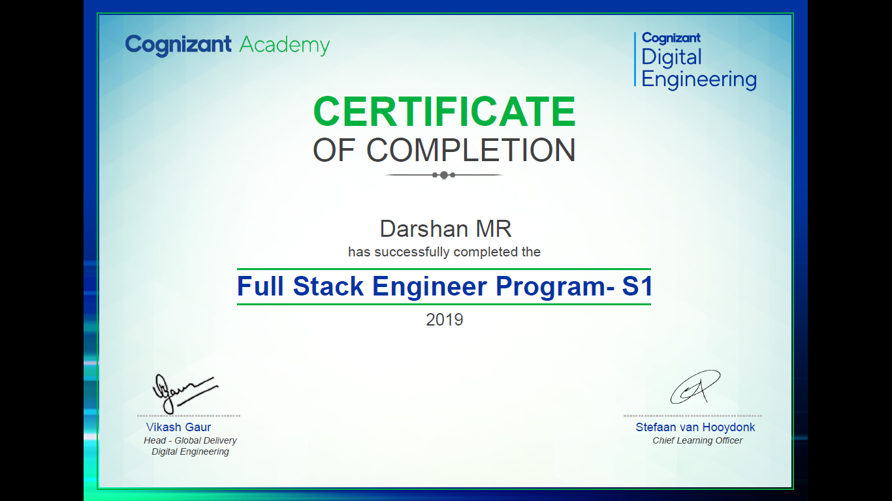

- Parlay-X Multimedia Conference Service Using JAIN SLEE Specification
Description | Parlay-X-MMC involves Parlay-X interface for handling the communication among the users. The Jain SIP is the Standardized java interface to the SIP used as API below Parlay-X.
Role | Developer
Operating System(s) | Windows XP
Environment | JDK(Windows)
Contribution | Developed java code for accelerating the SIP calls to enable the conference and calling various participants to join the conference (Conference Setup).
Web Server | Mobicents Jain SLEE Server(includes JBoss Server)
Build & Testing Tool | Ant & SoapUI version
Duration | 01/01/2009-15/06/2009

- AP4SAAS [Aggregation Platform for Software as a Service]

Description | AP4SAAS is an emerging technology in the web which targets the pay per usage of Software and infra structure services over the web.
Software’s used | J2EE, Spring framework, Oracle and Web Service, HPSA, IUM, JBOSS Seam
Contribution | Involved in designing and implementing the Web Service using Spring Web service  functionality. Performed lead role in maintaining the team. Involved in developing the Web  service layer between SaaS and Service activation tool named. HP Service Activator which  activates the subscriptions in the end service. Wrote cleanup scripts (Shell Scripts) to clean the  old records from the DB tables.
Duration | 07/09/2009 – 12/05/2014

- SDP: SGF [Service Discovery Platform: Service Governance Framework]

Description | SDP: SGF provides the SOA Governance and Management functions across design  and runtime using telecom specific “virtualization” and customization on top of HP software –  HP SDP PE HP REST gateway Policy Enforcer and access management.
Software’s used | Java (JDK7 version), Spring framework, Squirrelsql, Jetty9.2 Server, Linux, Eclipse developer  Tool
Contribution | Involved in designing and implementing the Web Service API’s for SGF portals using Spring  Web service functionality. Designed and developed some web pages using JSPs. Web Pages  designed for various modules such as Service Discovery Management, Partner Management
Duration | 12/05/2014– 12/11/2014

- HP Dynamic SIM Provisioning

Description | HP Dynamic SIM Provisioning covers the solution required within the operator’s  organization: an automated Detect & Allocate module, Provisioning and Inventory  Management system for handsets and Data card.
Software’s used | Java(JDK7 version), Struts, Postgresql, Jboss7 Server, Linux, Eclipse developer tool
Contribution | Involved in designing and implementing the Web Service API’s using Axis Web Services, Designed and developed HPSA (HP Service Activator) Workflows for DSP flows (involves Detection, Activation and Handover phases in SIM Provisioning). Written many batch jobs for scheduling the Preprovision or Preactivation phases in DSP. Designed and developed DSP GUI for different projects in DSP.
Duration | 12/11/2014 – 30/04/2018
Achievements

- Received Certificate of Appreciation for the completion of Full Stack Engineer – S1 program by <Hack> /FSE program, Cognizant’s biggest Hackathon of 2019 with a mission.
- Received Highest rating for the Best performance (Exceeds All expectations) on 2018, 2019, 2020
- Achieved many E-Awards and Recognition@HP awards for the Best Performer in the Projects.
- Received WAH Key award from CTS for quality Interview skills.
- I awarded as a Key Contributor and Star Performer in the projects.
- Won Prizes in School, Colleges and District level sports (Athletics, Cricket, Badminton etc.,)
Personal Details:
Father’s Name : Ramaiah. M

Date of Birth : 18th May 1985

Languages Known : English, Kannada and Hindi

Address : #151, 1st Main, NRI Layout, Kalkere Main road, Ramamurthynagar,
Bengaluru-560016

I hereby declare that all the above details given are true to the best of my knowledge and belief.

Yours Truly,
Darshan M R

