Mallikarjun Kaparthi  Email: mallikarjunkaparthi@gmail.com  Mobile:  +91 9901826048 | 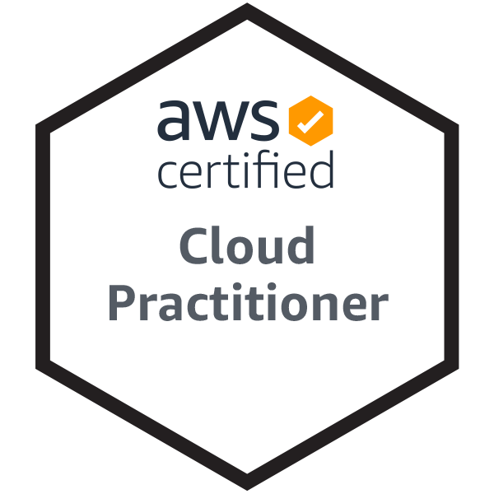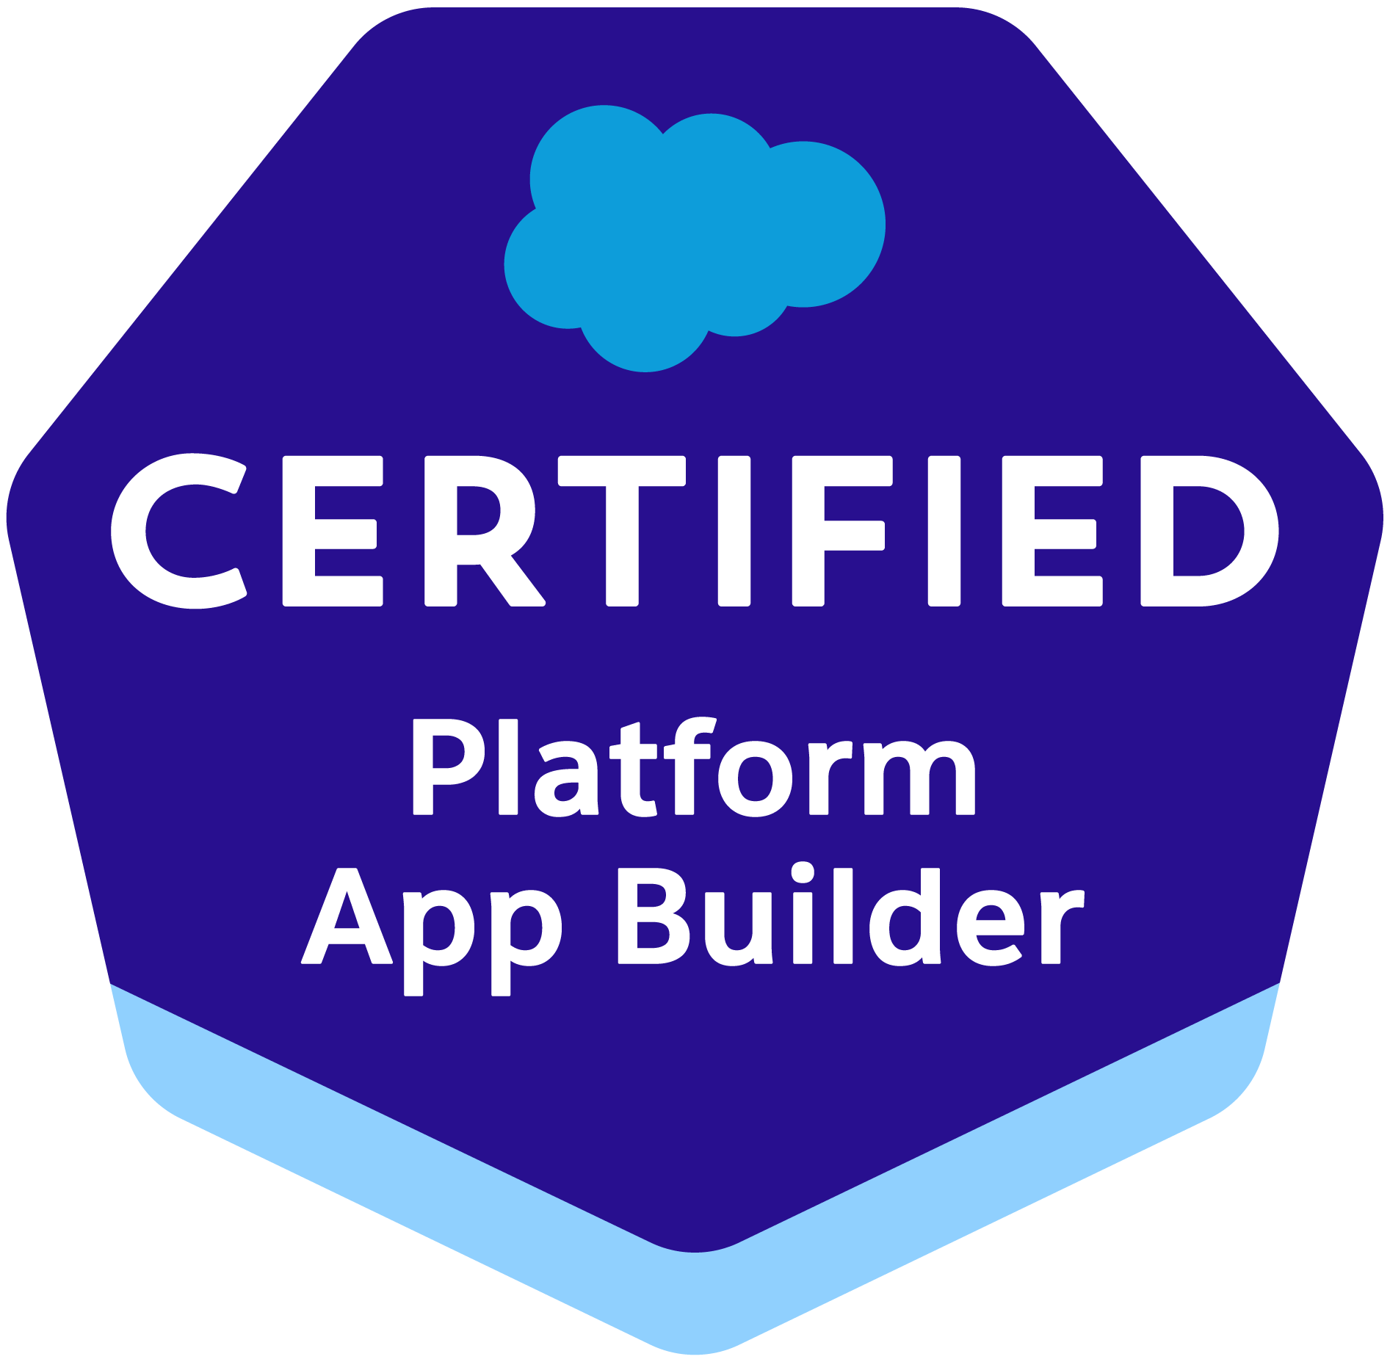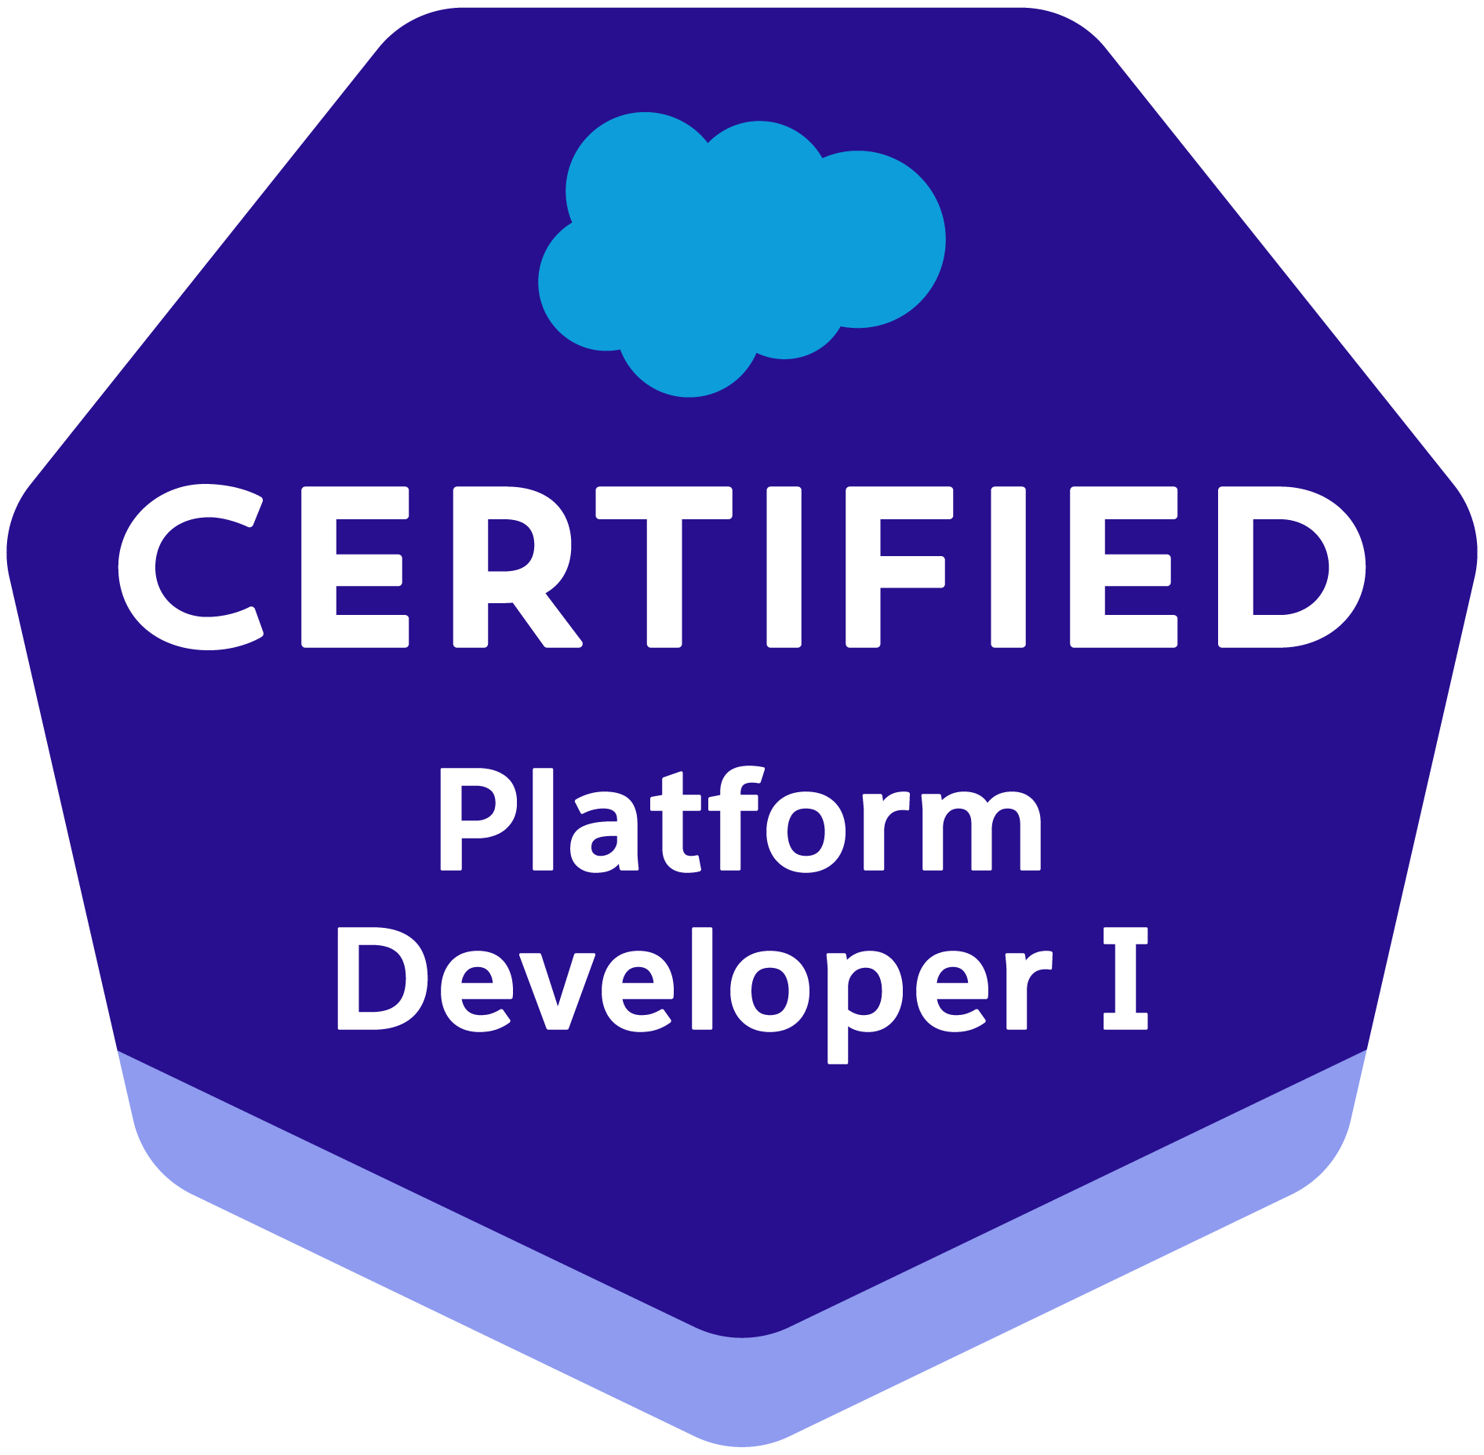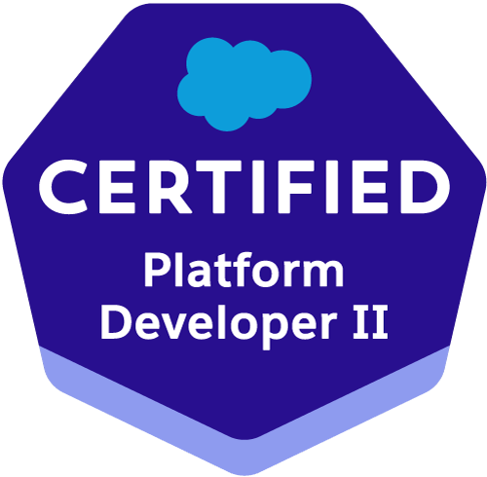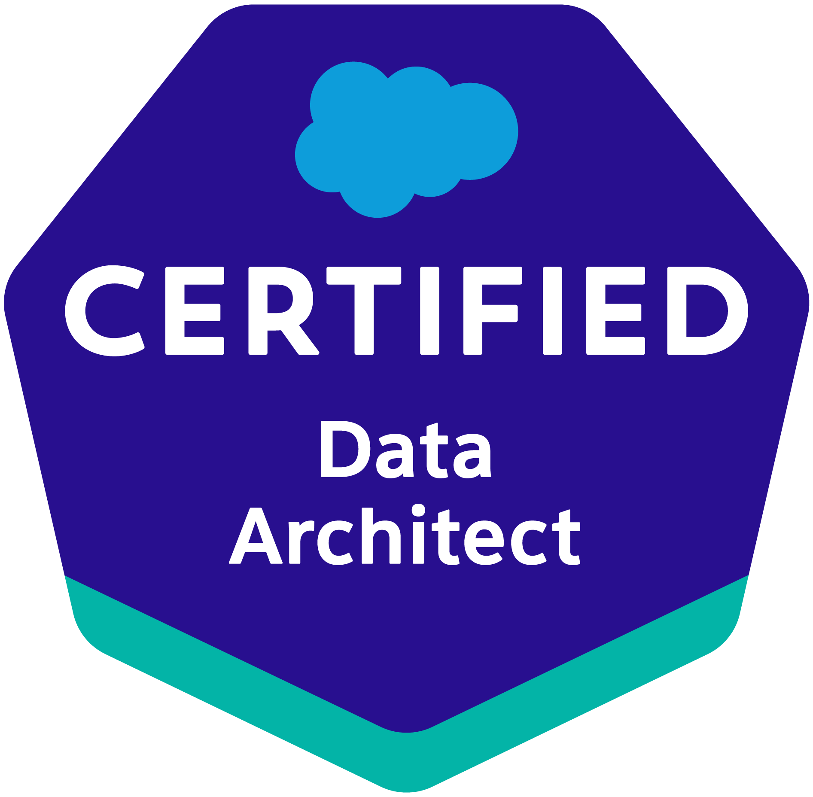
Profile Summary  - Around 9.5 years of Professional IT experience in SFDC technologies  - Experience in Development, Administration and Integration in Salesforce.com.  - Experienced in Sales Cloud and Service Cloud implementation  - Experienced in Apex Classes, Apex Triggers, Visual force pages, Aura and LWC  - Experienced in Force.com IDE Eclipse and Salesforce.com data tools (Data Loader).  - Experienced in Salesforce.com Administration (Creating Custom Settings,  Custom Metadata types, Roles, Sharing settings, Profiles, Permission sets,  Page Layouts, Workflows, and Approval process etc.).  - Experience in deployment methods like Change sets, Force.com IDE, Ant Migration  Tool, Flosum, VS Code and Jenkins.  - Experience in handling multiple projects and interaction with customer/product  owners.  - Having onsite exposure and client facing abilities.  CERTIFICATIONS  Salesforce.com Certified Data Architect.  Salesforce.com Certified Platform Developer 2 (PD2).  Salesforce.com Certified Platform Developer 1 (PD1).  Salesforce.com Certified Platform App Builder.  AWS Certified Cloud Practitioner.  EXPERIENCE  IBM India Private Ltd between April 2019 to Till Date  HappiestMinds Technologies between Jan 2014 to April 2019  EMC Corporation between April 2013 to Nov 2013 (SA Technologies Payroll)  PROJECTS  IBM India Private Ltd From: July 2021 to present  Client: Banking Corporation  Role: Senior Consultant  Duration: 10 months  The client is a banking company which uses the salesforce to search or verify the customer details by a support agent. Agents can be connected via chat/voice call to verify the customers and also update the customer details. Client is using LWC, Aura and integrations with multiple applications to help the agent to support the customers.  Responsibilities:  - Worked on the Lightning web components and Aura.  - Worked on Lightning Experience and classic.  - Worked on Rest API to implement the integrations between salesforce and multiple applications and Salesforce.  - Worked on Apex classes and triggers to implement custom logic.  - Worked on Lightning Message Services.  - Worked with multiple teams to implement the requirements.  - Involved in administrator activities like using permission settings, custom settings  and Custom Metadata etc.  - Involved in the deployment using Changeset, ANT, Flosum, SFDX and Jenkins.  - Used GitHub for release management and involved in the code review process.  - Involved in sprint story meetings and guiding the dev team for requirements and implementations.  IBM India Private Ltd From: Sep 2019 to June 2021  Client: Hertz  Role: Senior Developer  Duration: 20 Months  The Hertz Corporation is an American car rental company which uses multiple applications to keep the customers data and rental history. CMDR is an application where customers' enrolments and payments will be registered. Hertz wants to migrate the CMDR to salesforce to implement the rich UI and use the CRM capabilities to improve their rental process and use the automations to improve their business. Used Salesforce to process the data from multiple rental applications using MuleSoft.  Responsibilities:  - Worked on Rest API to implement the integration between MuleSoft and Salesforce.  - Worked on Apex classes to implement custom logic.  - Worked on Apex triggers for automation.  - Worked on Batch apex to create the records which were uploaded by ETL tools.  - Worked on Lighting Components (aura and lwc) to implement the rich User Interface.  - Involved in administrator activities like using permission settings, custom settings  and Custom Metadata etc.  - Used GitHub for the development and code review process.  - Involved in the deployment using Changeset, ANT, Flosum  IBM India Private Ltd From: May 2019 to Aug 2019  Client: Shell  Role: Senior Developer  Duration: 2 months  ITGC Cockpit is aimed at bringing transparency to the status of LOD1 control operation activities. It is the one stop shop for LOD1 control operations, with easy access to collected and easy to understand management reporting. An IRM tool, which is the source of the data coming into Salesforce through a third party.  Responsibilities:  - Implemented the approval process with multiple approvals.  - Implemented the triggers for the automation to create the related records.  - Implemented the Batch apex to create the related records as per requirements.  - Implemented the workflows for the sending email alerts and field updates.  - Created email templates for the email notifications.  - Involved in administrator activities like using permission settings, custom settings  and Custom Metadata etc.  - Involved in Deployments using changeset.  - Involved in Technical Design document update.  HappiestMinds Technologies From: Jan 2014 to Mar 2019  Client: OppLoans  Role: Technical Lead  Duration: 20 months  OppLoans is a US based payday lender and the scope of this project is to implement Cloud lending solutions for Loan origination, underwriting and Loan servicing on salesforce platform.  This platform is integrated KYC /AML verification service, Credit reporting and online payment  processing service (MicroBilt). The entire Loan processing is automated and the whole process can take a few minutes typically for loan application to disbursal and automated the payment process through ACH/RCC.  Responsibilities:  - Involved Technical Design / Solution Design and Technical evaluations of 3rd party vendors, code review.  - Implemented the Apex Rest services for Credit reporting and KYC verification service.  - Implemented the Batch apex for the payment process using ACH/RCC.  - Involved in administrator activities like creating static resources, custom settings and Custom Metadata etc.  - Extensively used Ant migration tool and GitHub for the migration process and version control.  Client: mCaaS-BoS-Forrester-Reprints POC  Role: Module Lead  Duration: 3 months  Forrester is a premier research company that works with business and technology leaders to develop customer-obsessed strategies that drive growth. The objective of this project is to communicate the Chatbot in real time with the salesforce for the customer enquiries about the products and related information. Based on the customer enquiries, created the cases in the Salesforce for further Investigations. Salesforce is used as a Back-End database which stores the product information and related details.  Responsibilities:  - Implemented the Apex Rest services to communicate with the Chatbot.  - Implemented the Batch apex to clean up the cases and related information frequently.  - Used the Salesforce Public sites.  - Involved in administrator activities like creating static resources, custom settings.  - Extensively used Ant migration tool and SVN for the migration process and version control.  - Designed the various email templates based on the business logic.  Client: Cadence Design Systems, Inc.  Role: Module Lead  Duration: 8 months  Cadence Design systems needs to migrate the existing COS 1.0 to a new platform COS 2.0 in  Salesforce.com with enhanced functionalities.  - Cadence community users to be able to communicate with cadence using Cadence Online Support system.  Responsibilities:  - Implemented Apex classes, Triggers and Visual force pages.  - Involved in administrator activities like creating static resources, custom settings and custom  - labels etc.  - Involved in Experience in implementing Visual force pages with multilingual languages.  - Extensively used HTML, CSS, javascript and jQuery.  - Extensively used Ant migration tool and SVN for the migration process and version control.  - Involved in Data migration activity from legacy systems to SFDC.  Client: Cadence Design Systems, Inc.  Role: Module Lead  Duration: 4 months  Cadence Design systems needs to migrate the existing search portal COS 1.0 to a new platform COS 2.0 in Salesforce.com with enhanced functionalities –  - Cadence community users to be able to perform Search through their Cadence Online Support system  - Search Enterprise engine through Google Search Appliances (GSA)  Responsibilities:  - Worked on salesforce communities to build the web pages.  - Implemented auto suggestion on Search through client-side integration.  - Involved in to identify the cross-domain issues and resolutions.  - Implemented Apex classes and Visual force pages  - Extensively used HTML, CSS, javascript and jQuery.  Client: Cadence Design Systems, Inc.  Role: Senior Software Engineer  Duration: 8 Months  The objective of the project is to migrate On-Premise Single-Sign-on to Cloud based OKTA with  Force.com Registration. New and /or Update User Registration screens and Account Management screens will be developed in cloud (Salesforce.com) and be able to seamlessly communicate with OKTA.  The portal technology, which served its purpose till now is slowly giving way to Salesforce  communities, which enables customer conversations about the brand in the organization’s backyard, thus seizing various customer interaction moments like answering customer service queries or giving details on the product.  Responsibilities:  - Involved in Implementation of Single Sign on for OKTA using Salesforce.com.  - Involved in Implementation of Registration and Login Process of four downstream applications  - using Salesforce.com for OKTA.  - Implemented Apex classes, Triggers and Visual force pages  - Responsible for creating workflows, process builders, email templates and validation rules  - Responsible for creating Batch Apex and Schedule apex.  Client: Sears Holdings Corporation  Role: Senior Software Engineer  Duration: 8 months  The objective of the project is to implement an Escalation Handling System to address chronic  complaint areas to encapsulate Member Resolution and Root Cause processes.  Built customized CRM solution based on salesforce.com Service Cloud Enterprise Edition.  Responsibilities:  - Configured email to case functionality and customized based on customer requirement.  - Worked on service console customization.  - Implemented Custom chatter capability.  - Extensively used apex, Visual-force, javascript and jQuery.  - Involved in the deployment process and handling deployment issues.  Client: Peerless Developers Ltd  Role: Senior Software Engineer  Duration: 9 months  A solution based on Salesforce.com Sales Cloud platform which consolidates various existing Legacy applications. Implemented state of the art technologies to drive operational efficiencies through increase customer reach and sales across the product portfolio i.e. Financial Distribution Business.  Responsibilities:  - Worked as Salesforce Developer and administrator.  - Implemented custom reports for the remittance process.  - Implemented the batch process to process large amounts of data in SFDC.  - Extensively used apex, Visual-force and data-loader.  - Performed configuration things like workflows, validation rules and approval process.  - Involved in deployment and handling deployment issues.  - Good exposure in customer engagement.  - Prepared Functional Design document and provided troubleshooting document.  EMC Corporation, India From: Apr 2013 to Nov 2013  Client: EMC Corporation, India  Role: Senior Software Engineer  Duration: 7 months  EMC is a global leader in enabling businesses and service providers to transform their operations and deliver information technology as a service. EMC offers data storage, information security, virtualization, analytics, cloud computing and other products and services that enable businesses to store, manage, protect, and analyze data. EMC provides the technologies and tools that can help you release the power of your information. EMC ranks among the ten most valuable technology companies. EMC is using Salesforce.com for CRM sales, Partner Management, and Custom application development on the Force.com platform.  Responsibilities:  - Created Apex classes, Triggers and Visual force pages for customizing the application.  - Responsible for Creating Page layouts, Record types, Roles, Profiles, Public groups and Queues.  - Responsible for Creation of Workflows, Approval Process and Validation rules.  - Responsible for production Deployment Coordination/Support.  - Responsible for optimizing the classes to fix run test errors during PROD deployment.  - Responsible for writing test class to increase code coverage  EDUCATION  M. TECH in Systems and Signal Processing - 2011  Jawaharlal Nehru Technological University, Hyderabad |  | SKILLS  Salesforce.com  Apex  Triggers  Visualforce  Aura  LWC  Workflows  Approvals  OWD  Sharing Rules  Profiles  Sites  Apex Data Loader  Chatter  Force.com IDE  REST API  SOAP API  Communities  Lightning Experience  Sales Cloud  Service Cloud  Sites  Reports and Dashboards  Other  Java  JavaScript  HTML  jQuery  Tools  Eclipse IDE  SVN  GitHub  VS Code  Jenkins  Bit Bucket  Flosum  Data Loader  Jitterbit

