CURRICULUM-VITAE

SHASHI KUMAR 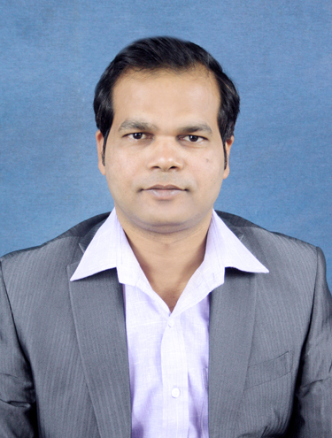

Kmr_sash11@yahoo.co.in
8826568724 / 9871093079
House no -343, G-10
Masjid Moth, south Ext-II
New Delhi-110049

CAREER OBJECTIVE

To excel in the field of marketing and to be a part of growth oriented team with a challenging environment.
SUMMARY OF PROFESSIONAL EXPERIENCE

- 11 years + of Professional experience in Business Development for IT Software Products and services
- Developed new business relations for business growth & sales close.
- Knowledge of (ERP, WEBSITE, BIDDING & e-Portal) IT products.
- Mapping Client Requirements and providing better Services for Selection of IT Software Products and services.
- Adept in Identifying Prospective Clients, Establishing Strategic Partnership and Alliances.
- Has the motivation to take independent responsibility as well as leading a Team.
- Collaborate with cross-functional teams from Marketing, Operations, I.T, analysis & reporting.

- PROFESSIONAL EXPERIENCE

- Sep 2019 to Till date Ecode Networks Ltd, London, U.K
- Business Development Manager-International
- Generate and qualify inbound and outbound leads, often acting as the first person to speak to a potential customer.
- Organize and prioritize outreach, demos, and follow-up to qualified prospects.
- Generate and manage sales pipeline
- Created strategic partnerships across all management levels
- Worked closely with Sales Director to prospect, pitch & close new business
- Built and maintained business relationship with target clients
- Prepare regional strategy and sales meetings, both internal and external
- Supported Sales team with market analysis and assessment of competitors
- Social media marketing

- April 2018 to Sep 2019 RSN InfoTech Pvt Ltd, Gurgaon
- Business Development Manager
- Generating New Business from bidding portals. Handling International & National Clients
- Proficiency in writing and reviewing proposals for online market.
- Making quotes, technical proposals & doing market research.
- Handling the team & Maintaining Weekly, Monthly reports.
- Contacting potential clients via email or phone to establish rapport and set up meetings
- Maintain Look ahead sheets.

- February 2017 to Dec 2017 WeCart Online Solutions, Karol Bagh, New Delhi
- Business Development Manager
- Generating new business from bidding portals. Identifying new sales leads
- Maintaining fruitful relationships with existing customers
- Contacting potential clients via email or phone to establish rapport and set up meetings
- Pitching products and/or services. Planning and overseeing new marketing initiatives
- Contacting clients to inform them about new developments in the company's products
- Developing quotes and proposals
- Negotiating and renegotiating by phone, email, and in person
- To keep healthy relationships with clients, this mostly requires socialisation.
- Able to provide quality leadership to a large team of sales people
- The ability to handle pressure and meet deadlines
- Excellent time management and organization.

- April 2015 to January 2017 Xtracare Business Solutions Pvt ltd, NSP Pitampura
- Business Development Manager

- Generating new business from bidding portals.
- Understanding of IT industry and terms like web designing & Development, web applications,SEO
- Responsible for generating, maintaining and managing strong relationships with the client
- International Client handling, International Client Support, International Marketing.
- Expertise in negotiation and deal closure.
- Ability to write proposals, ability to estimate the project price based on the requirement gathered.

- February 2014 to Dec 2014 Tee Innovation, Indirapuram, Ghaziabad
- Business Development Manager (Online Bidding)

- Generating new business from bidding portals.
- Responsible for generating, maintaining and managing strong relationships with the client
- Writing proposal, RFP, RFI responses for prospects, follow up, requirement gathering, link between the development team & client.
- Making cold calls to leads generation, and following up the E-mails and reply.
- International Client handling, International Client Support, International Marketing.
- Communicates regularly with client to ensure satisfaction with newly placed individuals and resolves issues promptly.
- Responsible for all documentation with the Client once the candidate is placed.
- Proficiency in writing and reviewing proposals for online market.

- December '09 to January 2014 Wow Technologies International Pvt.Ltd, Faridabad
- Asst. Manager (Business Development)

- To identifying the new clients particularly in Pan India.
- Mainly focusing to the Software (ERP) and website, Direct Marketing, online marketing, Branding.
- Developing new business relation with national & international Clients.
- Developed concept and created marketing tools & programs to maintain strategic alliances.
- Making cold calls to leads generation, and following up the E-mails and reply for school and college management systems.
- Fixed up the meetings with the head person of the company.
- Handling the team & directly report to the Senior Person.
- Making quotes, technical proposals & doing market research.
- Preparing the data through the different search- engines to find the right contact person.
- EDUCATIONAL QUALIFICATION
- PGDBM (Post Graduate Diploma in Business Management) in July, 2008-10 NIILM-CMS, New Delhi.

- B.I.T (Bachelor in Information Technology ) IGNOU,New Delhi

- ISc ( Intermediate in Science ) B.I.E.C.E, Patna

- TENTH CBSE,New Delhi

- Date Shashi kumar
- Place

