Naman Jain

# PROFILE

ADM-201 Certified Salesforce Admin, Certified Sales Cloud

Consultant and Proficient in Agile Methodology. Salesforce

Administrator/CPQ Specialist/FSL Expert.

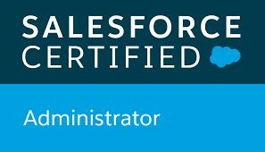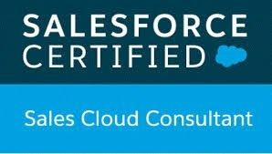

# SKILLS

## EXPERT SKILLS

Salesforce Administration, CPQ, Field Service Lightning, Sales Cloud, Service Cloud, Pardot, Community, Conga, DocuSign, Adobe Signature, Salesforce Automation Tools, Manual Testing

**CPQ SKILLS**

CPQ configuration, Price rule, Product rule, Advanced Approval, Quote Template, Guided Selling, Renewal & Amendment, Product Bundle Configurations, VF templates, Document Generation using Conga, Docu sign

## BEGINNER SKILLS

Apex, Lightning Component, Visualforce Development,

HTML, CSS

## Area Of Interest (Basic Knowledge)

Marketing Cloud, Health Cloud, Non-profit Cloud,

Accounting seed

# CONTACT

**PHONE:**

+91-9660909200

**LINKEDIN**​: https://www.linkedin.com/in/naman-jain-44072a159/

**EMAIL:**

Namanjn284@gmail.com

**ADDRESS:**

134, Bus Stand - Mahua, tehsil – Mandalgarh, Dis.- Bhilwara

(311604), Rajasthan, India

# ACTIVITIES AND INTERESTS

Traveling, Trekking, Cooking

**WORK EXPERIENCE**

### Appcino Technologies Pvt. Ltd. (Jaipur, Rajasthan. India ​*Sep*

*2018– May 2021****)***

***360 Degree Cloud Technology (Faridabad, Haryana*** *May 2021- Present****)***

Working as a Salesforce Administrator, CPQ Specialist, FSL Expert and Manual QA. Responsible for Requirement Analysis and implementation of the requirements provided by the

Customer in an efficient manner. Experienced with Agile

Methodology.

## PROJECTS

### Salesforce CPQ - Cognex

* Implement Salesforce solutions for customers on Sales, Service and CPQ environments.
* Used data loader to load the products and worked on the product configuration with features, options and product rules according to the client’s requirement.
* Configured Products, Bundles, Bundles within Bundle, Price Lists across all products.
* Implemented product rules and price rules as per the business requirements.
* Created Quote templates as part of quote generation.
* Created and organized usage-based products including invoice usage related to order products.
* Maintain multiple user roles, security, profiles, and workflow rules, Flows.
* Complete bulk imports of data using Apex Data Loader.
* CPQ Contracts lifecycle management like amendments.

### Document Generator With CPQ Implementation – GE/Aviation

Worked on a ​**Document Generator** ​product where users could select several object’s merge fields and the fields from their child objects.

### Service Cloud - FSL centric Organizations - Willington

Worked for a client on Several projects involving ​**Service Cloud** Implemented ​**Field Service Lightning** for the Client.​ Major emphasis was on ​**Salesforce’s Declarative Approach**​.

## EDUCATION

### Apex Institute OF Management & Science, Jaipur

*2014-2017*​. Bachelor of Computer Application (Agg. 67%)

*2013*​. Shiv Jyoti Sen Sec School, Kota with 59%

*2010*​. Govt Sen Sec School, Mahua with 69%