## Chaitanya Makani

## +91 7022448696

**AWS Certified SysOps Administrator  
Associate Level  
August 2019**

**CAREER OBJECTIVE:**

An experienced IT professional with Bachelors in Computer Science and Engineering, Linux System Administrator with 5 Years of professional experience .Currently working as Senior software Engineer at Tech Mahindra ltd.

**WORK EXPERINCE:**

* Having 5 years of experience in **Linux System Administration**, **DEVOPS**, certified in **AWS SysOps Administrator Associate** and **Oracle Cloud Infrastructure.**
* System Engineer at Neviton Softech Pvt ltd, Bangalore from July -2016 to August 2017.
* Technology Analyst at Infosys, Bangalore from August 2017 to Dec 2018.
* Worked at Tech Mahindra Ltd. as Senior Software Engineer from Dec 2018 to Dec 2019
* Currently working in DXC Technologies ltd. From Dec 2019.

**Academic Profile:**

* B. Tech from Jawaharlal Nehru Technological University.
* Done my PUC at VidhyaVikas junior college, Eluru with 77.9%.
* Done SSC from Vidhya Vikas Residential schools, Eluru with 84.5%.

**Technical Skills:**

* Operating System: Red hat Linux 6 &7, UBUNTU, Windows, and Centos.
* Advanced file System management : LVM.
* Network File Sharing Services : NFS and FTP Server.
* Monitoring Tool : Nagios.
* Configuration management : Jenkins.
* Scripting language : Shell scripting.

**Experience Summary:**

* Technical background with approximately 5 years of Production Administration and project experience in Linux Systems and AWS Infrastructure.
* Performance Monitoring on Linux Systems.
* Extensive space allocation to various applications upon requirement, detaching and clearing the devices if not in use.
* Responded to all Linux System problems 24/7 and resolved them on a timely basis with communication with clients and end users as a part of daily job.
* Worked on Service now ticketing tool and assigning tickets, responding back to the users and resolving them as per the SLA.
* Proven Ability to identify problem, analyze possible solutions and determine best course of action to meet objective.
* Updating Internal Wiki with new procedures, troubleshooting steps for common issues.
* High adaptability to any new business to any new business environments with ability and willingness to learn latest developments in emerging technologies.
* Working on AWS with the features of EC2 setting up under virtual private network (VPC) on AWS and provisioning cloud Instances.

**AWS Cloud Administrator:**

* Migrated EC2 Instances to private cloud environment and created security groups ACL’s and route table, NAT and IGW for the VPC.
* Moving web application servers running in on-premises to AWS cloud.
* Planned, implemented and controlled user and account security rights and restrictions using IAM and MFA
* Working on AWS Cloud services such as ELB, Auto scaling, Cloud watch, Cloud Trail etc.
* Used S3 Object storage services (Cross region replication, Versioning, Life cycle management for taking snapshots of Storage volumes and archival of data using glacier.
* Creating and attaching Elastic block storage for Instances in Cloud environment and scaling them as Clients requirement.
* Worked on database services such as RDS, Redshift, Aurora etc…
* Managing application cluster servers for uninterrupted availability of services using HA cluster using Elastic load balancing (ELB).

**Linux Administrator:**

**Roles & Responsibilities:**

As a Linux System Administrator, I involved into the following Roles & Responsibilities.

* System administration, maintenance and monitoring various day-to-day operations
* Installation & Configuration Red Hat Enterprise Linux.
* Installation and Managing of Packages using RPM and YUM.
* User & Group Administration and Resolving the user related problems.
* Automated few daily jobs such as disk, memory and CPU utilization monitoring on Linux systems which throws a alert using shell script.
* Automation of jobs using AT & CRON tab utility.
* Setting up file, folder permission using by ACL, SUID, GUID, Sticky bit and adding users to the Sudoers file if needed.
* Remote applications like SSH, SCP, RSync.
* Creating SSL certificate and making Web service of application more secured.
* Backup & Restoration by using TAR.
* Creating and managing SWAP Space management.
* Configuring and Managing Logical Volume Manager (LVM).
* Monitoring disk status, system processes, user process activity, memory activity, and Network, memory and Swap space management.
* Experienced in handling production Application Servers.
* Giving access to new users by generating new SSH keys and allowing them with specific permissions.
* Configuring Nagios monitoring on both client and server side on Linux servers.
* Installing and configuration of Tomcat server as per the requirement.

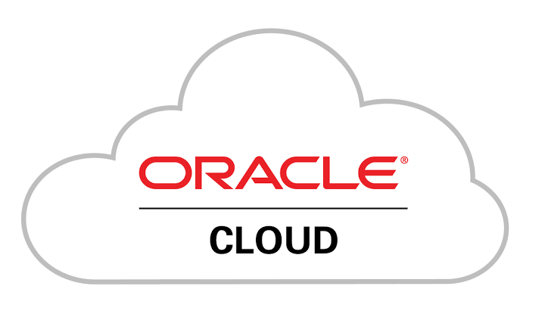

**Oracle Cloud Infrastructure:**

* Deploying, managing, and operating scalable, highly available, and fault tolerant systems on Oracle Cloud
* Migrating an existing on-premises application to Oracle Cloud
* Worked Oracle cloud EBS, networking, Orchestrations and various service in OCI.
* Orchestrated Server build by JSON script auto-built 50 Servers.
* Received appreciation in delivering the project with-in timelines and minimal manual intervention in build process.
* Worked on Cloud Endure which is used for migration of servers on different platforms without a downtime.

**Declaration:**

I here by declare that all the information made above is true to the best of my knowledge.

Place: Bengaluru.

Chaitanya M.