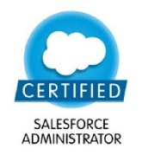
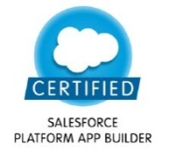
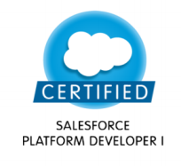
Shashi Ranjan

Mobile: - +91-7760168686
Email: - shashisforce13@gmail.com

OBJECTIVE:
To work for an organization where I can apply my technical, managerial and creative skills up to my best to achieve organizational goals and continuously strive to learn new skills in pursuance of an objective of becoming a competent software professional and build a promising career.

Professional Summary:

- Involved in Implementation & Support Areas in both customization and configuration.
- Analyzing the functional Inputs and developed the technical specification documents.
- Actively involved in the overall development of the Project.
- Experience in making Proposals for Business Development, interacting with the client, gathering the requirements and distributing it to the team.
- Worked on multiple projects for end-to-end implementation as a single resource

Technical Summary:

- Apex classes, Triggers and Test classes, Chatter Development
- Visualforce pages & Controllers, Extensions
- Lightning Components – Aura and LWC
- Validation Rules, workflow processes and Approval Process
- Security Model of Salesforce – Profiles, OWD and Managed sharing
- Reports- standard salesforce.com applications
- Production deployments and salesforce.com administration
- Technical and functional documentation
- Communities (using Standard Salesforce Template – Visualforce+Tabs and Custom Templates like Napili, Kokua and Koa)
- Experience in Release Management via Change Set, Metadata and Eclipse
- Worked on 3rd party apps such as Configero and Tibco Spotfire
- Experience on deployment tool like Copado and Amplify DX

Professional Experience:

Organization Name | Role | Duration
Accenture Solutions Private Limited | Application Development Analyst | May 2021-Till date
Deloitte India | Consultant | May 2017-May 2021
Accenture Solutions Private Limited | Software Engineer Analyst | November 2013 – April 2017

Academic Qualifications:
- B.E. (CSE) from SDM College of Engineering & Technology, Dharwad with aggregate of 88% during period 2009-2013.
- Class XII (CBSE) from St.Karen's Senior Secondary School, Patna with aggregate of 74.4%in 2008.
- Class X (ICSE) from St.Karen's High School, Patna with aggregate of 90.8%in 2006.

Certifications:
- Salesforce Certified Administrator (ADM - 201)
- Salesforce Certified Platform App Builder(DEV - 401)
- Salesforce Certified Platform Developer 1
- DocuSign CLM Administrator

Personal Strengths:
- Flexible, Adapt easily and creatively to new environments.
- Work effectively in team-based environment.
- Maintain composure under pressure and react positively to changing events.
- Strong interpersonal skills & communication skills.
- Have Positive Attitude and Willingness to Learn New Things.

Personal Details:
Name : Shashi Ranjan
Father’s Name : Balindra Prasad Singh
Date of Birth : 23-Oct-1989
Address : H. No- 15/A, North S.K. Puri, Patna – 800013, Bihar
Gender : Male
Marital Status : Married
Nationality : Indian
Languages : English, Hindi
Strengths : Positive Attitude, Punctuality, Hardworking

Declaration:
I hereby declare that the entire statements and information make in this are true and correct to the best of my Knowledge and Belief.

Place: Delhi
Date: (Shashi Ranjan)

