Akash Tammewar
Software Test Engineer with 13+ years of IT experience




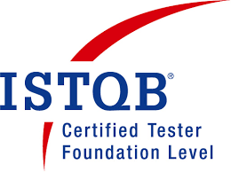
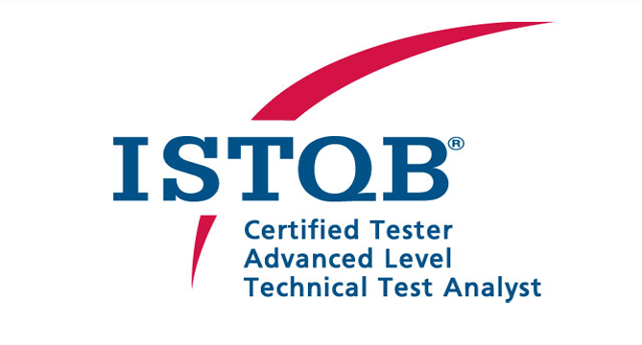
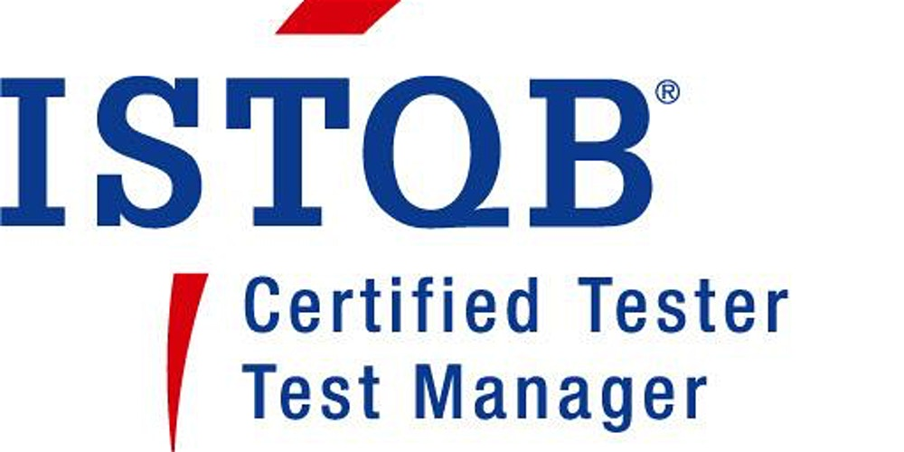

HIGHLIGHTS
- Primary Skills:
- Software Test Engineer / Test Management
- Scrum Master
- Additional Skills:
- Tools/ Technologies: ALM/ Quality Center 12.00, JIRA, MS SQL Server 2016, UNIX
- Product owner, Business Analyst
- Domains:
- Banking Financial Services and Insurance, Risk Management

SUMMARY
- Expert in Agile Scrum methodologies with 4+ year experience in functioning as Scrum Master
- Experience in software testing in BFSI domain with 10+ year experience
- Experience in client interaction and customer relationship management
- Expertise in requirement analysis and test plan preparation for the project
- Experience in preforming Team Lead role in creation and execution of QA and testing tasks for test strategies, test plans, and test design specification
- Experience working closely with Manager in handling 50+ QA team members team and individually handed 10 QA members team
- As a scrum master responsible for ensuring daily stand-ups and other scrum ceremonies for two scrum team takes place, Work with Product Owners for Product backlog grooming and sprint planning, Track, escalate and remove impediments and involved in conducting retrospective meetings.
- As a scrum master coaches and mentors agile team members to utilize Agile Methodology with Scrum, and modelled core agile principles of collaboration, prioritization, team accountability and visibility.
- Ensured consistent application of scrum methodologies across different sprint team and encourage team for self-organization to boost the efficiency and coordination, Evangelized the benefits of Scrum to ensure its smooth adoption.
- As Agile expert help team in learning self-organization, training about agile scaling, facilitate scrum of scrum, ensures business agility across organization.
- Work with Product Owners to develop project roadmaps which align to business objectives, Helping PO to do prioritization and write stories using INVEST and Definition of Ready
- Adequate knowledge of UNIX commands
- Experience in performing individual contributor role and have team leadership experience
- Specialized in Software Quality Assurance and project management
- Extremely proficient in accomplishing end to end test management using Quality Center 12.0
- Sound knowledge of system and integration testing for web-based applications
- Good knowledge of Software Development Life Cycle (SDLC) process
- Skills include Functional Test Engineer, Scrum Master, project management, test plan, test strategy, test estimation, test management, and test summary report
- In-depth understanding of various systems and applications used in the banking industry such as core banking, general ledger systems, having worked with industry majors such as HSBC Bank
- Extensive knowledge of Quality Audit for testing process
- Extensive knowledge of testing methodology
- Ability to work under stringent time lines and meet predefined project goals
- Good team player with good communication and interpersonal skills, good analytical/ logical skills, excellent work ethic and ability to lead a team
- Achievements:
- Winner of Surpass Award for Q2 for successful release of the project
- Received Employee of the Month award for critical delivery for financial component
- Received surpass award for Q2 for handling Client deliverable and completed on time
- Nominated for SPOT Award twice
- Received Oscar Award – Annual award for Best QA, Synechron Technologies Pvt. Ltd.
- Nominated for Surpass Award for Q4, Synechron Technologies Pvt. Ltd.
- Received STAR Award from the client for most defects found for the release
- Received TEAM award twice for outstanding performance as a TEAM, HSBC
- Onsite exposure:
- Travelled to Chicago (United State) in 2017 to handle Client Critical deliverable
- Visa:
- H1B, valid till Dec 2020
- B1 (Business Visa), valid till Sep 2027

EDUCATIONAL QUALIFICATION
- Bachelor of Engineering (Computer Science and Engineering), Amaravati University, Amaravati, Maharashtra

TRAININGS/ CERTIFICATION
- CSM Certified Software Professional
- Certified Scrum Product Owner (CSPO) Certified Software Professional
- AINS 24 – GENERAL INSURANCE FOR INSURANCE AND IT PROFESSIONALS
- ISTQB Certified Software Tester:
- Foundation Level
- Advanced Level – Test Analyst
- Advanced Level – Test Manager
- Prince2 Certification Professional:
- Foundation Level
- Practitioner Certified

PROJECT EXPERIENCE
Synechron Technologies Pvt. Ltd., Pune Jan’10 till date
Project 1: Kraken - Risk Feb’19 to Aug 20
Client: Wells Fargo, USA
Role: Software Test Consultant
Description: Kraken is an integrated software platform with various trading systems such as Market Data, Calypso, Catalyst, Risk Analytics, and RFQ. It is a system which deals with various type of bond security such as agency, treasury, and government bonds. It provides real time risk analysis to trading desks. It consists of pricing engine which streams prices to Bloomberg, Trade Web, and multiple other exchanges. Trade Engine generates trade based on market data and relation specified by traders.
The Agile - Scrum methodology used in this project.
Team Size: 12
Responsibilities:
- Performed individual contributor role: Involved in test case writing, test execution, and defect management
- Engaged in automation of test cases execution for multiple releases
- Developed test strategy, test scenarios, test plan, and test cases for functional testing
- Involved in black box testing, and performed integration and regression testing
- Responsible for test case review and test coverage
- Responsible for preparation of estimation and preparation of weekly/ monthly status report
- Resolved conflicts related to functional understanding/ defects/ issues, concerns for Testing Team by communicating to BA Team and client whenever necessary
Environment: Java, AngularJS, ALM, JIRA, Wiki

Project 2: Marsh - ClearSight Jun’10 to Jan’19
Client: Marsh, USA
Role: Software Test Engineer / Scrum Master
Description: Marsh McLennan is a world leader in delivering risk and insurance services and solutions to his clients. We have developed web based application called Claim Admin which is used by leading insurance companies, TPA, Individual organizations that manage their own claims, process the insurance claims, and claim administrations.
The Agile - Scrum methodology used in this project.
Team Size: 60
Responsibilities:
- Leaded a team for 10 members responsible for task allocation and tracking automation and manual task
- Help teams in identifying deviation from scrum methodology and corrected it
- Helped different teams in adopting scrum framework and form scrum teams, ensure consistent application of scrum methodologies across different sprint team and encourage team for self-organization to boost the efficiency
- Coaching teams on agile, scrum methodology, learning self-organization,
- Drives continuous improvement initiatives at the team level
- Bring efficiency by tracking working agreement noted from retrospective ceremony till closure
- Ensure grooming meetings are consistently held to have stories in Ready status for next sprint
- Facilitating backlog refinement, sprint planning, review and retrospective events at the team level
- Maintaining relevant metrics to help the team monitor their performance
- Performed individual contributor role: Involved in test case writing, test execution, and defect management
- Engaged in automation of test cases execution for multiple releases
- Attended daily Scrum and provided progress report to client on daily, weekly, and sprint delivery day as per the requirements
- Performed Scrum Master role in this project
- Developed test strategy, test scenarios, test plan, and test cases for functional testing
- Involved in black box testing, and performed integration and regression testing
- Responsible for test case review and test coverage
- Responsible for preparation of estimation, and preparation of weekly/ monthly status report
- Resolved conflicts related to functional understanding/ defects/ issues, concerns for Testing Team by communicating to BA Team and client whenever necessary

Environment: Java, TestNG, Silverlight, Oracle, AngularJS, Eclipse, Quality Center 12.0, JIRA, Wiki

Cybage Pvt. Ltd., Pune Dec’06 to Jan’10
Project 1: One HSBC – HFE Teller Dec’06 to Jan’10
Client: HSBC, USA
Role: Software Tester
Description: In conjunction with the deposit account migration to core banking, HBUS will implement the Group’s Hub Front End (HFE) Teller System for processing financial transactions in branch locations and money centers against Core Banking and Legacy system accounts. HBUS branches will convert from the existing Online Teller system to the Group sanctioned HUB Front End (HFE) Teller System.
HFE teller is a new development as a part of One HSBC. HFE teller has various functionalities such as check withdrawal and cash deposit which will be performed by a teller in a branch. These transactions when involving an HBUS legacy account will be routed to PTW. PTW will process these requests on the basis of the request. PTW will perform the following functions for transaction requests from HFE teller. HFE teller allows transfers from any HFE account to any HFE account.
Team Size: 25
Responsibilities:
- Involved in black box testing, and performed integration, GUI, and regression testing
- Responsible for identification and documentation of defects
- Prepared test cases according to project requirements and involved in review of test cases
- Module Lead: Led a team of three resources and allocated work to the resources
- Coordinated with ONC and POC for resolution of queries, reports, and the normal follow up

Environment: J2EE, Mainframe, AS/400, DB2, Quality Center 9.2, JIRA, Wiki

Compulink Systems Ltd., Pune Mar’06 to Dec’06
Project 1: Project Management System (WhizibleSEM) Mar’06 to Dec’06
Client: Wipro, Accenture
Role: Software Tester
Description: Whizible™ is a solution of choice to manage the entire cycle from initiatives to projects for Corporate IT; IT Services and Engineering Services. Over 150 leading organizations world over depend on Whizible™ to help them 'Do the right things and do them right'
Whizible™ SEM (Service Execution Management) product aims at enhanced visibility into the projects and service delivery aspects across the various stakeholders, including senior management and customers of the organization by providing alerts and dashboards. Whizible SEM optimizes resources, mitigates risks and facilitates compliance and financial prudence. This web-based solution allows geographically dispersed teams to collaborate on projects and optimize the delivery.
Responsibilities:
- Identified and documented defects
- Responsible for preparation of root cause analysis report for the defects
- Prepared test cases according to project requirements
- Performed integration, GUI, and regression testing

Environment: .NET, Oracle

