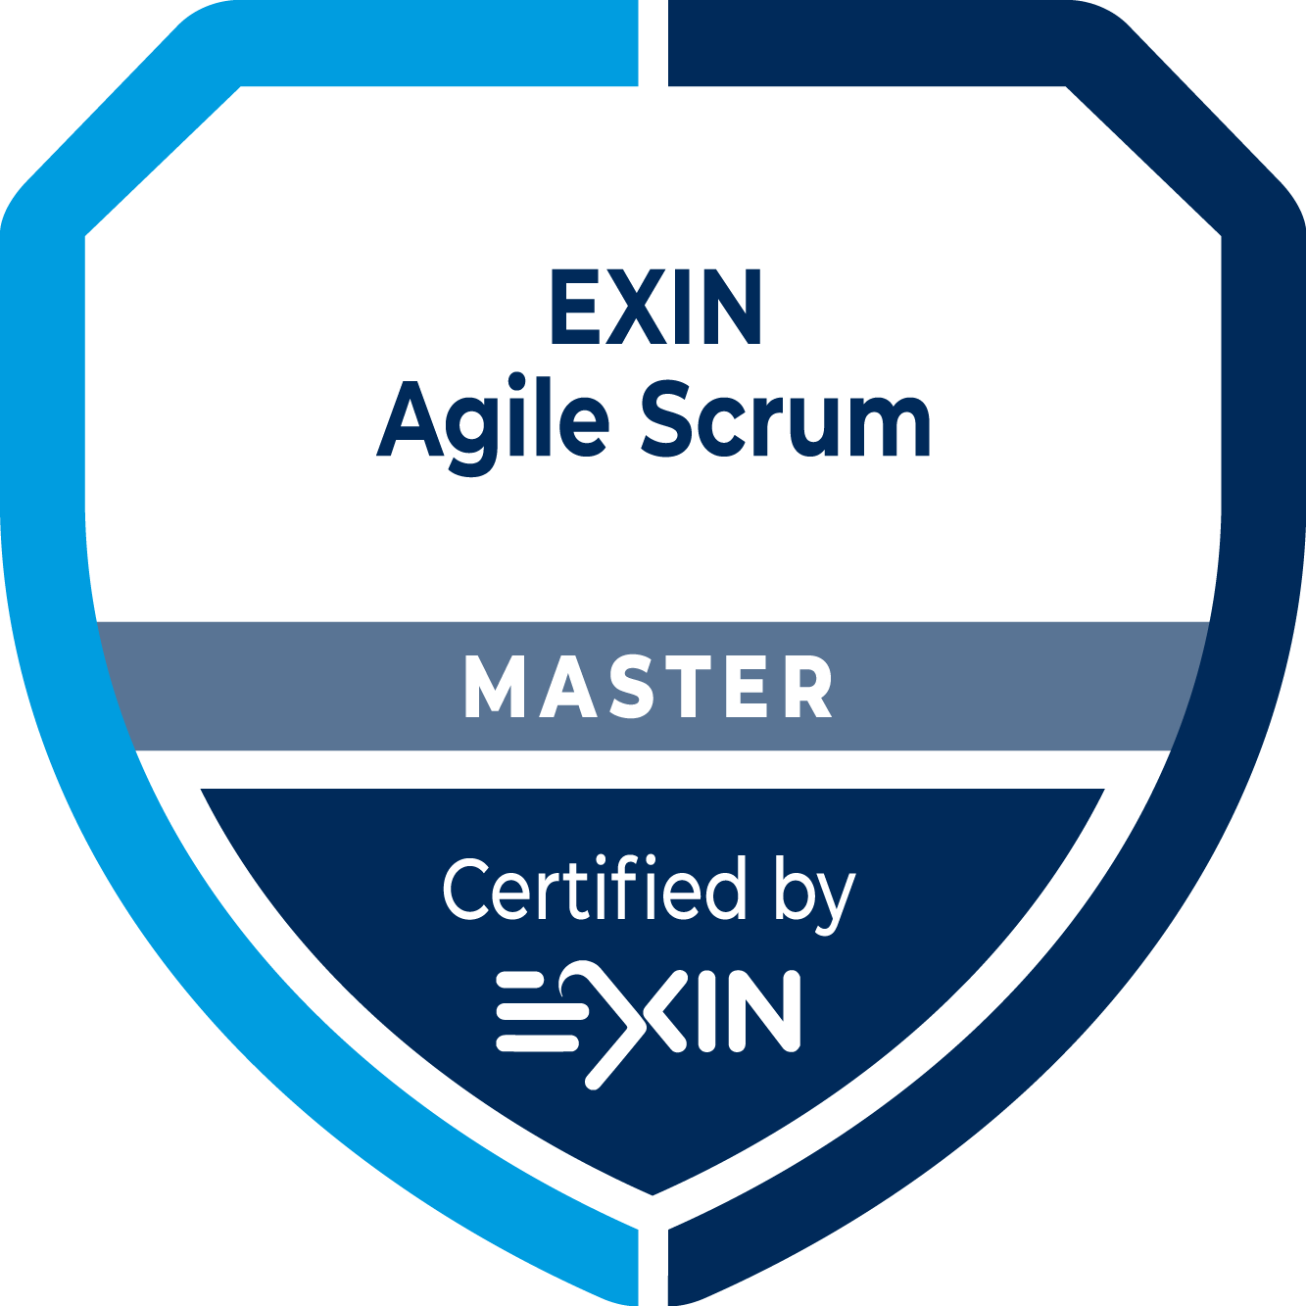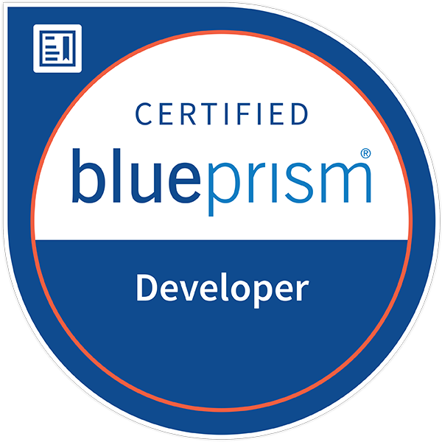**Ranjit Miryala**

**RPA Lead Automation Specialist**, Los Angeles

[**ranjit.miryala1@gmail.com**](mailto:ranjit.miryala1@gmail.com) **+1-917-535-5331**

[**https://www.linkedin.com/in/ranjit-miryala/**](https://www.linkedin.com/in/ranjit-miryala/)

**Professional Summary**

* Overall **9+ years** of professional IT experience, includes **5+ years** in **Robotic Process Automation** & **4+ years** in **Software Automation.**
* **Certified - Blue Prism Accredited Developer AD01** & **EXIN Agile Scrum Master.**
* Excellent skills in automating **Business Process Automation at the enterprise level.**
* Proven success in implementing **30+ RPA processes** ensuring effective savings to clients.
* **Introduced RPA to various business teams** & supported with Opportunity Assessment.
* Involved in all **RPA life cycle** – **Planning, Development, QA, UAT, Release Activities & Production Support**.
* Strong experience in **Blue Prism Upgrade Strategies** from V5.0.24 to V6.4.3a & V6.6.
* Strong experience in **leading offshore teams** includes Developers, Process Controllers & QA resources.
* Worked on **Queue Configuration, Monitoring, Multi Bots, Exceptional Handling, Stages, Blocks, Session & Environment Variables** for processing Processes.
* Prepared & reviewed **Process Design Document** (PDD) & **Solution Design Document** (SDD).
* Strong experience in **production support by resolving issues** in short notice.
* Strong experience in automating applications like **SAP, Java, PDF, Web API, REST API, SOAP, Workday, SOXHUB apps, Microsoft, Web-based** & various other windows applications.
* Experience in integrating **Chat-Bot, Message Media API & other Artificial Intelligence** with RPA Blue Prism.
* Good knowledge on **Blockchain, BTC, ETH Smart Contracts & Hyperledger** concepts.
* Good knowledge of other famous RPA tools like **Microsoft Power Automate,** **UiPath**, **Automation Anywhere** & various **Artificial Intelligence** technologies**.**
* Strong experience working with **Agile, Scrum & Waterfall** software development methodologies.
* Outstanding experience in various domains like **Finance, Entertainment & Travel Industry sectors**.
* Proficient in management tools like **JIRA/Confluence.**
* Good Knowledge in programming languages like **Python, Solidity, Java, JavaScript, C#.NET & Excel Macros.**
* Exceptional ability to quickly master new concepts with strong **problem solving, analytical skills, interpersonal abilities, communication skills, time management & team skills.**

**CERTIFICATION**

**Blue Prism Accredited Developer - AD01 Mar’18**

**Pearson | VUE,** Registration#: 332409169 Validation#: 422055472

**Agile Scrum Master - ASM Nov’17**

**EXIN,** Reference Code: 6131634.2071377

**EDUCATION**

**Master’s in Computer Science, USA Sept’15 - Feb’17**

**Fairleigh Dickinson University**

**Bachelor of Technology in Electronics and Instrumentation Engineering, India Jun’08 - May’12**

**Amrita School of Engineering**

**WORK EXPERIENCE**

**Client: Sony Pictures Entertainment, Culver City Nov’18 – till date**

**Role: Full Time - RPA Lead Automation Specialist**

**Environment** Blue Prism V6.6, V6.4.3a, V5.0.24

**Responsibilities**

* Involved in end to end development of Business Processes using RPA – Blue Prism.
* Provide direction and support to Automation Specialists and Digital Workforce Leads.
* Ensure that Automation Specialists can perform role effectively and train the Digital Workforce Leads on development and process controller function.
* Identify best option for addressing automation requests from the business teams.
* Develop bot processes, automation based on agreed upon Process Definition and Solution Design documents, including inputs, process, outputs, exception paths, error handling and focusing on the more complex processes.
* Follows, enforces, and makes recommendations to improve standards, guidelines, and leading practices.
* Seek and build relationships through assignments on individual efforts to enhance delivery and to better understand, identify, and work through issues across efforts. Effectively escalate within Project teams, direct and indirect leadership when issues arise.
* Support existing processes and update in case of change requests with structured change control process.
* Provide support for any production issues.
* Reviewed key documents like Process Definition and Solution Design documents.
* Stay abreast of Artificial Intelligence and Robotic Processed Automation related technologies and evaluate and recommend products / tools.

**Company: Hermes Network Inc.**

**Client: American Express, New York Sept’16 – Nov’18**

**Role: Contract - Automation Specialist**

**Environment** Blue Prism V5.0.24

**Responsibilities**

* Involved in E2E development of Business Processes using Robotic Processed Automation – Blue Prism.
* Designed, Developed robot processes in accordance with standard and guidelines.
* Developed E2E automation robots, which involves analysis, feasibility study, technical, architecture, development, testing and production deployments of processes.
* Supported existing processes and updating the change requests with structured change control process.
* Worked with the project management to translate process in to Process Definition Document & Solution Design Document.
* Worked on Blue Prism Credential Manager for securing, maintaining and retrieving the user credentials.
* Worked on automation of web-based, excel, MS Office, Outlook and non-Win32 applications.
* Using Excel VBO object to perform operations in excel sheet while taking excel sheet data as input.
* Fixed, resolved and closed defects that arise in day to day running of automated processes and providing timely responses and solutions as required.
* Utilized various actions like condition and loops, collections, user prompts, error logging, and exception handling for designing automation process.
* Spoken with Blue Prism on programming issues, proposed changes and taking an interest with different designers in Blue Prism Community
* Broke down process into reusable objects using object studio and utilized in building efficient processes.
* Worked on JIRA/Confluence for Management.

**Fairleigh Dickinson University, New Jersey Sept’15 – Aug’16**

**Role: Mathematics Grader**

**Responsibilities:**

* Assisted faculty in evaluating assignments for Mathematic Courses.
* Adapted arithmetic educational programs for class gathering, and healing guideline to address the issues of distinguished understudies or subgroups of understudies.
* Worked intimately with Professor's by arranging and executing lessons.
* Assigned errand to understudies, engaged with remedies took after by score reports.
* Evaluated the scholastic assignments and social development of understudies.
* Planned and executing sections that mirror the educational programs.
* Evaluated understudy advance and the capacity to meet courses benchmarks in numerical information.
* Planned and creating exercise designs and educating plots.
* Utilized instructive hardware, for example, materials, books, and other learning helps.

**Company: Cognizant Technology Solutions, Telangana May’12- Jul’15**

**Client: American Express**

**Role: Full Time - Associate**

**Environment** Selenium Automation

**Responsibilities:**

* Acted as testing team lead, supporting all phases of testing activities.
* Coordinate with onsite team and assigned the task to team members on daily bases.
* Involved in Releases, walk-thru, demos & presentations of the new releases and documentation.
* Involved in Requirements Streamlining and prepared test strategies and guided the team.
* Used TestNG annotations in Selenium, Web driver and executed a batch of tests as TestNG suite.
* Integrated with CI tools Jenkins and SVN for weekly and daily schedule as per regular release cycle.
* Worked effectively with Developers, Project Management to achieve Selenium framework.
* Developed Keyword Driven TestNG Framework using Java. Regression Test Suite and Sanity Test Suite.
* Coordinating team members, development team, and Product Owners in order to solve issues.
* Interacting with Clients to solve issues and update status.
* Worked on cloud-based testing using Sauce Labs, Appium mobile automation, and version controllers named GIT/SVN.
* Involved in working with cross-functional teams like Oracle, Mainframe, PDT teams to get additional information and provide the solution to customers.
* Involved in analyzing enhancement requests, Sprint Meetings and Demos.
* Involved in various project level activities and handled the project as well as a team effectively.
* Prepared many Work Instructions about the process flow of the application for internal team and to all users across the globe.