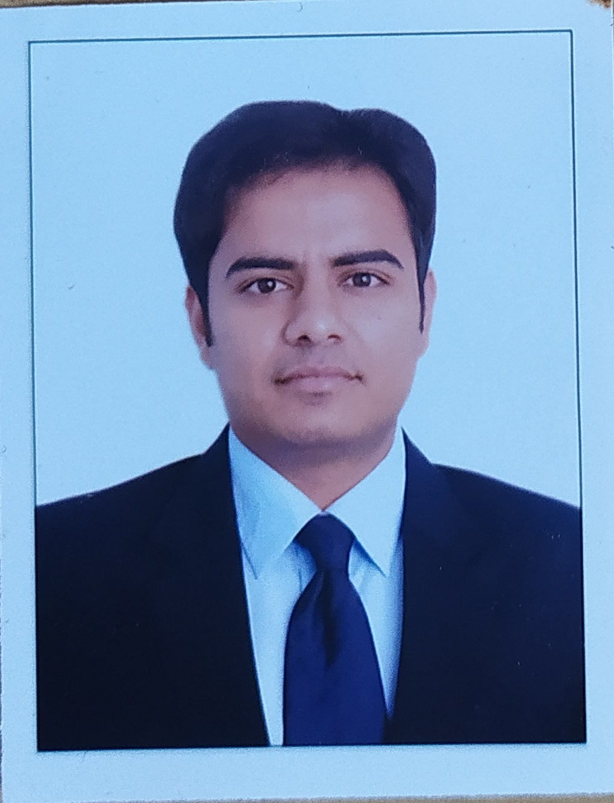
Sani Raj Singh
E-mail: sanirajsingh1203@gmail.com
Phone: +91-7507415534
Linkedin: https://www.linkedin.com/in/sanirajsingh/

An enthusiastic professional, targeting assignments in Information Technology industry having experience as an Agile Practitioner, Certified Scrum Master, Product Owner and Business Analyst

- A focused professional with zeal to make a winning career as a Certified Scrum Master and Certified Product Owner in IT industry

PROFILE
SUMMARY
- 8+ Years of experience as a Scrum Master, Product Owner and Business Analyst
- Experienced in Agile Development Methodologies like Scrum, Kanban, SAFe with good client or customer interfacing skills
- Facilitate the readiness for the Agile Release Train activities, including ART sync, PI Planning, System Demo and Inspect and Adapt
- Worked in different domains like Banking, Retail, Energy, Finance, CT SAP
- Gained knowledge in Cloud Technologies like AWS and Microsoft Azure
- Data analytics through Tableau, Power BI
- Documentation and dashboard creation for Business/stakeholders
- Skills in quickly learning and mastering new technologies; capable of working in both team and self-directed settings

ORGANISATIONAL EXPERIENCE

EY GDS, Bangalore, India as Supervising Associate Sept 2021 to Present
- Working as Scrum master for 2 products (2 team) in Cloud Technology SAP
- Connecting with EY Partners for the identification and conceptualization of product roadmap based on the current market trends
- Collaborating with Product Manager, stakeholder for scope planning, documentation such as BRD, business process, As-is and To-be process, Dependency chart
- Bridge between the development and the Business team
- Responsible for creation and maintenance of dashboards for regular project updates for stakeholders
- Promoting Agile concepts and methodologies (Sprint Planning, PBR, Sprint review and retrospective, Scrum of Scrum) along with CMMI 5 best practices

Apptio, Bangalore, India as Implementation Consultant Dec 2019 to Sept 2021

- Involved in agile mode of working as a scrum master, responsible for facilitating the Scrum Events for 3 Cross Functional Teams
- Facilitate Feature level grooming and User story estimation as a part Sprint planning
- Track intra team Risks and Dependencies along with Backlog Refinements
- Provide Sprint Reviews with required metrices to Management and Stakeholders
- Hands on experience in Cost Transparency configurations and custom reporting in Apptio

Infosys, Bangalore, India as Senior Associate Consultant Apr 2016 to Dec 2019

- Involved in agile mode of working as proxy PO and participated in the Scrum Events (Retail Domain)
- Involved in activities starting from Release plan preparation, Measurement and analysis metrics for quality, Risk management, competency, and training plan for new employees
- Coordinated and participated in estimation meetings to provide high level estimates (User Story Points) for Sprint Backlog items
- Also contributed to Data Analytics using Tableau (part of Infosys DNA team)
- Tableau integration with excel. SQL Server, SAP Hana, SharePoint

Tata Consultancy Services, Chennai, India as Business Analyst Feb 2013 to May 2014
- Responsible for getting requirements from client
- Working as Business Analyst cum Tableau developer for building analytics solution and reports
- Test scenario/case preparation and conducting UAT and QA testing
- Played as a bridge between client and technical team
- Hands on experience with requirement specifications tools like HPALM

Highlights:
- Won Squad of the Quater Award – April 2021 – ‘Recognized by CEO of Apptio for successfully delivering complex banking before deadline and providing competitive edge to the customer’

Certifications

- Certified SAFe 5 Scrum Master by Scaled Agile
- Certified Advanced Scrum Master (ACSM) by Scrum Alliance
- Certified ScrumMaster® (CSM®) by Scrum Alliance
- Certified Scrum Product Owner by Scrum Alliance
- Microsoft Certified Azure Fundamentals
IT SKILLS
- Skill: Scrum Master(CSM), Agile Methodology, Product Owner (PO), Business Analyst
- Tools: TFS, Jira, Azure DevOps, Tableau, Power BI, Visio, Apptio

ACADEMIC DETAILS
- MBA in Finance and Marketing from Symbiosis Institute of Management Studies, Pune: Secured CGPA 3.1 / 4
- B.Tech. in Computer Science and Engineering from SKIT, Jaipur in 2012; secured 72%

