

AUDYOGIK SHIKSHAN MANDAL’S
Institute of Management & Computer Studies

www.imcost.edu.in
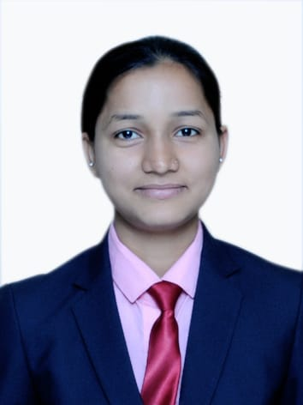

BABLI SADANAND YADAV

Application for Summer Internship

Educational Qualification:
Name of Exam | Name of College | Board/University | Percentage | Year of Passing
MMS (SEM 1) | ASM IMCOST | MUMBAI | 64% | 2018
BMS | ASM IMCOST | MUMBAI | 60% | 2017
H.S.C  (12th) | G.V.M. College | MAHARASHTRA | 60% | 2014
S.S.C  (10th) | G.V.M School | MAHARASHTRA | 50% | 2012

Work Experience: Fresher

Skills & Achievements:

Personal Details:
Date of Birth :30/01/1997
Language Known :Hindi, Marathi, English
Marital Status : Unmarried
Hobbies : Cooking, Listening Music
Extra-Curricular Activities: Genisis(IMCOST), ISR Activities

Strengths: Patience

I hereby declare that above information is true to the best of my knowledge.
______________________________________________________________________________________

Place:

Date: (BABLI YADAV)

