Sangeetha Hariharan
Email: sangeetha.hariharan@gmail.com (M) +91 9884591912
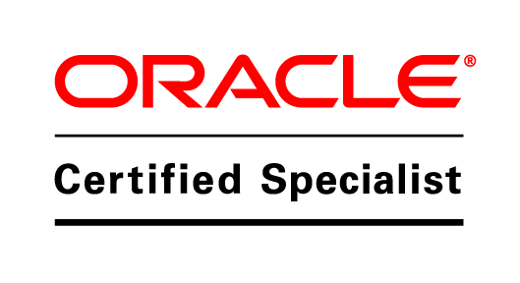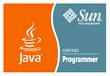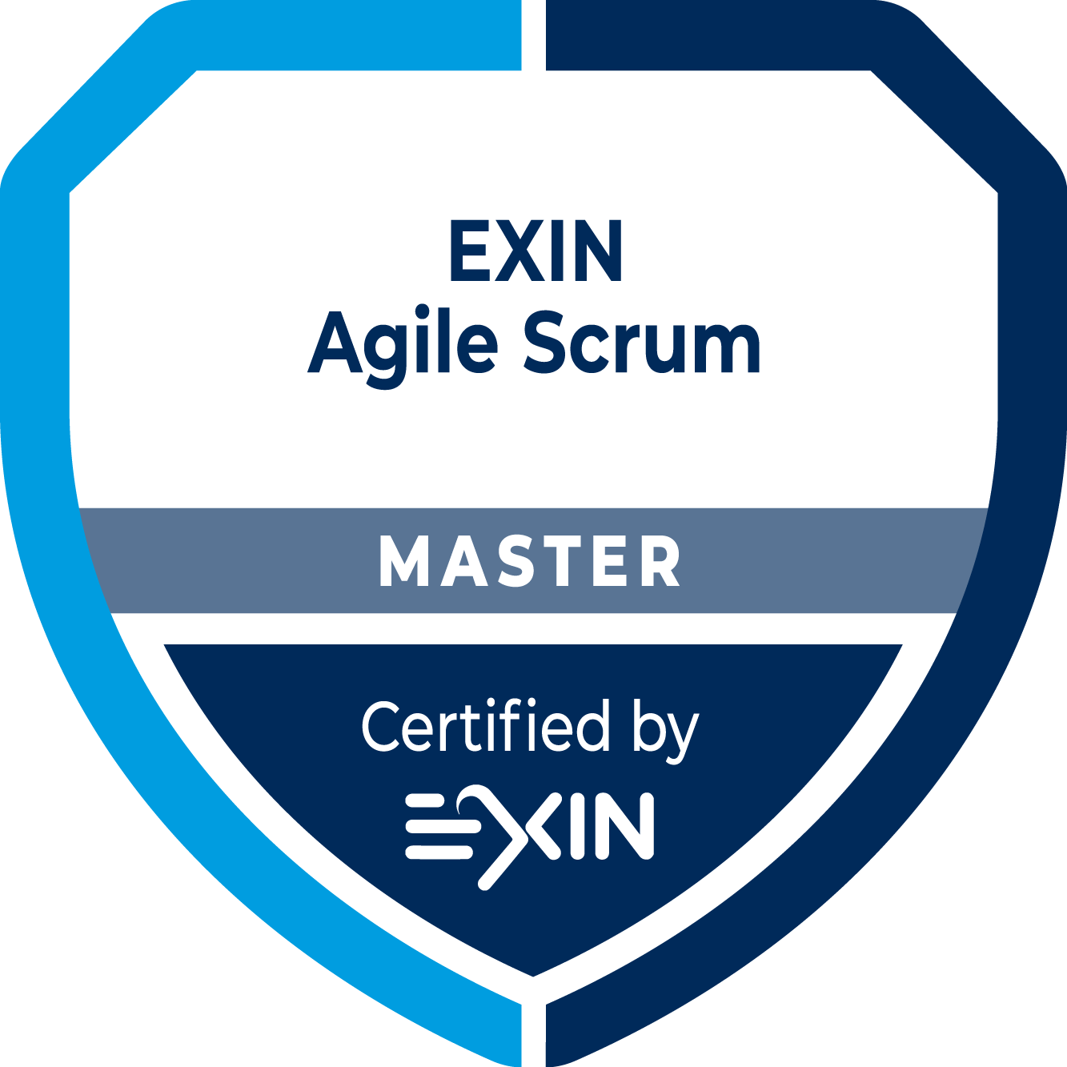

Experience Summary:

A lead technology specialist/manager/consultant, I have 16+ years of work experience primarily on architecting and delivering Data Integration Solutions by leveraging architectural framework like SOA, OSB, BPEL and AIA.

While my work experience has predominantly been in the banking and the life sciences domain and in-house IT maintenance and support, my strengths such as quick learning ability, dynamism, and ability to lead and manage multiple teams and projects, besides my interpersonal skills in dealing with multiple teams efficiently, make my expertise instantly transferable and applicable to other domains as well.

Technical Skill-Set Synopsis:

(I) Oracle Integration Cloud (OIC), SOA CS, AWS working knowledge.

(I) Service Oriented Architecture (SOA) and BPM
Application Integration Architecture (AIA), Service Component Architecture (SCA), Event Driven Architecture (EDA), Oracle BPM 11g.Oracle SOA, BPM, Web center content.

(II) SOA Core Proficiency
Oracle SOA 10g/11g – SOA composites, Mediator, Oracle BPEL, B2B, BAM, Business rules, Human Work Flow, Adapters, ESB, Oracle BPM 11g

Oracle OSB 11g, JDev 10g/11g, Oracle ADF

Weblogic 10g/11g/12c, SDLC management

Experience with OSB and BPEL service development, Solution Architecture and Administration

Oracle API Gateway 11g - 12c

(III) Integration Technologies
XML, XSLT, Xquery, SOAP 2.0, Web Services, WSDL, WS-Addressing, WS-BPEL

(IV) Oracle Sql/Plsql

(V) Oracle Enterprise Manager Cloud Control 13c, Oracle Database, Microsoft SQL Server, MySQL database,

(VI) Oracle weblogic server administration/performance tuning, certificates renewal, Patches application.

(VII) Application servers - Oracle HTTP server, Apache, Tomcat, JBoss, Glassfish, IIS.

(VIII) Linux/ubuntu Operating knowledge -Shell scripting, Python.

(iX) Basic statistics, Foundations of Business Analytics, Big data and Hadoop,
Elements of Machine learning, Analytics process management, Marketing Analytics,
Operation Analytics

(X) R programming

(Xi)Working and server management knowledge on the Cloud Solutions and hybrid cloud environments, container technologies like Docker, kubernetes.

(Xii) iPaaS, SaaS, Microservices, Azure, APIs, Integration, Fusion Middleware, SOA12c

Project Management Skill set:

EXIN Agile Scrum Master certified

Career and Project Profile:

(I) AMPLEXOR International: Senior Databases and Middleware Technical Analyst: Aug 2017 – Till date

In charge of ensuring business continuity of application services in Amplexor, concerning database and middleware layers, as well as participating in internal projects or efforts to build and extend those application services. Good Experience in weblogic version 11g and 12c C: Expertise in Web Logic Server Administration including infrastructure creation, deploying applications, Configuration resources, Patches installation and performance tuning. Experience in configuring and renewal of SSL certificates across various platforms

Technical Expertise in

    - Set up the Production 12C FMW Servers by installing Weblogic, SOA, OSB, BAM, OER, OWSM and RCU creation, Domain creation, Domain extension and configuration.
    - Installation and configuration of open source products like Apache HTTP servers and Nginx servers.
    - Installation and migration of Oracle SOA, BPM and WCC, OAG servers.
    - Change requests and new Application deployments.
    - Migration of servers.
    - Oracle Enterprise manager 13.2.0 configuration and management.
    - Experience in configuring and renewal of SSL certificates across the servers
    - Experience in implementing solutions to improve site scores in various platforms like Apache HTTP server, Nginx and Microsoft IIS servers.
    - Deployment of SOA, docker, OSB, tomcat components to SIT, UAT, and Production.
    - Several applications support.

Responsibilities:
1) Operation on database and middleware layers of application services in Amplexor:
- Monitor and maintain environments
Provided support for all SOA/APACHE environments (Oracle SOA Suite 12c)
- Actively involved in improving the SSL site scores of all the internal sites by mitigating all the vulnerabilities.
- Wrote shell scripts for SOA administration tasks
- Held cross-departmental meetings for all SOA-related issues
- Contributed to internal documentation by utilizing the Oracle support site
- Setup reverse proxy for internal websites using Apache for both UAT and PROD.
- Applied Oracle Critical Patch set updates periodically for maintaining these environments.
- Installation and configuration of new environments for DEV, TEST, UAT and PROD.
    - Installed and configured new environments from DEV through PROD for products like Oracle SOA/BPM, Oracle ADF, and Oracle web center content.

- Incident management
- Change/request management, including deployments

2) Projects:
- Consultancy
- Consolidation and migration efforts
- Solution architecture
- Micro-management

3) Reporting

(II) Cognizant Technology Solution, India: Manager-Projects: Sep 2008 – April 2017

- Projects for Network Rail(UK)
-Network Rail (UK) AIA to SOA 12c migration (Aug 2016 – Dec 2016)
Team lead responsible for preparation of high level design and low level design documents using Oracle SOA, BPEL, and OSB.
- Technical Architect responsible for designing the SOA architecture for migrating the components from SOA suite 11g to 12c.

- Projects for AstraZeneca

-DOA Phase 4 Implementation: Sep 2016 – Feb 2017
Project Manager responsible for implementation of Delegation of Authority (DoA) Phase4 for Astra Zeneca employees using Oracle ADF, Oracle BPEL, weblogic 11g, Oracle DB
-DOA BAU Support: Mar 2016 – till date
- Technical Architect responsible for designing the SOA architecture solution
- BAU lead responsible for production support and monthly releases

- Projects for Pfizer

- CUE Integration Support: Sep – Dec 2014
Project lead responsible for handling Integration Support of Pfizer CUE using Weblogic 10g/11
Oracle BPEL/ ESB, SQL

- CUE Integration: Sep – Dec 2014
Project lead involved in Analysis, design, development, unit testing, documenting, deploying
Offshore mentoring/ coordination and support of in-house applications employing Oracle BPEL ESB, BAM

- Projects for Rogers Telecommunications, Toronto, Canada

- E-business Suite (EBS) R11 to R12 upgrade (Redesign/retrofittment of interfaces) – Dec 2013 to Aug 2014

Architect/Project lead responsible for Analysis and Design of SOA interfaces involved in the migration of E-business Suite (EBS) R11 to R12 upgrade exercise. Rogers is undertaking an E-business Suite (EBS) R11 to R12 upgrade exercise and has an existing middleware platform built on Oracle Service Bus, Oracle SOA suite and Oracle Data Integrator (ODI). There are about 200 interfaces with ~100 each between OSB/SOA and ODI. Many of these interfaces may undergo change and the scope of FMW development is to identify the nature of the changes due to R12 upgrade (to the interface tables, API or other interfacing modes) and make modifications so as to make it work with EBS R12.

- Projects for NothernTrust, Chicago, IL

- JCAPs to Oracle SOA conversion (Development of interfaces) – July 2013 to Dec 2013
Architect/Project lead responsible for Analysis and Design of SOA interfaces involved in the migration of existing JCAPS system to SOA conversion. The SOA interfaces would be developed employing OSB 11g and SOA 11g.

- Projects for AstraZeneca, Wilmington, DE

- Application Maintenance team: June 2013-July 2013
Managing a team of Developers/Senior developers. Key activities of the team include –SOA application maintenance, Fixing production bugs across SOA applications, Managing New Enhancement requirements development across SOA applications, Weblogic monitoring.

- Kiosk Performance SER (Purchase order approval system):May2013 – June 2013
Project lead responsible for performance optimization of existing purchase order approval system employing OSB 11g R4 and Oracle SOA 11g.

- Kiosk Phase3Development (Purchase order approval system):Sep2011 – Aug 2012
Team lead responsible for enhancement of existing purchase order approval system employing OSB11g R4 and Oracle SOA 11g R4 composite.

- Application Maintenance team: Aug 2011-till date
Leading a team of developers. Key activities of the team include –SOA application maintenance,
Fixing production bugs across SOA applications, New Enhancement requirements development across SOA applications, Weblogic monitoring.

- Yosemite Implementation for Sample Central: June 2011 – present
Project lead taking care of creation of new proxy servers in OSB 11g

- OSB/ SOA version upgrade: April – June 2011
Project lead responsible for upgrade of operational OSB10g to OSB11g and SOA 11gR1 to SOA 11gR4

- CIA Webtables: April – June 2011
Project lead responsible for developing dynamic content based routing employing OSB 11g, Oracle
DB, Weblogic 11g

- Kiosk (Purchase order approval system): Jan – April 2011
Team lead involved in developing of procurement availability system across vendors using oracle SOA 11g, Oracle OSB 10g and Oracle BAM

- Projects for Pfizer

- CUE Integration Support: Jan – Dec 2010 (On-site in New York, USA)
Senior Integration Analyst responsible for handling Integration Support using Weblogic 10g/11
Oracle BPEL/ ESB

- CUE Integration: July – Dec 2009
Technical team lead involved in Analysis, design, development, unit testing, documenting, deploying
Offshore mentoring/ coordination and support of in-house applications employing Oracle BPEL ESB, BAM

- AIA/ ODI Implementation: Jan – July 2009
Technical team lead involved in Analysis, design, development, unit testing, documenting, deploying
Offshore mentoring/ coordination and support of integration interfaces using Oracle AIA (BPEL ESB), Data integrator & BAM

- Project for Rabo Bank

- Prototype for Loan Approval System: Sep – Dec 2008
Senior Developer handling Analysis, design, development, unit testing, and deploying using
Oracle BPEL and Human Workflow

(III) Capgemini Consulting Ltd, India: Technical Team Lead: Jan – Sep 2008

Project for Centraal Justitieel Incasso Bureau (On-site Leeuwarden, Netherlands Jun – Aug 2008)

- SOA enabled Oracle Apps Implementation for Dutch Ministry of Justice
Technical team lead responsible for Analysis, design, development, unit testing, documenting,
Deploying, offshore mentoring/ coordination and support of integration interfaces employing Oracle BPEL ESB, SQL, PLSQL, Oracle E-business suite Adapters

(IV) Oracle, India: Developer Consultant: Aug 2004 – Jan 2008

Pre-sales technical consultant for APAC region; handled POC creation, post sales support, technical
Demonstrations involving Oracle Fusion middleware products like Oracle SOA Suite 10g, BAM etc.

Educational Background, Achievements, and Certifications:

- Alagappa Chettiar College of Engineering and Technology, Karaikudi, India
Bachelor of Engineering in Electronics and Communication, June 2004

- Post Graduate Diploma in Business Analytics at Loyola Institute of Business Administration

- Exin Agile Scrum Master.

- Oracle SOA Suite 11g Certified Implementation Specialist (1Z0-478).

- Sun Certified Java Professional (SCJP 1.4), India 2004

- Oracle 9i SQL Certified, India 2005

- College topper in the common B.E. examinations, 2000 – 2004

- Individual Excellence Award: Oracle India, for exceptional clarity and commitment on projects, 2005

- Event participant: Java Sun Tech Days organized by Sun Microsystems, Bangalore, India: 2005

- Event participant: JAX India Event, Bangalore, India: 2006

References available upon request.

