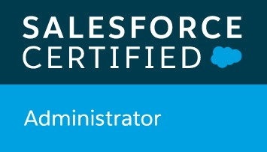  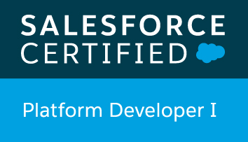    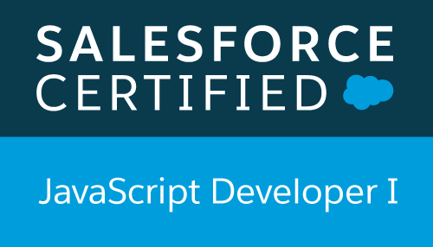  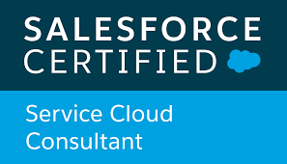 |  | KAMALAKAR RAO  Senior Software Engineer  Contact  PHONE:  +919603338603  EMAIL :  lightningdeveloperr@gmail.com  Professional Certification/ trainings  Salesforce Certified Administrator  Salesforce Certified Platform Developer-1  Salesforce Certified CPQ Specialist  Salesforce Certified JavaScript Developer-I  Salesforce Certified Service Cloud Consultant  Salesforce Trailhead Ranger  ACHIEVEMENTS and SUMMARY  - A passionate and skilled IT professional with hands-on working experience of 6+ years including 5+ years on various Salesforce related technologies.  - Expertise using apex, visual force, trigger, batch apex, scheduler apex , integration, Lightning Components based coding as a part of customization using programmatic approach.  - Design, develop and deploy Apex Classes, Controller Classes and Apex Triggers for various functional needs in the application.  - Design, develop and deploy Visual force Pages and Lightning Components for meeting custom requirements.
PROFILE  - More than 6 years of total IT experience in FORCE.COM Designing, Lightning, Integration, Developing in Salesforce platform.  - Expertise in Salesforce Lightning, Configuration, Customization and Integration.  - Proficiency in SFDC Administrative tasks like creating custom Profiles, Role Hierarchies, Users, Permission sets, sharing setting, Groups and Queues.  - Worked on Configuration of  SalesForce.com Data model using Objects, Fields, Roll- up Summary, Lookup, Master Detail, Record Types, View through page layouts.  - Designed Custom Formula Fields,  Field Dependencies, Validation  Rules, Work Flows, Process Builder  and Approval Processes for  automated alerts, field updates,  and Email generation according  to application requirements.  - Experience in Service cloud –  Case Management which  include Email-to-Case, Web-to-Case, Assignment rule,  Auto response rule and Escalation rules, Case Milestones, Entitlements.  - Implemented security and sharing rules at object, field, and record level for different users at different levels of organization, also created various profiles and configured the permissions based on the organizational hierarchy.  - Hands on Experience performing  database operations using Data  Loader, Workbench, Import Wizard in maintaining the data quality in migration.  - Deployed using Change Sets. |  | Skills summary  Domain –  Cloud Apps  Programming Languages  Web Designing, Apex, Visual Force, HTML, CSS, Lightning  Tools/DB/Packages/Framework/ERP Components  SFDC Developer Console, Apex Data Loader, Workbench, Sales force Aura Framework, LWC  WORK EXPERIENCE  Project : SHIBHURA MACHINERY  July - 2021 – May - 2022  Domain: Power  Account Name: Shibaura Machinery, India  Project Description:-  This Project is to provide Sales/Service Cloud CRM platform that delivers multiple feature user stories per release for Shibaura Machinery services business. Shibaura Machinery project is a comprehensive collection of custom modules developed on the force.com Platform to manage Field service activities of manufactured Machines. It enables tracking of Leads, Opportunities, Accounts, Machine Serial Number, Warranty, AMC, service contracts, corrective and preventive maintenance, basic and advanced dispatch management, onward & return logistics and parts inventory.  Roles & Responsiblities:-  1) Worked on Both Standard and Custom Objects, Business  Processes and field-level Security.  2) Involved in daily standup meetings, Scrum. This resulted to bring good solution to the business requirement.  3) customized the force.com platform by developing Apex Triggers, Apex Classes, Visual force pages and force.com declarative features  - 4) Customize and personalize Service Module based on requirements.  - 5) End to end support on all modules of Service like Case, Work Order and Line Items  - 6) Creating Objects and Validation Rules and Mapping them to the existing functionalities and Objects.  7) Worked on various Service standard & Custom objects like, Work Orders, MSN, AMC.  8) Created multiple Lightning Components, added CSS and Design Parameters that makes the Lightning component look and feel better.  5) Integrated the Web Services for extracting the data from external systems to display in the pages of Salesforce.  7) Expertise in field level security along with page layouts in Lightning to manage access to certain fields.  Project : ROCHE DIABETES CARE  Period: June-2020 - May - 2021  Role: Salesforce Developer  Domain: Health  Project Description:-  Roche Diabetes Care is a pioneer in the development of blood glucose monitoring systems and a global leader for diabetes management systems and services. For more than 40 years, the Accu-Chek brand has been dedicated to enable people with diabetes to live life as normal and active as possible as well as to empower healthcare professionals manage their patients’ condition in an optimal way. Today, the Accu-Chek portfolio offers people with diabetes and healthcare professional’s innovative products and impactful solutions for convenient, efficient and effective diabetes management.  Roles & Responsiblities:-  - Maintaining Users, defined security settings based on Profiles, Roles, Sharing Rules and Permission Sets.  - Defined sharing settings for different objects based on the requirement.  - Creating custom settings for specific business requirement.  - Configuration of Salesforce.com application for various modules Accounts, Contacts,  Opportunity, User Object.  - Reports and Dashboards.  - Creating Custom Objects, Fields, Page Layouts, and Record types, Workflow Rules, Email Templates and Validation Rules.  - Writing Apex classes to meet the business needs.  - Writing Triggers to meet the business requirements.  - Created Reports and Dashboards according to the business needs.  - Translations using translation workbench.  - Involved in deployment activities.  - Data migration using Apex Data Loader.  Project : BAYER HEALTH CARE  Period: April - 2019 – May - 2020  Role: Salesforce Developer  Domain: Health  Project Description:-  This Project is to provide Service Cloud CRM platform that delivers multiple feature user stories per release for Bayer Health services business. Bayer project is a comprehensive collection of custom modules developed on the force.com Platform to manage Field service activities of manufacturing organizations. It enables tracking of installed base, service contracts, warranty, corrective and preventive maintenance, basic and advanced dispatch management, onward & return logistics and parts inventory.  Roles & Responsiblities:-  - 1) Working with standard objects, business processes and field-level security  - 2) Customized the force.com platform by developing Apex Triggers, Apex Classes, Visual force pages and force.com declarative features  - 3) Customize and personalize Service based on requirements  - 4) End to end support on all modules of Services like Dispatch Console, Service Flow Manager and mobile Applications like FSA and Classic Apps  - 5) Creating Objects and Validation Rules inside Service and Mapping them to the existing functionalities and Objects.  - 6) Worked on various servicemax.com standard objects like, Work Orders, Installed Product, Service Team and Technician objects.  Project : SCHNEIDER ELECTRIC  Period: July - 2017 – March - 2019  Role: Developer  Domain: POWER  Project Description:-  Schneider is built and delivered as a native force.com cloud application, which is a best solution for the post-sales service, field service and strategic service chain management, service gives you completed functionality to accurately control, monitor and track all the activities a field service organization performs.  Roles & Responsiblities:-  - 1) Working with standard objects, business processes and field-level security  - 2) Customized the force.com platform by developing Apex Triggers, Apex Classes, Visual force pages and force.com declarative features  - 3) Customize and personalize Service Cloud based on requirements  - 4) End to end support on all modules of Service like Dispatch Console, Service Flow Manager and offline client.  - 5) Creating Objects and Validation Rules inside Service and Mapping them to the existing functionalities and Objects.  - 6) Worked on various service standerd objects like, Work Orders, Installed Product, Service Team and Technician objects.  - 7) Handling calls with Clients if require.  Project : GE HEALTH CARE GLOBAL APPLICATION  Period: Sept - 2015 – June - 2017  Role : Salesforce Administrator / Developer  Domain : Health  Project Description:-  GE Healthcare provides transformational medical technologies and services helping to deliver patient care to people around the world. The company provides medical imaging and information technologies, medical diagnostics, patient monitoring systems, drug discovery, biopharmaceutical manufacturing technologies and performance solutions services. GEHC Global Application is built in Salesforce to manage the sales part of GE Health Care and being used by 30000 users. This application is used by the Asia and Non Asia Regions to manage Sales Processes.  Roles & Responsiblities:-  - 1) Creating Custom Objects, Fields, Page Layouts, and Record types, Workflow Rules, Email Templates and Validation Rules.  - 2) Maintaining Users, defined security settings based on Profiles, Roles, Sharing Rules and Permission Sets.  - 3) Defined sharing settings for different objects based on the requirement.  - 4) Configuration, Customization and Data load scripts.  - 5) Understanding the business logic and preparation of technical design document.  - 6) Developing apex classes and triggers.  - 7) Creating Workflow rules and different actions associated to the rules.  - 8) Defining lookup and master detailed relations on the objects to provide connectivity among the objects.  - 9) Developing Visual Force pages and Apex Controllers  - 10) Translations using translation workbench.  - 9) Reports and Dashboards.  WORK EXPERIENCE  # Marlabs innovations pvt ltd.  Start Date - End Date  June - 2021– May-2022  Designation: Sr. Software Engineer  # WIPRO  Start Date - End Date  July - 2017 – May - 2021  Designation: Salesforce Developer
  Education & credential
  Post Graduation (MBA-HR)
  Malla Reddy Institute of Business Mngmt
  JNTU(Hyd), Hyderabad, Telangana
  64%, June 2013
  Graduation (B.Sc) (M.S.Cs)
  HRD Degree College
  Osmania University, Hyderabad, Telangana
  59%, June – 2009
  INTERMEDIATE (M.P.C.)
  NEW GENERATION JUNIOR COLLEGE
  Hyderabad, Telangana
  59%, April – 2006
  SSC
  NAVEEN PUBLIC SCHOOL
  Guntur, Andhra Pradesh
  74% , June - 2003
# Birlasoft india ltd.
Start Date- End Date
Sep - 2015 – July-2017
Designation: Software Engineer

