Sreenivasulu Reddy Mukkidi

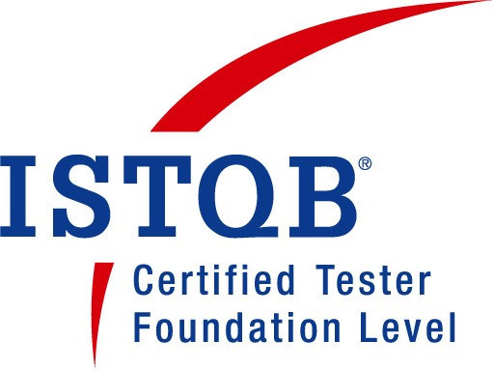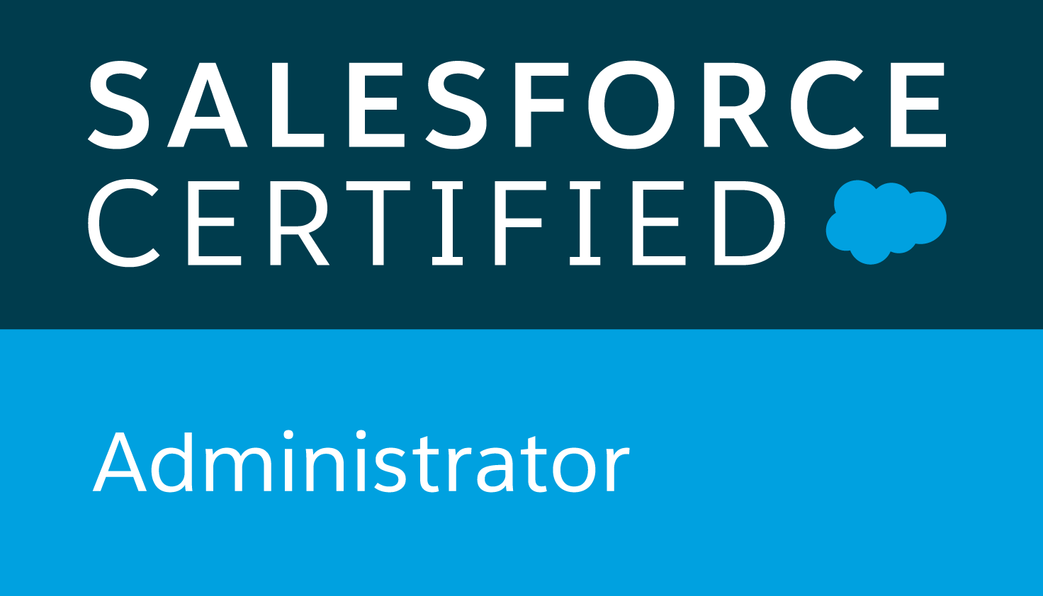

Email:smukkidi@gmail.com

Contact no: +91 9650917954

**CAREER OBJECTIVE:**

Sreenivasulu Reddy has more than 9 years of IT experience which includes comprehensive experience in software testing with a wide variety of projects and environments. He is having strong experience in Manual, Automation (web and mobile) and Load Testing **using Selenium WebDriver, UFT, and Jmeter**.

**TECHANICAL SKILL:**

**Automation Testing:-**

* 5 years extended experience in automation testing tools like selenium web Driver, selenium RC, selenium IDE and QTP/UFT.
* Worked in an **Agile SCRUM** methodology.
* **Developed automation framework using Java, Selenium, Junit, TestNG, Cucumber BDD.**
* **Worked in API/Web-Services both soap and REST automation.**
* **Worked with Cucumber in selenium including Junit, TestNG**and**Gherkin .**
* Written **Automation scripts to validate against databases like oracle, My SQL.**
* Experience in Manual and Automation Testing of Web Services/Mobile Apps, Client Server and Web based Applications in different domains using QTP/UFT, Quality Centre and Selenium.
* Created and implemented Automation scripts for performing **Functional, Regression, System, Integration testing. Expertise in Smoke/Sanity, Black Box, UAT**, Alpha and Beta, Load, performance, Stress testing.
* Designed and built Test Cases, developed, maintained and troubleshot Test Scripts, coordinated with team members in debugging effort and assisted developers in Root Cause Analysis and clarified them the results.
* Automated Test cases in TDD (Test   Driven Development) and   BDD (Behavior Driven Development).
* Developing BDD  scripts with Cucumber/Java and writing step definitions for behavior and step definitions.
* Proficient in Java-Selenium and Web Driver architecture.
* Extensive experience with tools such as **Junit/TestNG, ALM, JMeter, JIRA.**
* Implemented functional tests using Java, TestNG/Junit framework and also Cucumber framework.
* Worked on version control GIT Hub tool and Continuous Integration with Jenkins
* Sound knowledge on Junit, TestNG framework for Unit testing, Maven and Ant for Project building tool.
* **Used Firebug/Fire Path Add-on tools to identify the Object's id, Name, XPath, link in the application**.
* Experience in mobile testing using APPIUM in IOS and Android applications using simulator and emulator.
* Extensive experience in writing Xpath, CSS selector.
* Extensive experience in handling Synchronization Waits.
* Proficient in handling keyboard and Mouse action using Action class and Robot Class.
* **Expert in Automation Frameworks like data-driven, keyword-driven, Hybrid FrameWork and TestNG.**

**Core Java:-**

* More than 5 years extended experience in OOP’s concept with Core Java with multithreading, Concurrency, Exception Handling, File handling, IO, Generics, Data structures and Collections, Garbage Collection.

**Manual Testing:-**

* More than 5 years of Experience in Software Quality Assurance **Automation testing** using **Selenium WebDriver, UFT, Jmeter, JIRA** and ALM as tools.
* Solid knowledge in SDLC and STLC lifecycles and working experience in agile.
* Extensive Manual testing experience in Black Box testing, Functional, Integration, Regression, User, Acceptance (Alpha and Beta Testing), System, UI-testing, Smoke, Sanity, Content testing.
* Experience in API/Web - Services testing using SOAP UI/postman tools.
* Using SOAP UI Tool performed cross-platform Functional Testing involving XML messages, constructing different field values, data and validating HTTP Request and HTTP Response.
* Collaboratively worked with different stakeholders like BA, Dev, QA, onsite coordinators.
* Experience in understanding of the project team's business domain by participating in project planning sessions.
* Participated in user story reviews to provide input on functional requirements, Acceptance Criteria, schedules, or potential problems.
* Extended experience in systems testing, integration testing, UAT testing, positive and negative, functionality, exploratory, integration, and regression testing to ensure that the product delivered is of high quality.
* Experience with Manual Testing, writing test plans, test design, writing test cases and reviewing test cases.
* Experience in automation testing, retesting and regression testing process.
* Extended experience in Bug life Cycle and reporting defects.
* Experience in preparing traceability matrix to achieve minimum coverage in the project
* Expertise in analyzing, updating and maintaining Business/System Requirement documents.
* Supported the planning of test schedules in accordance with project scope/delivery dates and ensured that the timelines are adhered to without fail.
* 5 years experience in Test Automation from an Agile background using BDD and TDD methods.
* Worked in Agile Methodologies with good knowledge on different SDLC such as SCRUM, waterfall models and TDD,BDD

**Agile process:-**

* 4 years extended experience in understanding, implementing, and updating the Agile Test Strategy
* Worked with Product Owners to define Acceptance Criteria and the Definition of Done.
* Measuring and reporting test coverage across all applicable coverage dimensions
* Actively collaborating with developers and business stakeholders to clarify requirements, especially in terms of testability, consistency, and completeness
* Participated proactively in daily standup meetings, story grooming sessions, planning poker activity, team retrospectives, suggesting and implementing improvements
* Participated in user story reviews to provide input on functional requirements, Acceptance Criteria, schedules, or potential problems.

**Salesforce CRM Testing/Admin:-**

* 3+ years of experience in Administration, Configuration and Customization, Requirements, Implementation, Data Migration, QA and Support of Salesforce CRM.
* Experience in developing Validation Rules, Work Flows and Approval Processes for new Tasks, field updates, and Email generation as per application requirements.
* Experience in implementation of salesforce.com applications like the Sales, Marketing, Service and support Modules.
* Conducted training on all Salesforce related systems to sales and marketing teams.
* Maintained and customized Salesforce.com scopes such as users, roles, profiles, groups, accounts, contacts, record types, sharing rules, custom objects, pick lists and page layout customization to support vital business functions.
* Strong knowledge/exposure to Salesforce.com Standard Objects and custom objects (Classic and Lightning).

**SQL:-**

* Extensive experience in writing SQL queries.
* Good experience in of SQL concepts like Sub queries, Joins, Function

**Personal Qualities:-**

* Be flexible to work in second shift and also over weekends to support production releases.
* Excellent analytical and problem solving skills.
* Excellent verbal and written communication skills.
* Very good team player abilities.
* Proven ability to effectively share knowledge and stay aware of current trends and technical advancements.
* Ability to work in large distributed local and international teams.
* Ability to work under pressure to resolve issues affecting the production services

**Experience :-**

* Worked as a Technical Lead in Estuate Software Pvt Ltd from 26-July-19 to May-2020
* Worked as a Quality Assurance Analyst in McGraw-Hill, from July 2017 to June-2019.
* Worked as a Senior QA in iBoss, Tech Solutions from June 2015 to July 2017.
* Worked as a Quality Analyst-Q2 in Ebix, from Dec 2013 to June 2015.

**EDUCATIONAL QUALIFICATION:-**

* Completed BSC in Computer Science from SV University with at SDHR. College Rayachoti, KADAPA, Andhra Pradesh.

**Project Details:-**

# Estate(Client: Sparta Systems)

TrackWise Digital offers a suite of quality and compliance solutions on a centralized, validated platform.Built on over two decades of experience, TrackWise Digital combines out-of-the-box best practices processes with the flexibility and scalability of the Salesforce platform:

**Responsibilities:**

* Performed BDD (Behavior Driven Development), ATDD (Acceptance Test Driven Development) using Cucumber Features, Scenarios and Step Definitions in Gherkin format.
* Developed Test Scripts to implement Test Cases, Test Scenarios, and features for BDD (Behavior Driven Development), TDD (Test Driven Development) using Cucumber Developed Test Scripts to implement Test Cases, Test Scenarios, and features for BDD (Behavior Driven Development), TDD (Test Driven Development) using Cucumber
* Involved in the use of BDD and ATTD based Step Definition, Scenarios and Features in Gherkin language using Cucumber.
* Reviewing, sizing and approving test cases.
* Proven ability in developing BDD (Behavior Driven Development) and TDD (Test Driven Development) with Cucumber and writing step definitions, features in Gherkin
* Assisted Manager by providing automation strategies, Selenium/Cucumber automation and JIRA reports.
* Performed BDD (Behavior Driven Development), ATDD (Acceptance Test Driven Development) using Cucumber Features, Scenarios and Step Definitions in Gherkin format.
* Developed Test Scripts to implement Test Cases, Test Scenarios, and features for BDD (Behavior Driven Development), TDD (Test Driven Development) using Cucumber.
* Performed Agile testing, review the stories and participated in Daily Scrum, Sprint Kickoff, Review Meetings and Release Planning meeting and used JIRA Tool.
* Performed Defect Tracking & Management in JIRA. Generated automated daily reports using the JIRA API.
* Assisted Manager by providing automation strategies, Selenium/Cucumber automation and JIRA reports.
* Participated in Daily Scrum, Iteration Planning, Release Planning meeting and used JIRA Tool and peer review with team.
* Involved in creating the Traceability matrix based on Functional requirement.
* Performing daily defect triage meeting and priorities the defects with Project team.

# McGraw-Hill

McGraw-Hill is a learning science company that delivers personalized learning experiences that help students, parents, educators and professionals improve results. In the United States, McGraw-Hill products are sold in over 5,000 higher education institutions and 13,000 K-12 school districts across all 50 states, with different Digital & Print product with the help of ERP, CRM (Salesforce.com) and oracle

McGraw-Hill is using salesforce instance to help their sales team to maintain lead and expedite sales process.

**Responsibilities:**

* Performed Functional Testing, Unit Testing, Manual Testing, Automated Testing, Load Testing, Deployment Testing.
* Performed, Negative, Positive, Integration, Regression, End to End and User Acceptance Testing.
* Implemented automation
* Handled all basic administrative functions including user account maintenance, reports and dashboards, workflows and other routine tasks
* Assist in training of new users, and grow the Salesforce.com skill set
* Extensively involved in writing templates for the Test Plans and Test cases.
* Identified the Test Cases and documented the min PMO tool.
* Worked with the Developers and the Test team to verify the Test Cases.
* Involved in creating the Traceability matrix based on Functional requirement.
* Performing daily defect triage meeting and priorities the defects with Project team.

# iBoss – Clinent: Safe-Guard Project: Riskonnect

**Riskonnect** IRM platform facilitates and encourages the capture, analysis, and delivery of risk information, giving organizations a greater ability to act more quickly and intelligently to respond to both risks and opportunities in their respective markets.

Through Riskonnect is built on the Force.com cloud-computing platform provided by Salesforce.com.

**Responsibilities:**

* Analyzed business requirements, use case documents, functional specs.
* Configured page layouts, workflows, document templates, record types, & data fields.
* Designed, setup and maintained Salesforce standard objects, custom objects and junction objects, while also structuring user roles, security profiles and workflow rules.
* Performed, Negative, Positive, Integration, Regression, End to End and User Acceptance Testing.
* Created automation scripts for Sanity and Regression testing using Selenium WebDriver.
* Designed automation frame work using Cucumber, POM, TestNg Selenium WebDriver.
* Performed user & administration training sessions for clients to utilize Salesforce and respective programs.
* Identified the Test Cases and documented the min PMO tool.
* Worked with the Developers and the Test team to verify the Test Cases.
* Assist in training of new users, and grow the Salesforce.com skill set across the organization
* Expertise in using JIRA to open bugs, create tasks and user stories, initiate change requests.

1. **Safe-Guard Web and Mobile Claim Lite. Role: Quality Analyst**

**Project Description:** This is a Risk Management application for Web and Mobile is a program that will support the business vision and strategy going forward for the SAFE- GUARD PRODUCTS INTERNATIONAL core claim processing through mobile, next generation claims system and other channels. This facilitates end users to file claim for different components of Products like Mercedes, BMW, Toyota etc.

**Environment:** Mobile Automation Testing using SeeTest, Appium, Selenium, TestNG, Web- Services Testing using SOAP UI, PGSQL and MS SQL, Performance Testing using Jmeter and Neoload.

**Responsibilities:**

* Analyzed business requirements, use case documents, functional specs.
* Prepared Performance Testing Strategy Document.
* Prepared Test Scenarios and Test Data.
* Prepared Performance testing using Jmeter and Neoload.
* Preparing and Executing of Test Scripts using Selenium WebDriver.
* Performed baseline, benchmark and stress testing.
* Scheduling of Performance execution script using Jenkins.
* Performed Native Mobile Automation Testing using Selenium and SeeTest.
* Performed Web-Services Testing using SOAP UI, PGSQL and MSSQL.
* Reporting bug found during performance testing, Automation and Web- Services Testing using JIRA.
* Find out the area where performance tuning is required using new relic.

1. **Ebix: AnnuityNet**

**Project Description:** This is a web application used to sell annuity (insurance) in US market.

**Client**: US Bank, Fidelity, Merrill Lynch, Ameriprise, Prudential, New York Life, Jackson National, MetLife, Allianz and many more Insurance Companies of US.

**Environment**: WebEx (Cisco), I-Track, Windows 2000, QTP, Selenium WebDriver

**Responsibilities**

* Writing the project plans, report, metrics and test objectives and individual test cases.
* Analyzing (SRS) and prepare test case accordingly. Also, Involved in Internal Test Case Review for Other Team Members.
* Effectuating new processes and redefining processes. Perform UAT
* Coordinating with IT and clients for timely completion of the project by arranging meetings as well as documenting the same.
* Creating Automation Resources such as Object Repository, Function Libraries.
* Involved to Develop the Automation Frame Work using QTP.
* Preparing and Executing of Test Scripts using Selenium WebDriver.
* Automation of the Test Scripts for Regression Testing using WebDriver.
* Debugging and Running Tests and Analyzing Test Results.
* Prepared the Weekly Status Reports and Daily Status Reports and Involved to
* Prepare the Test Deliverables.