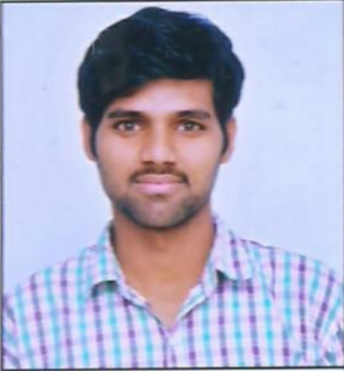
Ravinder Reddy Kottabad

Software Engineer
# 94/5 V P Layout, Basavanna Gudi,
Southend Road, Jayanagar, Bangalore

(+91)9666366139
ravinder.reddy.jb2@gmail.com

SUMMARY
Software Engineer with 2+ years of experience in full-stack development. Supportive and enthusiastic team member and efficient in resolving project issues, quick in learning, and adopting new technologies. Passionate in working as Full Stack Developer or Java Back-End Developer

SKILLS
- Sound knowledge in Java technologies like Core Java, J2EE (Servlets, JSP, Core-Spring, Spring-MVC, Spring-Boot, Hibernate )
- Good understanding of Node-Js and its related technologies like Electron-Js, Express, Sequelize, etc
- experience in Front-end frameworks like Vue, React, and Angular
- Have knowledge of REST and Graph-QL web services
- Worked with databases like MS-SQL, PostgreSQL, Oracle, HSQL, and MongoDB
- Good understanding of Data Structures Concepts ( Linked Lists, Stack, Ques, Trees, and Sorting Techniques )
- Have some basic knowledge of Cloud Services like Firebase, AWS, and Git

EXPERIENCE

Durvah IT Consulting Pvt Ltd, Bangalore— Full Stack Developer
September 2019 - PRESENT

Uttara Info Solutions, Bangalore( Black Lotus Technologies Pvt Ltd ) — Full Stack Developer
April 2018 - July 2019

TECHNICAL EXPERIENCE

Java, Spring-MVC, Spring Boot | 1 Year 4 Months
Node-Js, Express-Js | 1 Year 6 Months
React-Js | 1 Year 8 Months
Angular | 3 Months
MS-SQL | 1 Year

EDUCATION

Chandigarh University, Chandigarh — B.E Mechanical(1st year only)
August 2017 - December 2018,
- 1 Sem GPA 9.28/10
- 2 Sem GPA 7.98/10
- 3 Sem discontinued, to join in IT Industry

Gurukul Vidyalaya (T.S Residential Junior College), Telangana— 11th & 12th Classes
2013 - 2015,
- Marks 90.7%

Gurukul Vidyalaya (A.P Residential School), Telangana— Secondary Education
2007 - 2013,
- SSC GPA 10/10

JOB & SALARY DETAILS
Current CTC: 6 LPA,
Expected CTC: 10 LPA,
Notice Period: 2 Months,

PROJECTS & THEIR DETAILS

mVBRI App

Designation: Software Engineer

Role : Full Stack Developer

Technologies: React-Js, Node-Js with Express and Sequelize

Company: Durvah IT Consulting Pvt Ltd

Team Size: 8

Responsibilities :
- Designed and developed some front-end modules and dashboards
- Developed some back-end APIs for mobile and web apps
- Handling deployment and maintenance services

Description :
mVBRI ( Mobile Village Based Rehabilitation Initiative ) app is a cloud-based app ( Mobile & Web). It is used by the Amar Seva Sangam, an NGO from Tamil Nadu, which provides rehabilitation for specially-abled children. They use the mVBRI app to monitor the Children, Rehabilitation Workers, Therapists, and Team Leaders.
Rehabilitation Workers visit the children at home/ Rehabilitation Center and they do basic treatment activities and they update status in the app. Based on the children’s status Therapists will do special treatments. During this time Team Leaders and Admin can track the locations of Workers and Children and can see how many treatments and basic activities have been conducted, and they can see working and traveling time details. And also they can see some other events ( Screening, Awareness, Training Programs) details in Web app dashboards

Live Video Streaming App

Designation: Software Engineer

Role : Front-End Developer & Security Provider

Technologies: ReactJs and Google Firebase for authentication

Company: Black Lotus Technologies Pvt Ltd ( as a consultant from Uttara Info Solutions )
Team Size: 10

Responsibilities :
- Fixing the bugs and issues in the existing project
- Providing security features in the front-end app.

Description :
Live Streaming App is a web-based ReactJs app which can be used to watch live video of an event. Only registered users can access the app on one browser. If the users try to access the site from multiple devices( browsers ), it’ll show corresponding notifications and it'll log out the users automatically.

Uttara Desktop App

Designation: Software Engineer

Role : Full Stack Developer

Technologies : ElectronJs( Front-end ), Java- Spring Boot ( Back-end )

Company: Uttara Info Solution
Team Size: 1

Responsibilities :
- involved in the entire life cycle ( Planning, Development, Testing, and Production) of the project.
- Distributed executable app for the users and fixed the bugs/issues at a later time.

Description :
Uttara Desktop App is a cross-platform video app through which only registered users can watch the videos but can’t download them. And it works only on one specific system per one user account. It is in use for online classes for students in Uttara

Uttara Video App Admin Console

Designation: Software Engineer

Role : Full Stack Developer

Technologies: ReactJs in front-end, Java ( Spring Boot, Hibernate ) in the back-end, Oracle database, and Apache Tomcat Server

Company: Uttara Info Solution
Team Size: 1

Responsibilities :
- Involved in planning and developing for all the modules in the Application.
- Built complete front-end Admin UI for Video App.
- Developed back-end app for all CRUD actions of Videos and Users.
- Developed Authentication and Authorization feature

Description :
Admin Console App is a web app for Admin User through which he can add/delete users and videos. Admin can fetch user information like fees, status, year and he can activate/deactivate a user.

PERSONAL DETAILS
Father Name: Ram Reddy
Mother Name: Ramulamma
Date Of Birth: 14-03-1997
Permanent Address: # 1-58, Mirzapur[N], Nyalkal, Sangareddy, Telangana, 502256
Known Languages: Telugu, English, Hindi, and Kannada

Place:
Date: ( Ravinder Reddy Kottabad )

