Ajay Suresh Kale  Salesforce developer/administrator  Email: ajaykale.sfdc@gmail.com  Trailhead:https://trailblazer.me/id/pjamnikhttps://trailblazer.me/id/akale91  Linkedin: linkedin.com/in/ajay-kale-620b70226  Contact: 9604830242 | 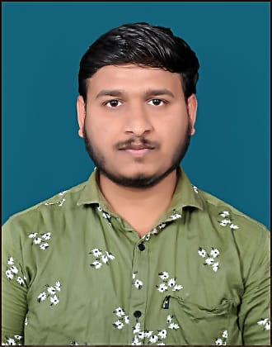
OBJECTIVE:
Salesforce Developer with 1years' relevant experience in salesforce technologies. I Can be your Salesforce Administrator and developer with hands-on experience in Salesforce development. Areas of expertise include Apex and trigger.Motivated to stay informed of the latest industry innovations to provide users with most up-to-date solutions.

PROFESSIONAL SUMMARY:
Role: Trainee-Developer
Profile Summary:-
- Development, Administration, Implementation and Customization Support of Salesforce CRM based on Admin and Application on Salesforce.com platform.
- Experience in SFDC development using Apex Classes, Triggers.
- Implemented security and sharing rules at object, fields, and record level for different users.
- Hands on Experience in writing queries using SOQL and SOSL, in Apex Classes and Triggers.
- Proficiency in SFDC Administrative tasks like creating Profiles, Roles, Users, Page Layouts, Workflows, Reports, Dashboards, Tasks and Events.
- Creating Custom Apps, Custom Objects, Custom fields, Handling Page Layouts and Related List and defining Field Dependencies.
- Experience in data migration using Data Loader, Data Import Wizard.
- Developing reports, dashboards, and processes to continuously monitor data quality and integrity.

TECHNICAL SKILLS:
Salesforce Platform, Apex, Trigger, Batch Apex, Schedule Apex, SOQL, SOSL, HTML, JavaScript, CSS (Cascading Style Sheets).

EDUCATION QUALIFICATION:
Program | Institution | % /CGPA | Year of Passing
Bachelor of Engineering (IT) | Priyadarshini Bhagwati College of Engineering | 84.08 %  (8.83/10 CGPA) | Aug-2021
XII (State Board, Maharashtra) | NUTAN ADARSH JR. COLLAGE, UMRED | 60.92 % | Mar-2017
X (State Board, Maharashtra) | VIKAS VIDYALAYA SHANKARPUR, DIST. CHANDRAPUR | 72.2 % | Mar-2015

I worked as a team member and performed the roles of administrator and Developer and handled the following responsibilities.
- Create custom objects and relationships.
- Generate email alert for client registration through workflow.
- Using process builder for updating location when delivery status updated to ready.
- Use triggers to count the number of orders.
- Also create client forms by using lightning Aura.
- Creating Toast component for client form.
- Applying formula fields for managing the billing calculation for client

PERSONAL INFORMATION:
Name : Ajay Suresh Kale
Date Of Birth : 05/06/1999
Marital Status : Single
Languages : English, Hindi, Marathi
Nationality : Indian

DECLARATION:
I hereby, declare that all the Above mentioned information given by me is true and correct to the best of my knowledge and belief.

Place: Nagpur Regards
Date: / / Ajay S. Kale

