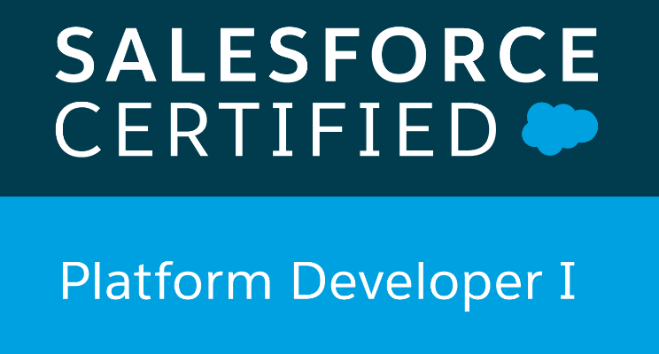

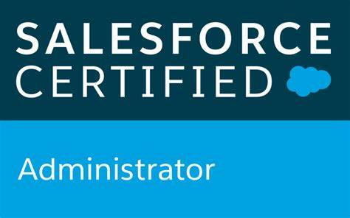

**Name: DUSHYANTHA**

**Email Id:** **dushyantha.sfdc@gmail.com**

**Mobile No:** **+91-7892887462**

**PROFESSIONAL SUMMARY**

* **C**ertified salesforce **administrator** and Certified **PD1** With **3** **years** of experience in **Salesforce.com CRM, Force.com** platform using **Visual force**, **Triggers and Apex** as **Developer and Administrator**/**Lightning.**
* Experience in **Requirement Capture** from client, **Designing, Development, and Deploying Salesforce** applications.
* Experience in working on **Sales Cloud and Service Cloud,**
* Expertise in **Salesforce.com CRM, Force.com, Apex Classes, and Apex triggers, Visual force, Force.com API, SOQL and SOSL.**
* Experience in **customizing standard objects**, creating **roles and Profiles** and configuring the permissions based on the organizational hierarchy.
* Designed custom Formula Fields, Validation Rules, Field Dependencies, **Workflows, Approval Processes**, Page layouts and search layout.
* Implemented security and **sharing rules at object, field, and record level** for different users at different levels of organization, also created various profiles and configured the permissions based on the organizational hierarchy.
* Experience on **Eclipse IDE with Force.com** Plug-in for writing business logic in Apex programming language, VisualForce.
* Experience in building in re-usable L**ightning components** and using Lightning Framework
* Experience in using client side and server-side controllers in **Lightning Design.**
* Worked on designing and developed Lightning Components using Lightning Design System.
* Hands on experience in **OOPS**, **Apex, VisualForce programming.**
* Experience in **Batch Processing (Batch Apex) with scheduling** (Manual & Automated).
* Experience in working with **Salesforce.com sandbox and production** environments.
* Have good knowledge about **Java Concepts.**
* Experience in web technologies including **HTML, XML** & **JavaScript.**
* Experience with **Agile Methodology** Development (Scrum Methodology).
* Developed SFDC Customized **Reports and Dashboards.**
* Experience working with **Force.com IDE**, **Data Loader, Import Wizard and salesforce.com Sandbox Environments.**

**Certifications and Licenses**

**Salesforce Platform Developer 1**

**Salesforce Administrator**

**SKILL SET:**

**CRM :** Salesforce.com

**Salesforce.com :** Apex, Lightning, Visualforce, SOQL, SOSL, Data Loader

**Web Technologies :**HTML, JavaScript, XML

**Languages :** Apex, SOQL,Triggers **IDE Environments :** Apex Data Loader, Eclipse IDE, Force.com

**PROFESSIONAL EXPERIENCE:**

**C**urrently working with **MPL TECHNOLOGIES LTD** as a **Associate Software Engineer** From August-2019 Till Date.

**EDUCATIONAL QUALIFICATION:**

**G**raduation in **B.E(Computer Science & Engineering**) from **NITTE MEENAKSHI INSTITUTE OF TECHNOLOGY** –Bangalore-2018

**PROJECTS**

**Project-1**

**CANTEEN AUTOMATION SYSTEM**

Canteen Automation System is about maintaining the organizations relationship with customers. The main objective of this project is to build an application program to reduce the manual work for Managing the canteen, customer, Item, Delivery and Payment Details.

**PROJECT OVERVIEW:**

The registered user can access the account with valid credentials. User can surv the food items in

Canteen according to categories, Cart and online payment options are available to user. User can

Track their orders with the food details by Email Alert. In Canteen Automation system Admin can Handle the functionalities like add new food items, edit/delete food items, Enable/Disable the food Items according to season and availability.

**ROLES AND RESPONSIBILITIES:**

Customize and personalize Salesforce.com based on requirements.

* Creating Objects and Validation Rules inside Salesforce.com and Mapping them to the Objects.
* Maintain and developed the Custom objects, Custom fields, Custom tabs, and Validation rule Customized different page layouts and assigned them for different profile users.
* Creating Workflow Rules, Tasks, Email Alerts, and Components to the needs of the application.
* Worked on process builder for field updates.
* Involved in creating action components based on client requirements. Involved in field and record level Security.
* Import & Export of the Bulk data through Data Loader. Applied Backup Trigger for backup details.

**PROJECT - 2**

**International Conference-An Event Management System**

The Main Objective of the Event System is to manage the details of Event, Registration of Candidate,

Research Paper Details, Payment Option; Delivery of Proceeding is to enable scalability and flexibility within the assessment process. I worked as administrator and developer handled the following responsibilities.

* Worked on Automation Tool
* Familiar with Data Modelling

## Modules Done

* Developed various Custom objects, Tabs, Relationship data model, validation rules
* Involved in setting up field level access for each custom object created based on the
* Created a commission Approval process based on the Agent and Sales Manager.
* Defined lookup and master-detail relationships on the objects and created junction objects to establish connectivity among objects.
* Involved in field & page layout customization for the standard objects like Account, Contact, and Leads.
* Involved in creating custom E-mail template for email alert.
* Created workflow rules and defined related tasks, email alert to implement business logic.
* Defined lookup and master-detail relationships on the objects and created junction objects to establish connectivity among objects.
* Applied trigger for finding duplicates Email.

**Project-3**

**Name:Yosana Software Services**

**PROJECT DESCRIPTION:**

CG Power and Industrial Solutions Limited, previously known as Crompton Greaves (CG) is an Indian multinational company engaged in design, manufacturing, and marketing of products related to power generation, transmission, and distribution

**ROLES AND RESPONSIBILITIES:**

* Understanding and analyzing business process and to design solutions.
* Created Custom Objects, Fields and Page layouts.
* Worked on Tracking History on objects using custom tracking.
* Worked on the Security model using Profiles, Roles and Sharing Model

(Organizational-wide defaults & Sharing rules) settings.

* Developed Apex Classes, Triggers.
* Designed and developed Workflow rules / Approval Processes.
* Taking part in for data migration process for existing system from/into Salesforce.com.
* Created SOQL & SOSL for data handling using platform database objects.
* Involved in Weekly Status reports and Scrum calls.
* Participated and given knowledge Transfer sessions.
* Reports and Dashboards.

**(DUSHYANTHA)**