Nawnit Kumar Tiwary**

:+91-8793744923:nawnitkt@gmail.com

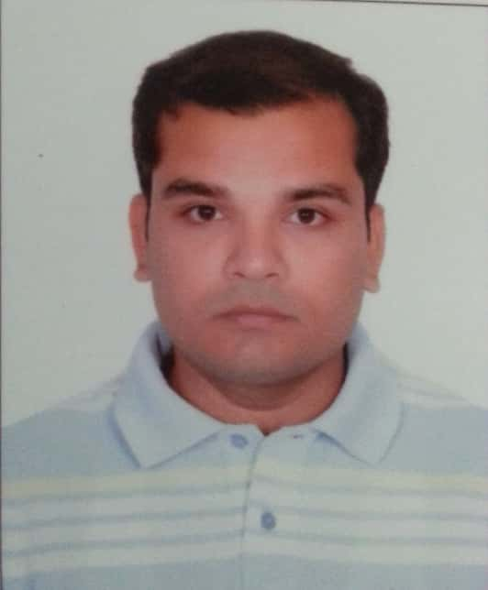

**Professional Summary**

* Salesforce Developer with 7 Years of expertise in C# and MS SQL that includes **3 Years** of experience in **Salesforce.com CRM** platform.
* Involved in various stages SDLC including analysis, requirement gathering, architecture design, lead developer, enhancement, testing, deployment and maintenance.
* Expert in working with **Force.com IDE, Data Loader** and Salesforce.com **Sandbox** environments.
* Proficiency in **SFDC Administrative** tasks including creating Profiles, Roles, Users, Page Layouts, Email Services, Approvals, Workflows, Reports, Dashboards, Actions, Tasks and Events.
* Developed **Visualforce** page using the extension controller, **Apex Classes and Triggers** to implement the business logic as per requirements.
* Developed Unit Test class for Apex class and worked for improving code coverage.
* Developed **SOQL** queries to get data from different related objects.
* Good experience on **Lightning** , **Aura Components** and **App Builder**.
* **Hands-On Task Owner** with on time deliverables, which includes maintenance & deployment of QA/Production releases. Also having strong focus on documentation, Communication, Process and Constant improvements.
* Shown Flexibility, quick learner, proactive attitude and an **amazing team player**.
* Highly efficient in **Complex, Agile, Dynamic, Onshore -Offshore** project environments.
* Good proficiency of Batch Apex, Apex Triggers and Test classes.
* Completed various **certifications** such as
* Salesforce **Certified Administrator** [19205219]
* Salesforce **Certified Platform developer** **1**[19843762]
* Salesforce **Platform App Builder** [19164825]

**Working Experience**

**Current: - Persistent Systems working** as a Salesforce Developer.

**Projects**: -**Amgen (April 2020 – Sep 2020)**

**Technology:** Salesforce, Apex, VF Pages

**Description:-**

* Understanding the requirement from client and Providing solution
* Communicating with customer to providing detailed description of work
* Development of Visualforce pages, VF Controller, Test Class code coverage above 80 percent
* Scheduling batch class
* Preparing different kind of Reports and Dashboards
* Deploying Change set from one sandbox to other.
* Deployment using ANT
* Data Migration using Data Loader.
* Unit Testing

**Projects**: -**Humana/Atena(March 2019 – March 2020)-Syntel Ltd**

**Technology:** Salesforce, Apex, JavaScript.

**Description: -**

* Involved in requirement gathering from Onsite Team.
* Design Requirement documents and functional document for the development.
* Deployed Apex using Force.com IDE.
* Used Picklists, Dependent Picklists and Record Types to enforce data quality.
* Used Tab permissions, Record Type permissions and Field Level Security to implement Component-based security.
* Created Many-to-Many relationships and created Junction objects to implement Roll-up Summary fields to aggregate data from child records on the parent.
* Designed Validation Rules along with Roll-Up Summary Fields to maintain data quantity and data consistency.
* Good knowledge and understanding of RESTful Apex Web services integration.

**Projects**: - **SLI Insurance (June 2018 – Feb 2019)-Syntel Ltd**

**Technology:** Salesforce, Apex, VF Pages, JavaScript.

**Description: -**

* Involved in requirement gathering from Onsite Team.
* Design Requirement documents and functional document for the development.
* Worked with Dynamic Apex to access sObjects and Field describe information, execute dynamic SOQL, SOSL and DML queries.
* Used Picklists, Dependent Picklists, and Record Types to enforce data quality.
* Used Tab permissions, Record Type permissions and Field Level Security to implement Component-based security.
* Created Many-to-Many relationships and created Junction objects to implement Roll-up Summary fields to aggregate data from child records on the parent.
* Designed Validation Rules along with Roll-Up Summary Fields to maintain data quantity and data consistency.

**Projects:-Amex BFSI (March 2017 –May 2018)-Syntel Ltd**

**Technology: Salesforce, Apex, Visual force, JavaScript.**

**Description:-**

* Created Custom objects and fields to store data.
* Created Custom Visualforce components and attributes to override the look and feel of standard Visualforce components.
* Created Visualforce pages which identified a region to be updated to enforce partial page refreshes and display the status of Ajax requests to display different values depending on whether it is in progress or completed.
* Used Tab permissions, Record Type permissions and Field Level Security to implement Component-based security.
* Designed and deployed Custom tabs, Custom Objects, Components, Visual Force Pages, Apex Code.
* Worked with standard Salesforce objects like Accounts, Contacts, Leads, Cases and Opportunities.

**Projects:-Humana, Manulife (March 2013 –May 2017)-Syntel Ltd**

* Worked on Asp.net, C#, MS-SQL Server.
* Used Jira, CA workload automation tool.

**Education**

**B.TECH. (ECE) - 2012, Camellia Institute Of Technology, Kolkata** (W.B) with (7.25 CGPA)

**12th – 2007,DAV Public School, Jamadoba, Dhanbad(CBSE Board)** with 84.4%

**10th – 2005, DAV Public School, Jamadoba, Dhanbad (CBSE Board)** with 89.8%

**Skills**

* Salesforce.com: Apex, visual force, SOQL, SOSL, Email Template, formula, validation rules, apex trigger, workflow and approvals, App exchange, Eclipse, Salesforce.com IDE, Apex data loader, web services.
* Programming languages : C#, Java
* Web Technologies : HTML, XML, CSS, JavaScript, WSDL and SOAP
* Tools: Eclipse, Visual Studio Code.
* Operating System: Windows X

**Personal Information**

Name : Nawnit Kumar Tiwary

Gender : Male.

Hobbies : Playing Cricket, Net surfing.

Date of Birth : 31 December, 1989.

Present Location : Pune

Preferred Location : Bangalore

Total Work

Experience : 7 Years

Relevant Experience : 3 Years

Certifications : Salesforce Certified Administrator, Salesforce Certified Platform developer 1,

Salesforce Platform App Builder.

**Declaration**

I hereby submit that all information is true and to the best of my knowledge and belief.

**Place:** Pune (Maharashtra) **Nawnit Kumar Tiwary**