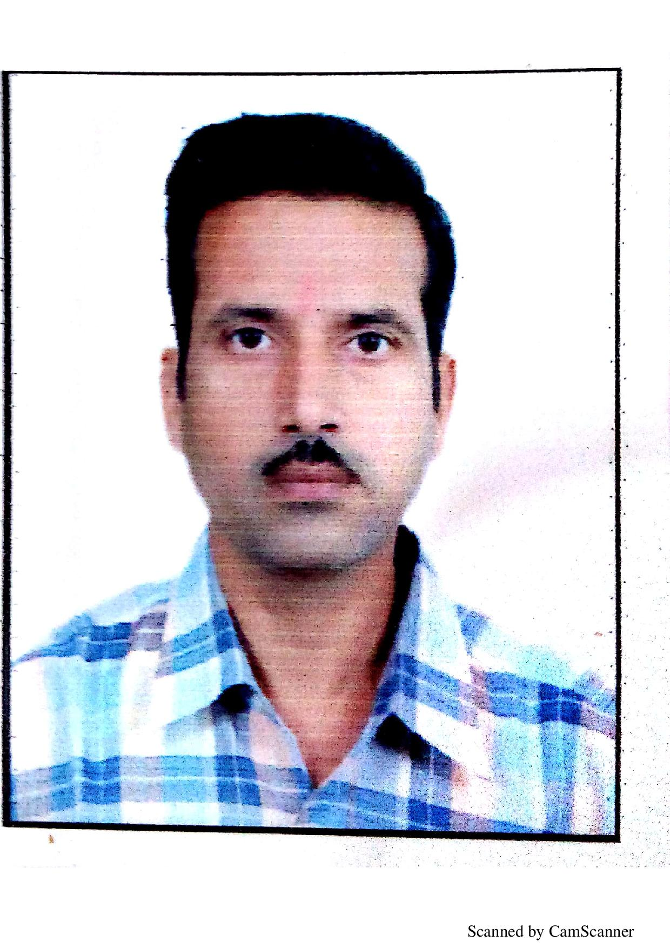
RAGHAVENDRA DIXIT
Contacts +91 7709016452/0712-2261025
Email Id : d_raghavendrapr@yahoo.com
Skype ID : raghavendra.dixit3
Whatsapp No:- 00 966 592392915
______________________________________________________________________
Senior Level Assignments
Finance & Accounts~ Auditing
___________________________________________________________________

P R O F I L E S U M M A R Y

- A result –oriented professional offering over 20+ years of successful career with diverse role in:

Cross Functional co-ordination Ledger Scrutinizing Yearly Auditing
Accounts Finalization Account Receivable/Payable Reconciliation

Synopsis

Graduate in Commerce in the year 1990 with Experience in accounts and finance sector.
- Worked with AL ADIL TRADING CO LLC., DUBAI as a ACCOUNTS –RECEIVABLE.
- Worked with JAL HUMAN RESOURCES CO. SAUDI ARABIA as a ACCOUNTANT-RECEIVABLE. Accounts & Finance for 2 years.
- Expertise in management Accounting & Auditing, Finance, TDS, CST, Monthly Excise Return, Service Tax Return, SAP, & MIS
- Experience in software systems like SAP, TALLY, MS-Office, Internet, Operating systems like Windows XP, 2000, Windows 7, etc.

ORGANIZATIONS WORK WITH

Al Adil Trading Co.L.L.C, Dubai, UAE, JAL Human Resources Co. Saudi Arabia, Adani Wilmar Ltd., Ruchi Soya Industries Ltd., Minor Hydro Systems Pvt Ltd., Anand Mohato Agro Industries Pvt Ltd., Gas Point Petroleum India Ltd., Ferro Alloys Corporation Ltd., Neco Schuberet & Salzar Ltd

DETAIL WORK KNOWLEDG

- SAP Accounting Professional, offering over experience in handling Accounts, Finance & Taxation

- Professional credibility in the areas of Taxation, Auditing, generating reports on VAT & CST Return, VAT Audit and Sales Tax Assessment work etc., and Excise and service tax return on monthly basis

- Awarded by the management team for good work in timely feeling of all Report Generation & statutory returns with the respective departments in time schedule.

- Well versed in costing reports, like material variances accurate report to head office.

- Preparation of Report on Quarterly, Monthly, Half Yearly & Annually Profit & Loss A/C , Balance Sheet related work like preparation of Balance sheet, schedules duly reconcile with Trial Balance.

- Preparation of variances analysis reports verses budget & material consumption report.

Well versed in preparation of Value Added Tax return & its filing online works.

Handling of Internal audit as well as statutory audit related work quarterly, half yearly & yearly basis.

Smoothly handling of SAP system for material variances reports & costing reports.

Preparation of customers & suppliers ledger A/C reconciliation work.

Interpersonal and management skills with ability to handle multiple tasks, Exceptional talent for problem solving and ability to handle multiple functions and activities in high pressure environments with tight deadlines.

WORK EXPERIENCE

AL ADIL TRADING CO LLC.,DUBAI Accounts Receivable Dec.18 to Feb.2020

Company Profile : Establish in the year 1984 in Dubai-UAE and dealing with All kinds of Indian Foodstuff different types of Dals and Masala and wheat and Papad, Nankeen, total 25 super market in UAE and 3 Shops in Bahrain.

Key Result Area:-

- Sales Invoices Authorization and Posting and Bank Receipts Posting
- Issuance of Debit & Credit Notes
- Preparation of monthly sales report for management.
- Periodic visit to customers for collection.
- Daily routine accounting cash & Bank receipt & payment entries.
- Monthly Stock Counting at Various Shops
- Verifying & Checking of Supplies’ Invoices and making online payments
- Customers Account reconciliation

JAL INTERNATIONAL CO. LTD. Saudi Arabia Accounts Receivable Jan.16 to jan18

Company Profile: Established 1985 in Saudi Arabia. Company has its Different Division of Working, Involved in Energy, Oil & Gas, Petrochemical, Hospitality Industry, Recruitment and Manpower Supply, A major provider of a world-class technical and management solutions and manpower supply to SAUDI ARAMCO, SABIC, MAADEN, SAMREF, SCECO, KAUST, and other major clients in the Kingdom of Saudi Arabia in respective Industry.

Key Result Area:-
- Preparation of Monthly Manpower Supply Invoicing to Clients In the Kingdom of Saudi Arabia.
- Preparation of Receivable Statement on weekly basic and follow-up with clients for Payment recovery.
- Issuance of Debit & Credit Notes to Clients & their accounting.
- Invoices Booking In Accounting Software
- Monthly Bank Reconciliation.

ADANI WILMAR LIMITED, NAGPUR Executive - Senior Accounts Officer Aug-‘08 to Jan-‘16

Company Profile: Company Engaged in Manufacturing Of Edible Refined Soya Bean Oil With Production Capacity Of Around 1000 MT. Per Day Approx. Also Engaged In Coal Mining, Ports, Logistics, Power Generation Projects in a Huge Manner in Indian Operations.

Key Result Area :-

- Handling Accounting, & Taxation work as the core responsibility through Leading, Co-coordinating, Directing, and managing a large team.
- Handling out all day to day accounting and multiple accounting works like passing JV, Reconciliation work, Trial Balance with head office on monthly basis.
- Review and supervise the MIS Reports of the company and manage funds under management authority.
- Efficiently and effectively carry out direct and indirect taxes.
- Monitoring execution of accounting functions within strict timeline. Adhering to the various quality measures and implementing it efficiently. Implementing initiatives to ensure cost effective accounting process as per decided standard.
- Completion of statutory and other audits by engaging external auditors.
- Finalization of Accounts with Costing, also handling TDS and CST matters.
- Maintaining payment books in SAP accounting package.

Ruchi Soya Industries Ltd, Buti-bori Accounts Officer Nov 2005 – July 2008

Key Result Area:-

- In Direct Taxation work (Excise ,Service Tax & VAT Returns Filing and Payments)
- Preparation of VAT Audit Data & Assessment working
- Preparation of Quarterly Service Tax refund claim for Export Services
- Routine accounting work and head office reconciliation on monthly basis.

Minor Hydro Systems Pvt Ltd, Nagpur Accounts Officer May 2004 to Oct 2005

Key Result Area :-

- Responsible for maintaining balance sheet, Sales tax, Service tax & Income tax and day to day routine accounting work.
- Checking of monthly sales bills with parties order, Acceptance & Purchase order, Checking of monthly journal voucher, cash voucher and preparing reconciliation like Maruti Udyog Ltd, Kelvinator, Hero Honda Ltd, Escorts Ltd, and All Div. Mark Auto Ltd. situated in North Zone, Delhi.

Anand Mohata Agro Industries Pvt Ltd, Nagpur Accountant Jun 2002 to May 2004

Key Result Area :-

- Responsible for day to day account activities like cash & bank entries, journal entries.
- Preparation of monthly TDS and Sales Tax return along with annual return of sales.

Gas Point Petroleum India Ltd, Nagpur Assistant Manager Aug 2001 to Jun 2002

Key Result Area :-

- Accountable for branch accounting process like balance sheet and also responsible for coordination with all India branches.
- Preparation of monthly Bank Reconciliation Statement, Head Office Reconciliation.
- Preparation of monthly TDS and Sales tax return.
- Scrutiny of Sundry debtor and Sundry credit

Ferro Alloys Corporation Ltd, Nagpur Accounts Assistant April 2000 – Aug 2001

Key Result Area :-

- Responsible for maintaining Export Accounting and Export Documentation work.
- Responsible for maintaining Export Incentive Scheme like Duty Entitled Pass Book scheme (DEPB) which was issued by Director General of Foreign Trade and also responsible for maintaining Anti Dumping Works.
- Preparation of Letter of Credit bills for the company.

Neco Schuberet & Salzar Ltd, Nagpur Accounts Officer Oct 1997 – Apr 2000

Key Result Area :-

- Preparation of Monthly Stock System, Finalization Of Accounts, responsible for Tax Auditing.
- Analyzing of reports with the help of Management Information System (MIS).
- Highlighting the performance through Fund Flow statement and Cash Flow statement.

OTHER VALUABLE EXPERIENCE From: FY 1989-1996

- Responsible for Sales Tax Assessment with Sales Tax Authorities.

- Three years of Work Experience in Trading Books Writing where the key responsibility was to maintain F.O.B. and C.I.F. value as per accounting standards.

PERSONAL PROFILE

Name : Raghavendra B. Dixit

Date of Birth : 26-Oct-1969
- Marital Status : Married

Languages Known : English, Hindi, and Marathi

Permanent Address : Neelkanth Apartment, 375, Shankar Nagar, Nagupr-440010, INDIA

DECLARATION

I, hereby declare that all the above information given by me is true to the best of knowledge and belief.

Date:
Place: Nagpur Signature

