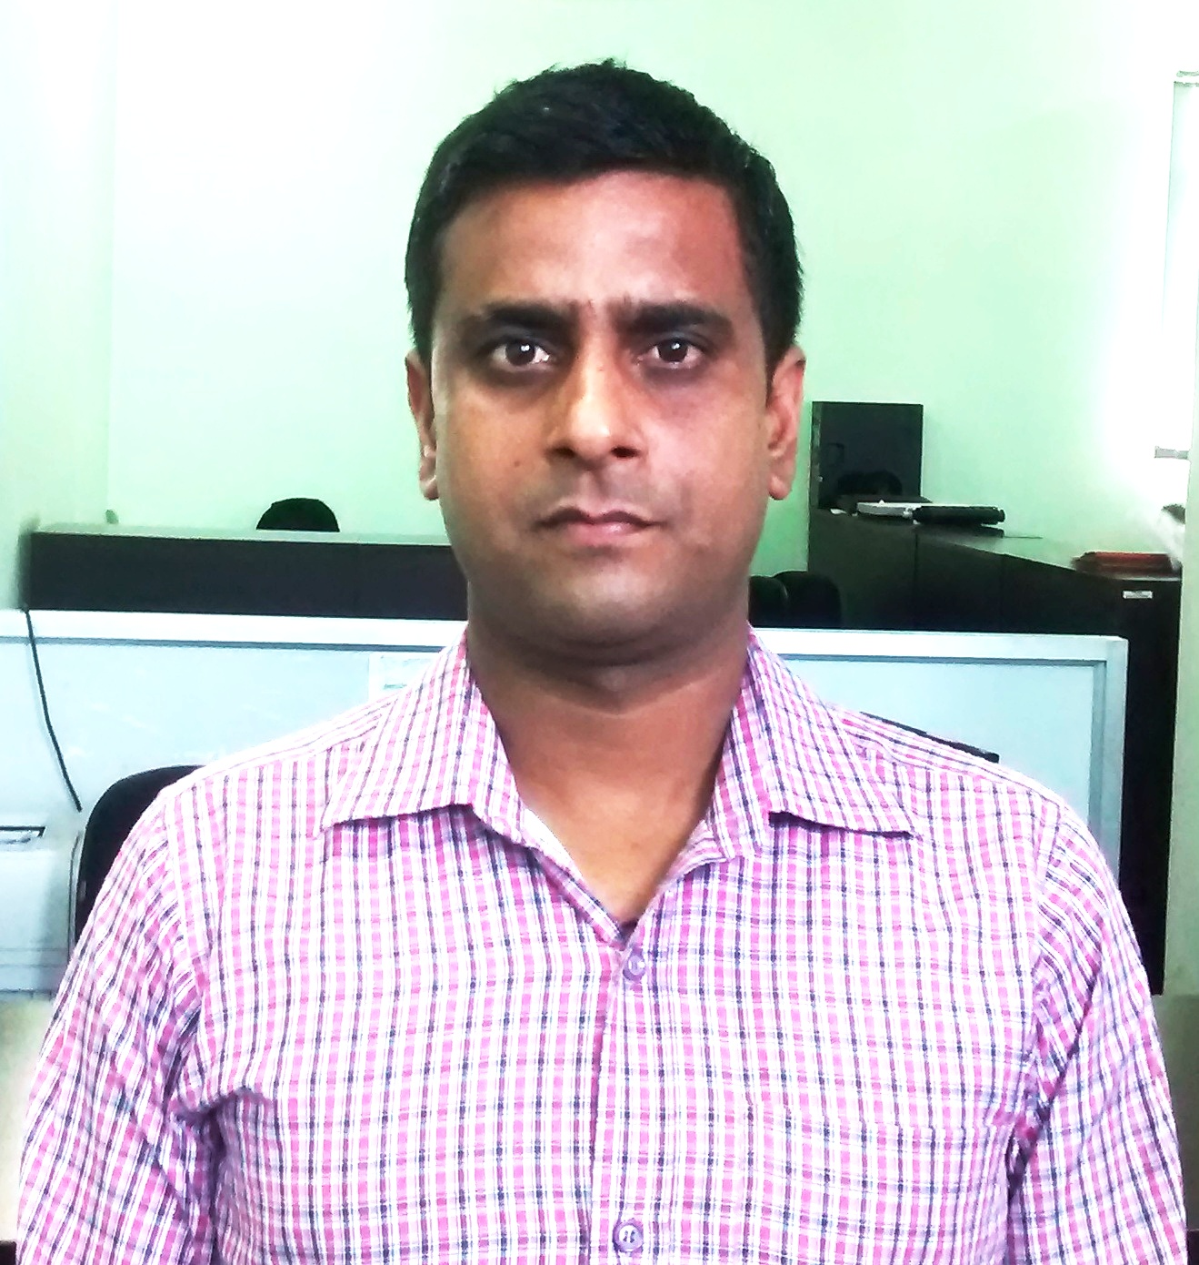
Balwant Kumar Singh
Email : singh.vikas26@gmail.com
Mobile: +91-7309035993
S/o Narendra Singh
Village :Dawani,P.O Dawani
Distt. Ballia. Pin : 277203
Uttar Pradesh

Professional Summary

An astute, results-oriented leader with over 3 years of experience in Toll Operations & Team Management. Presently associated with SOMA-ISOLUX as a Plaza Controller on a BOT Toll road project. Proficient at managing & leading teams for running successful process operations & experience of developing procedures, service standards for business excellence. A thorough professional with a proactive attitude, capable of thinking in and out of the box, generating new design solutions and ideas. Possess excellent interpersonal, communication and organizational skills with proven abilities in team management and planning.

Objective:
To accept the challenge of today's fastest developing and growing fields in India by utilizing all the knowledge, skills and experience gathered so far to meet their stringent requirements. To acquire advance skills and knowledge by being in the company of highly skilled and practical technocrats. And see my growth as an essential sign of my achievements.
Professional Strengths:
➢ Excellent communication and interpersonal skills.
➢ Ability to direct people and achieve success through teamwork.
➢ Ability to learn various system and use effectively.

Education:
Name Of Examination | Board/University | Name Of School | Result | Year Of Passing
Bachelor Of Arts | Purvanchal University | V.B.S Purvanchal Univ. | 2nd Div. | 1999
H.S.C. | U.P Board | S.B.R.H.L.U.M.B | 2nd Div. | 1996
S.S.C. | U.P Board | Ram Dahin Singh Inter College | 2nd Div. | 1994

Professional Qualification:

Completed Six Months Diploma course from NIIT C.W.C (Computer Web Centric Course) from South-x, New Delhi.

Organizational Experience

Since Sep 2012 to till date: SOMA-ISOLUX as Sr. PLAZA CONTROLLER (Toll Operations)

Currently working with SOMA-ISOLUX Pvt. Ltd. on Daffi Toll Plaza on NH-2
A Joint venture between Soma Enterprises Ltd., India and Isolux Corsan Spain. Currently this company is implementing approx Rs.12, 000 crore highway projects on Build Operate & Transfer basis in Haryana, Punjab, Rajasthan, Gujarat, and Bihar & U.P.

Chief tasks handled

- Responsible for managing operations & spearheading teams for excelling business targets & service delivery metrics.
- Overseeing process improvement initiatives through system changes, process re alignment/ redefining & efficiency management.
- Forecasting workload and scheduling staff to meet anticipated workload within scheduled turnaround time thereby enhancing efficiency.
- Creating and sustaining an environment that fosters development opportunities and motivating the employees for enhancing the existing performance levels.
- Adhering to leave policy and ensuring the same with the same from the account.
- Managing & monitoring the performance of teams, maintaining Shift Statistics to ensure efficiency in process operations.
- Preparing & compiling various daily, weekly/monthly MIS reports pertaining to process, and productivity.
- Carrying out appraisals & performance reviews of various teams & providing feedbacks on areas of improvements.
Notable Distinctions
- Presently directing a team of 40 people
- Efficiently coordinating with other department i.e.: Maintenance. System. Route & Security.
- Liasioning with general public (users / Govt/ Administrative bodies in connection to the plaza operations)
- Successfully initiated corrective action after reviewing security frisking/ confidential security report on daily basis
- Trained the new recruits along with existing, Lane Assistant, POS executive and Toll Collectors.
- Finalizing Documentation and preparing a comparative statement and forwarding it to the higher management for further action.
- Coordinating with the superiors in initialing various training to improve the performance of the team.
- Temporarily handled the Patrolling and traffic control of the TOLLWAY successfully

PRIOR WORK EXPERIENCE

RT Outsourcing Pvt. Ltd. (Intarvo Services Pvt. Ltd.), New Delhi
Industry : Telecom
Duration : Feb’08 to May’10
Designation: Part Planner
Job Responsibilities:
I am in Sony erricson mobile project as a part planner I am allocation Sony erricsson mobile Part & accessories in all over India Repair centre & prepare MIS Report on Excel 2003 & update data in CIRIMS (Customer integrated relationship management system).

G.E Money (Corporate Park) Gurgaon
Industry : Financial
Duration : Feb’07 to Jan’08
Designation: M.I.S
Job Responsibilities:
I am Handling customer query in financial problems & prepare MIS Report on Excel 2003 & sending our client.

Evolve Brands Pvt. Ltd.
Industry : Event & Promotions
Duration : Apr’06 to Jan’08
Designation: M.I.S(Handling the J.K Paper Project)
Job Responsibilities:
I am Team Leader in Database and handling 20 peoples and maintain the data & profiling data and provide the call center for calling purpose.

Personal info
Nationality Indian
Marital Status Married
Date of Birth 01st Feb 1980
Languages Known English, Hindi
Hobbies Working on computer, net surfing, playing cricket, watching tv.

Strengths Getting along with everyone, inquisitiveness to learn new things
Concentration, good communication skill Ability to work under pressure

I hereby declare that the above written particulars are true to the best of my knowledge & belief.

Date:
Place: Balwant Singh

