Lakshmi P Nannapaneni 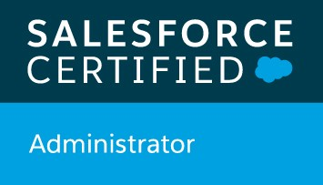 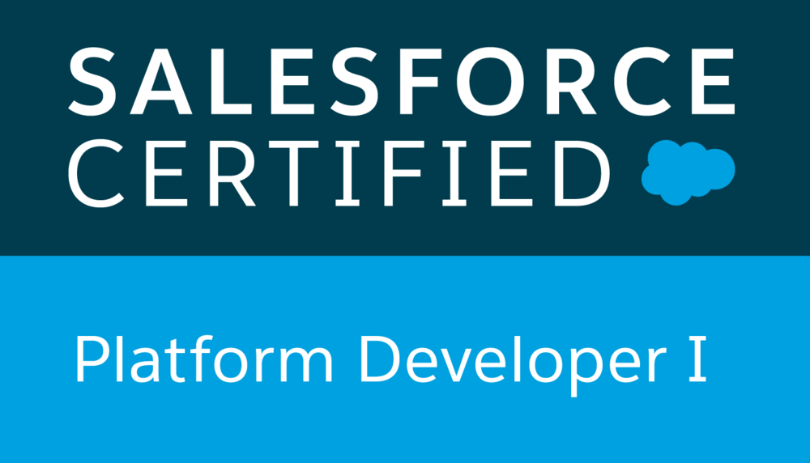

[Lakshmisfdc15@gmail.com](mailto:Lakshmisfdc15@gmail.com)

(512)666-4012

**Professional Summary:**

* 6plus years of hands on experience in force.com platform as an administrator and developer includes Design, Development, Testing and around Three years of experience on salesforce lightning to develop mobile apps and maintain the web sites.
* Experienced in Software Development Life Cycle (SDLC) such as Requirements Gathering, Project Design, Development, Support and maintenance phases to meet requirement of project.
* Experience working with Force.com IDE in design and development of Custom Application for Complex Business Processes in both Sales and Service Cloud Modules and customization of Standard Objects Leads, Accounts, Contacts, Opportunities, Opportunity Products, Campaigns, Campaign Members, Cases, Solutions, Knowledge, and Articles
* Extensive experience in maintenance of web and CRM applications - Salesforce.com, Apex, Visual Force, SOQL, SOSL, Communities, Sales Cloud, Service Cloud, SOAP, REST, Java Script, jQuery, JSON, Core Java, Data Loader, Informatics On-Demand
* Extensive experience in designing of Custom Fields, Role Based Page Layouts, Workflow Approval, force.com, Validation Rules, Approval Processes, Custom Tabs, Custom Reports, Report Folders, Report Extractions to various formats, Design of Visual Force Pages, Snapshots, Dashboards, and Email generation according to application requirements.
* Developed Schedule Apex, Batch Apex, Apex classes, Apex Triggers, Visual Force (Page, Component & Controllers), Lightning Components on Force.com platform to customize application according to the functional needs and Wrapper classes and Apex test Classes for SFDC Testing, Batch Apex for data processing and writing queries in SOQL and SOSL, Customized queries to avoid governor limits and also strong exposure on front-end technologies like HTML, CSS, AJAX
* Hands on experience in implementing security and sharing rules at object, field, and record level for different users at different levels of organization. Also created various profiles and configured the permissions based on the organizational hierarchy
* Experienced in enabling customer facing communities which are hosted in Salesforce Communities which creates a Web to lead and experienced with Community cloud to build deeper relationship with customers to provide better service and assist them through online.
* Used Lightning process builder for visualizing and creating automated business processes
* Extensively used Salesforce Lightning Design Systems (SDLS) components in the Lightning Application.
* Have knowledge in implementing various advanced fields like Pick lists, Custom Formula Fields, Many to Many Relationships, Lookups, Master-Details, Field Dependencies, Validation Rules, Work Flows, and Approval Processes for automated alerts, field updates & Email generation according to application requirements
* Experience in implementing SOAP, REST based web services to integrate Salesforce with various third-party applications.
* Hands-on experience in deploying components across Production and Sandbox instances using Force.com Migration tool, Change sets, and Workbench. Good at implementing Salesforce best practices.
* Involved and implemented the data integration and migration by using Apex data loader, web-based import wizards and Informatica ETL
* Have experience on creating and using Process Builder, Workflows and Approval Processes.
* Built customized Salesforce 1 Mobile Apps using Lighting Component Framework
* Good hands on practice with the new Lightning System Design which helps to quickly and easily create modern enterprise apps using Lightning App Builder and Lightning Components Performed.

**TECHNICAL SKILLS:**

|  |  |
| --- | --- |
| **Salesforce Technologies:** | Apex Language, Salesforce CRM, Classes/Controllers, SOSL, SOQL, Dashboards, Salesforce Security Model, Custom Objects, Apex Data Loader, Record Type, Role Hierarchy, Visual force Pages/ Components, Workflow & Approvals, S Controls, Service Cloud, Lightning Components, Chatter, Apex Web Services, AJAX, Analytic Snapshots Case Management Automation. |
| **Salesforce Tools:** | Apex Data loader, Web services APIs, Force.com Explorer, Force.com Eclipse IDE Plug-in, Force.com Platform (Sandbox and Production). |
| **Programming Languages:** | C, C++, Java |
| **Web Technologies:** | JavaScript, CSS, Ajax, HTML. |
| **Operating Systems:** | MS Windows, MAC OS. |
| **Data Bases:** | MS SQL, MS Access, Oracle 11g /12c. |
| **Other Tools:** | JIRA, Data Migrator, IBM Debug Tool, Informatica, Workbench, Version Control Tools, ANT Tools |

**CERTIFICATIONS**

* Salesforce.com Certified Force.com Platform Developer I (DEV – 401)
* Certified Salesforce Administrator (ADM 201)

**PROFESSIONAL EXPERIENCE:**

**Client: Abbott**

**Location: Austin, Texas**

**Role: Senior Salesforce developer with lightning Sep 2018 - Present**

Abbott Laboratories is an American Healthcare company that manufactures different Medical devices, Nutrition foods and Pharmaceutical drugs, working as Salesforce developer/Administrator to creating custom apps by using Lightning components to simplify the work

**Responsibilities:**

* Performed detailed analysis of business and technical requirements and created solutions by customizing various standard objects of Salesforce.com (SFDC) and other Platform based technologies like Visualforce, Force.com API, and Web Services.
* Worked as Admin to identifying, planning and implementing new salesforce.com features and functions (New screens, workflow, force.com objects, and reports, apex code) to meet business requirements.
* Created various Custom Objects, Custom Settings, Custom Labels, Validation rules, Record types, Custom Tabs, Workflow rule and approval process including Field updates and email alerts.
* Worked with various salesforce.com objects like Accounts, Contacts, Leads, Opportunities, Reports, and created custom objects based on Business need.

Worked as a Sales Force Chatter APP with the organization and regularly participated in the scrum and sprint meetings and chatter community.

* Created New Reports, New Dash Boards, and worked on Data Loader by uploading millions of records and experienced in cleansing and De-duplicating bulk loads.
* Implemented Wave Analytics, created datasets, dashboards and apps for Opportunity, Accounts and Cases.
* Service Cloud enhancements - Portal entitlement wizard changes.
* Experience with Service Cloud including: Service Console, Customer Portal, Case Feed, and Knowledge.
* Worked on Sales Cloud and Service Cloud with functionalities like Opportunity Management and Case Management.
* Created and maintained the email templates to be used in the Workflows, Auto Assignment Rules and Auto Response Rules related to Lead Management module in Sales Cloud.
* Integration of Sales cloud with external information systems using SOAP API web services.
* Created page layouts, search layouts to organize fields, custom links, related lists, and other components on record pages.
* Creating Apex Classes by using WSDL and writing business logic layer for integration with external web services to the system for functional needs.
* Implemented Apex Classes and Triggers and linked them to manage the workflows Implemented in the system.
* Integrating on premise Mainframe Case, CPQ and reporting systems with Salesforce REST APIs.
* Created profiles and implemented Object and field level security to hide important information
* Using force.com developer toolkit including visual force pages, apex classes, apex controllers and apex triggers to develop custom business logic.
* Developed Apex Classes, Apex Triggers, and Apex Controllers to develop custom business logic.
* Working on Lightning components along with controllers and used AJAX to retrieve the data

From an object.

* Created modern Enterprise Lightning Apps combining with Lightning Design System (CSS and Design Parameters), Lightning App Builder and Lightning Component features.
* I configured product and pricing setup using CPQ/Product consoles Formatted and migrated the user data into Lightning Experience. Tested the Lightning components.
* Enabled Lightning Components for use in Salesforce1 mobile Platform.
* Integrated the Web Services for extracting the data from external systems to display in the page
* Worked and configured on Devops tool Migration-GitHub to Bit bucket and Bamboo to Jenkins
* Worked and configured different App Exchange Apps (Social Sage Guard, Conga) in Production

**Environment:** Salesforce.com platform, Apex Language, CRM, Visual Force, Pages, Data Loader, Workflow & Approvals, Email Services, Security Controls, Sandbox Data loader, Eclipse IDE, Lightning, App Exchange, Informatica.

**Client: Meijer Jan 2018 – Aug 2018**

**Location: Walker, Michigan**

**Role: Salesforce Developer/ Administrator**

Meijer Inc. is an American supercenter chain throughout the Midwest, with its corporate headquarters in Walker, Michigan, which is a part of the Grand Rapids metropolitan area. Founded in 1934 as a supermarket chain. Working as Salesforce Lightning developer/Administrator to creating custom apps by using apex classes and triggers and Lightning Components to simplify the work.

**Responsibilities:**

* Responsibilities included design, administration, development, testing and customization of Salesforce.com applications.
* Gathered requirements from stakeholders and Product Managers and had a thorough understanding of interpreting customer/client’s business needs and translate them into operational requirements.
* Performed detailed analysis of business and technical requirements and designed the solution by customizing various standard objects of Salesforce.com (SFDC) and other Platform based Technologies like Visual Force, Force.com API, and Web Services.
* Used Batch Apex to build an archiving solution that ran on a nightly basis, looking for records past a certain date and added them to the archive.
* Maintained and customized Salesforce.com scopes such as users, roles, profiles, groups, accounts, contacts, products, opportunities, knowledge, chatter, record types, sharing rules, custom objects, pick lists and page layout customization to support vital business functions.
* Created modern Enterprise Lightning Apps combining Lightning Design System, Lightning App Builder and Lightning Component features.
* Created multiple Lightning Components, added CSS and Design Parameters that makes the Lightning component look and feel better.
* Enabled Aura Framework, by adding Aura Attributes and Aura Handlers for Events to focus on Logic and Interactions in Lightning Applications.
* Minimized code in JavaScript Controllers by adding reusable functions in Helper Component.
* Used the Force.com plugin for Eclipse IDE to develop, enhance, test, and deploy applications on the Salesforce Platform.
* Worked on Administrative tasks like creating and maintaining Users, Profiles, Roles, Record Types, Page Layouts, Email Services, Visual flows, Tasks and Events.
* Worked on developing the Salesforce Knowledge Articles and integrated them with the Visual Force Pages and Visual Flows, providing ease of access to the agent operating the script.
* Responsible for designing system/Unit test cases and involved for QA testing.
* Worked with Formula fields for calculation, related object display, auto-population based on related field values.
* Developed custom objects, worked on profiles, sharing rules, roles and Permission Sets in-order to create and maintain an efficient Security model for the organization.
* Worked with Organization Wide Defaults, Role Hierarchies, Sharing Rules and Manual Sharing to implement Record-based sharing.
* Defined permissions for Profiles and Administrative permissions to grant/deny users access to platform features.
* Worked closely with some of the AppExchange (CPQ) tools and Implemented a custom packaging application according to the requirements using custom Visual Force and Apex.
* Worked on implementing the REST-Based API to Integrate the data with an external Medical system allowing a two-way communication (exchange) of data.
* Worked on developing and integrating the Data from Salesforce to the SQL server, and back to Salesforce using the SQL Server Integration Services (SSIS) and SQL Server Data Tools(SSDT).
* Involved in administrative activities like data cleansing and data consolidating.
* Used Visualforce in development mode to change the behavior and appearance of Visualforce components.
* Implemented Visualforce components and Utility Classes to encapsulate page elements to be reused across several Visualforce pages and apex controller classes.
* Worked on different standard and custom objects. Used campaigns, promotions, leads, and accounts to dynamically save and display fields.
* Used standard and custom controllers. Used a base controller class for efficiency of the application.
* Used Batch Apex to handle bulk data and perform DML operation on them
* Created Reports, Dashboards and Dashboard Components and implemented multiple levels of Dashboards and scheduled Dashboard refresh. Worked with Apex Scheduler to run the reports and email to the related users in the org.
* Involved in administrative activities like periodic data cleansing, security setup and workflow update.

**Environment**: Salesforce.com platform, Workflow and Approvals, Reports, Custom Objects, Tabs, Email Services, Apex Language, Visual Force Pages, Components and Controller, Aura Framework, process builder, Flows, Email Services, HTML, CSS, JavaScript

**Client: Foot LOcker**

**Location: Chicago, IL**

**Role: Salesforce Developer/ Administrator April 2016 – Dec 2017**

Foot Locker is an American sportswear and footwear retailer company and famous for its employees’ uniforms at its flagship Foot Locker chain. Worked as Salesforce Administrator/ Developer to create users and develop their website in better way and solve the issues in previously developed websites.

**Responsibilities:**

* Worked as enhancement team member and performed the roles of Salesforce.com Administrator and Developer in the organization.
* Worked with various salesforce.com objects like Accounts, Contacts, Leads, Campaigns, Reports and Dashboards
* Interacted with various business user groups for gathering the requirements.
* Customized tab worked with various standard objects like Accounts, Contacts, Leads, and Campaigns, Cases.
* Developed Visualforce pages, controllers for goal setting and performance evaluation.
* Developed reports, dashboards, and processes to continuously monitor data quality and integrity
* Analyzing the Scenarios for switching between salesforce classic and the Lightning Experience
* Retrieved some data and its functionality from Third-Party API’s and displayed within the lightning component.
* Created multiple Lightning Components, added CSS and Design Parameters that makes the Lightning component look and feel better.
* Developed applications that connect using Web Services to download data from external data providers.
* Customized standard objects to better suit the requirements of the client, adding new fields, relationships, validation rules and Triggers wherever needed.
* Created Custom Applications and developed Custom Objects for the same.
* Created Custom Fields, Relationships, Field Dependencies, Validation Rules, Lookup Filters and Record Types for the Applications.
* Defined Workflows and set up Workflow Rules, Tasks and Alerts and created Approval Processes.
* Customized Page Layouts, Standard Related Lists, Tabs, and defined dependent Pick Lists.
* Experience working on community cloud enabling members to create and update records and processes from within the community.
* Updated opportunities so that customers can provide product feedback and employees can escalate customer support cases.
* Used Apex classes and Visual force pages to implement highly customized requirements.
* Strong Experience in ETL activities like data migration using APEX Data Loader, Excel Connector, Import Wizard.
* Used Data Loader for insert, update, upsert, and bulk import or export of data from Salesforce Objects. Used it to read, extract and load data from comma separated value (CSV) files.
* Developed reports, dashboards, and processes to continuously monitor data quality and integrity.
* Customized Dashboards to track project status and performance of business centers.
* Integrated the Web Services for extracting the data from external systems.
* Administered, configured, maintained Salesforce.com application user profiles, roles, assigning Permissions, generating security tokens, validation Rule, upgrade installation.
* Excellent writing skills in preparing business requirement documents **(BRD)**, system requirement specifications **(SRS)**, System Design Specification **(SDS)** & **Use Cases**.
* Comprehensive understanding& experience of SWOT, Risk & Cost/Benefit analysis.

**Environment:** Salesforce.com, Cast Iron, Apex Language, Visual Force (Pages, Component & Controllers), Workflow& Approvals, Custom Objects, Custom Tabs, Email Services, Page Layouts, Outlook Integration, Data Loader, Force.com IDE, Cast Iron, Sandbox data loading, Eclipse IDE Plug-in, Reports, Dashboards, Sandbox, Windows XP.

**Client: GE India, Chennai, India**

**Role: Salesforce Administrator Sep 2014 – December 2015**

Improving the efficiency in the Sales process by seamlessly integrating the Quoting, Configuration & Proposal Generation, Invoicing & Hardware fulfillment, Licensing & Software fulfillment. This implementation leveraged the standard Salesforce objects and functionalities including Accounts, Contacts, Lead, Opportunities. The project was implemented in Salesforce.com involving integrations with external systems.

**Responsibilities:**

* Interacted with the end users to understand the requirements.
* Developed validation rules, Page layouts, Search layouts, Custom objects and Tabs.
* Worked on developing and data modeling the application and made sure that they are within the Salesforce limits.
* Migrated data from external sources and performed insert, delete, export operations on millions of records.
* Created User, Roles, Public groups and implemented role hierarchies, sharing rules to manage access for different users.
* Imported data to Leads, Accounts, Contact and Opportunities using data loader and import wizard.
* Designed and improved various workflow rules, validation rules, approval process.
* Made sure that the data quality is maintained by deleting or merging duplicate records and updating inaccurate data.
* Configured sharing rules, field level security and record level permissions to protect valuable information by shared access.
* Designed and deployed Apex classes, Controller classes, and Apex triggers for various functional needs in the application using the Eclipse IDE.
* Created Many-to-Many relationships and created Junction objects to implement Roll-up Summary fields to aggregate data from child records on the parent.
* Created Page Layouts for various profiles to make users comfortable for inputting data into CRM from customers.
* Collaborated with other developers in performing unit testing and identifying bugs in the application.
* Developed UI using CSS, HTML tags, Visual Force components and used JavaScript for front-end validation.
* Tested application on various levels like integration and system testing by utilizing various methodologies.

**Environment:** Salesforce.com platform, Workflow and Approvals, Visual Force, Reports, Custom Objects, Tabs, Email Services Apex, Data Loader, Force.com, Import Wizard, Eclipse IDE, Security Controls, API.

**Educational Details:**

Master’s in computer science - 2017