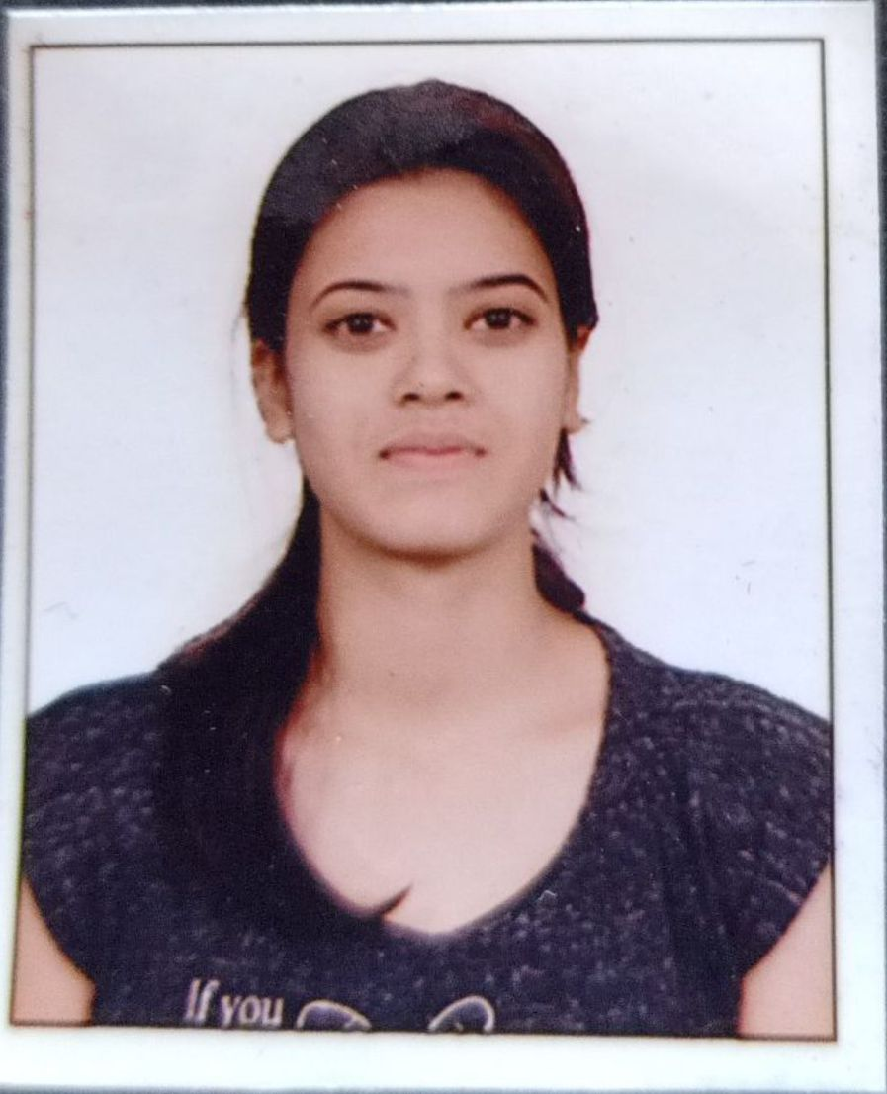 **Ms.Sonawane Pooja Vasant**

(BE Information Technology)

Email:poojasonawane9130@gmail.com

Contact:+91 9130114355

CAREER OBJECTIVE

Seeking a challenging position in Technical field so as to utilize my skills for organizational and individual growth.

EDUCATIONAL QUALIFICATIONS

|  |  |  |  |  |
| --- | --- | --- | --- | --- |
| **Qualification** | **Institute Name** | **Board/University** | **Year** | **Percentage** |
| B.E(Information Technology) | RMD Sinhgad School of Engineering,Pune | Savitribai Phule Pune University | 2021 | Appearing |
| H.S.C. | Shri Sainath Highscool And Junior College Alkuti,Tal-Parner Dist-A.nagar | Pune Divisional Board | 2017 | 68.92% |
| S.S.C. | Shri Sainath Highschool Alkuti,Tal-Parner Dist-A.nagar | Pune Divisional Board | 2015 | 92.40% |

TECHNICAL EXPERTISE

* **Programming Languages**: HTML C, C++, Java, Basic Python
* **Database:** SQL, MySQL
* **Tools:** Microsoft Office 2010/2013
* **Operating System:** Windows XP, Windows 7,Windows 8, Windows 10

ACADEMIC PROJECTS

* **Title: Eduguider: Carrier assistance based on new education system using ML**

Software: Java JDK 1.8, Eclipse Luna, MySQL

Description: The proposed system helps us in predicting the domain of the question from the question paper. By doing this we get the expertise for a particular user based on the solved question from the question paper. Here we are using a machine learning technique to predict the domain of the respective question from the tags already present in the question. By applying a machine learning algorithm on extracted data and based on the information, the system suggests the user with particular domain expertise and recommend the lacking domains for the users.

* Title: Car rental system

Software: XAMPP

Description: The main objective of the car rental system is to manage the details of car, Payment, Customer, Supplier, Insurance. It manages all the information about Car, Booking, Insurance, Car . The purpose of the project is to build an application program to reduce the manual work for managing the Car, Payment, Booking, Customer.

TRAINING

* Not yet

EXTRA CURRICULAR ACTIVITES

* Participated in web Development Workshop Organized by Department Of Information Technology, RMDSSOE, Warje, Pune.
* Successfully Organized FE Induction at Department Of Information Technology, RMDSSOE, Warje, Pune in August 2018.

INTERPERSONAL SKILLS

* + Quick Learner and Positive Attitude.
  + Adaptable to Working Environment.
  + Self Motivated and Confident.
  + Problem Solving Skills.

|  |
| --- |
| CERTIFICATES |

 Coursera

1. Python : Programming For Everybody ( Getting Started With Python )

Internshala

1. Data Science Training

Onlineinternship.in

1. Technical Java

|  |
| --- |
| HOBBIES |

Travelling

Photography

Listening Music

PERSONAL DETAILS

* Date of Birth**:-** 5 November 1999
* Gender**:-** Female
* Marital Status**:-** Unmarried
* Nationality**:-** Indian
* Languages Known**:-** English, Hindi and Marathi
* Interests**:-** Art and Programming
* Local Address**:-** Sinhgad Girls Hostel Ambegaon, Pune

DECLARATION

I hereby declare that the above-mentioned information is correct up to my knowledge and I bear the responsibility for the correctness of the above-mentioned particulars.

**Date:**

**Place:**Pune **(Signature)**