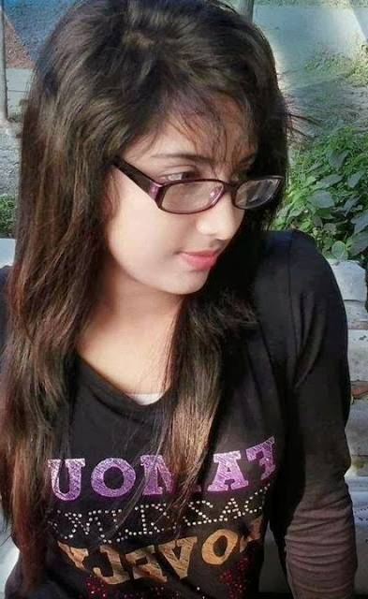
Aninditha Beeram
E-mail- anindithabeeram14@gmail.com , Ph No: +918500452846
# H.no:161/1, Kukunuru, Tallapudi, West Godavari (Dist), Andhra Pradesh, 534341 ___________________________________________________________________________
Objective: To work in an organization where I can contribute to the organization’s growth and profitability with my skills and in turn get an opportunity to gain exposure and expertise that would help me build a strong and successful career.
Educational Qualification:
- B.Tech (CSE) from KIET(W)in 2020 with 7.17CGPA
- Intermediate (M.P.C) from Sri Chaitanya in 2016 with 71.2%.
- SSC from Hamsavahini Academy High School in 2014 with 7.7CGPA%.

Computer Skills:
- Programming Languages : Basics of C,HTML & CSS,JAVA,Ms Excel
- Operating Systems : Windows XP, Windows 7,8,10.

Main Project: Task Management system.

Achievements:
- Participated in college and school level sports, debates and group discussions

Key Skills:
- Good communication & presentation skills.
- Positive attitude, Self -motivated and confident.

Hobbies:
- Listening to Music.
- Cooking.
- Crafting, Drawing.

Personal Details:
Name : B. Aniniditha
Father’s Name : B. Venkata Ratnam
Date of birth : 26th may 1999
Gender : Female
Marital Status : Unmarried
Languages known : English, Telugu, Hindi.
Nationality : Indian

Declaration:
The above-mentioned information is true and correct to the best of my knowledge and belief. If I am selected and given a chance to serve in your esteemed organization, I shall prove my best and ability to the entire satisfaction of my superiors.

Place:
Date: (B.Aninditha)

