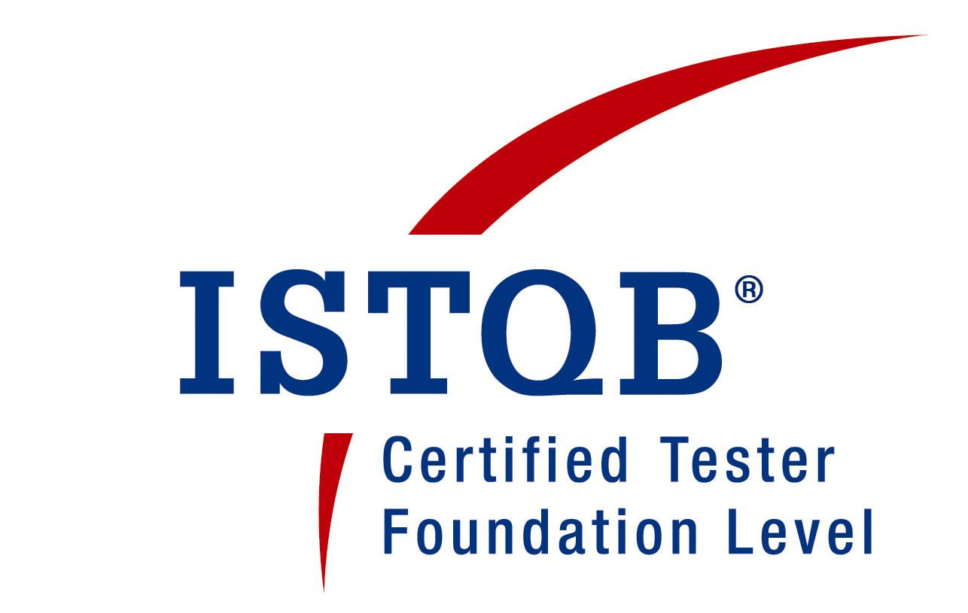

VEERESH DUDEKULA Mail: vdudekula12@gmail.com
Mobile: +91-8247807348

Summary

- Having 11 + years of professional IT experience in IT industry with core expertise in Agile as a Certified Scrum Master and Certified Scrum Professional.
- Around 3 years of experience in Agile Methodologies and working as Scrum Master/Agility Lead.
- Certified Scrum Master (CSM) from Scrum alliance.
- Working as Agile Transformation Agent at organization level and coaching the teams across LOB’s.
- Trained and enabled team on agile methodologies and SCRUM.
- Good exposure in US Healthcare, Pharma, US Mortgage and Capital Market domains.
- Well versed with Agile methodologies and tools like JIRA, VSTS, Confluence.
- Experience in writing Test Plans, defining Test Cases, developing, and maintaining Test scripts, analyzing the results of scripts, interaction with team members in fixing the errors
- Experience in Developing and executing the test plans, test strategy, test cases.
- Excellent understanding of Software Development Life Cycle and Test Methodologies from project definition to post-deployment documentation.

Educational Qualifications

- Bachelor of Information & Technology (B. Tech) in May-2009 from JNTU, ANANTAPUR.

Professional Experience

- Working for HCL Technologies Pvt Ltd as a Scrum Master from Aug-2018 to till date.
- Worked for Black Knight Financial Services as a QA Lead from Oct-2015 to Aug-2018.
- Worked for AppShark Software Pvt Ltd. as Sr QA Engineer from Feb -2014 to Aug-2015.
- Worked for Caliber Technologies Pvt Ltd. as Sr QA Engineer from May-2010 to Feb-2014.

WORK EXPERIENCE:

HCL TECHNOLOGIES
Aug’ 18- Present

Responsibilities as SCRUM Master/Agility Lead
- Working as a Scrum Master for 2 teams
- Familiarize the team with Agility and Scrum events like Sprint Planning, Daily Scrum, Sprint Review and Sprint Retrospective.
- Work with Product Owner and Dev team for continues backlog refinement and try to remove any impediments within team.
- Foster the trust and continuous collaboration across all team members.
- Responsible for conducting Sprint Review with all Stake holders, PO, and the team.
- Responsible to conduct Retrospective within Sprint Team in different ways.
- Recognize the results and motivate the team to be self organized.
- Responsible for all the project activities like Walkthroughs, daily stand-ups.
- Responsible for getting all signoffs required for project to release.

Black Knight Financial Services

Title : RealEC
Client : Bank of America, Wells Fargo
Tools : VSTS-Test manager, TFS – Team Foundation Server
Software : SQL Server 2008, Fiddler, Postman
Duration : Oct -2015 to Aug-2018
Team Size : 9
Role : QA Lead

Description:
RealEC - Exchange provides access to the largest fully interconnected network of lenders and service providers in the U.S. for ordering and fulfillment of mortgage services, including credit, Appraisal, title, close, verifications, mortgage insurance, flood, document signing, GFE services and fraud tools.
.
Responsibilities
- Involved in the preparation of test plan and provided Test estimates for the test phases
- Involved in the preparation of test scenarios, test cases based on the requirements
- Validating test cases using Fiddler/Postman.
- Executed test cases in Test and Stage environments
- Reviewing the project artifacts
- Involved in training new resources within the project
- Attending daily scrum & status calls to discuss about the issues and concerns encountered during testing.
- Maintaining the Knowledge management portal for the project
- Worked as interim Scrum master.
- Responsible for Daily and Weekly status reports preparation and sharing the status to clients in the Weekly status calls.

APPSHARK SOFTWARE PVT LTD
Title : Vendorin
Client : CITI BANK
Tools : TFS
Operating System : Windows.
Duration : Feb -2014 to Aug-2015
Role : Sr Quality Analyst

Description:
Vendorin is a leading provider of vendor enablement services focused on helping companies of all sizes to collect, validate and manage the type of vendor information needed to do business with confidence.
The Vendorin network and the company’s profile hosting service provides an efficient and low- cost method for companies to create an online profile, easily manage their profile over time, and securely share their profile with selected trading partners.

Responsibilities

- Understanding business requirements.
- Analyzed requirements and documented them as test scenarios.
- Conducted regression testing on modified build to ensure the bug fixing.
- Created & Executed Manual test cases and analyzed the test results.
- Detecting, classifying, and reporting bugs through TFS.
- Bug Tracking and Reporting with bug tracking tool TFS.
- Actively Participated in production issues related to the Functional Testing.
- Reviewing the Test Reports and Preparing Test Summary Report.
- Performed functional, compatibility and regression testing, sanity testing.
- Participated in identifying the Test scenarios and designing the Test cases.
- Prepared and Executed Test Cases as per System Requirements.
- Demonstrated the Weekly status and developments to client every week.
- Reviewing the Team works and status.
- Participating in weekly review and status meetings.

CALIBER TECHNOLOGIES PVT LTD

Title : Homecare
Client : HealthX.
Tools : TFS
Duration : Sep- 2012 to Feb-2014.

Team size : 10

Role : Sr Quality Analyst

Description:
Home Care representing the interests and concerns of home care agencies, home care aide organizations, and medical equipment suppliers. Increasingly professionals such as social workers, nurses, and home care aides who are employed by home care agencies. Americans should receive health care and social services in their own homes, so far as this is possible. Senior citizens and other vulnerable groups should be able to live in independence through the assistance of home care services, making institutionalization a last resort. Home Care agencies believes that home care keeps families together and is devoted to doing all in its power to preserve the sanctity of the American family, the bedrock of American democracy.

Responsibilities

- Understanding business requirements.
- Analyzed requirements and documented them as test scenarios.
- Conducted regression testing on modified build to ensure the bug fixing.
- Created & Executed Manual test cases and analyzed the test results.
- Detecting, classifying, and reporting bugs through TFS.
- Bug Tracking and Reporting with bug tracking tool TFS.
- Actively Participated in production issues related to the Functional Testing.
- Reviewing the Test Reports and Preparing Test Summary Report.
- Performed functional, compatibility and regression testing, sanity testing.
- Participated in identifying the Test scenarios and designing the Test cases.
- Prepared and Executed Test Cases as per System Requirements.
- Demonstrated the Weekly status and developments to client every week.
- Reviewing the Team works and status.

Title : CALIBER LIMS

Client : DR. Reddy’s, DIVIS, HETERO

Tools : TFS

Duration : May-2010 to Sep 2012

Team size : 12

Role : Quality Analyst

Description:

The Laboratory Information Management System or simply called as ‘Caliber LIMS’ is designed for implementation at a QC lab, which supports manufacturing in a regulated process, traditional manufacturing QA/QC and R&D team developing new drugs. Caliber LIMS automate Sample Management process with completes traceability of a sample there by helping users ensure that products are manufactured to the specifications of both internal and external customers.

Responsibilities

- Performed System Testing, System Integration Testing, Smoke testing, Regression testing and Database testing.
- Validated the application as per the CGMP and 21 CFR Part 11 Rules.
- Involved in requirement Mapping, Test case creation, Test case execution, Defect logging and tracking using Quality Center
- Co-coordinated the offshore delivery for the complicated integration project and Status Reporting
- Attending daily client calls and discuss about the issues and concerns encountered during testing.

