Chethan S Nagaraja  Email: meetchethan.sn@gmail.com  Mobile: +91 9738549845 | 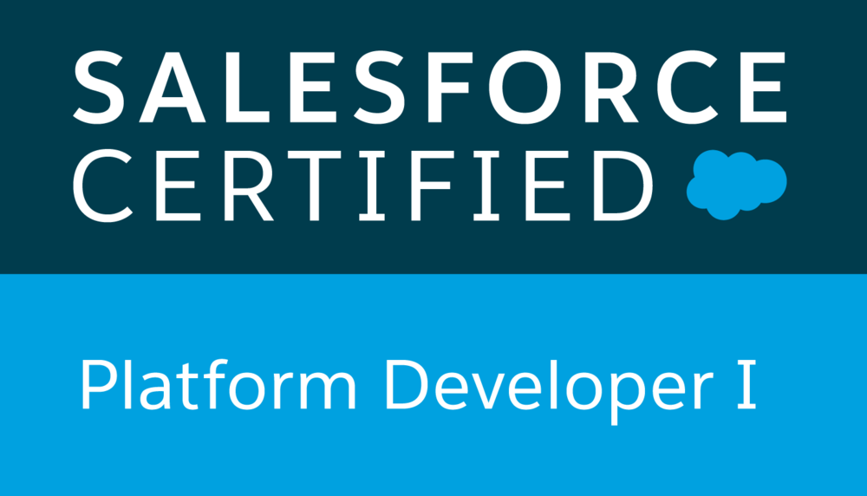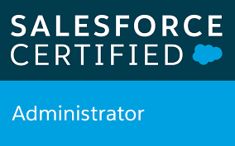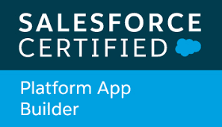
Profile Summary  - Total 6+ of experience in IT industry.  - 5+ years of experience on Salesforce.com Platform – CRM, Apex, Triggers, lightning, Visualforce, Web Services, Workflows and Approvals, Community Setup, Test Classes, Deployment, Apex data loader.  - Hands-on Experience of lightning components and web components.  - 3+ years of experience in lightning components development.  - 1+ years of experience in lightning web component implementation.  - Experience in end-to-end product development. This involves development, quality analysis, test classes, bug fixes and deployment.  - Worked on sales and service clouds widely across multiple industries.  - Experienced in Agile methodology.  - Always tried my best to follow code standards in all development work.  EDUCATION  Bachelor of Engineering (information Science and Engineering), Bangalore, India.  CERTIFICATIONS  Salesforce.com Platform Developer 1 (PD1)  Salesforce.com Platform App Builder  Salesforce.com Administrator  EXPERIENCE  Tech Mahindra Ltd: June 2014 to June 2017  CRMIT Solutions: June 2017 to November 2018  IBM India Pvt. Ltd (Shell Infotech - Client location): December 2018 to till date  PROJECTS  BLAZE  Role: Senior Developer  Project aims to give feasible solution for case management. SF system is integrated with third party system called as MarketHUB from where customer can initiate case creation flow for any dispute or query, he/she has. Raising service requests and managing case through agent login is handled from salesforce end.  Responsibilities:  - Worked on Lightning web components development.  - Building community page.  - Writing apex classes, test classes.  - Using declarative tools in salesforce such as Process builder, Flows etc.  SMARTOPS & TDS (Trade and Supply)  Role: Senior Developer  While TDS aims at resolving business requirements for trade and supply, providing solutions o  Within salesforce environment, SMARTOPS provides solutions for shipment and large oil containers management related problems. TDS also allows integration with other systems for robust data.  Responsibilities:  - Worked on Lightning components development.  - Writing apex classes, test classes.  - Using declarative tools in salesforce such as Process builder and etc.  Sales 1st (Global Commercials)  Role: Senior Developer  Project aims at solving various business problems in sales cloud implementations using majorly in Lightning environment. Migration of entire sales process from classic to lightning which enabled sales users for better salesforce experience and loaded features.  Responsibilities:  - Got a great chance to work on lightning web components development along with aura components.  - Write apex classes, triggers, test classes.  - Using best of declarative tools in salesforce.  - Track Defects using VSTS and fix them by target date.  - Review User stories and acceptance criteria in VSTS along with BA.  - Worked on Sales cloud.  MoA Lubes (US)  Role: Developer, Designer.  Lubes project aims at automating pipeline process management. This brings shift from heavy paperwork of users to a fully automated and clean process management with using salesforce out of box functionalities.  Responsibilities:  - Business calls with clients to gather requirements.  - Designing the solutions in best way.  - Worked on Approval Process, Aura components development, Triggers majorly.  Appreciated for timely delivery of the project with user’s satisfaction on delivered solutions.  MARS.  Role: Developer.  Project aims at providing business solutions through salesforce declarative and development tools for Pet Industry business.  Responsibilities:  - Worked closely with Salesforce architects and developers to build optimal business solutions.  - Worked on riggers, lightning components, apex classes, test classes and configurations.  - Implemented trigger framework and followed best practices at every stage of development including test classes.  AMP Capital and Real Estate  Role: Designer & Developer.  AMP is a financial services company in Australia providing superannuation and investment products and banking products including home loans. Project aims at providing business solutions through salesforce declarative and development tools.  Responsibilities:  - Involved in requirement gathering directly with business analysts and clients.  - Involved in designing HLD, LLD, solutions and handled a team of 4 developers.  - Configuration/Administration changes to achieve functionality.  - Involved in creating customer reports.  - Test classes’ development to achieve code coverage.  Field Sales Pro and Field Force Pro  Role: Designer & Developer.  This project aims to build two tools, sales tool which accelerates the company's sales by providing features like catalog synchronization, quote management, sales meeting preparedness and analytics (through  reports and dashboards) FFP use SF system to assign WorkOrder to service agent and communities to enable service agent to follow up and update the Work Order which got assigned to him.  Responsibilities:  - Development in Apex, Lightning components, VisulaForce.  - Involved in creation of managed and un-managed package to deploy codes in different environments and Usage of communities.  - Data Migration through Apex Data Loader.  - FSL modal functionality implementation  SFDC Capability Development  Role: Developer.  This project aims to build CPQ (configure Price Quote) is a tool which has complex rule engine and user-friendly interface with telecom products displaying for configuration. Configuration is based on the user inputs. Pricing happens dynamically. CPQ tool enables guided selling which plays vital role in product selection and configuration.  Responsibilities:  - Development in Apex, VisulaForce and Javascript and involved in configuration.  - Integrating CPQ tool to Siebel for Order generation using REST Web Services.  - Involved in writing Apex test classes to achieve the code coverage.  - Involved in creation of managed and unmanaged package to deploy codes in different environments, worked on Data migration through apex data loader.  3UK CIO Development  Role: Developer  Three UK is a telecom company providing telecom products includes mobile network connections. It uses JAVA technologies for application development. It also uses PeopleSoft CRM and EAI Tibco middleware. Web application development allows customers to directly interact to buy new connections, maintaining the user account which also involves lodging complaints, issues.  Responsibilities:  - Developing web applications using struts and struts frameworks.  - Backend Services integration using SOAP and REST.  - Unit Testing and code optimization.  - Fourth Line Support to application (Resolving Production Issues). |  | SKILLS  Salesforce.com  Declarative development  tools.  Lightning Components  Lightning Web Components  Apex  Visualforce  Triggers  Approvals  Profiles  Apex Data Loader  Chatter  Force.com IDE  Other  JavaScript  HTML  SLDS  Tools  Eclipse IDE  Copado  VS Code  Visual Studio  ANT

